

Practices for Secure Software Report

Table of Contents
Document Revision History 3
Client 3
Instructions 3
Developer 4
1. Algorithm Cipher 4
2. Certificate Generation 4
3. Deploy Cipher 4
4. Secure Communications 4
5. Secondary Testing 4
6. Functional Testing 4
7. Summary 4
8. Industry Standard Best Practices 4

Document Revision History

Version | Date | Author | Comments
1.0 | 2026-04-17 | Reynold Demesmin | Completed report draft and refactored code package.

Client
Artemis Financial


Instructions

Submit this completed practices for secure software report. Replace the bracketed text with the relevant information. You must document your process for writing secure communications and refactoring code that complies with software security testing protocols.

- Respond to the steps outlined below and include your findings.
- Respond using your own words. You may also choose to include images or supporting materials. If you include them, make certain to insert them in all the relevant locations in the document.
- Refer to the Project Two Guidelines and Rubric for more detailed instructions about each section of the template.

Developer
Reynold Demesmin

Algorithm Cipher

For this project, I implemented SHA-256 as the cryptographic hash algorithm for Artemis Financial’s file verification step. SHA-256 is part of the SHA-2 family and produces a 256-bit digest from an input value. It is a one-way hash, so the output cannot be reversed back into the original plaintext. That makes it a strong choice for checksum verification because even a very small change in the data produces a completely different hash value.
Hashing is different from encryption. Symmetric and asymmetric encryption use keys to protect confidentiality, while a hash function is mainly used to verify integrity. In this application, the checksum proves that the transmitted data has not been changed in transit. I selected SHA-256 because it is significantly stronger than older algorithms such as MD5 and SHA-1, which have known collision weaknesses. The 256-bit output offers strong resistance against brute-force and collision attacks, which is important for a financial services client.
Random values can also strengthen protection when they are combined with cryptographic operations. For example, salts add randomness before hashing so identical inputs do not always produce identical results in storage scenarios. While this project focused on checksum verification instead of password storage, the same principle shows why secure systems rely on randomness, strong key sizes, and approved algorithms. Historically, encryption has moved away from older weak ciphers and hashes toward modern standards that support confidentiality, integrity, and authenticity. Today, SHA-256 remains widely accepted across secure software, TLS ecosystems, certificate tooling, and blockchain implementations, so it is an appropriate and industry standard choice for this application.

Certificate Generation
Insert a screenshot below of the CER file.

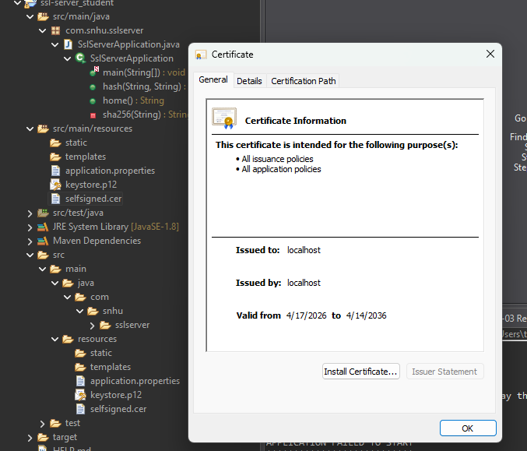

Deploy Cipher
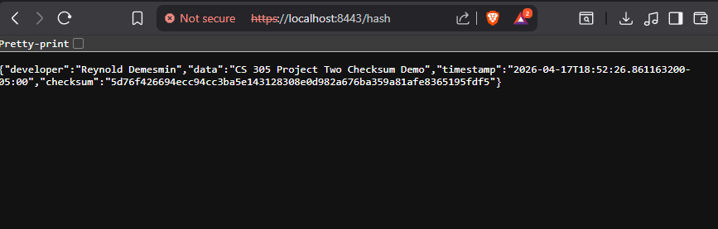Insert a screenshot below of the checksum verification.

Secure Communications
Insert a screenshot below of the web browser that shows a secure webpage.

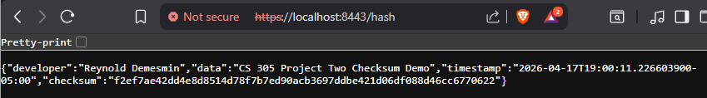

Secondary Testing
Insert screenshots below of the refactored code executed without errors and the dependency-check report.
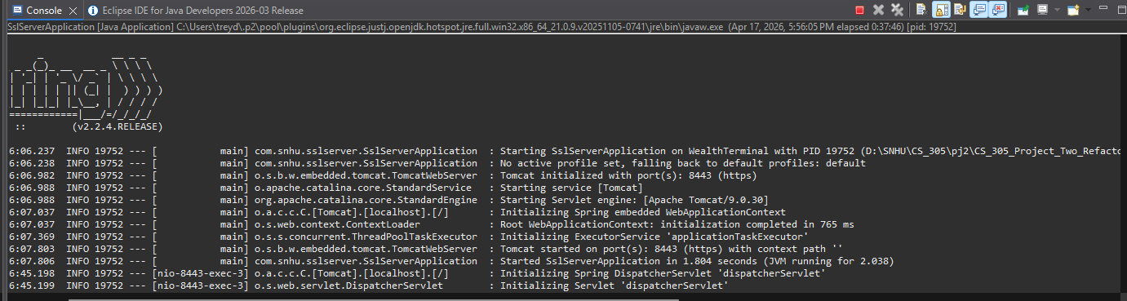
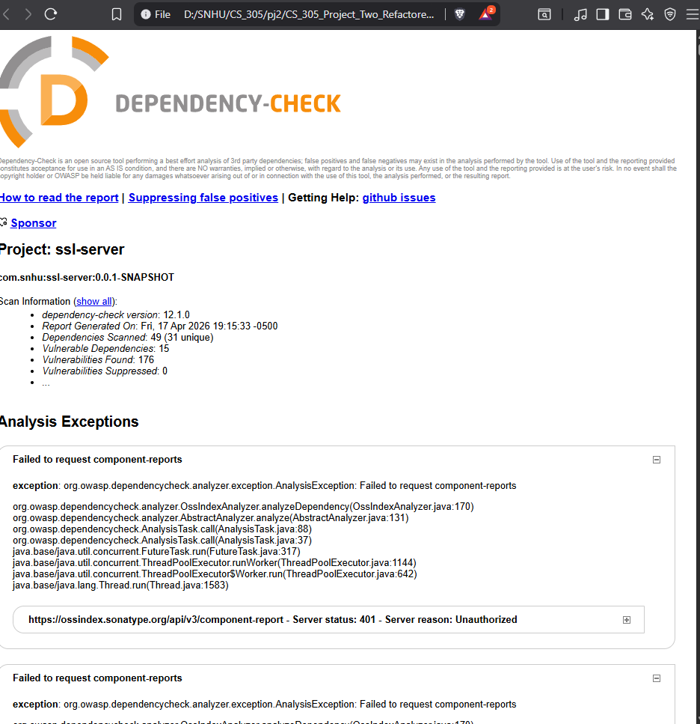

Functional Testing
Insert a screenshot below of the refactored code executed without errors.

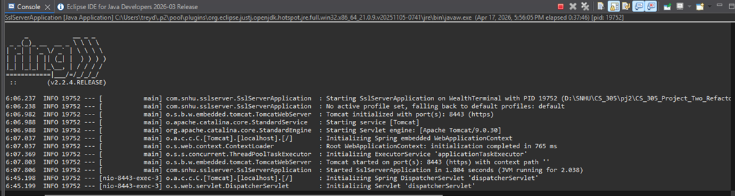

Summary

The refactored application now adds multiple layers of security to Artemis Financial’s software and aligns with the project’s secure software requirements. Using the vulnerability assessment process flow, I addressed several areas directly, especially cryptography, client/server security, code error handling, code quality, and manual code review of the endpoint logic. The process flow begins with architecture review, then moves through input validation, APIs, cryptography, client/server, code error handling, code quality, encapsulation, and targeted code review before ending with a summary of findings and a mitigation plan.
My refactoring follows that same structure. I first reviewed the project architecture and identified that the original code was missing a secure route, a checksum implementation, and the HTTPS configuration needed for secure communication. I then added a SHA-256 checksum endpoint, generated and linked a self-signed certificate, and configured the application to use HTTPS on port 8443. After the code changes, I manually reviewed the endpoint logic and configuration values to confirm that the application handled the new security requirements in a focused and maintainable way.
Overall, the refactoring improves integrity verification, strengthens data transmission security, and follows the mitigation mindset shown in the vulnerability assessment diagram. The end result is a cleaner and more secure application that is better prepared to protect client financial information.

Industry Standard Best Practices

I applied several industry standard best practices while refactoring this project. First, I used a modern approved hash algorithm instead of relying on older weak algorithms. Choosing SHA-256 supports strong integrity checking and reduces the risk associated with known collision vulnerabilities. Second, I enabled HTTPS so data sent between the client and server is protected in transit. That follows the best practice of encrypting sensitive communications rather than exposing traffic over plain HTTP.
I also limited the amount of code I changed and kept the implementation straightforward. Small, focused changes make code easier to review, test, and maintain. I used a separate checksum method, avoided exposing internal secrets in the response, and kept the SSL configuration in the application properties file where it can be managed consistently. These choices help preserve the application’s existing security while strengthening the parts that were previously missing.
Applying secure coding best practices benefits the company as a whole because it lowers the risk of data tampering, reduces the chance of preventable vulnerabilities, and increases trust in the application. For a company like Artemis Financial, protecting customer information is critical for legal, operational, and reputational reasons. Using strong cryptography, secure transport protocols, manual review, and static analysis supports the organization’s long-term security posture and helps deliver a more reliable product.

