CS 255 System Design Document
DriverPass System
[Student Name]

Purpose: This document presents the UML models and technical design requirements for the DriverPass system. The design supports online driver training, practice testing, lesson scheduling, reporting, security controls, and DMV content updates.
Primary Users | Core Services | Design Priorities
Customers, secretary, trainers, owner, and IT officer | Registration, packages, scheduling, practice tests, progress tracking, reporting | Security, cloud access, role-based permissions, audit tracking, and flexible package management

UML Use Case Diagram
The use case model below identifies the main people and connected systems that interact with DriverPass. It reflects the business need for online registration, scheduling, training progress, reporting, administration, and DMV content updates.
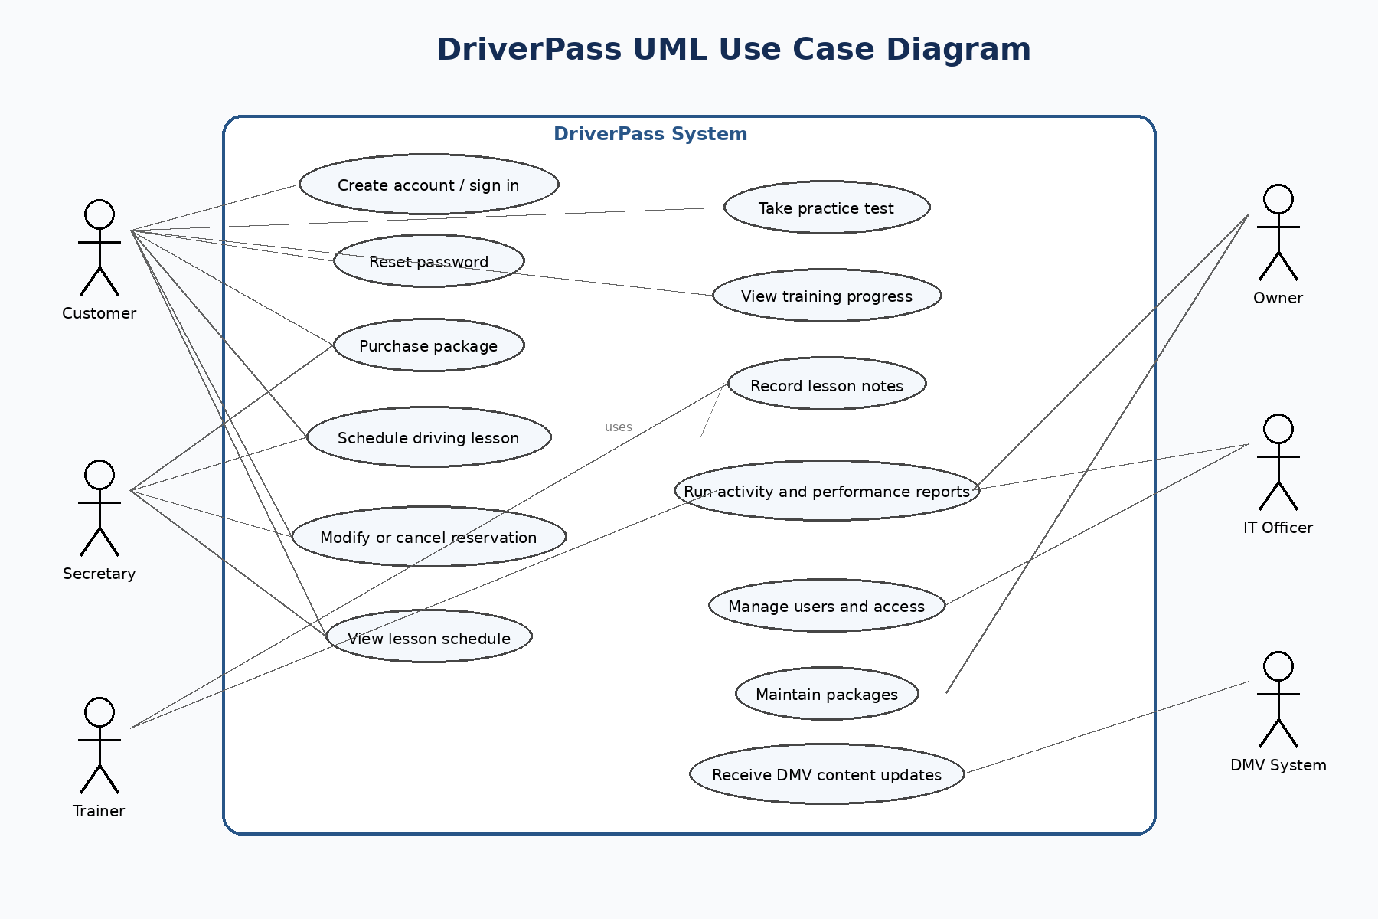
Use Case Diagram

UML Activity Diagram 1: Schedule Driving Lesson
This activity diagram shows the end-to-end scheduling flow. It improves on the earlier work by specifically checking remaining package hours before booking, checking time-slot availability, offering alternate lesson times, and recording the reservation in the audit trail.
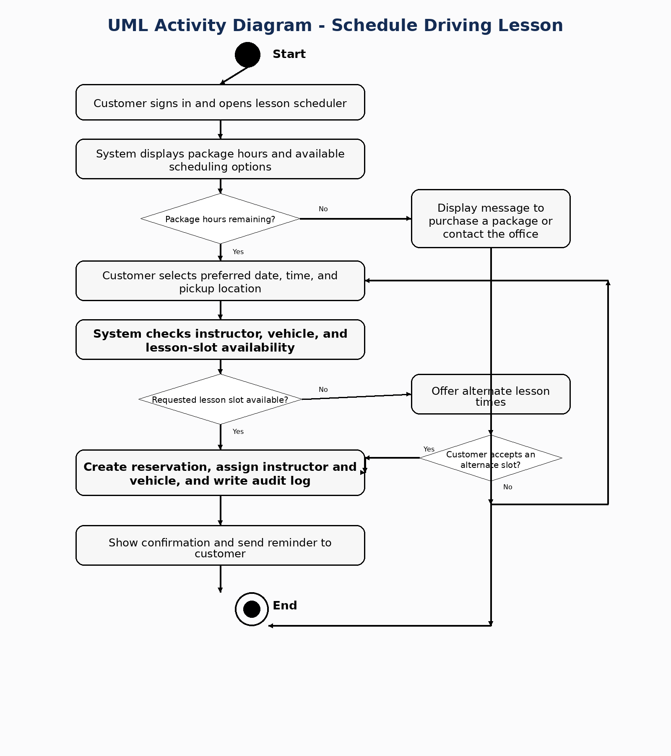
Activity Schedule

UML Activity Diagram 2: Take Online Practice Test
This activity diagram breaks down the online practice test process. It shows test selection, loading DMV-based content, scoring, pass or fail status handling, and updating the customer progress dashboard.
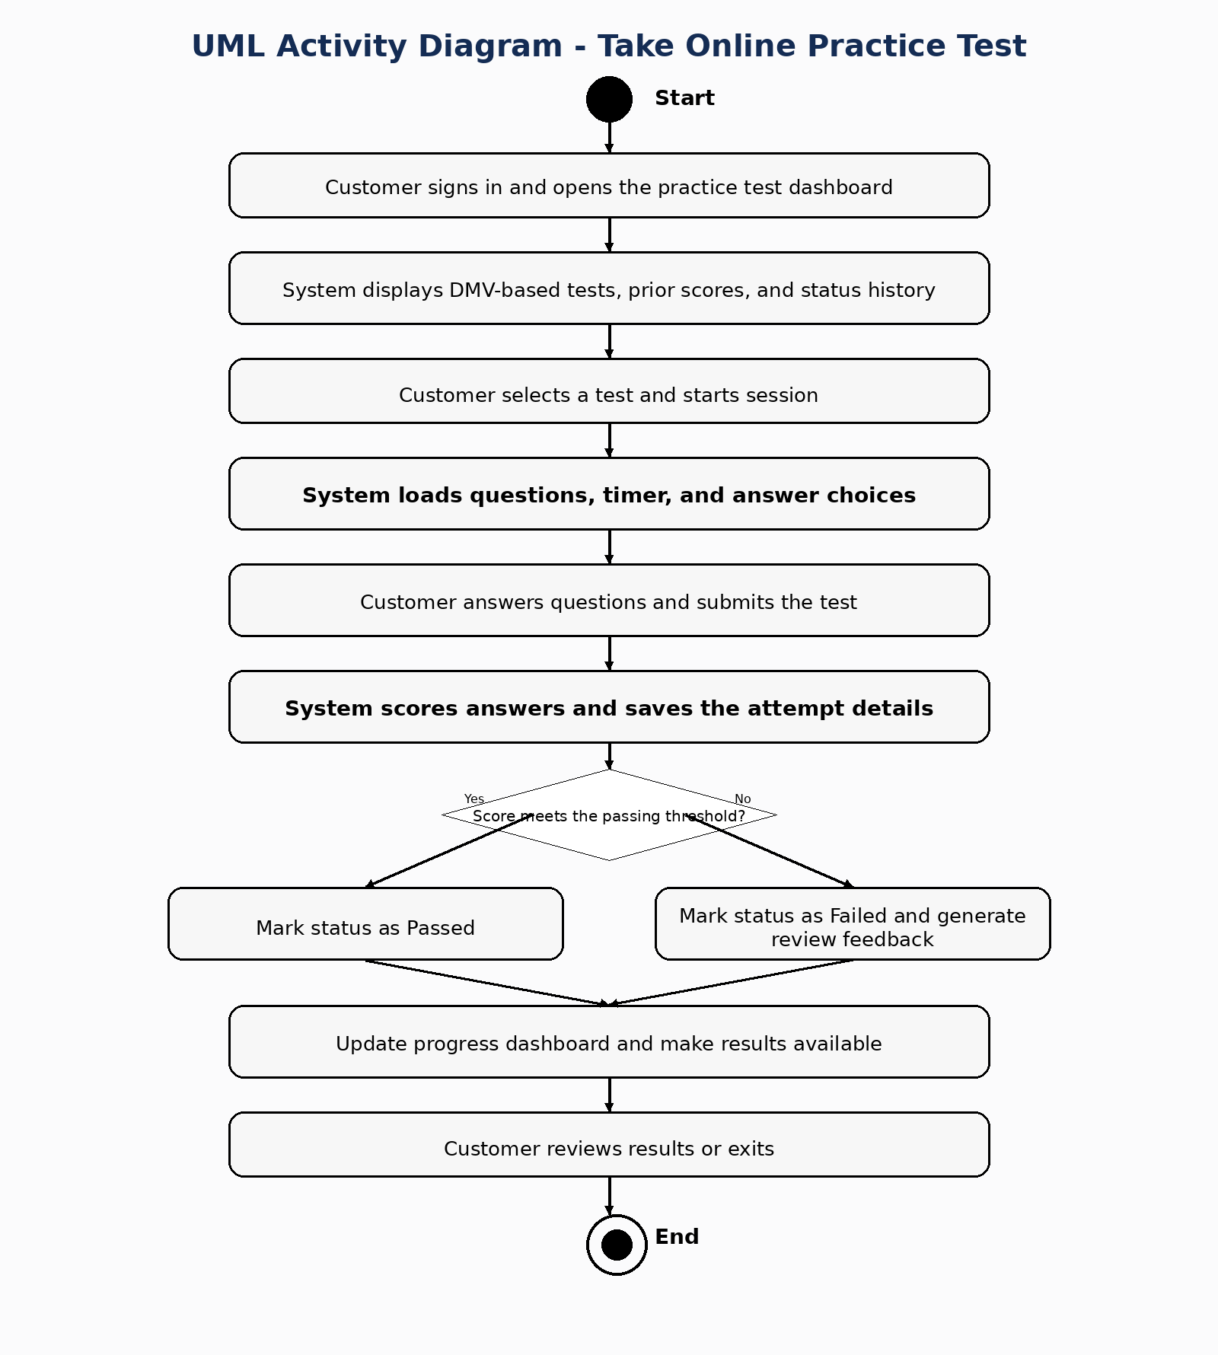
Activity Practice Test

UML Sequence Diagram
The sequence diagram focuses on the lesson scheduling use case. It shows how the customer, web application, scheduling service, and database coordinate to verify package availability, check open lesson slots, save the reservation, and return a confirmation.
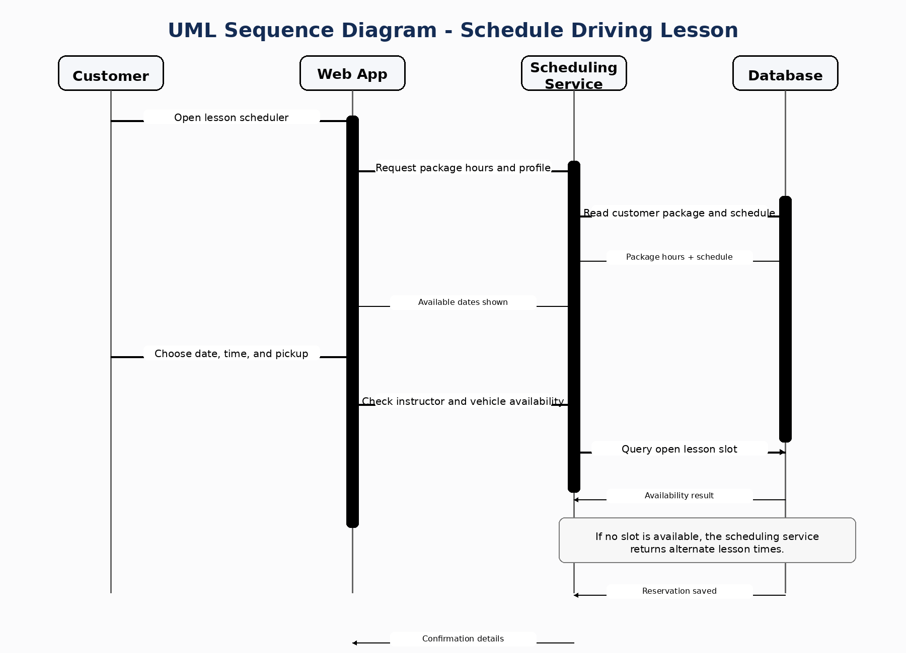
Sequence Schedule

UML Class Diagram
The class diagram identifies the core data objects required by the system. It includes customers, accounts, packages, reservations, vehicles, practice tests, DMV updates, payments, test attempts, and audit logs.
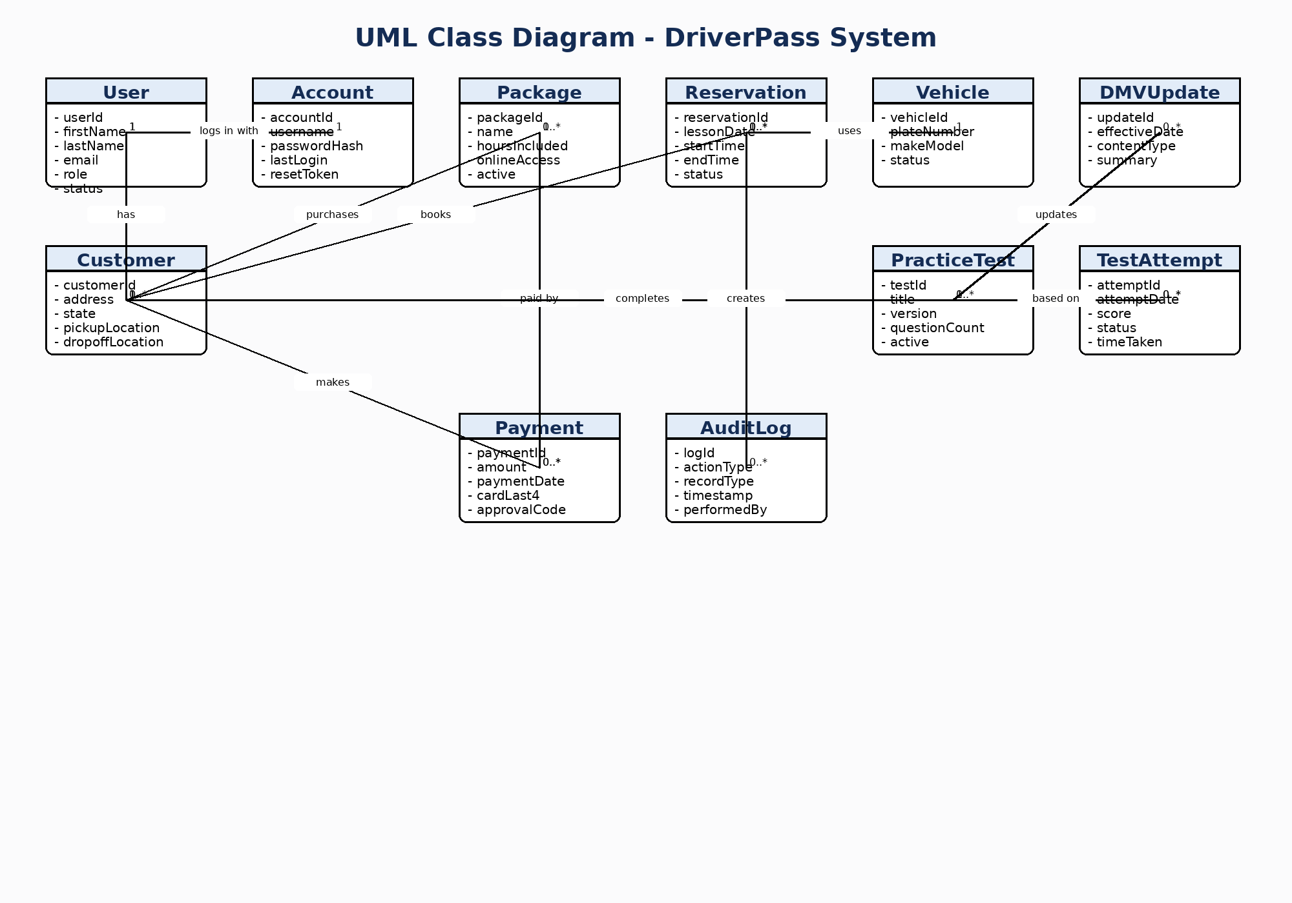
Class Diagram

Technical Requirements
The DriverPass system should use a secure cloud-based web architecture so the client can access current data from any location while still maintaining centralized control. The following requirements align the design with the needs identified in the interview transcript.
Hardware
- Cloud-hosted application servers and database servers with automatic backup and recovery support.
- Office workstations for the secretary, owner, trainers, and IT officer with standard web browser access.
- Customer access through desktop computers, laptops, tablets, and mobile phones.
- Networked printer support for activity reports, schedules, and customer-facing documents.
Software
- Responsive web application for customer self-service, employee scheduling, reporting, and account management.
- Relational database management system to store users, reservations, packages, payments, lesson assignments, and test history.
- Authentication and password reset services with encrypted credential storage.
- Reporting capability that allows staff to export operational data to formats such as Excel.
Infrastructure and Integration
- Cloud hosting environment with high availability, secure remote access, and centralized updates.
- Role-based access controls so each employee only sees the functions needed for the job.
- DMV content integration or administrative update feed to keep practice tests and class material current.
- Email or text notification service for reminders, confirmations, and password reset messages.
Security and Quality Controls
- Transport encryption for all web sessions and encryption for sensitive data at rest.
- Audit logging for reservation creation, cancellation, updates, and administrative changes.
- Input validation and payment handling controls to protect customer registration data.
- Routine backups, monitoring, and recovery procedures to support business continuity.
System Constraints and Assumptions
- The system requires an internet connection for real-time updates; offline work is limited to downloaded reports or exported files.
- Package creation and major feature changes would still require developer support in a later release.
- Scheduling accuracy depends on up-to-date instructor, vehicle, and availability data being maintained by staff.
Design Rationale
This design uses a blended approach by combining process models and object models. The activity and sequence diagrams explain how important workflows behave, while the class diagram defines the information structure required to support those workflows. Together, the models address DriverPass needs for web access, clear reservation tracking, different employee permissions, online practice content, reporting, and future flexibility.

