**summary | AUSTRALIA UX STUDY – AUGUST 2012**

**User Study – August 2012: Australia**

In August 2012 we visited three cities in the Australia market to study users behavior in three basic tasks. The purpose of these tasks was to evaluate and capture problems with the functional processes of the website; specifically signup, shopping, and ADR management.

We conducted studies with a total of 27 users over 2 days in each city including Sydney, Brisbane, and Perth.

As a result of these studies we have compiled a list of actionable items split into three groups:

* Bugs (**13**) – Things that are broken and should be fixed as soon as possible
* Design Changes (**10**) – Issues that can be addressed by design changes to improve the usability of the site.
* Projects (**6**) – New ideas that have come up as a result of the study that could be incorporated into a larger project plan.

Each user was invited to participate in the task by their account manager and was given an incentive of $250 in product for their time.

Users facial expressions and voice were recorded by webcam as well as their entire screen during the task exercises. Users sat with the moderator in one room while the rest of the UX team was in another room observing and making annotations to the recording.

The moderator explains the task and the user may ask any questions before the task begins. Once the task has begun, the moderator should not help the user in most cases. During the task, the moderator may prompt the user to give feedback about what they are thinking about, how they are feeling, or what they would do next.

After each task, the user was presented with a short survey.

|  |  |  |  |
| --- | --- | --- | --- |
| **9/5/2012** | **Page 1** | **Brian Hansen** | **bhansen@nuskin.com** |
|  |  |  |  |

**WEB**

**summary | AUSTRALIA UX STUDY – AUGUST 2012**

**Task #1**

*Imagine that you have decided to become a Nu Skin distributor today. You would like to sign up online using the Nu Skin website. As part of your signup, select a Fast Start Package and create an automatic monthly shipment (ADR).*

The purpose of this task is to observe how users move through the signup form, product selection, ADR creation and checkout.

Generally speaking, users were able to successfully complete this task. The main areas of difficulty were centered on product selection. Many of these issues will be addressed in the upcoming signup front-end redesign.

***Survey***

**1. Overall this task was:**

|  |  |  |  |  |  |  |  |  |  |  |  |  |  |  |  |
| --- | --- | --- | --- | --- | --- | --- | --- | --- | --- | --- | --- | --- | --- | --- | --- |
| Very Easy | |  |  |  |  |  |  |  |  |  |  |  |  | 56% |  |
|  |  |  |  |  |  |  |  |  |  |  |  |  |  |  |
| Very Difficult | |  |  |  |  |  |  |  |  |  | 44% |  |  |  |  |
|  |  |  |  |  |  |  |  |  |  |  |  |  |  |  |
|  |  |  |  |  |  |  |  |  |  |  |  |  |  |  |  |
|  |  |  |  |  |  |  |  |  |  |  |  |  |  |  |  |
| 0% | | | 10% | | 20% | | 30% | | 40% | | 50% | | 60% | |  |



Most of the users who had difficulty with this task were Distributors who were used to using the paper form/phone method of signing up distributors. We should do a better job of making sure that our online signup process is as easy to complete as it is on the phone. This study shows that nearly half of users would describe our online signup process as “difficult”. Distributors also gave feedback that they enjoyed the personal nature of the phone and the commitment of the paper form. The online signup flow should incorporate a more human voice as well as creating a sense of commitment while signing up. We have design changes planned later this year to address some of these issues by allowing the local markets more control over the content and voice that is communicated during signup.

|  |  |  |  |
| --- | --- | --- | --- |
| **9/5/2012** | **Page 2** | **Brian Hansen** | **bhansen@nuskin.com** |
|  |  |  |  |

**WEB**

**summary | AUSTRALIA UX STUDY – AUGUST 2012**

**2. When you signed up as a distributor, how did you do it?**

|  |  |  |  |  |  |  |
| --- | --- | --- | --- | --- | --- | --- |
| Paper Form |  |  |  | 69% |  |  |
|  |  |  |  |  |  |
| Fax | 4% |  |  |  |  |  |
|  |  |  |  |  |  |
| On a mobile device | 0% |  |  |  |  |  |
|  |  |  |  |  |  |
| By Phone |  | 15% |  |  |  |  |
|  |  |  |  |  |  |
| Online | 12% |  |  |  |  |  |
|  |  |  |  |  |  |
|  |  |  |  |  |  |  |

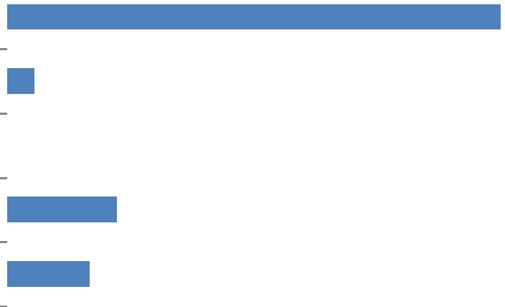

**3. When you sign up distributors under you, how do you prefer that they do it?**

|  |  |  |  |  |  |  |  |  |  |
| --- | --- | --- | --- | --- | --- | --- | --- | --- | --- |
| Paper Form |  |  | 19% |  |  |  |  |  |  |
|  |  |  |  |  |  |  |  |  |
| Fax | 0% |  |  |  |  |  |  |  |  |
|  |  |  |  |  |  |  |  |  |
| On a mobile device | 0% |  |  |  |  |  |  |  |  |
|  |  |  |  |  |  |  |  |  |
| By Phone |  |  | 19% |  |  |  |  |  |  |
|  |  |  |  |  |  |  |  |  |
| Online |  |  |  |  |  |  | 62% |  |  |
|  |  |  |  |  |  |  |  |  |
|  |  |  |  |  |  |  |  |  |  |

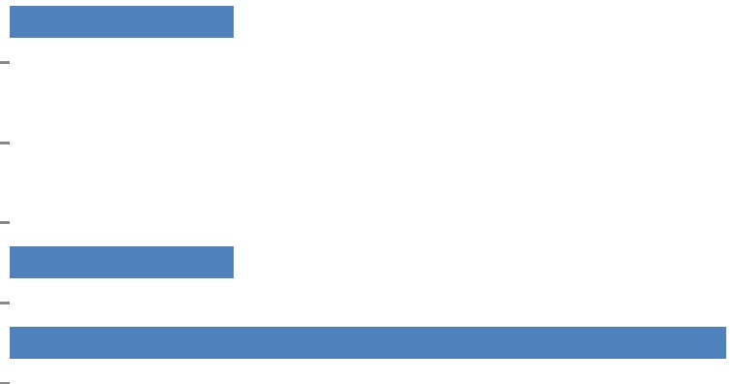

Although many of the Distributors who participated in our study signed up by paper form, most of them stated that they currently sign new Distributors up online. It is not uncommon for these online signups to be done with the Sponsor’s guidance either in person or over the phone. Other

Distributors said that they might complete the signup as the new person sat next to them so that they could “teach” them about the online signup process and use that training to sign up others the same way. They might also use this time to show the new Distributor parts of the website and where they can find the things that they need to grow their business.

Adding the new Office section should make this even easier. The Office section adds upfront access to many of the things that Distributors need, rather than having someone train them where to find them on the website.

|  |  |  |  |
| --- | --- | --- | --- |
| **9/5/2012** | **Page 3** | **Brian Hansen** | **bhansen@nuskin.com** |
|  |  |  |  |

**WEB**

**summary | AUSTRALIA UX STUDY – AUGUST 2012**

**Task #2**

*You have been feeling tired lately. Using the login below, find a product that gives energy and purchase it.*

The purpose of this task is to observe how a Distributor finds products, their interactions with the cart, and the checkout process.

***Survey***

**1. Overall, this task was:**

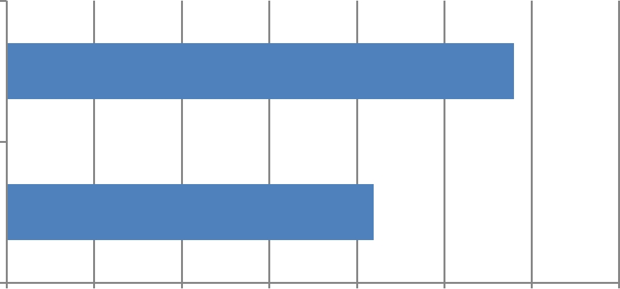

|  |  |  |
| --- | --- | --- |
| Very Easy | 58% |  |
|  |  |

|  |  |  |  |  |  |  |  |  |
| --- | --- | --- | --- | --- | --- | --- | --- | --- |
| Very Difficult |  |  |  |  | 42% |  |  |  |
|  |  |  |  |  |  |  |  |
| 0% | 10% | 20% | 30% | 40% | 50% | 60% | 70% |  |

Users utilized many different ways to find products including: search, view all, add a product tool, and express shopping

While most of the users were successful in this task, errors with the shopping cart added difficulty or, in some cases, resulted in a failure.

By making some simple enhancements to the shopping process we will focus on improving the satisfaction rating from “difficult” to “easy”.

**2. Would you ever buy Nu Skin products on a mobile device?**

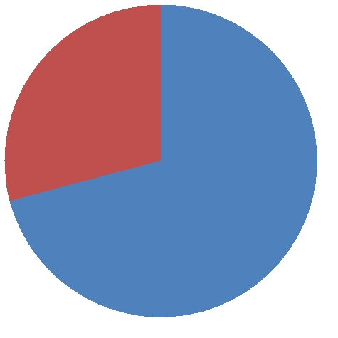

29%

71%

Yes

No

Feedback was positive for those who said that they would purchase products on a mobile device such as a smartphone or a tablet. Our web metrics show that there are more signups and orders completed on the website using a mobile device than there are from the native apps that users can download from iTunes or the Google Play store. This should spawn discussion about how we can start to make the signup and shop functions more mobile-friendly on the website even if the mobile content work will be done later.

|  |  |  |  |
| --- | --- | --- | --- |
| **9/5/2012** | **Page 4** | **Brian Hansen** | **bhansen@nuskin.com** |
|  |  |  |  |

**WEB**

**summary | AUSTRALIA UX STUDY – AUGUST 2012**

**3. When do you normally purchase Nu Skin products?**

|  |  |  |  |  |  |  |  |
| --- | --- | --- | --- | --- | --- | --- | --- |
| Other |  |  |  |  | 46% |  |  |
|  |  |  |  |  |  |  |
| Last week of the month |  |  | 17% |  |  |  |  |
|  |  |  |  |  |  |  |
| Last half of the month |  |  | 17% |  |  |  |  |
|  |  |  |  |  |  |  |
| First half of the month |  |  | 21% |  |  |  |  |
|  |  |  |  |  |  |  |
|  |  |  |  |  |  |  |  |

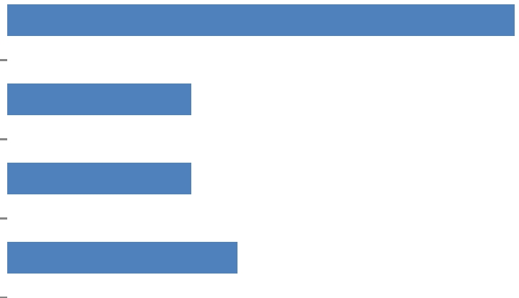

The feedback on this question was very random. Most people basically said that they purchase products “when they need them” or that they just modified their ADR in order to purchase the products that they need. We should focus on improving the Manage ADR process to support users who want to use the ADR shipment as their primary way of receiving products.

|  |  |  |  |
| --- | --- | --- | --- |
| **9/5/2012** | **Page 5** | **Brian Hansen** | **bhansen@nuskin.com** |
|  |  |  |  |

**WEB**

**summary | AUSTRALIA UX STUDY – AUGUST 2012**

**Task #3**

*You currently have an active ADR shipped to your address every month. This month, you would like to remove a product and add a product to your existing ADR.*

*Using the Nu Skin website and the login and password listed below; remove one product from this ADR and then add different product.*

***Survey***

**1. Overall, this task was:**

|  |  |  |  |  |  |  |  |  |  |  |  |  |  |  |  |
| --- | --- | --- | --- | --- | --- | --- | --- | --- | --- | --- | --- | --- | --- | --- | --- |
| Very Easy | |  |  |  |  |  |  |  |  |  |  |  | 57% |  |  |
|  |  |  |  |  |  |  |  |  |  |  |  |  |  |  |
| Very Difficult | |  |  |  |  |  |  |  |  |  | 43% |  |  |  |  |
|  |  |  |  |  |  |  |  |  |  |  |  |  |  |  |
|  |  |  |  |  |  |  |  |  |  |  |  |  |  |  |  |
|  |  |  |  |  |  |  |  |  |  |  |  |  |  |  |  |
| 0% | | | 10% | | 20% | | 30% | | 40% | | 50% | | 60% | |  |

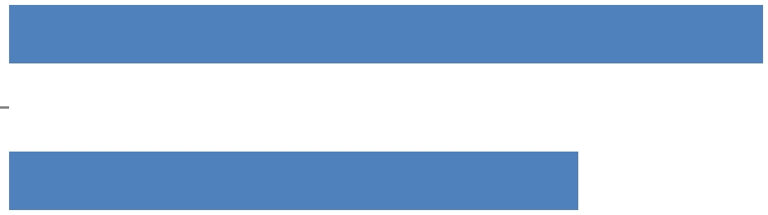

The purpose of this task was to observe how Distributors interact with the Manage ADR process. Users were mostly successful with this task. Most of the issues with this task were associated with application errors or improper placement of buttons.

|  |  |  |  |  |  |  |  |  |  |  |  |  |  |  |
| --- | --- | --- | --- | --- | --- | --- | --- | --- | --- | --- | --- | --- | --- | --- |
| **2.** | **How do you normally manage your ADR?** | | | | | | | | | |  | | |  |
|  |  |  | | | | | | | | |  | | |  |
|  | I don't have an ADR | 5% | | |  | | |  | | |  | |  |  |
|  |  |  | | |  | | |  | |  |  |
|  | Other | 0% | | |  | | |  | | |  | |  |  |
|  |  |  | | |  | | |  | |  |  |
|  | Fax | 0% | | |  | | |  | | |  | |  |  |
|  |  |  | | |  | | |  | |  |  |
|  | By Phone |  | | | 24% | | |  | | |  | |  |  |
|  |  |  | | |  | | |  | |  |  |
|  | Online |  | | |  | | |  | | | 71% | |  |  |
|  |  |  | | |  | | |  | | |  |  |
| **3.** | **How often do you normally change the products within your ADR?** | | | | | | | | | | | | |  |
|  |  |  | | | | | | | | |  | | |  |
|  | I don't have an ADR |  | 5% |  |  |  |  |  |  |  |  |  |  |  |
|  |  |  |  | |  |  | |  |  |  |  |  |  |
|  | Never |  |  | 10% | |  |  | |  |  |  |  |  |  |
|  |  |  |  |  |  | |  |  |  |  |  |  |
|  | About once a year |  | 5% |  | |  |  | |  |  |  |  |  |  |
|  |  |  |  | |  |  | |  |  |  |  |  |  |
|  | About every 6 months |  |  | 10% | |  |  | |  |  |  |  |  |  |
|  |  |  |  |  |  | |  |  |  |  |  |  |
|  | About every 3 months |  | 5% |  | |  |  | |  |  |  |  |  |  |
|  |  |  |  | |  |  | |  |  |  |  |  |  |
|  | Monthly |  |  |  | |  |  | |  |  |  | 67% |  |  |
|  |  |  |  |  | |  |  | |  |  |  |  |  |
|  | It was surprising to see how many users changed the products in their ADR every month online. | | | | | | | | | | | | |  |
|  | This validates the need to make the Manage/Override ADR process even easier online, keeping | | | | | | | | | | | | |  |
|  | in mind that Distributors frequently use this method to purchase products as opposed to the | | | | | | | | | | | | |  |
|  | traditional cart/checkout experience. | | | | | | | | | |  | | |  |

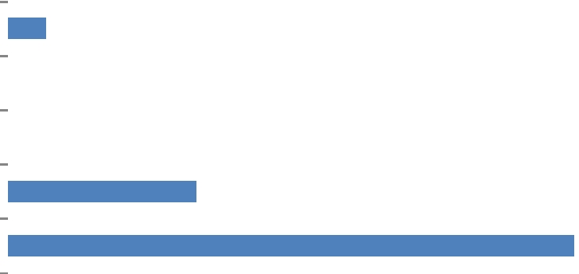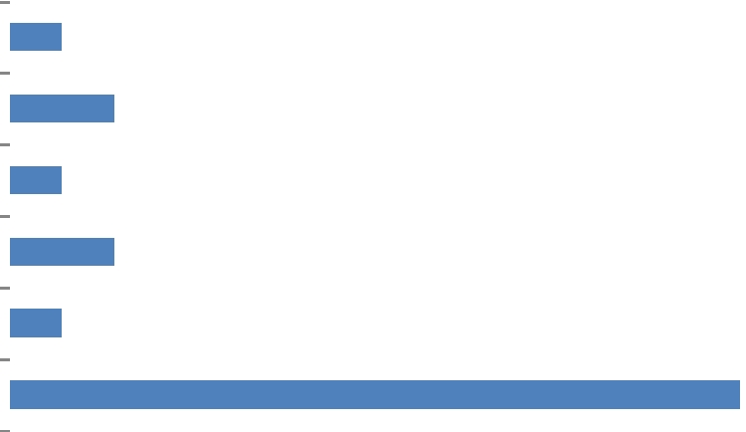

|  |  |  |  |
| --- | --- | --- | --- |
| **9/5/2012** | **Page 6** | **Brian Hansen** | **bhansen@nuskin.com** |
|  |  |  |  |

**WEB**

**summary | AUSTRALIA UX STUDY – AUGUST 2012**

**Discoveries**

The items below detail all of the items that were discovered during the user study. Each of these has been captured and documented. Bugs will be fixed as soon as possible; many were fixed on the spot. Design changes will be defined and implemented as soon as possible.

Bugs

Unsecure content warning on some product pages

Order Summary: all items checked as ADR

View all products: Section headers in Chrome are not styled

Cart is cleared after adding an item

Discontinued products in the Add A Product search

Add to cart popup does nothing from FSP page

Hero image alignment problem

Product detail page popup window is not visible without scrolling

Shop all categories different than Energy and Stamina

[Design Change](https://basecamp.com/1759485/projects/621434-australia-ux-study/todolists/2513627-design-changes)s

There is no call to action from the About ADR page

On the FSP page the continue button is hard to find

After adding an item to the cart, the continue shopping button does nothing

Edit Cart looks like a Checkout button on the Order Summary page

DA from phone numbers, check boxes for type of number?

DA from errors, why are they at the top?

Fast Start Packages naming

ADR confirmation screen continue button

Add to cart from FSP or ADR during signup is not confirmed

Edit ADR products button is in the wrong place

Manage ADR screen - change the date is in shipping options

Manage ADR screen - no email, shipping instructions

Quick view from the cart

|  |  |  |  |
| --- | --- | --- | --- |
| **9/5/2012** | **Page 7** | **Brian Hansen** | **bhansen@nuskin.com** |
|  |  |  |  |

**WEB**

[PDF to Word](http://pdfonline.blogspot.com)