
MICROSOFT
SBUYS
Target Price: $487.55
Current Market Price: $400.46
Percent Difference: 21.74%
NYSE Ticker: MSFT
Market Cap: 2.97T
52 Week Range: $344.79 - $555.45

Risks:
- High CAPEX may pressure short term margins
- Increasing regulatory scrutiny in AI and cloud markets
Catalysts:
- Expansion of cloud market share
- Monetization of AI products (Copilot and Azure)
- Increased enterprise adoption of AI-driven productivity tools
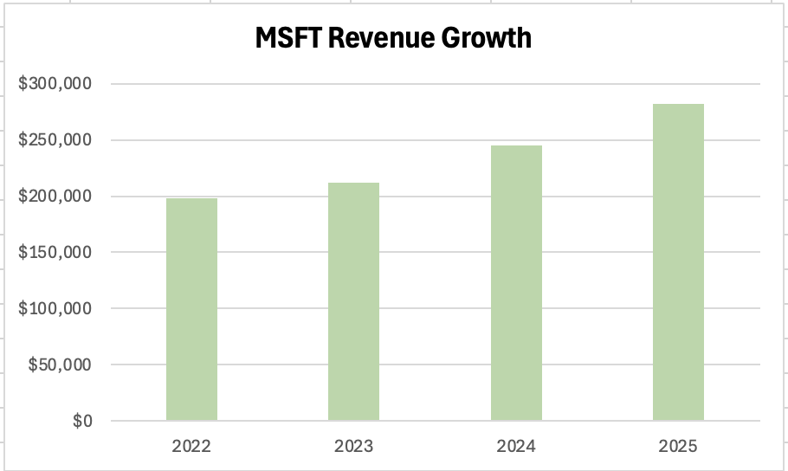
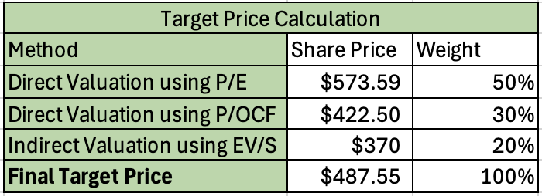

dExecutive SummaryS

The Valuation analysis indicates that Microsoft is currently undervalued, with a derived target price of $487.55 implying an upside of 217% compared to the current market price of the stock. Both direct and indirect valuation approaches support this conclusion with consistent results across all multiples.

Microsoft's strong positioning in cloud computing and artificial intelligence continues to drive growth, particularly through Azure and the integration of AI tools such as Copilot across its product ecosystem. While recent increases in CAPEX related to AI infrastructure have raised concerns about short term margin pressure, these investments are expected to support long term revenue expansion and reinforce Microsoft's competitive advantage

Relative to its peers, Microsoft demonstrates superior profitability and cash flow generation, often placing in the upper range of key value drivers. This reflects its scale, diversified revenue base, and high margin enterprise offerings. The company’s strong ecosystem, high switching costs, and long standing enterprise relationships further enhance its stability and growth potential

Overall, the analysis supports a BUY recommendation, as the current market price does not fully reflect Microsoft's long term earnings power and strategic positioning within the evolving AI-driven technology landscape
S Recent News S

Microsoft (MSFT):
- Microsoft has continued to expand its AI strategy around their flagship Copilot and agentic tools. This has been received as a positive signal due to Wall Street seeing Microsoft’s AI product stack as a long term growth driver.
- In mid February Yahoo Finance reported the stock was rebounding after an earnings-driven selloff. Main investor concern was related to heavy AI related capital spending ($37.5 billion in quarterly capex). AI investment supports future growth but it also pressures near term margins and free cash flow.
Alphabet (GOOG):
- Alphabet has continued to increase their Google Cloud infrastructure and AI partnerships, including talks with Apple centered around hosting parts of their next generation AI workloads. Suggesting that the company is becoming more competitive in the enterprise AI and cloud industry.
- The company’s generative AI capex is expected to support future cloud income and broader AI monetization. This implication is that their current rampant spending is justified by expected growth in cloud and AI related revenue.
Oracle (ORCL):
- Oracle has recently entered multiple high-value strategic partnerships, the most notable being a $300 billion cloud agreement with OpenAI and participation in the large-scale “Stargate” AI infrastructure project.
- These deals help them reposition from a legacy software firm to a major player as a future AI infrastructure provider. Investors couldn’t be more pleased as the stock rose almost 9% following strong earnings driven by these pivotal partnerships requiring them to build large-scale AI data centers and cloud capacity, increasing their future revenue dramatically.

S Industry Specific RiskS

Politics:
Microsoft, Alphabet, and Oracle are all currently exposed to increasing regulatory and political pressure, specifically related to antitrust enforcement, data privacy, and AI governance. Alphabet seems to be the most vulnerable due to its dominance in digital advertising and search which has made it a primary target for regulators. Microsoft also faces scrutiny surrounding its AI partnerships and cloud market share. However the company has historically done a good job managing these domestic and international regulatory relationships. Comparably Oracle faces less antitrust pressure but remains exposed to government policy changes through its enterprise and government contracts. Overall Microsoft is less exposed to political risk than Alphabet, while Oracle sits in a more moderate position.

Technological Change:
The rapid growth in AI advancements we are currently witnessing presents both opportunities and risks for all three firms. Microsoft is strongly positioned due to its integration of AI across its product ecosystem and leading cloud infrastructure platform, Azure. Alphabet is heavily invested in AI but faces unique challenges of adapting its business model without disrupting its core revenue from advertising. Oracle continues to expand its cloud offerings but it lags behind the other two in scale and innovation. This results with Oracle being more exposed to technological disruption, an example being the threat of quantum computing to one of their pillars of business being cybersecurity.

International Developments:
It's well known that all three companies generate a significant portion of their revenue internationally. This choice exposes them to currency fluctuations, geopolitical tensions, and regulatory differences across markets. Microsoft (49%) and Alphabet (51%) both generate half of their revenue from international markets. Recent trade tensions between the U.S and China may limit expansion and increase operating costs. Alphabet is more sensitive to these foreign demands due to its reliance on these inflows from international advertising while Microsoft benefits from a more diversified revenue base.

ISSI Risk:
Microsoft demonstrates a stronger overall governance with a lower ISSI score of 6, while Alphabet and Oracle show higher risk levels with both scores reaching a 10. Their scores show a lacking particularly in compensation and shareholder rights which could negatively impact investor perception.

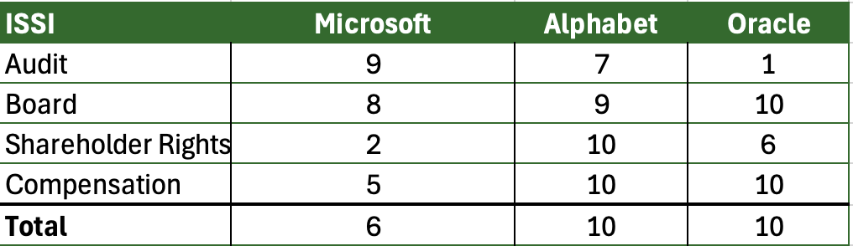

10k Risks Comparison:
While Microsoft, Alphabet, and Oracle share several common risk factors such as cybersecurity threats, regulatory scrutiny, and intense competition in the technology sector, there are meaningful differences in their firm-specific risks. Microsoft's risks are heavily tied to its enterprise cloud and AI infrastructure, including execution risk from large scale data center investments and reliance on enterprise clients. Alphabet faces greater exposure to regulatory and antitrust risk, particularly related to its dominance in search and digital advertising as well as its dependence on this revenue from advertising. Oracle seems to be more worried about its transition to cloud services and its reliance on large capital investments and acquisitions, which introduce integration and execution risk. In conclusion while the firms operate within the same industry their risk profiles differ based on their business models and strategic focus.

S Competitive Structure of the IndustryS

Competitors:
- The cloud computing and enterprise software industry is highly competitive, dominated by large players including Amazon Web Services, Microsoft, Google, Salesforce, Adobe, and Oracle
- Barriers to entry are extremely high due to massive capital requirements for data centers, AI infrastructure, and global scale
- While new startups can emerge it is very difficult for them to compete with these incumbents benefiting from network effects and established relationships

Positioning:
- Microsoft is strongly positioned as a market leader in cloud computing (Azure) and enterprise software (Microsoft 365)
- Their product offerings across productivity, cloud, and AI tools (Copilot) all come together to make a seamless ecosystem for their users
- Benefit from high switching costs and long term enterprise relationships, making it difficult for customers to migrate to competitors
- Early aggressive investment in AI has further reinforced its position as a leader in next generation enterprise technology

S Firm Specific InformationS

True Intangibles:
Microsoft benefits from strong intangible assets including its global brand, long-standing enterprise relationships, and continuous investment in R&D. Its reputation as a reliable enterprise software provider has created high customer loyalty over the years. Additionally Microsoft's proven ability to adapt and innovate, especially with AI and cloud technologies, has positioned it at the forefront of the industry. The biggest example of this currently is their integration of Copilot into their previously successful products such as Word, Excel, PowerPoint in an effort to automate tasks and improve productivity for users. Compared to its peers Microsoft's combination of brand strength, ecosystem integration, and enterprise trust provides a sustainable competitive advantage.
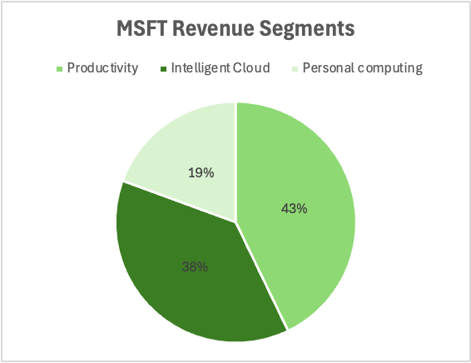
Revenue Segments:
Microsoft operates under three primary business segments: Productivity & Business Processes, Intelligent Cloud, and Personal Computing. All together they synergize to provide a diversified and balanced revenue base. Each segment serves a role, cloud drives growth, productivity offers stable recurring income, and personal computing contributes additional scale and increases brand exposure

Productivity:
- Includes Microsoft 365, Linkedin, and Dynamics, generating 42.9% of total revenue in 2025 which was a +13% jump from the previous year
- This growth is driven by Microsoft 365 subscriptions and AI monetization from Copilot, providing stable recurring revenue and strong margins
Intelligent Cloud:
- The cloud segment is made up of Azure, server products, and enterprise cloud services which contribute 37.7% of total revenue and increase a staggering +21% last year.
- This leap is driven by Azure and AI/cloud demand making this Microsoft’s primary long-term growth engine. Heavy investments in this segment reinforce Microsoft's strategic shift toward AI and cloud driven revenue.
Personal Computing:
- This sector includes what many people recognize Microsoft for in their daily lives. Including Windows, Xbox devices, and search advertising which all accounts for 19.39% of total revenue (+7% increase from last year)
- This revenue is more cyclical and tied to consumer demand, with growth supported by gaming and search but less consistent than other segments

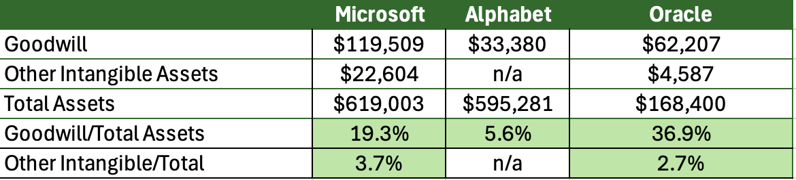
Goodwill & Other Intangible Assets:
Microsoft’s Goodwill is mainly driven by large strategic acquisitions such as LinkedIn(~$26B), GitHub, and Activision(~$69B). Alphabet's recorded goodwill is relatively low because the company relies less on large acquisitions and more on internally developed assets such as search algorithms and AI models. Goodwill for Oracle is very large due to its acquisition-heavy growth strategy. Particularly deals such as the healthcare company Cerner(~$28B) are aimed to secure large locked in client bases with high renewal rates which justifies the premium

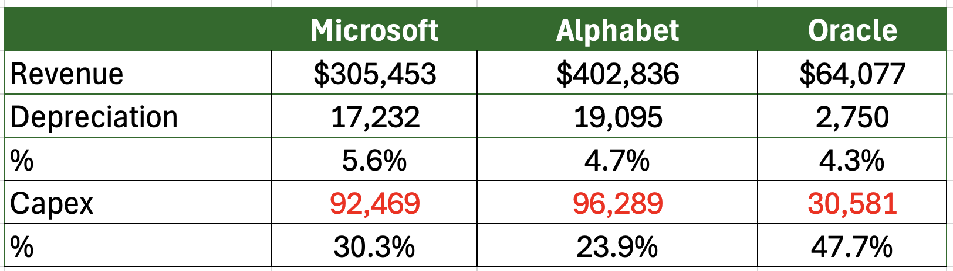
Depreciation vs. CapEx:
All three firms have CAPEX significantly exceeding depreciation which indicates strong ongoing investment in infrastructure and future growth rather than just maintaining existing assets. This makes perfect sense because this high CAPEX is driven by needed investments in cloud computing and AI data centers. It seems like they are not using special purpose vehicles to finance these moves. Oracle shows the largest gap between CAPEX and depreciation which follows in line with the fact that they are contractually obligated to build a lot of data centers for OpenAI and Meta. This supports growth but it also introduces higher execution and capital intensity risk compared to its peers.

Unfunded Pension Liabilities:
All three firms have no unfunded pension liabilities.

S Comparable Companies AnalysisS
An initial set of comparable companies to Microsoft was created using Bloomberg's database and other outside research. All of the companies for the most part are U.S based, with SAP being the exception being stationed in Walldorf, Germany. The companies were selected due to their
similarity to MIcrosoft in terms of business model, scale, and exposure to key industry drivers such as cloud computing, enterprise software, and artificial intelligence. All these firms are large-cap companies with global operations, ensuring that differences in size won’t materially distort the analysis.
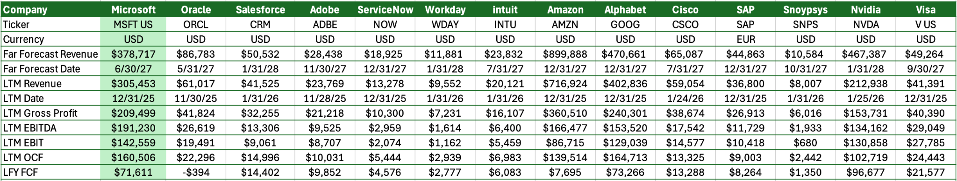

This dataset was used to calculate key value drivers as percentages of LTM revenue and to assess comparable companies relative to Microsoft. The figure below highlights these metrics and illustrates how each firm compares to Microsoft.
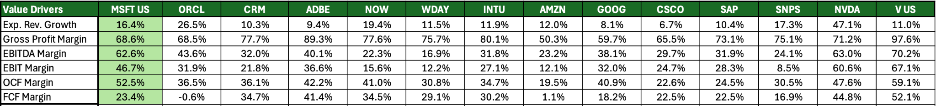
As shown below each value driver was sorted from smallest to largest to identity firms that were most comparable to Microsoft. Banding was applied across each metric to highlight companies with similar performance. Firms were then subsequently ranked based on how frequently they fell within Microsoft's comparable ranges. Microsoft tends to fall in the upper range across several metrics reflecting its strong margin and cash flow generation by its cloud leadership and significant economies of scale.
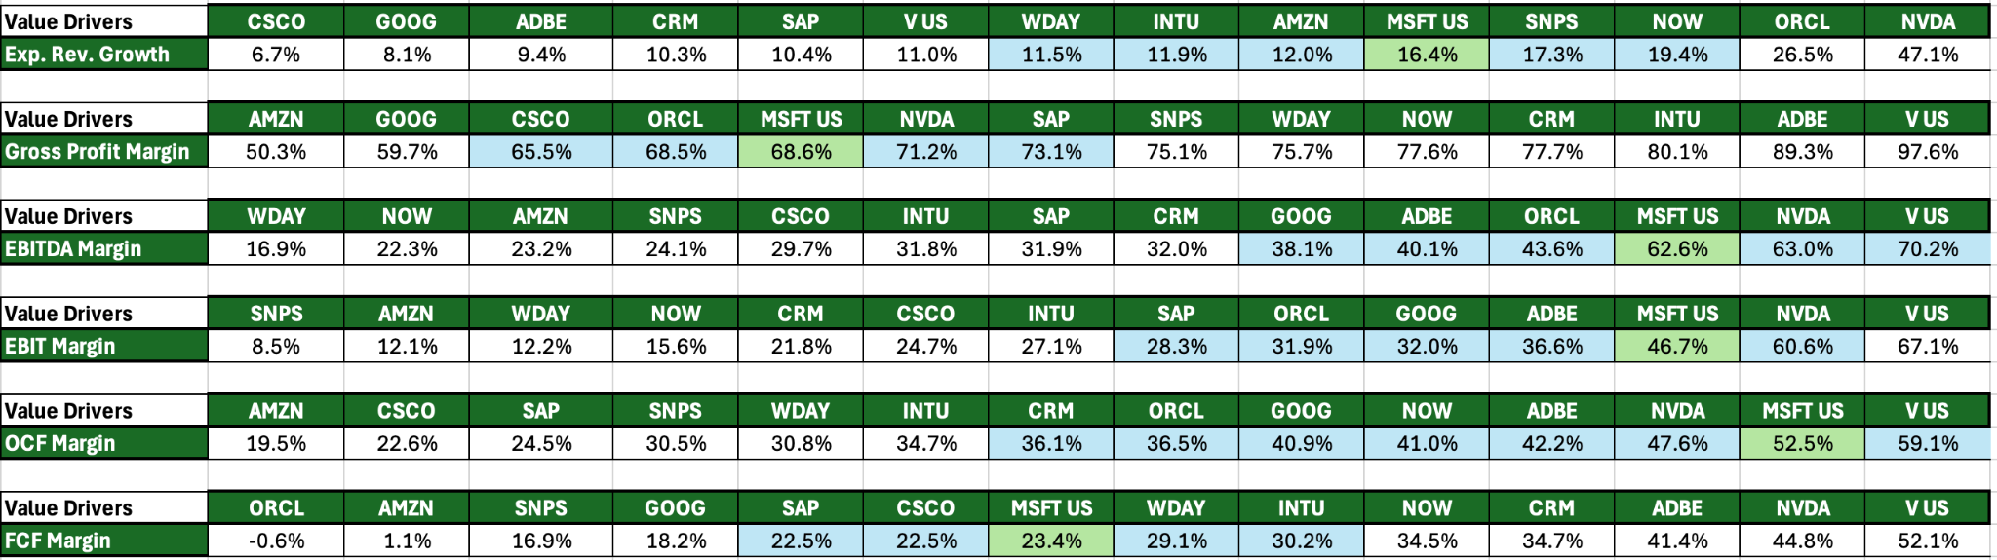

Based on the analysis of value drivers and valuation multiples, Alphabet, Oracle, Nvidia, Adobe, Visa, and SAP were identified as the most comparable firms to Microsoft. These companies consistently align with Microsoft across key growth, profitability, and cash flow metrics, making them appropriate benchmarks. The multiples below were collected to establish valuation ranges which will

S Direct ValuationS
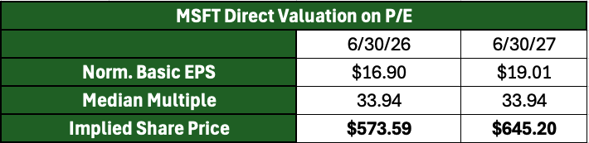
P/E was selected as the primary valuation multiple due to its broad use and comparability, with the median 33.9X chosen instead of the mean in order to reduce the impact of outliers
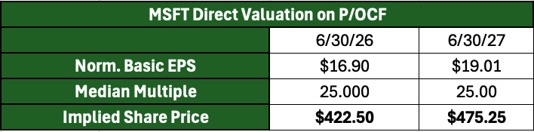
P/OCF was also included to capture Microsoft's strong cash flow profile, with the median multiple of 25.0x used given its low dispersion and reliability.

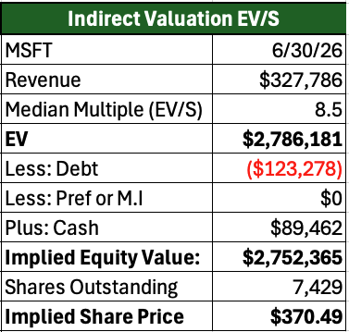
S Indirect ValuationS

After calculating the direct valuation, the same process was applied to enterprise value multiples. Among these, EV/Sales appeared to be the highest consistency due to its low percentage difference, leading to the selection of the median EV/S multiple of 8.5x.

Applying LTM sales and this multiple yielded a implied EV of $2.78 Trillion, the table to the right show the steps taken that lead us to a implied share price of $370.49

S Target PriceS
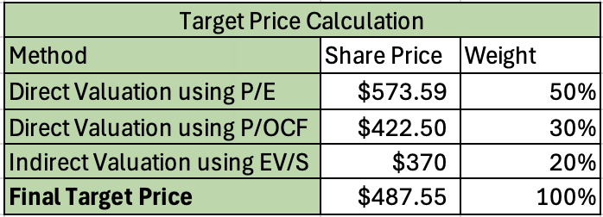
After both methods of direct and indirect were used, we next utilized a weighted average split that was applied to determine the final target price. Greater weight was placed on the P/E (50%) and P/OCF(30%) multiples, as they showed lower dispersion across the comparable set and more directly reflected Microsoft's strong earnings and cash flow generation. In contrast, EV/S multiple was given a smaller weight of 20% as it does not account for profitability differences and tends to undervalue high margin firms like Microsoft. These weights leave us with a final target share price of $487.55 suggesting that Microsoft is currently undervalued to its fundamentals and long term growth potential. BUY!

