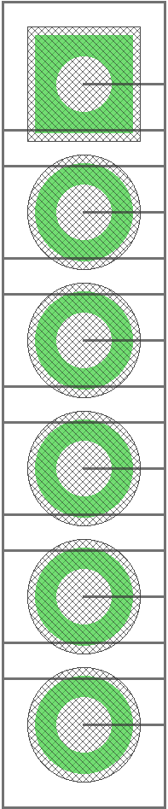 | 1 RST  2 GND  3 SWO  4 SWCLK  5 SWDIO  6 VDD

distance: 0.0625 inch

drill: 0.7 mm

programmer: ST-Link/V2

