# Angola

## Summary

### Nodes

|  |  |
| --- | --- |
| railway | count |
| null | 1981 |
| level_crossing | 627 |
| switch | 215 |
| station | 160 |
| buffer_stop | 84 |
| platform | 66 |
| crossing | 24 |
| halt | 24 |
| milestone | 5 |
| facility | 3 |
| stop | 2 |
| engine_shed | 1 |
|  |  |
|  |  |
|  |  |

Railway tag value and count where name tag value is not null.

|  |  |
| --- | --- |
| railway | count |
| station | 153 |
| halt | 22 |
| milestone | 4 |
| stop | 2 |
| facility | 1 |
| null | 1 |
|  |  |
|  |  |
|  |  |
|  |  |

### Edges

#### All edges – status

|  |  |
| --- | --- |
| open | 2371 |
| abandoned | 204 |
| disused | 118 |
| construction | 8 |
|  |  |
|  |  |

#### All edges – type

|  |  |
| --- | --- |
| conventional | 2257 |
| other | 444 |
|  |  |
|  |  |
|  |  |
|  |  |
|  |  |

#### Named edges

#### Bridge/viaduct

|  |  |
| --- | --- |
| null | 2415 |
| bridge | 172 |
| platform | 109 |
| station | 3 |
| viaduct | 2 |
|  |  |
|  |  |

## Information

https://en.wikipedia.org/wiki/Rail_transport_in_Angola

* Three 1067mm gauge (Cape Gauge) lines that all connect to the Atlantic coast
  + Luanda Railway (northern line)
  + Benguela Railway (central line) – link to DRC
  + Moçâmedes Railway (southern line)
* According to Wikipedia much of railway infrastructure was destroyed in civil war that lasted until 2002. All three lines were said to have been rebuilt by 2015. Kuanda and Benguela by the China Railway Construction Corporation and Moçâmedes by a Chinese mining company.

See also for general, and recent, overview of infrastructure including Rail: <https://www.trade.gov/country-commercial-guides/angola-transportation-aviation-and-rail>

### Luanda Railway

<https://en.wikipedia.org/wiki/Luanda_Railway>

* Single track
* Luanda to Malanje
* Branch line Zenza do Itombe – Dondo
* New branch to serve New International Airport of Luanda (<https://www.a1v2.pt/en/portfolio/railway/>. Airport project has been going on for many years. Estimated to open in 2023.
* State railway company - Caminho de Ferro de Luanda E.P (CFL) - <https://cflep.co.ao>
* Timetable for part of line only to Catete. This is the suburban service and most passenger trains run on this section of line with much fewer services between Luanda and Malange.
* Line is definitely running to Malange for freight. See: https://cflep.co.ao/2022/03/11/caminho-de-ferro-de-luanda-e-parametro-perfeito-dao-inicio-ao-processo-de-transportacao-de-gasoleo-para-malange/

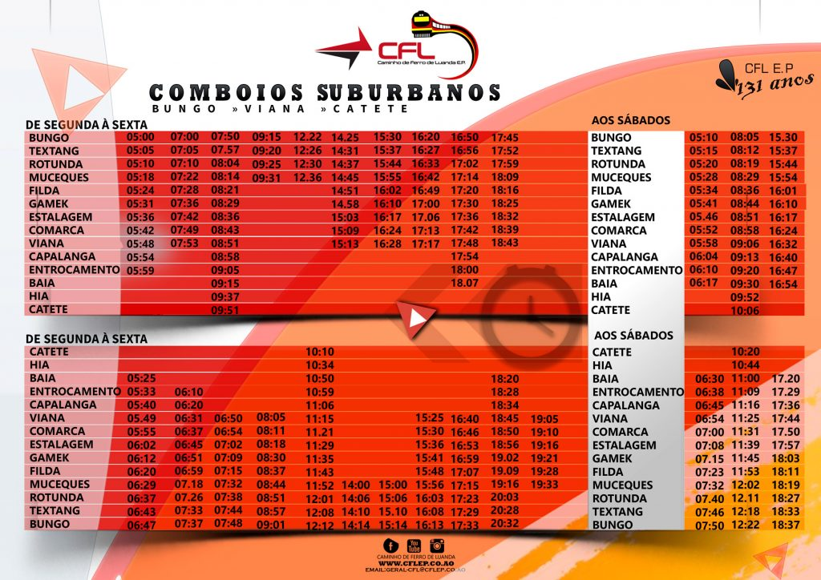

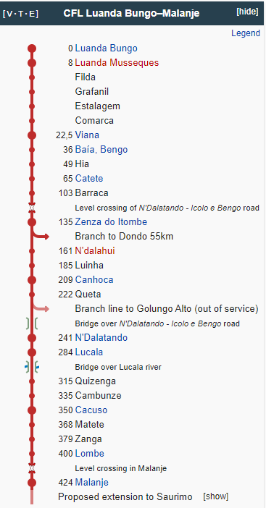

### Benguela Railway

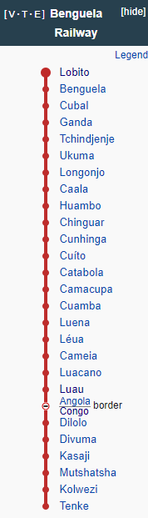

* Port of Lobito – Luau and then DRC (nr Dilolo)
* Said to be Electrified from Lobito to Cuamba (according to: <https://en.wikipedia.org/wiki/Benguela_railway>). Source? More likely planned.
* Operating speed 90 km/h 56 mph (<https://en.wikipedia.org/wiki/Benguela_railway>)
* New concession agreement for the line July 2022: https://zambianbusinesstimes.com/zambia-to-lose-out-on-drc-traffic-to-angola/
* Run by state owned Empresa do Caminho de Ferro de Benguela-E.P (ECFB)
* Facebook site: https://www.facebook.com/profile.php?id=100057527767117
* Timetables on facebook site, show services between Huambo and Luau and not from Lobito (November 2022):

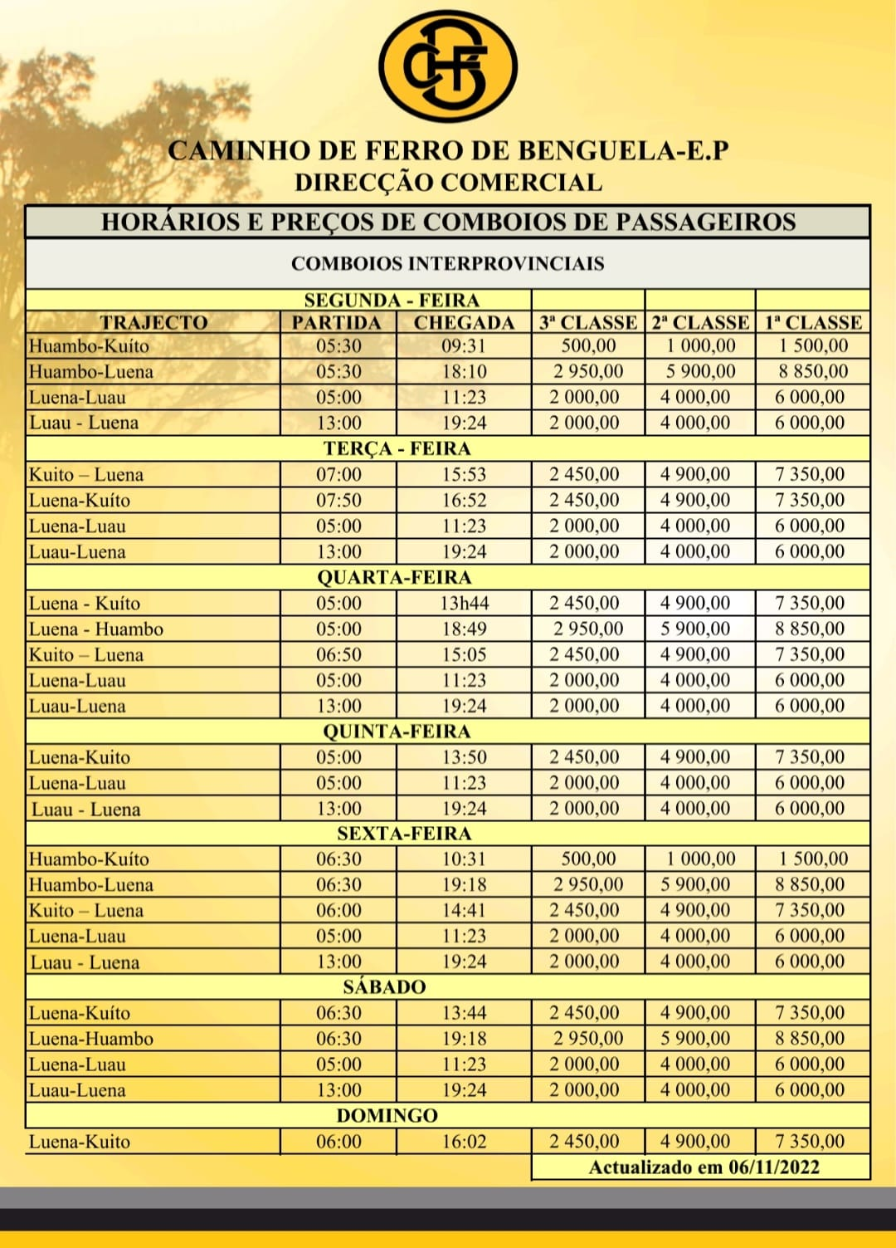

* Older timetable for August 2022 for Lobito – Luau

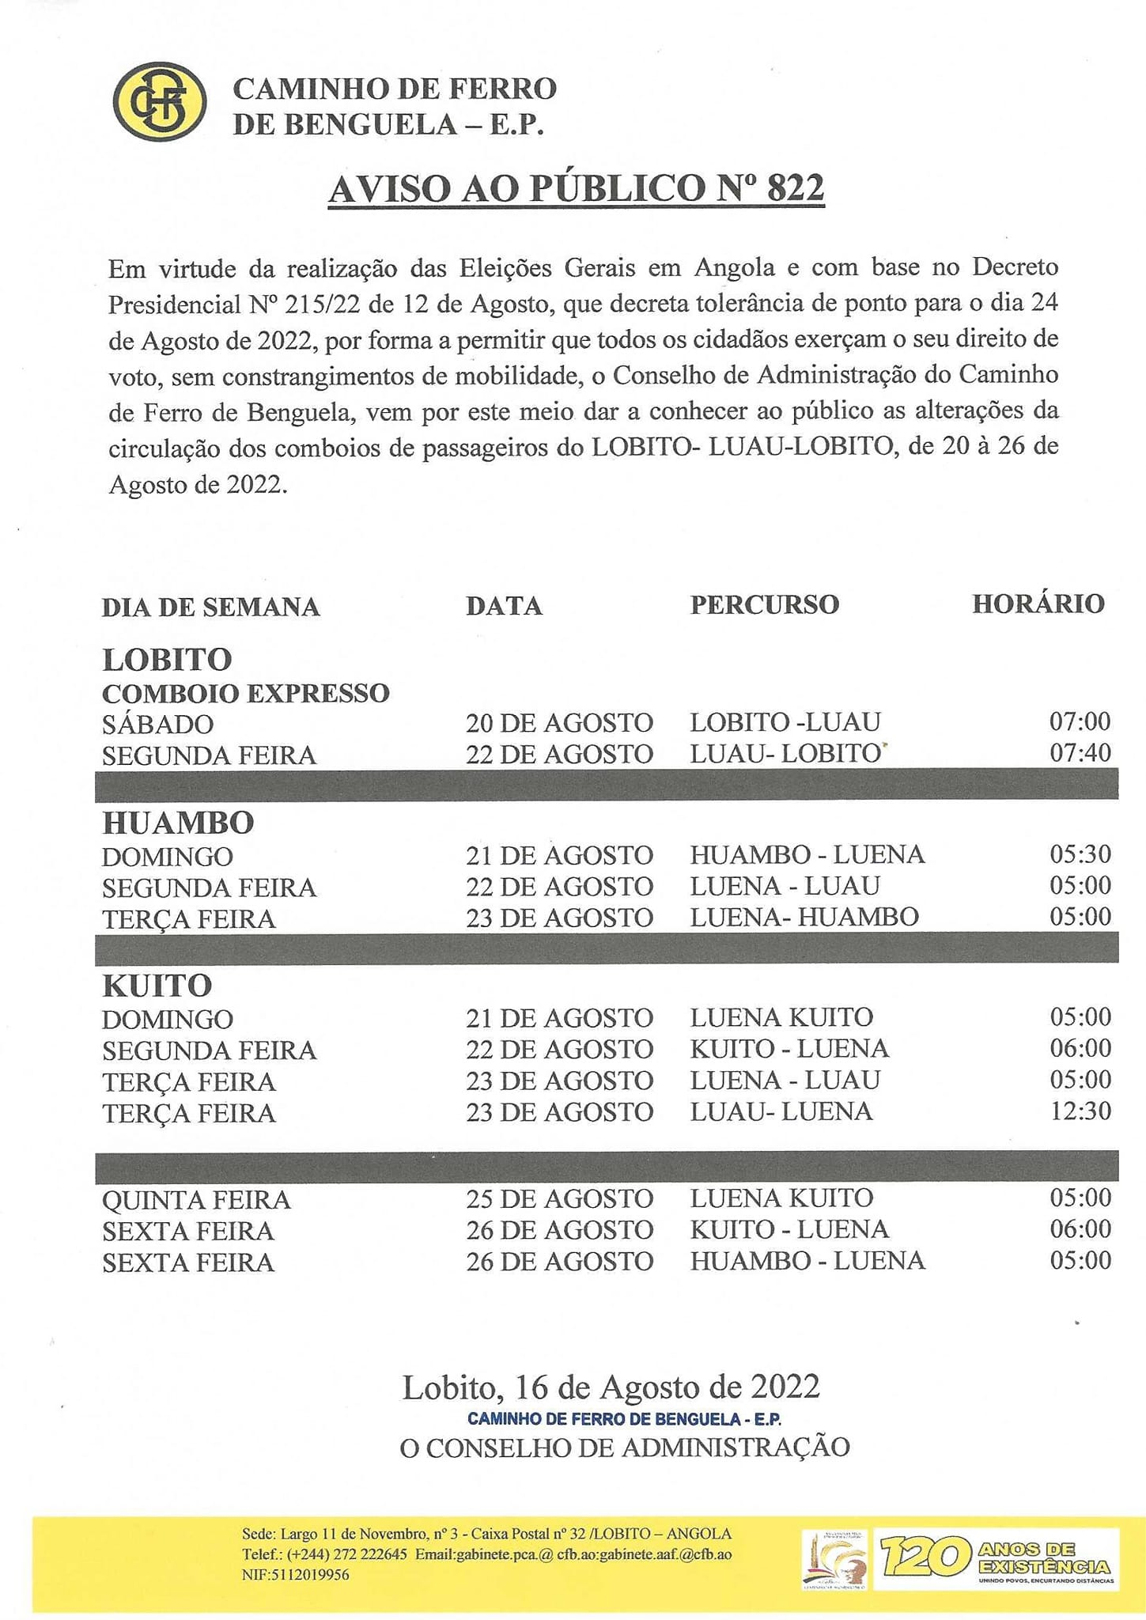

* “On 5 March 2018, ore transport was restarted from the Tenke Fungurume Mine, in the DRC, from where copper and cobalt are extracted, and the cargo transported to the port of Lobito. From that date the railway went into full operation, connecting the city of Tenke to the city of Lobito” (<https://en.wikipedia.org/wiki/Benguela_railway>).

### Moçâmedes Railway

* Between Moçâmedes (called Namibe 1985-2016) and Menongue: https://en.wikipedia.org/wiki/Mo%C3%A7%C3%A2medes_Railway
* Operated by Caminhos de Ferro de Moçâmedes E.P.(CFM)
* Branches to Chamutete (incl mines) and Jamba that appear in use. See: https://www.verangola.net/va/en/042022/Transports/30514/CFM-train-connects-Lubango-to-Jamba-again-after-two-years-paralyzed.htm

Future proposal

* Luanda Light Rail (<https://en.wikipedia.org/wiki/Luanda_Light_Rail>)
* “In 2022, CF de Moçâmedes launched a feasibility study into a 300km branch line to Oshikango, Namibia, where it would connect with the Namibian rail network”: <https://www.sinfin.net/railways/world/angola.html>
* https://www.verangola.net/va/en/052022/Transports/30983/Mo%C3%A7%C3%A2medes-Railway-plans-to-launch-300-kilometers-of-line-to-link-Angola-to-Namibia.htm
* “Also in 2022, an operating and maintenance concession for the CF de Benguela was awarded to a consortium of Trafigura, Mota-Engil, and Vecturis. Under the termsof the concession, extensive upgrades and improvements will be made to the existing route. These may include a branch line from Luacano to Jimbe on the border with Zambia (West of James Benwa), where it would connect with a planned new line in that country.”

International connections

* DRC – operating
* Zambia – possible (see above)
* Namibia – possible future link (see: https://angola.org/caminho-de-ferro-de-mocamedes-projecta-ligacao-com-a-namibia/)