# Cameroon

## Summary

### Nodes

|  |  |
| --- | --- |
| railway | count |
| null | 709 |
| level_crossing | 202 |
| buffer_stop | 51 |
| station | 42 |
| switch | 36 |
| crossing | 22 |
| halt | 17 |
| stop | 3 |
| platform | 1 |
|  |  |
|  |  |
|  |  |
|  |  |
|  |  |
|  |  |

Railway tag value and count where name tag value is not null.

|  |  |
| --- | --- |
| railway | count |
| station | 38 |
| halt | 17 |
| null | 3 |
|  |  |
|  |  |
|  |  |
|  |  |
|  |  |
|  |  |
|  |  |

### Edges

#### All edges – status

|  |  |
| --- | --- |
| open | 838 |
| abandoned | 42 |
| disused | 17 |
|  |  |
|  |  |

#### All edges – type

|  |  |
| --- | --- |
| conventional | 827 |
| other | 67 |
| tram | 3 |
|  |  |
|  |  |
|  |  |
|  |  |

#### Named edges

#### Bridge/viaduct

|  |  |
| --- | --- |
| null | 826 |
| bridge | 63 |
| platform | 8 |
|  |  |
|  |  |
|  |  |

## Information

All metre gauge and virtually entirely single track.

<https://en.wikipedia.org/wiki/Rail_transport_in_Cameroon>

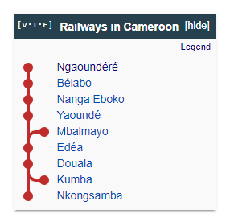

<https://en.wikipedia.org/wiki/Railway_stations_in_Cameroon>

[www.camrail.net](http://www.camrail.net) (in French) - timetables available.

Online schedules: <https://www.mycamrail.cm>

<https://www.sinfin.net/railways/world/cameroon.html>

<https://dlca.logcluster.org/display/public/DLCA/2.4+Cameroon+Railway+Assessment>

Three lines:

It appears the line from Mbanga to Nkongsamba is abandoned.

1. Douala – Kumba
2. Douala – Yaoundé
3. Belabo - Ngaoundéré

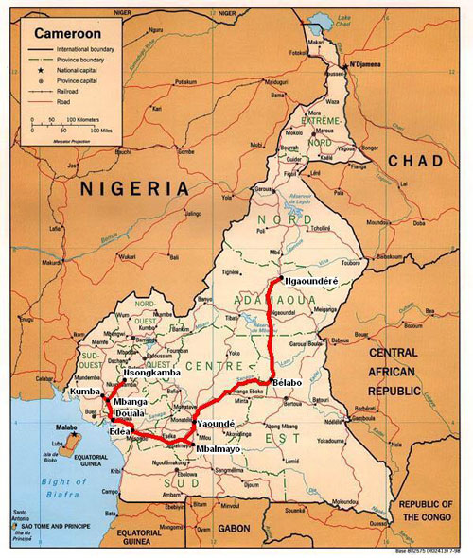

* primarily operated by Camrail,[1] a subsidiary of Bolloré Africa Logistics. In January 2022 announced that container shipping company MSC would take over Bolloré Africa Logistics.

“Express Train”

The Express Train connects the cities of Douala and Yaoundé with stops of two (2) minutes each in Edéa, Messondo, Eséka, Makak, and Ngoumou. It is made up of 3 1st class cars, 5 Premium cars, a 1st restaurant car and 2 fully air-conditioned vans, the passenger cars of the Train Express are even more comfortable. Its seats are self-adjustable and each passenger in their seat can take advantage of the sockets that have been installed for recharging telephones and laptops. See: <http://www.camrail.net/Train_Express.html>

“Train Couchette”

“The Couchette train connects the cities of Yaoundé and Ngaoundéré with stops at the main stations, notably in Obala; Batchenga; Mbandjock; Tabene; Nanga Eboko; Ouassa Mbamvele; Mengue Bibey; Mbargue; Belabo; Goyoum; Elephant head; Mbitom; Pangar; Ngaoundal; It is made up of sleeping cars (2 and 4 beds), the 1st Seat class and the 2nd Seat class, a bar-restaurant wagon, and 2 vans wagons The bar-restaurant wagon gives the possibility of tasting various dishes accompanied by drinks adapted to the trip.” See: <http://www.camrail.net/Train_Couchette.html>

“Omnibus” is slow train – all stops

Services/Stops

[Yaoundé - Ngaoundéré](http://www.camrail.net/h_yde_nge.html):

191/192 (couchette): Obala; Batchenga; Mbandjock; Tabene; Nanga Eboko; Ouassa Mbamvele; Mengue Bibey; Mbargue; Belabo; Goyoum; Elephant head; Mbitom; Pangar; Ngaoundal; Makor; Bawa

112/113 (omnibus): Mbambo; Mbaki II; Goyoum; Lom; Liguim; Elephant head; Mbitom; Kaoutal; Alamada; Gaindera; Pangar; Gaza Gazade; Ngaoundal; Djerem; Makor; Assom; Manden; Bawa; Mahamoud; Pastoral

[Douala - Yaoundé](http://www.camrail.net/h_dla_yde.html)

103/104 (omnibus) : Arrêts : Bassa; Nyalla; Japoma; Dibamba; Nkondjock; Kendeck; Pitti; Lungahe; Logbadjeck; Hikoa-Gan; Malimba I; Malimba II; Edea croisement; Edea voyageurs; Mbengue;Makondo;Mayamba; Mandjab;Sodibanga; Messondo; Lep Sonda; Ndogbessol; Hikoa-Malep; Djassock; Badjob; Eseka; Njock; Nguibassal; Mandjack; Minloh-Maloume; Ngwate; Makak; Minka; Mom; Otele; Ngoumou; Oweng; Nkolngong; Binguela; Mbalngong; Mvolye

181/184 : Arrêts : Bassa; Lungahe; Edea; Makondo; Mandjab;Sodibanga; Messondo; Ndogbessol; Hikoa-Malep; Badjob; Eseka; Minloh-Maloume; Makak; Minka; Mom; Otele; Ngoumou

185/186 Train Express

Douala - Kumba

172-177 (omnibus) Barombi; Mabondji; Ediki; Mbalangui; L Beach; Ndoh

Schedule: http://www.camrail.net/guide_horaires_tarifs.pdf

Freight times (see: http://www.camrail.net/prestation_fret.html)

* Transport times
* The maximum time limits for the transport of goods are as follows:
  + Douala-Yaoundé relationship and vice versa: 2 days
  + Douala-Belabo relationship and vice versa: 4 days
  + Douala-Ngaoundéré relationship and vice versa: 6 days
  + Other relationships: 3 days up to 350 kilometers and 2 more days per additional and indivisible fraction of 250 kilometers

Freight Branches

* Appear to serve Port of Douala
* Minim Martap – proposal to provide rail access to this mine. See: <https://www.railjournal.com/africa/camrail-signs-mou-to-increase-freight-capacity-on-douala-line/>

Future proposals

See: <https://www.sinfin.net/railways/world/cameroon.html>