# Democratic Republic of Congo

## Summary

### Nodes

|  |  |
| --- | --- |
| railway | count |
| null | 2636 |
| level_crossing | 1084 |
| station | 252 |
| crossing | 80 |
| halt | 14 |
| switch | 6 |
| railway_crossing | 5 |
| stop | 3 |
| platform | 2 |
| buffer_stop | 2 |
| subway_entrance | 1 |
|  |  |
|  |  |
|  |  |
|  |  |

Railway tag value and count where name tag value is not null.

|  |  |
| --- | --- |
| railway | count |
| station | 201 |
| halt | 8 |
| null | 5 |
| stop | 2 |
| platform | 1 |
| subway_entrance | 1 |
|  |  |
|  |  |
|  |  |
|  |  |

### Edges

#### All edges – status

|  |  |
| --- | --- |
| open | 2768 |
| disused | 468 |
| abandoned | 73 |
| razed | 2 |
|  |  |
|  |  |

#### All edges – type

|  |  |
| --- | --- |
| conventional | 2736 |
| other | 548 |
| light_rail | 26 |
| funicular | 1 |
|  |  |
|  |  |
|  |  |

#### Named edges

#### Bridge/viaduct

|  |  |
| --- | --- |
| null | 3189 |
| bridge | 118 |
| station | 2 |
| platform | 1 |
| turntable | 1 |
|  |  |
|  |  |

## Information

<https://en.wikipedia.org/wiki/Rail_transport_in_the_Democratic_Republic_of_the_Congo>

<https://www.sinfin.net/railways/world/congo-kinshasa.html>

Operated primarily by Société Nationale des Chemins de Fer du Congo (SNCC) - <https://www.snccsa.com> (French). Map from their website, page dated 30/09/2022.

Key

Voie Navigable - waterway

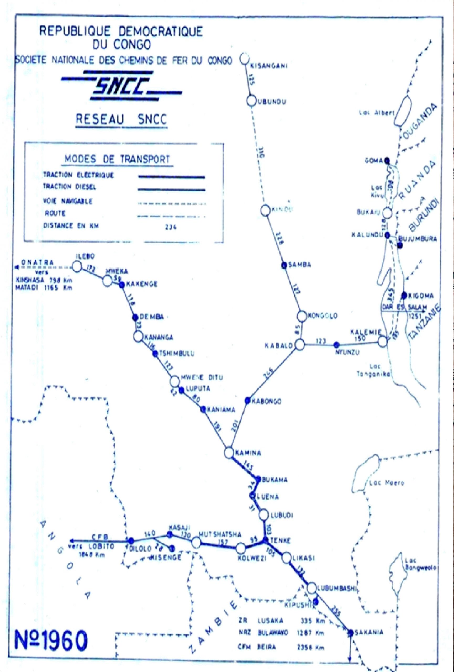

The Matadi-Kinshasa Railway is operated by ONATRA under an agreement with under an agreement with SNCC

Lines believed to be operational in 2022 (according to Wikipedia page):

### Matadi – Kinshasa Railway

* https://en.wikipedia.org/wiki/Matadi%E2%80%93Kinshasa_Railway
* 1067mm gauge
* Continues beyond Matadi to oil terminals at Ango Ango (7km) - in fact appears to serve a container and general cargo terminal on the congo river at Mbengu Matadi (line to the oil terminals is disused according to OSM).
* Branch at Mbanza-Ngungu to railway workshops (15km)
* Beyond Kinshasa to riverside wharfes (2km)
* Also branch serving N’djili International Airport (<https://www.kinshasa-airport.com/train.php>). But is this open? This article would suggest out of service: <https://acpcongo.com/index.php/2022/04/28/la-jica-explore-le-chemin-de-fer-gare-centrale-aeroport-de-ndjili-en-vue-de-sa-rehabilitation/>

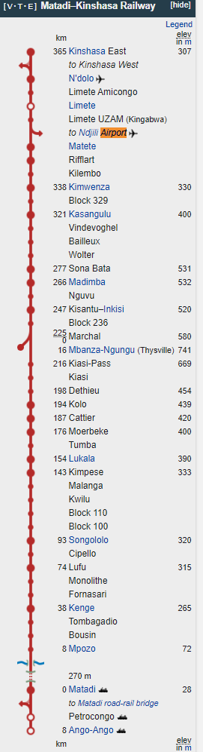

### Great Lakes Line

#### First section

* Kisangani (congo river port) – Ubundu (upper Congo River (Lualaba) Port
* 1000mm gauge
* Linked to ships b/w Kisangani and Kinshasa
* Services only when ships run (every 2-3 months)

#### Second Section

* Kindu (Lualaba River Port) – Kibombo – Kongolo – Kabalo (River port and junction with Katanga line) – Nyunzu – Niemba – Kalemie (port on Lake Tanganyika)
* 1067mm gauge
* Kalemie – Niemba section believed not operational

### Katanga Line

* Kabalo – Kamungu – Katumba – Kabongo – Kamina (Junction with Kasia Line) – Bukama (Lualaba River Port) – Tenke (junction with Benguela railway) – Likasi – Lubumbashi – Sakania – Zambia
* 1067mm gauge
* Mining branches in mining area between Tenke and Kolwezi
* Electrified Lubumbashi - Tenke - Kamina

### Kasai Line

* Ilebo (Lualabi River Port / junction with Great Lakes line) – Kananga – Mwene Ditu – Kaniama – Kamina (junction with Katanga line)
* 1067 mm gauge
* Connects the Katanga line to the river port at Ilebo

### Benguela Line

* From Tenke junction (Katanga Line) – Kolwezi - Dilolo (at Angolan border)
* 1067mm gauge
* Connects with the Benguela line in Angola
* Electrified Tenke – Mutshatsha
* Refurbished 2018

### Lines thought to be not operating:

* Vicicongo Line (Bumba – Titule)

### International Links

Zambia and Angola (Link to Angola believed to be in operation for freight). See: <https://www.trade.gov/country-commercial-guides/angola-transportation-aviation-and-rail>: “The African Development Bank is funding a feasibility study to refurbish the rail line connecting Zambia and Angola [via DRC] and link to the Benguela line.”

Ferries for freight and passengers across Congo River from Kinshasa to Brazzaville (Republic of Congo) Same gauge

Tanzania – boats take freight b/w Kalemie and Kigoma (to Tanzania Central Line) Break of gauge.

Freight

Lobito Railway

See: <https://zambianbusinesstimes.com/zambia-to-lose-out-on-drc-traffic-to-angola/>

Signed agreement July 2022 b/w angola and DRC.

### Proposals

<http://ndjandja.org/en/>

Proposed national railway development project – only at pre-feasibility stage