# Gabon

## Summary

### Nodes

|  |  |
| --- | --- |
| railway | count |
| null | 531 |
| level_crossing | 65 |
| station | 21 |
| buffer_stop | 9 |
| crossing | 4 |
| halt | 2 |
| stop | 1 |
|  |  |
|  |  |
|  |  |
|  |  |
|  |  |
|  |  |
|  |  |
|  |  |

Railway tag value and count where name tag value is not null.

|  |  |
| --- | --- |
| railway | count |
| station | 21 |
| halt | 2 |
| stop | 1 |
|  |  |
|  |  |
|  |  |
|  |  |
|  |  |
|  |  |
|  |  |

### Edges

#### All edges – status

|  |  |
| --- | --- |
| open | 429 |
| disused | 6 |
|  |  |
|  |  |
|  |  |

#### All edges – type

|  |  |
| --- | --- |
| conventional | 427 |
| other | 8 |
|  |  |
|  |  |
|  |  |
|  |  |
|  |  |

#### Named edges

#### Bridge/viaduct

|  |  |
| --- | --- |
| null | 399 |
| bridge | 34 |
| platform | 2 |
|  |  |
|  |  |
|  |  |

## Information

A single railway – the Trans-Gabon Railway: <https://en.wikipedia.org/wiki/Trans-Gabon_Railway>

From Owendon port to Franceville.

Standard Gauge 1435. Opened 1987. Single track.

Run by Société d’Exploitation du Transgabonais (SETRAG) *see: <https://www.eramet.com/en/group/subsidiaries/setrag>)

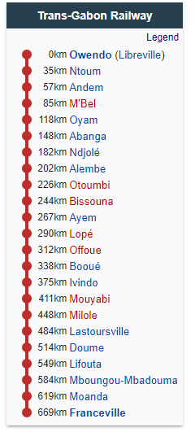

<https://www.sinfin.net/railways/world/gabon.html>

Primary traffic said to be manganese ore from Moanda to Owendo, but other freight and passenger services.

### Proposed (status unclear)

* Makokou - iron ore
* Cape Santa Clara - proposed deep water port for Makokou iron ore.
* Bélinga - possible iron ore mine. Potential new line.