# Mozambique

## Summary

### Nodes

|  |  |
| --- | --- |
| railway | count |
| null | 1516 |
| level_crossing | 730 |
| crossing | 139 |
| station | 64 |
| buffer_stop | 34 |
| halt | 3 |
| switch | 3 |
| platform | 1 |
|  |  |
|  |  |
|  |  |
|  |  |
|  |  |
|  |  |
|  |  |

Railway tag value and count where name tag value is not null.

|  |  |
| --- | --- |
| railway | count |
| station | 45 |
| platform | 1 |
| null | 1 |
|  |  |
|  |  |
|  |  |
|  |  |
|  |  |
|  |  |
|  |  |

### Edges

#### All edges – status

|  |  |
| --- | --- |
| open | 1842 |
| abandoned | 114 |
| disused | 62 |
| construction | 1 |
| dismantled | 1 |
|  |  |

#### All edges – type

|  |  |
| --- | --- |
| conventional | 1829 |
| other | 188 |
| monorail | 3 |
|  |  |
|  |  |
|  |  |
|  |  |

#### Named edges

#### Bridge/viaduct

|  |  |
| --- | --- |
| null | 1832 |
| bridge | 177 |
| platform | 8 |
| station | 1 |
| turntable | 1 |
| viaduct | 1 |
|  |  |

## Information

<https://en.wikipedia.org/wiki/Mozambique_Ports_and_Railways>

<https://en.wikipedia.org/wiki/Railway_stations_in_Mozambique>

<https://www.cfm.co.mz/index.php/en/>

### Passenger Services

According to CFM website:

* “Right now, at the South Railway System, CFM operates daily passenger trains on Goba, Ressano Garcia and Limpopo Lines”. See: <https://www.cfm.co.mz/index.php/pt/zona-sul#sort=position&sortdir=asc&page=1>
  + Maputo – Goba
  + Maputo – Ressano Garcia
  + Maputo – Matola-Gare
  + Manhiça – Maputo
  + Chokwé – Maputo
  + Maputo - Chicualacuala
  + Cabine B - Mlawula
  + M'paka - Cabine B
  + Cabine B - Ressano Garcia
  + Komatipoort - Cabine B
  + Maputo - Ressano Garcia
  + Entreposto da Matola - Komatipoort
  + Cabine B - Chicualacuala
  + Maputo - Matola-Gare
* “an inter-city passenger service connecting the City of Maputo and Matola-Gare Marracuene” ?
* “trains connecting Beira City to Moatize Town, and Beira to Machipanda border town.”
  + See timetables : <https://www.cfm.co.mz/index.php/pt/zona-centro#sort=position&sortdir=desc>
  + Marromeu - Beira
  + Moatize – Beira
  + There do no currently appear to be services on the Machipanda line after Dondo. Not mentioned in the timetables. This news story suggested that stations were being rehabilitated with the aim of opening up to passenger services in 2022: <https://clubofmozambique.com/news/mozambique-beira-zimbabwe-line-passenger-trains-to-resume-in-2022-domingo-172105/>, but that is perhaps yet to happen.
* In the North Region, passenger transport is provided by CDN- Northern Development Corridor. See: https://nacalalogistics.com/servi%C3%A7o/transporte-de-passageiros/
* Nampula – Cuamba
* Lichinga – Cuamba
* Entre-Lagos – Cuamba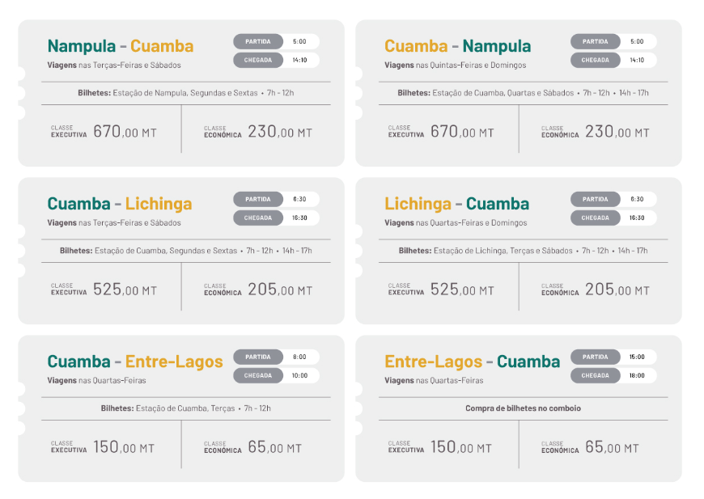

### Lines

* Railway system and connected ports overseen by Portos e Caminhos de Ferro de Moçambique (CFM) [Mozambique Ports and Railways].
* Primarily 1067 mm gauge
* 762mm gauge Gaza Railway (140km) from Xai-Xai to Chicomo and Mauela. Reported to have been partly destroyed by floods in 2000 and not used since.
* System developed from three ports – Nacala, Beira and Maputu.
* Nacala Port (CFM Norte) 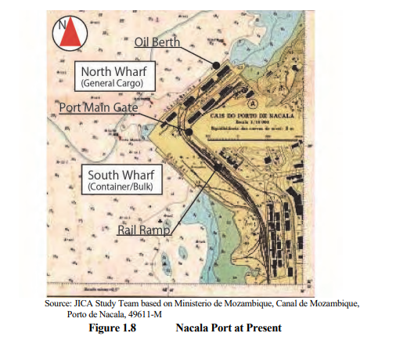

Figure From: https://openjicareport.jica.go.jp/pdf/12268124.pdf

* + Nacala-Cuamba Line
  + Cuamba-Lichinga Line
  + Cuamba-Entre Lagos (near Malawi Border) Line
  + Line was closed in 1984 when damaged during civil war. Rehabilitation began in 2005. Operated by Northern Development Corridor
  + 2017 – Nacala Logistics Corridor (<https://en.wikipedia.org/wiki/Nacala_Logistics_Corridor> ) – new link from coal mines at Moatize to Nacala port via Milawi (connecting at Nkaya Junction) and rebuild of track in Malawi. Includes a coal export terminal and coal storage yard at the port of Nacala-a-Velha. Test trains began operating over the line in November 2014. Formally completed in May 2017 (22 coal trains per day). See: <https://en.wikipedia.org/wiki/Nacala_Logistics_Corridor>
* Beira Port (CFM Centro)
  + Freight only?
  + Connects from Beira to Bulawayo in Zimbabwe (Beira-Bulawayo line or Machipanda line)
  + Has been undergoing rehabilitation to improve speeds and increase wagon weight. See: <https://allafrica.com/stories/202107131004.html> [new speed should be 60km/h – was expected to be completed in 2022]. Construction started in 2020 and is expected to be completed in the first quarter of 2023. See: <https://www.railjournal.com/in_depth/projects-to-watch-in-2023-africa/>
  + Beira connects to coal fields in Moatize (Sena line) – branches at Dondo
  + Branch at Inhamitanga to Marromeu? Yes and passenger services on this branch
  + Férra Line - branch at Mutarara - Vila Nova da Fronteira (marked as disused on OSM, but the Mozambique portion 44km appears to have been rehabilitated (or mostly on 2023 google maps data), and now awaiting section in Malawi to be completed. See: <https://www.cfm.co.mz/index.php/en/documents-and-media/destaques/491-cfm-apoia-malawi-com-o-transporte-de-material-para-as-obras-de-reconstrucao-da-linha-ferrea> and <https://www.porttechnology.org/news/mozambique-malawi-rail-route-reopens/> . This may only be 1km construction in Malawi and a dry port on the border (in Marka) OR line reconstruction from Marka to Nsanje (26km) see: <https://www.cfm.co.mz/index.php/en/documents-and-media/destaques/461-cfm-disponivel-para-apoiar-ao-malawi-na-reconstrucao-da-linha-ferrea> . The line in Mozambique has speed of 60km/hour. According to this article: <https://timveni.com/timveni/cr20-to-commence-construction-works-of-a-mwk69-b-bangula-nsanje-marka-railway-project/> the line in Malawi between Bangula – Nsanje – Marka is to be rehabilitated/re-built with work starting in 2022.
  + Beira Port Terminals

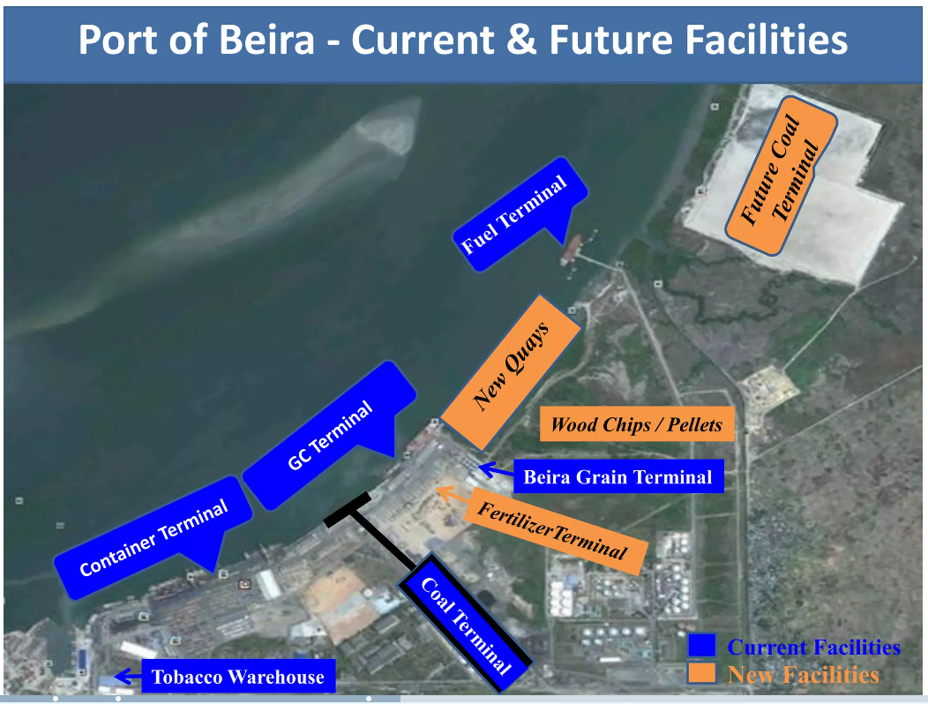

Figure https://www.slideshare.net/TristanWiggill/port-of-beira [2015]

* Maputo Port (CFM Sul)
  + Pretoria – Maputo line. Branch to NE South Africa (Pretoria (SA) - Ressano Garcia - Maputo line – see: <https://en.wikipedia.org/wiki/Pretoria%E2%80%93Maputo_railway>; known in Mozambique as the Ressano Garcia Line)
  + Goba Line - branch to Eswatini – Goba – Mlawaulu (Eswatini) – Lusoti - Mpaka See: <https://en.wikipedia.org/wiki/Goba_railway>
    - Salamanga branch: connects the village of Boane to the village of Salamanga (limestone quarry for cement materials). See: <https://en.wikipedia.org/wiki/Salamanga>
  + Limpopo Railway to Zimbabwe
  + Appear to have been passenger services in 2018 on all these branches. See: <https://en.wikipedia.org/wiki/Mozambique_Ports_and_Railways#/media/File:Train_timetable_of_Maputo.jpg>
  + 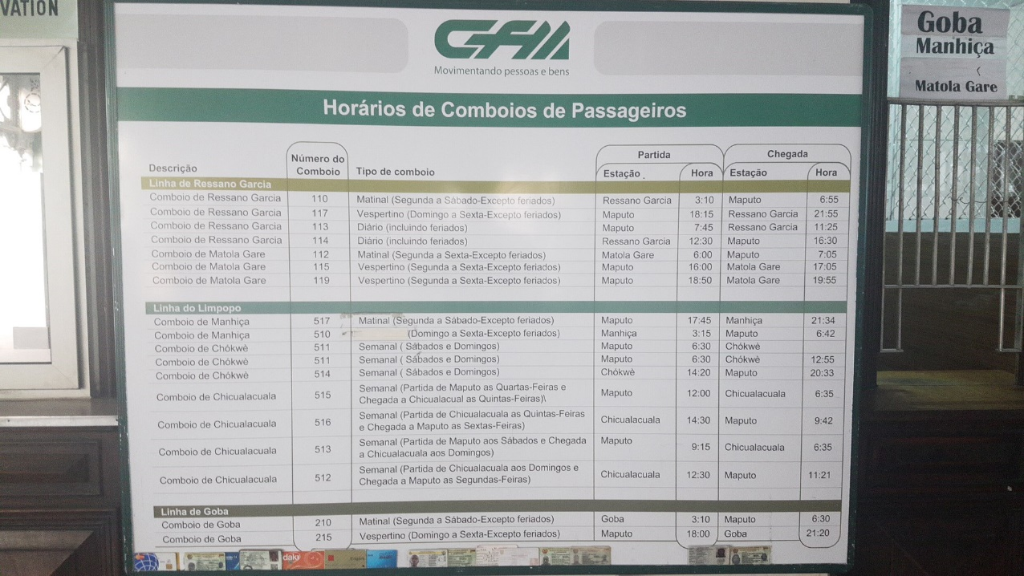

### Future development

* In August 2010, Mozambique and Botswana signed a memorandum of understanding to develop a 1,100 km railway through Zimbabwe, to carry coal from Serule in Botswana to a deepwater port at Techobanine Point in Mozambique (<https://en.wikipedia.org/wiki/Mozambique_Ports_and_Railways>)