# Namibia

## Summary

### Nodes

|  |  |
| --- | --- |
| railway | count |
| null | 1661 |
| level_crossing | 414 |
| switch | 142 |
| buffer_stop | 91 |
| station | 85 |
| halt | 44 |
| abandoned | 8 |
| crossing | 7 |
| platform | 5 |
| stop | 1 |
|  |  |
|  |  |
|  |  |
|  |  |
|  |  |

Railway tag value and count where name tag value is not null.

|  |  |
| --- | --- |
| railway | count |
| station | 80 |
| halt | 44 |
| abandoned | 8 |
| null | 5 |
| stop | 1 |
|  |  |
|  |  |
|  |  |
|  |  |
|  |  |

### Edges

#### All edges – status

|  |  |
| --- | --- |
| open | 2004 |
| disused | 45 |
| abandoned | 36 |
| construction | 1 |
|  |  |
|  |  |

#### All edges – type

|  |  |
| --- | --- |
| conventional | 2000 |
| other | 86 |
|  |  |
|  |  |
|  |  |
|  |  |
|  |  |

#### Named edges

#### Bridge/viaduct

|  |  |
| --- | --- |
| null | 1769 |
| bridge | 313 |
| platform | 4 |
|  |  |
|  |  |
|  |  |
|  |  |

## Information

Rail services provided by TRansNamib (<https://en.wikipedia.org/wiki/TransNamib>) - passenger and freight services. Passenger services run under “Starline” name.

<https://www.transnamib.com.na>

“TransNamib’s rail system is linked to Transnet rail in South Africa. Our rail network stretches from the South (South African border) to the Northern part of our country (Angolan border) and from the midline of the country to its coast and its harbour towns. Beyond that, neighbours are also connected via the Trans-Caprivi, Trans Cunene and Trans-Kalahari highways which in turn, connects with all countries in the SADC region.

“

1067mm Cape Gauge

### Passenger

See: <https://www.seat61.com/Namibia.htm> for duration of passenger services on key routes. 2019/20 timetable (services were suspended during COVID and may not have returned to this timetable in 2022): <https://www.seat61.com/reference/Namibia-starline-2019.pdf>

Passenger routes are therefore:

Ondangwa – Tsumeb

Ondangwa – Oshikango

Karasburg – Keetmanshoop – Windhoek

Windhoek – Walvis Bay

### Freight

Freight - Windhoek Container Terminal (WINCON) facilities. At: -22.500961, 17.080551. https://www.google.co.uk/maps/place/TransNamib+Container+Depot/@-22.5010498,17.0782334,17z/data=!3m1!4b1!4m5!3m4!1s0x1c0b1d95b5667ed1:0xc6944143f360a394!8m2!3d-22.5010498!4d17.0804264

**“Container depot in Windhoek is equipped with two heavy-duty (45 ton) reach stackers and one 12-tone forklift on average the container terminal handles 2000 containers per month on average. Mini-container depots stations such as Tsumeb, Keetmanshoop, Otjiwarongo, Grootfontein and Ondangwa also handle containers, dealing with an average of 900 per month.”**

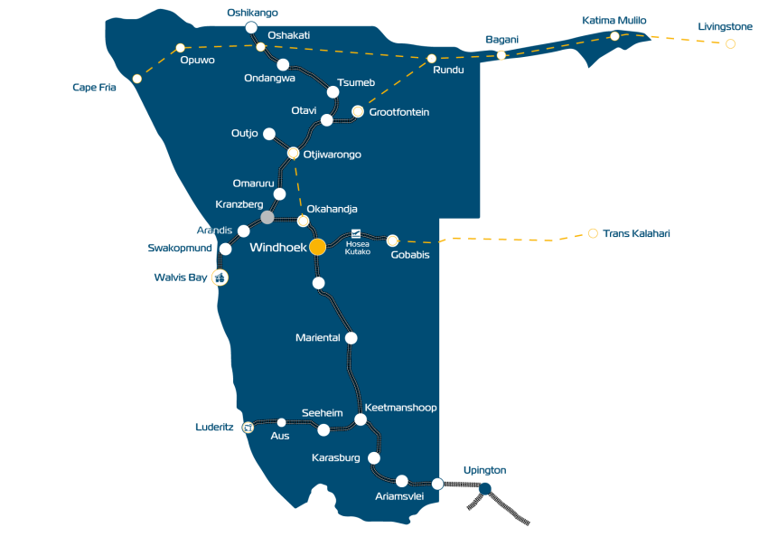

Yellow dashed are highways.

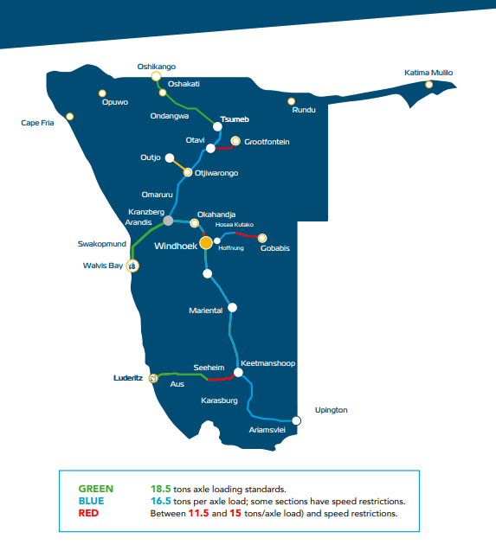

The line from Aus – Luderitz reopened in 2019. The railway network is connected to the port of Luderitz (see: https://www.namport.com.na/port-engineering/port-of-luderitz/451/)

Walvis Bay (Port here for freight) to Kranzberg (Usakos) is operational but poor condition and slow speeds. A rehabilitation has commenced post covid. IN two parts. Part 1 (Walvis Bay to Arandis) and Part 2 (Arandis to Kranzberg). Three year project will enable when finished freight at 80 km/h and passenger at up to 100 km/h. Still to remain 1067mm. [from TransNamib 2020/21 annual report]

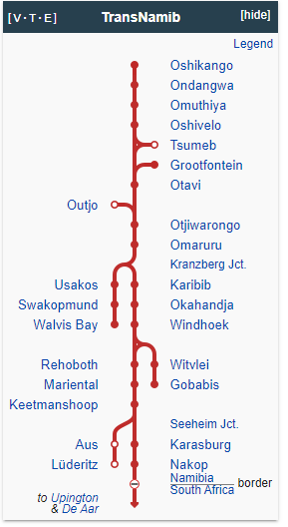

### International Links

International link open b/w Namibia and South Africa (Capetown). Probably freight only though (and luxury holiday services).

In 2012, a new line opened from a connection with the existing network at Tsumeb to Oshikango on the border with Angola. This is planned to connect with a proposed railway in southern Angola, ultimately allowing a through connection via the existing Angolan network to Zambia. (<https://www.sinfin.net/railways/world/namibia.html>)

### Potential Future Developments

In 2022, a feasibility study was completed for the 772km Trans-Zambezi Railway Extension, from a connection with the existing network at Grootfontein to Katima Mulilo near the eastern end of the Caprivi Strip. It is planned eventually to extend to Livingstone in Zambia (<https://www.sinfin.net/railways/world/namibia.html>). See: https://tsodiloresources.com/s/Metals-671052.asp.html

The Trans-Kalahari Railway is a proposed heavy haul freight railway between Walvis Bay and Lobatse in Botswana. It would include the upgrading of 640km of existing railway between Walvis Bay and Gobabis, and the construction of approximately 860km of new line from there to Lobatse. In 2014, the governments of Namibia and Botswana signed an agreement for its implementation, but little progress has been made, partly because of a global decline in the demand for coal, which would be its principal traffic (https://www.sinfin.net/railways/world/namibia.html).