# Nigeria

## Summary

### Nodes

|  |  |
| --- | --- |
| railway | count |
| null | 2165 |
| level_crossing | 1117 |
| station | 165 |
| crossing | 58 |
| stop | 58 |
| buffer_stop | 40 |
| switch | 34 |
| tram_level_crossing | 23 |
| platform | 9 |
| milestone | 7 |
| halt | 5 |
| signal | 3 |
| derail | 1 |
|  |  |
|  |  |

Railway tag value and count where name tag value is not null.

|  |  |
| --- | --- |
| railway | count |
| station | 143 |
| stop | 58 |
| null | 12 |
| halt | 5 |
|  |  |
|  |  |
|  |  |
|  |  |
|  |  |
|  |  |

### Edges

#### All edges – status

|  |  |
| --- | --- |
| open | 2772 |
| disused | 155 |
| construction | 46 |
| abandoned | 27 |
|  |  |

#### All edges – type

|  |  |
| --- | --- |
| conventional | 2597 |
| other | 268 |
| light_rail | 115 |
| monorail | 18 |
| tram | 2 |
|  |  |
|  |  |

#### Named edges

#### Bridge/viaduct

|  |  |
| --- | --- |
| null | 2671 |
| bridge | 259 |
| platform | 35 |
| viaduct | 30 |
| station | 4 |
| turntable | 1 |

## Information

<https://en.wikipedia.org/wiki/Rail_transport_in_Nigeria>

<https://www.sinfin.net/railways/world/nigeria.html>

<https://en.wikipedia.org/wiki/Railway_stations_in_Nigeria>

<https://en.wikipedia.org/wiki/Nigerian_Railway_Corporation>

NRC (English): <https://nrc.gov.ng>

RC ticketing/timetables (English): <https://nrc.tps.ng> Appears to be for the AKTS route only.

Schedules: <https://nrc.gov.ng/schedules/> - indicate passenger services only on the Standard Gauge routes (with AKTS currently suspended). No mention of the cape gauge lines.

Mix of cape gauge (1067mm) and standard gauge. Run by Nigerian Railway Corporation.

“The Nigerian Railway Corporation is 112 years old and it runs a unilaterally designed track system of 1067mm cape gauge. Only 30km of its track distribution is in double track and that is within Lagos area. Nigerian Railway System actually commenced rail business activities with the construction of the first rail line from Lagos to Ibadan (193km) between 1898 and 1901. By 1964 when the construction of 640km kano – Maiduguri rail line, then known as Bornu extension, was completed, the present core of the railway network had been put in place.” <https://nrc.gov.ng>

## Lines/Routes

Standard gauge:

1. Abuja (begins at Idu) – Kaduna service (AKTS). Opened 26 July 2016. Currently suspended (<https://nrc.gov.ng/2022/05/19/press-release-19th-may-2022/>). This was due to an attack on a train with explosives on 28 March 2022 damaging track. Max speed 100km/h according to https://en.wikipedia.org/wiki/Rail_transport_in_Nigeria.
2. Lagos – Ibadan (LITS) (opened 10 June 2021). Said to be double track. Daily services, 2 each way). In addition links to Apapa port for Freight. See: https://www.premiumtimesng.com/regional/ssouth-west/440109-lagos-ibadan-rail-now-connected-to-apapa-port-contractor-says.html
3. Warri – Itakpe (WITS) Originally planned to supply the Ajaokuta Steel Mill with iron ore from Itakpe and coal imported via Warri. One service daily each way.

Other standard gauge:

1. Oturkpo to the Ajaokuta steel mill (217 km) – now forms part of WITS?

Cape gauge:

Two major lines:

1. Western Line – Lagos to Nguru (Lagos to Ibadan now has new standard gauge also). Supposedly a weekly service from Lagos to Kano resumed September 2021 (see: <https://www.vanguardngr.com/2021/09/nrc-resumes-lagos-kano-train-service-september-3/>). however, appears services are suspended due to terrorist activity. See: <https://nairametrics.com/2022/08/03/nrc-explains-why-it-suspended-train-services-on-lagos-kano-ajaokuta-routes/>. Also (partly) used for freight, see: <https://www.porttechnology.org/news/apmt-apapa-restores-rail-connectivity-by-bridging-communication-gap/> and <https://www.apmterminals.com/en/apapa/about/rail>. But only move a short distance to Ebute Metta or to Ijoko where transferred to container lorries.
2. Eastern Line – Port Harcourt to Maiduguri (said to have been restored since 2009 with a US$427m project) However, <https://www.sinfin.net/railways/world/nigeria.html> suggests that contracts were signed only in 2020 for rehabilitation and reconstruction along with new branches and an interconnection with the standard gauge line at Kafanchan. Also see: <https://nairametrics.com/2022/04/11/infrastructure-fg-commences-reconstruction-of-port-harcourt-maiduguri-line/>. So would appear to be currently out of use. May be some new branches as part of this rehabilitations/reconstruction (Onne and Bonny ports and Elele and possibly Owerri (new University), other potential branches: Awka) . Video: https://www.youtube.com/watch?v=V2psUk_VSc4&ab_channel=NedMedia

Several branch lines:

1. Linking line; Kaduna (Western Line) to Kafanchan (Eastern Line)
2. Ifaw (Ifo?) to Ilaro (Western Line) ?? Not on OSM. “However, there is a locomotive railway line linking the town to Lagos and Abeokuta via Ifo junction and also to the terminus of the Lagos Ifo rail trunk line “Idogo”” See: <https://en.wikipedia.org/wiki/Ilaro#Infrastructure>. Can’t see any sign of this on maps/satellite. Old documents indicate that this was a short branch line opened in 1930 Ifo-Ilaro-Idogo(Idawgo).
3. Minna to Baro (Western Line) - probably out of use. Rehabilitation contract awarded (with extension to Baro port), see: https://dailytrust.com/fg-awards-n80bn-minna-baro-port-railway-contract
4. Zaria to Kaura Namoda (Western Line) – out of use?
5. Kuru to Jos (Eastern Line)

### Light /metro rail:

1. Abuja Light Rail - Abuja Rail Mass Transit ARMT (<https://en.wikipedia.org/wiki/Abuja_Light_Rail>)
   1. Yellow Line - Abuja CBD to Nnamdi Azikiwe International Airport (8 stations) via Idu
   2. Blue Line – Idu to Kubwa (eventually). Currently appears to go as far as Gbazango with 5 stations including Idu.
   3. Appears all 12 stations in use since 2020.
2. Lagos Rail Mass Transit (Blue and Red lines planned to open December 2022 – looks like Blue line only is on track for this date) (<https://en.wikipedia.org/wiki/Lagos_Rail_Mass_Transit>). Appears to be standard gauge. <https://www.urbanrail.net/af/lagos/lagos.htm>. Appears Phase 1 to Mile 2 is largely complete and is due to open Q1 2023.
3. Rivers Monorail in Port Harcourt (appears never completed and not operational, see: https://en.wikipedia.org/wiki/Rivers_State_Monorail)
4. Calabar Monorail (in operation)
5. Kaduna State Light Rail (this appears only proposed. See: https://allafrica.com/stories/202104050185.html)

Under construction/proposed:

1. https://dmarketforces.com/nigerias-top-5-railway-projects-gulp-26-billion-report/  
   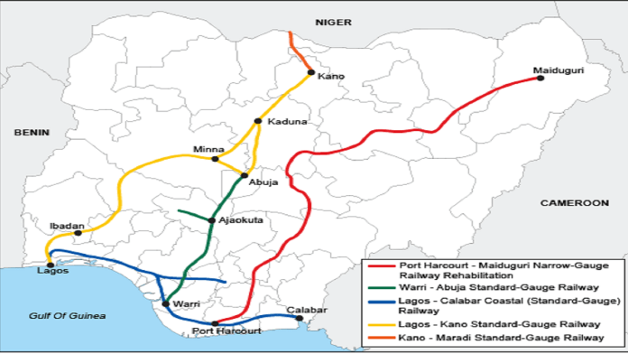
2. Standard gauge link from Kano to Maradi (Niger) (Construction began February 2021, planned opening 2023). See: https://www.howwemadeitinafrica.com/new-railway-connecting-northern-nigeria-with-niger-expected-to-boost-trade/142350/
3. Extension of WITS to Abuja (plans or under construction?)
4. “Red Line” of Lagos Light Railway (said to be utilising (sharing) old Lagos-Ibadan cape gauge track – though some confusion here. Other sources say this will be standard gauge?)
5. plans to replace most of the Western Line with the Lagos–Kano Standard Gauge Railway – being built in sections with AKTS and LITS already completed (see above)
6. Apparently funding was agreed in 2021 for a new standard gauge line form Lagos to Calabar (see: <https://www.sinfin.net/railways/world/nigeria.html>). See https://www.youtube.com/watch?v=jQ1vn8_WFWA&t=0s
7. In 2017, plans were announced for a new 275km line linking the steel works at Ajaokuta with the Agbaja Iron Ore Project in Kogi State (status?) according to https://www.sinfin.net/railways/world/nigeria.html . See: https://www.spglobal.com/marketintelligence/en/news-insights/blog/insight-weekly-august-2-2022

### Districts:

#### Lagos District

25 stations and major hub for freight trains.

Lagos – Ibadan. Starts at Mobolaji Johnson Station (MJS)

Mass Transit – services originating at Iddo/Ijoko daily

Freight: materials and goods from major port terminals (such as Apapa port, APMT, ENL, ABTL, GDNL and many others).

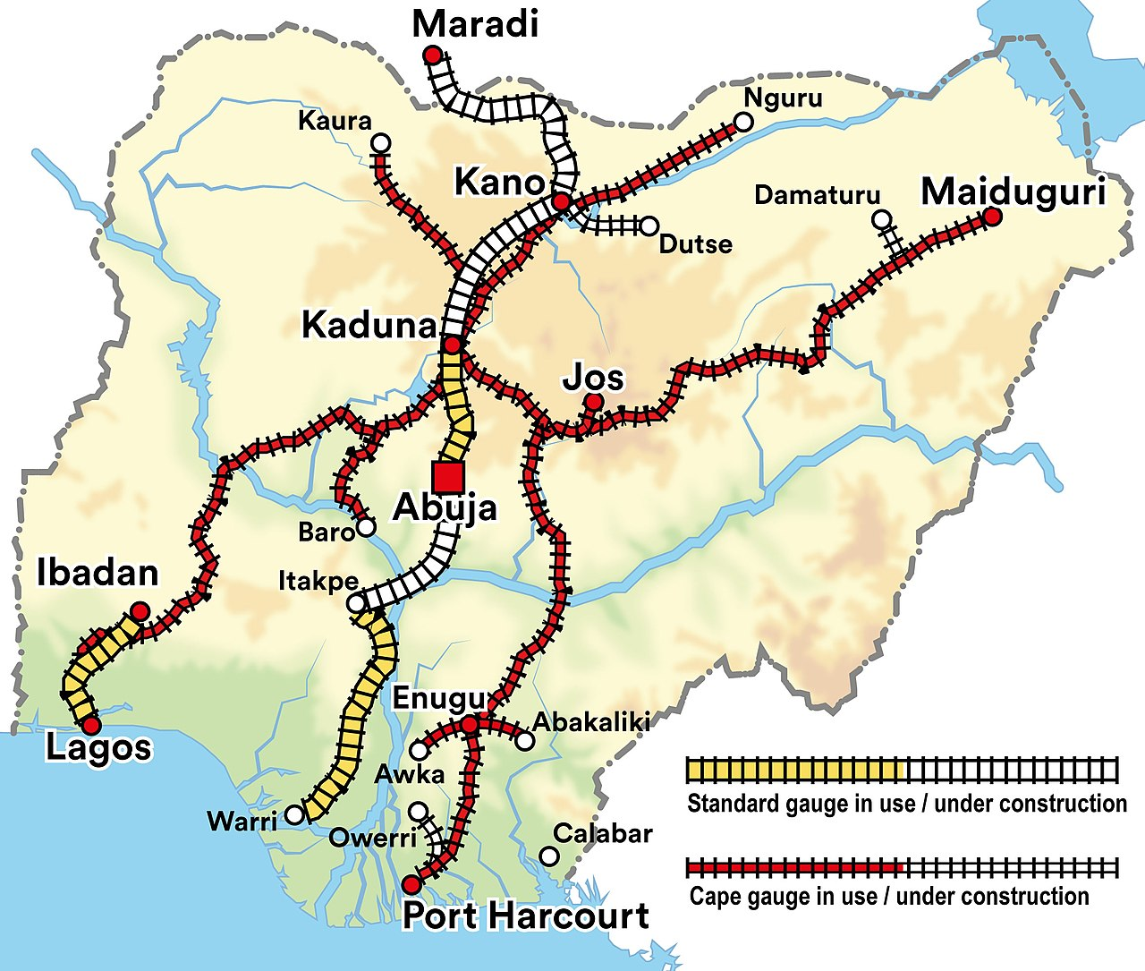

Figure https://en.wikipedia.org/wiki/Railway_stations_in_Nigeria#/media/File:Railway_system_Nigeria_2021_english.jpg

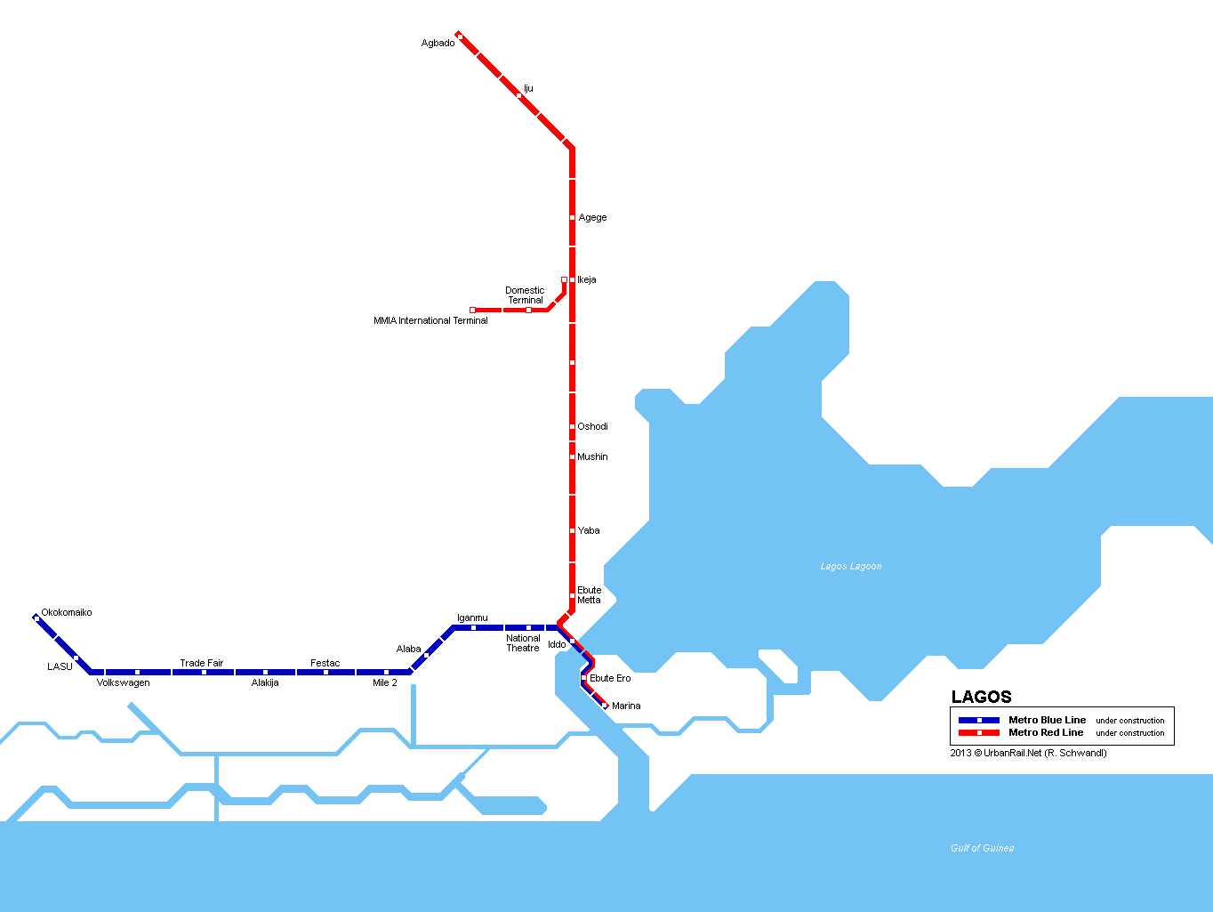

Figure LARM LAgos Rail Mass Transit- https://www.urbanrail.net/af/lagos/lagos.htm