# Democratic Republic of Congo

## Summary

### Nodes

|  |  |
| --- | --- |
| railway | count |
| null | 2636 |
| level_crossing | 1084 |
| station | 252 |
| crossing | 80 |
| halt | 14 |
| switch | 6 |
| railway_crossing | 5 |
| stop | 3 |
| platform | 2 |
| buffer_stop | 2 |
| subway_entrance | 1 |
|  |  |
|  |  |
|  |  |
|  |  |

Railway tag value and count where name tag value is not null.

|  |  |
| --- | --- |
| railway | count |
| station | 201 |
| halt | 8 |
| null | 5 |
| stop | 2 |
| platform | 1 |
| subway_entrance | 1 |
|  |  |
|  |  |
|  |  |
|  |  |

### Edges

#### All edges – status

|  |  |
| --- | --- |
| open | 2768 |
| disused | 468 |
| abandoned | 73 |
| razed | 2 |
|  |  |
|  |  |

#### All edges – type

|  |  |
| --- | --- |
| conventional | 2736 |
| other | 548 |
| light_rail | 26 |
| funicular | 1 |
|  |  |
|  |  |
|  |  |

#### Named edges

#### Bridge/viaduct

|  |  |
| --- | --- |
| null | 3189 |
| bridge | 118 |
| station | 2 |
| platform | 1 |
| turntable | 1 |
|  |  |
|  |  |

## Information

<https://en.wikipedia.org/wiki/Rail_transport_in_the_Democratic_Republic_of_the_Congo>

<https://www.sinfin.net/railways/world/congo-kinshasa.html>

Operated primarily by Société Nationale des Chemins de Fer du Congo (SNCC) - <https://www.snccsa.com> (French). Map from their website, page dated 30/09/2022.

Key

Voie Navigable - waterway

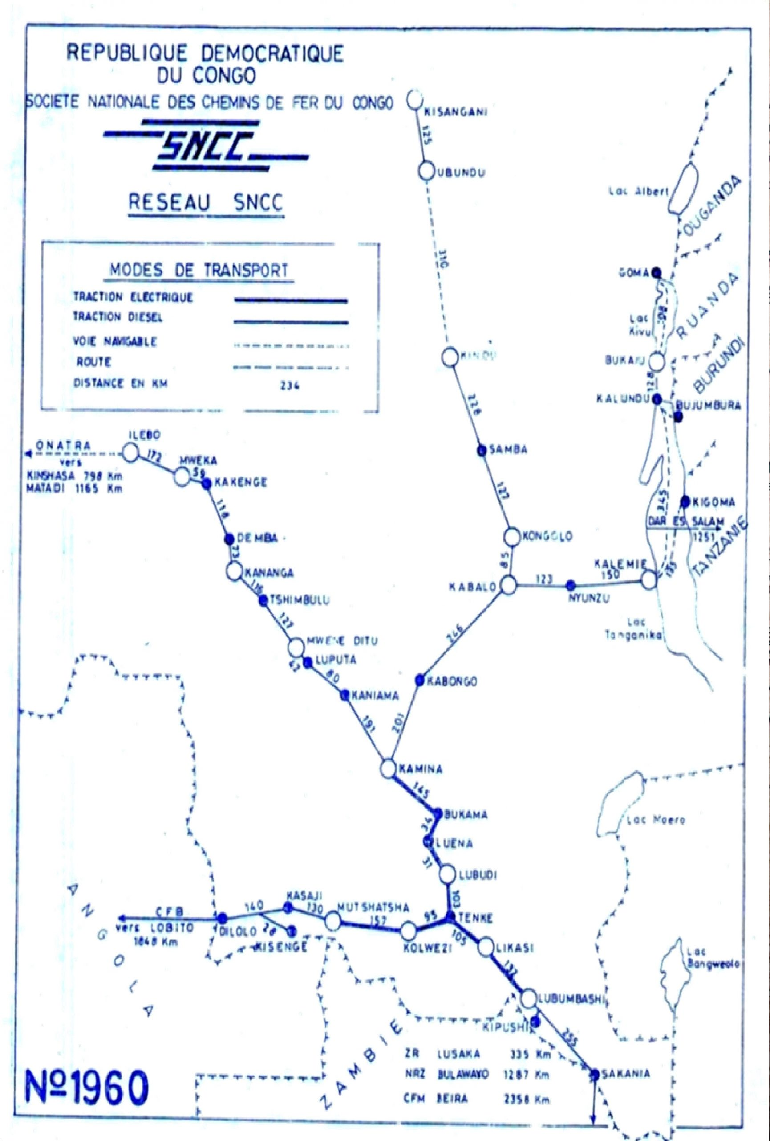

The Matadi-Kinshasa Railway is operated by ONATRA under an agreement with under an agreement with SNCC

Lines believed to be operational in 2022 (according to Wikipedia page):

### Matadi – Kinshasa Railway

* https://en.wikipedia.org/wiki/Matadi%E2%80%93Kinshasa_Railway
* 1067mm gauge
* Continues beyond Matadi to oil terminals at Ango Ango (7km) - in fact appears to serve a container and general cargo terminal on the congo river at Mbengu Matadi (line to the oil terminals is disused according to OSM).
* Branch at Mbanza-Ngungu to railway workshops (15km)
* Beyond Kinshasa to riverside wharfes (2km)
* Also branch serving N’djili International Airport (<https://www.kinshasa-airport.com/train.php>). But is this open? This article would suggest out of service: <https://acpcongo.com/index.php/2022/04/28/la-jica-explore-le-chemin-de-fer-gare-centrale-aeroport-de-ndjili-en-vue-de-sa-rehabilitation/>

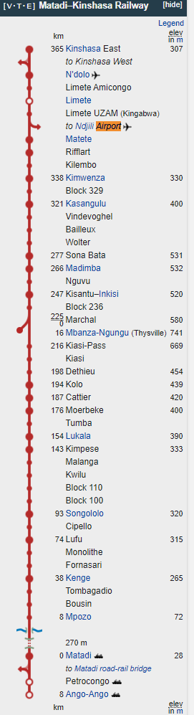

### Great Lakes Line

#### First section

* Kisangani (congo river port) – Ubundu (upper Congo River (Lualaba) Port
* 1000mm gauge
* Linked to ships b/w Kisangani and Kinshasa
* Services only when ships run (every 2-3 months)

#### Second Section

* Kindu (Lualaba River Port) – Kibombo – Kongolo – Kabalo (River port and junction with Katanga line) – Nyunzu – Niemba – Kalemie (port on Lake Tanganyika)
* 1067mm gauge
* Kalemie – Niemba section believed not operational

### Katanga Line

* Kabalo – Kamungu – Katumba – Kabongo – Kamina (Junction with Kasia Line) – Bukama (Lualaba River Port) – Tenke (junction with Benguela railway) – Likasi – Lubumbashi – Sakania – Zambia
* 1067mm gauge
* Mining branches in mining area between Tenke and Kolwezi
* Electrified Lubumbashi - Tenke - Kamina

### Kasai Line

* Ilebo (Lualabi River Port / junction with Great Lakes line) – Kananga – Mwene Ditu – Kaniama – Kamina (junction with Katanga line)
* 1067 mm gauge
* Connects the Katanga line to the river port at Ilebo

### Benguela Line

* From Tenke junction (Katanga Line) – Kolwezi - Dilolo (at Angolan border)
* 1067mm gauge
* Connects with the Benguela line in Angola
* Electrified Tenke – Mutshatsha
* Refurbished 2018

### Lines thought to be not operating:

* Vicicongo Line (Bumba – Titule)

### International Links

Zambia and Angola (though link to Angola may be out of use since 1970s?)

Ferries for freight and passengers across Congo River from Kinshasa to Brazzaville (Republic of Congo) Same gauge

Tanzania – boats take freight b/w Kalemie and Kigoma (to Tanzania Central Line) Break of gauge.

Freight

Lobito Railway

See: <https://zambianbusinesstimes.com/zambia-to-lose-out-on-drc-traffic-to-angola/>

Signed agreement July 2022 b/w angola and DRC.

### Proposals

<http://ndjandja.org/en/>

Proposed national railway development project – only at pre-feasibility stage