# Eritrea, Djibouti and Ethiopia

## Summary

### Nodes

|  |  |
| --- | --- |
| railway | count |
| null | 2409 |
| level_crossing | 280 |
| stop | 81 |
| station | 78 |
| switch | 75 |
| crossing | 41 |
| buffer_stop | 27 |
| halt | 19 |
| platform | 8 |
| subway_entrance | 4 |
| yard | 3 |
| engine_shed | 1 |
| roundhouse | 1 |
| turntable | 1 |
|  |  |

Railway tag value and count where name tag value is not null.

|  |  |
| --- | --- |
| railway | count |
| stop | 81 |
| station | 64 |
| halt | 19 |
| null | 6 |
| yard | 1 |
|  |  |
|  |  |
|  |  |
|  |  |
|  |  |

### Edges

#### All edges – status

|  |  |
| --- | --- |
| open | 1656 |
| disused | 440 |
| abandoned | 350 |
| construction | 212 |
| razed | 8 |
| dismantled | 1 |

#### All edges – type

|  |  |
| --- | --- |
| conventional | 1300 |
| other | 1142 |
| light_rail | 224 |
| funicular | 1 |
|  |  |
|  |  |
|  |  |

#### Named edges

#### Bridge/viaduct

|  |  |
| --- | --- |
| null | 1835 |
| bridge | 610 |
| platform | 105 |
| viaduct | 91 |
| station | 12 |
| loading_ramp | 12 |
| turntable | 2 |

## Information

## Eritrea

Eritrean Railroad Authority

<https://en.wikipedia.org/wiki/Eritrean_Railway#:~:text=The%20Eritrean%20Railway%20is%20the,was%20rebuilt%20in%20the%201990s>.

“The line has been restored from Massawa to Asmara, but as of 2006 no scheduled services traverse the whole length of the line. Charter trains for tourists now do, and regular train services exist in certain areas. While the surviving equipment is sufficient for such a limited service, the purchase or building of more is necessary to provide a serious form of transportation over the length of the line.”

<https://www.sinfin.net/railways/world/eritrea.html>

“The line between Massawa and Asmara carries some freight traffic, and a few short distance passenger services on Sundays and holidays. Equipment shortages preclude a more regular service. However, steam hauled passenger train is available for tourist excursions and private charters, which may cover the whole length of the line.”

Single route port of Massawa to Asmara.

Did used to extend to Bishia but that part is now abandoned (OSM says disused but track is incomplete and appears abandoned)

950mm gauge.

## Ethiopia/Djibouti

<https://en.wikipedia.org/wiki/Rail_transport_in_Ethiopia>

Ethiopian Railway Corporation (<http://www.erc.gov.et> – does not work)

METRE GAUGE

### Ethio – Djibouti

(partly operational potentially following rehabilitation completed in 2013 between Dire Dawa and Djibouti border stopping at Dewele (passengers) and Guelile (freight). See: <https://en.wikipedia.org/wiki/Ethio-Djibouti_Railways>. Plans announced in 2018 to rehabilitate from Dire Dawa to Mieso. However, OSM has this part of the line either abandoned or disused, so not convinced that this is still in use. Appears to be confirmed here: <https://www.sinfin.net/railways/world/djibouti.html> that the new standard gauge completely replaced this old line.

### STANDARD GAUGE

### Addis Ababa-Djibouti

**Ethio-Djibouti Railway**

<https://edr.gov.et/en/>

Freight (incl indicative timetable): <https://edr.gov.et/en/freight-service.html>

Passenger (timetables): https://edr.gov.et/en/passenger-service.html

(<https://en.wikipedia.org/wiki/Addis_Ababa%E2%80%93Djibouti_Railway>) – operational

See: https://www.railway-technology.com/projects/ethiopia-djibouti-railway-line-modernisation/

* Modernisation started in 2011 and completed in 2016, 756km
* Electrified
* Metre gauge was replaced with 1435 gauge
* Said to be double track for 115km (Addis Ababa to Adama) and single track for the remaining 600km to Djibouti.
* Design speed 120km/h passenger and 80km/h freight
* Freight began in 2015
* 21 stations

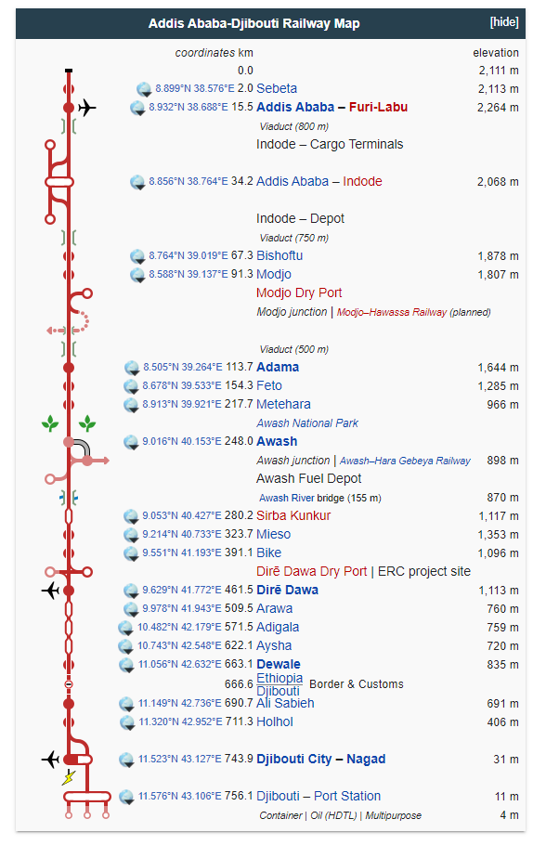

### Awash – Weldiya

(under construction [https:/en.wikipedia.org/wiki/Awash%E2%80%93Weldiya_Railway](https://en.wikipedia.org/wiki/Awash%E2%80%93Weldiya_Railway)) – said to have been test runs in 2018 between Awash and Kombolcha? Expected 120km/h passenger and 80-90km/h freight). Electrified. Delayed and damage due to Tigray War.

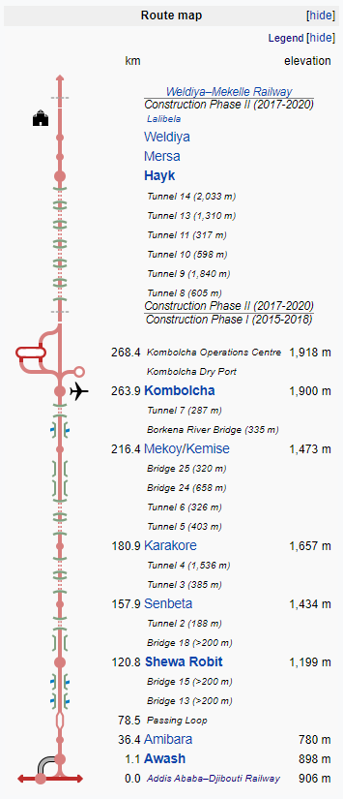

### Weldiya (Woldia) – Mekelle

(under construction) <https://en.wikipedia.org/wiki/Weldiya%E2%80%93Mekelle_Railway>

* Electrified
* 120km/h passenger
* 80-90km/h freight

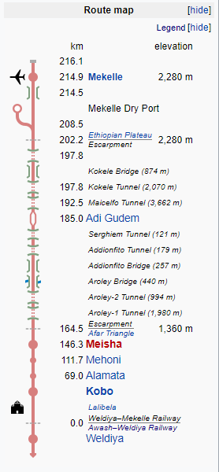

### Addis Ababa Light Rail

– operational <https://en.wikipedia.org/wiki/Addis_Ababa_Light_Rail>

* 17km from city centre to industrial areas in south
* Opened 20 september 2015
* Second west-east line opened 9 November 2015
* 39 stations
* Up to 70 km/h
* 1435 gauge
* electrified
* Blue Line (Menelik Square to Kaliti)
* Green Line (Ayat to Tor Hailoch)
* Common section (St. Lideta to Meskel Square)

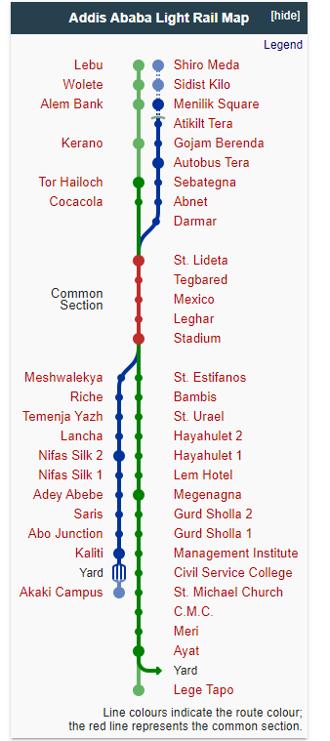

## Planned

Some planned projections but suggestion that many of these planned and future projects were cancelled in 2017

|  |  |  |  |  |  |
| --- | --- | --- | --- | --- | --- |
| **ERC-Route Nr.** | **Link** | **Status 2018** | **Course** | **Branches** | **Total Length** |
| 1 | [Addis Ababa–Djibouti Railway](https://en.wikipedia.org/wiki/Addis_Ababa%E2%80%93Djibouti_Railway) | operational | [Sebeta](https://en.wikipedia.org/wiki/Sebeta)–Addis Ababa–[Modjo](https://en.wikipedia.org/wiki/Mojo,_Ethiopia" \o "Mojo, Ethiopia)–[Awash](https://en.wikipedia.org/wiki/Awash,_Ethiopia)–[Dire Dawa](https://en.wikipedia.org/wiki/Dire_Dawa)–[Port of Doraleh](https://en.wikipedia.org/wiki/Port_of_Doraleh) |  | 759 km |
| 2 |  | planned | Modjo–[Shashamane](https://en.wikipedia.org/wiki/Shashamane" \o "Shashamane)–[Arba Minch](https://en.wikipedia.org/wiki/Arba_Minch" \o "Arba Minch)–[Konso](https://en.wikipedia.org/wiki/Konso" \o "Konso)–[Weito](https://en.wikipedia.org/wiki/Weito_River" \o "Weito River) | Shashamane–[Hawassa](https://en.wikipedia.org/wiki/Hawassa) Konso–[Moyale](https://en.wikipedia.org/wiki/Moyale) | 905 km |
| 3 |  | planned | Addis Ababa–[Ambo](https://en.wikipedia.org/wiki/Ambo,_Ethiopia)–[Jimma](https://en.wikipedia.org/wiki/Jimma" \o "Jimma)–[Bedele](https://en.wikipedia.org/wiki/Bedele" \o "Bedele) | Jimma–[Guraferda](https://en.wikipedia.org/wiki/Guraferda" \o "Guraferda)–[Dimma](https://en.wikipedia.org/wiki/Dimma_(woreda)" \o "Dimma (woreda)) | 700 km |
| 4 |  | planned | Ambo–[Nekemte](https://en.wikipedia.org/wiki/Nekemte" \o "Nekemte)–[Asosa](https://en.wikipedia.org/wiki/Asosa" \o "Asosa)–[Kurmuk](https://en.wikipedia.org/wiki/Kurmuk,_Ethiopia" \o "Kurmuk, Ethiopia) |  | 520 km |
| 5 | [Awash–Weldiya Railway](https://en.wikipedia.org/wiki/Awash%E2%80%93Weldiya_Railway)  [Weldiya–Mekelle Railway](https://en.wikipedia.org/wiki/Weldiya%E2%80%93Mekelle_Railway) | under construction | [Awash](https://en.wikipedia.org/wiki/Awash,_Ethiopia)–[Kombolcha](https://en.wikipedia.org/wiki/Kombolcha" \o "Kombolcha)–[Weldiya](https://en.wikipedia.org/wiki/Weldiya" \o "Weldiya)–[Mekelle](https://en.wikipedia.org/wiki/Mekelle) | Mekelle–[Shire](https://en.wikipedia.org/wiki/Shire,_Ethiopia) | 757 km |
| 6 |  | planned | [Finote Selam](https://en.wikipedia.org/wiki/Finote_Selam)–[Bahir Dar](https://en.wikipedia.org/wiki/Bahir_Dar)–[Wereta](https://en.wikipedia.org/wiki/Wereta" \o "Wereta)–[Weldya](https://en.wikipedia.org/wiki/Weldya" \o "Weldya)–Weldiya–[Semera](https://en.wikipedia.org/wiki/Semera" \o "Semera)–[Elidar](https://en.wikipedia.org/wiki/Elidar" \o "Elidar)–[Tadjoura](https://en.wikipedia.org/wiki/Tadjoura" \o "Tadjoura) |  | 734 km |
| 7 |  | planned | Wereta–[Azezo](https://en.wikipedia.org/wiki/Gondar_Airport" \o "Gondar Airport)–[Metemma](https://en.wikipedia.org/wiki/Metemma" \o "Metemma) |  | 244 km |
| 8 |  | planned | [Adama](https://en.wikipedia.org/wiki/Adama)–[Iteya](https://en.wikipedia.org/wiki/Iteya" \o "Iteya)–[Gasera](https://en.wikipedia.org/wiki/Gasera" \o "Gasera) | Iteya–[Asella](https://en.wikipedia.org/wiki/Asella" \o "Asella) | 248 km |

https://en.wikipedia.org/wiki/Rail_transport_in_Ethiopia

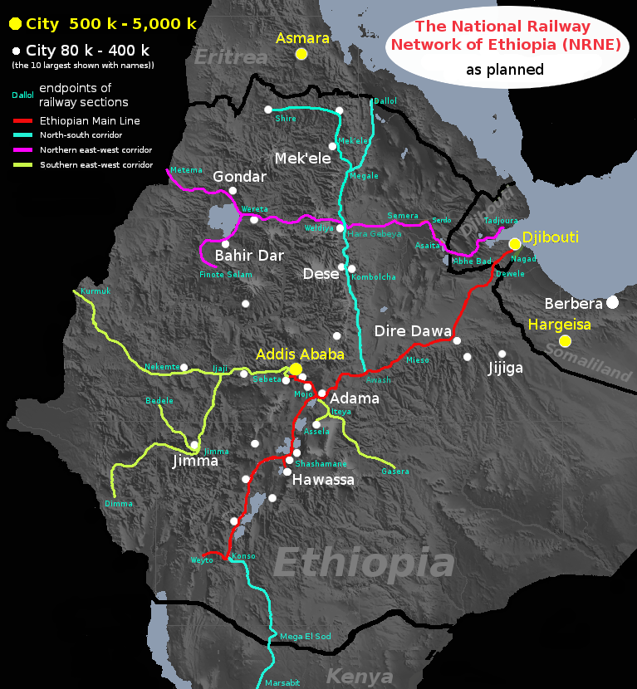

https://en.wikipedia.org/wiki/Rail_transport_in_Ethiopia#/media/File:National_Railway_Network_of_Ethiopia.png