# Eswatini

## Summary

### Nodes

|  |  |
| --- | --- |
| railway | count |
| null | 178 |
| level_crossing | 46 |
| buffer_stop | 6 |
| halt | 5 |
| station | 3 |
| crossing | 3 |
| switch | 2 |
|  |  |
|  |  |
|  |  |
|  |  |
|  |  |
|  |  |
|  |  |
|  |  |

Railway tag value and count where name tag value is not null.

|  |  |
| --- | --- |
| railway | count |
| station | 2 |
| halt | 1 |
|  |  |
|  |  |
|  |  |
|  |  |
|  |  |
|  |  |
|  |  |
|  |  |

### Edges

#### All edges – status

|  |  |
| --- | --- |
| open | 184 |
| abandoned | 11 |
|  |  |
|  |  |
|  |  |
|  |  |

#### All edges – type

|  |  |
| --- | --- |
| conventional | 184 |
| other | 11 |
|  |  |
|  |  |
|  |  |
|  |  |
|  |  |

#### Named edges

#### Bridge/viaduct

|  |  |
| --- | --- |
| null | 172 |
| bridge | 23 |
|  |  |
|  |  |
|  |  |
|  |  |
|  |  |

## Information

<https://en.wikipedia.org/wiki/Eswatini_Railways>

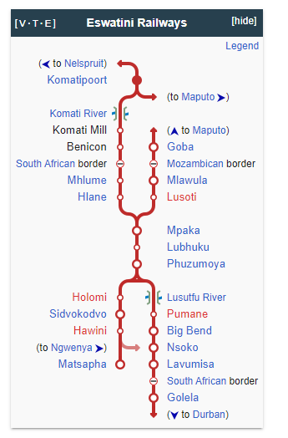

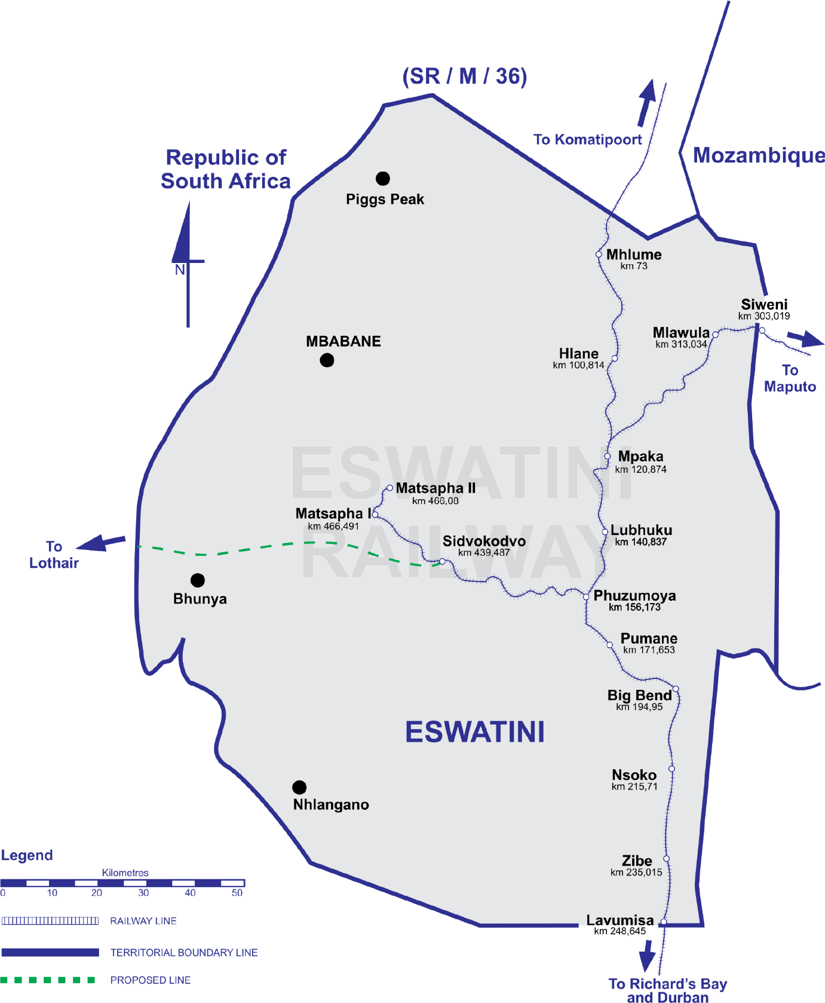

* Gauge 1067mm
* Eswatini Railways (ESR): https://eswatinirail.co.sz
* Freight only, no passenger services
* Main bulk freight services:
  + Sugar – our major client being Eswatini Sugar Association who has a warehouse and a siding at Mlawula and export the raw sugar to overseas markets via Maputo port.
  + Coal – our major client being Maloma Colliery who have a siding at Nsoko and export their Antracite to Richards Bay Mines in South Africa via Golela.
  + Canned Fruit – our major client being Rhodes Group.
  + Cement – our major client for this commodity is Afrisam Eswatini and they import this product from Lichternburg to Matsapa via Komatipoort
  + Wheat – our Major client here is Ngwane Mills who imports from Durban
  + Fuel – we have three clients who import fuel namely Galp Energia, Total Eswatini and Engen Oil they all import fuel products from Durban.
* Direct access to 3 ports:
  + Richards bay
  + Durban
  + Maputo port
* Dry port (Container terminal inland) at Matsapha. Matsapha Inland Clearance Depot (ICD). See: https://eswatinirail.co.sz/services/containerised-cargo/
* Lines
  + Goba Line – Matsapha – Mlawula – [Maputo]
  + Komatipoort Line – Komatipoort [SA] – Mpaka.
  + Richards Bay Line – Richards Bay (SA) – Siphofaneni/Phuzumoya
* Proposed
  + Sidvokodvo – Lothair (SA). Now know as the Eswatini Rail Link (ESRL) Project. Construction phase is expected to begin in 2023. See: https://eswatinirail.co.sz/opportunities/eswatini-raillink-project/