# Malawi

## Summary

### Nodes

|  |  |
| --- | --- |
| railway | count |
| level_crossing | 850 |
| null | 618 |
| crossing | 69 |
| station | 34 |
| halt | 2 |
| platform | 2 |
| buffer_stop | 1 |
|  |  |
|  |  |
|  |  |
|  |  |
|  |  |
|  |  |
|  |  |
|  |  |

Railway tag value and count where name tag value is not null.

|  |  |
| --- | --- |
| railway | count |
| station | 30 |
| null | 3 |
| halt | 2 |
|  |  |
|  |  |
|  |  |
|  |  |
|  |  |
|  |  |
|  |  |

### Edges

#### All edges – status

|  |  |
| --- | --- |
| open | 1201 |
| disused | 178 |
| abandoned | 21 |
|  |  |
|  |  |
|  |  |

#### All edges – type

|  |  |
| --- | --- |
| conventional | 1201 |
| other | 199 |
|  |  |
|  |  |
|  |  |
|  |  |
|  |  |

#### Named edges

#### Bridge/viaduct

|  |  |
| --- | --- |
| null | 1308 |
| bridge | 92 |
|  |  |
|  |  |
|  |  |
|  |  |
|  |  |

## Information

<https://en.wikipedia.org/wiki/Malawi_Railways>

<https://www.sinfin.net/railways/world/malawi.html>

* 1067mm gauge
* Lines
  + Mchinji (Zambian border) – Makhanga
    - Links with Nacala line at Nkaya Junction
    - Section south of Limbe is believed to be undergoing rehabilitation and not currently open. First stage due to be Limbe – Nansandi and then Nansandi to Luchenza and then Luchenza to Sandama. See: <https://times.mw/limbe-nansadi-railway-takes-shape/>. First phase was said to have been completed in May 2021, and the second phase said to be at an advanced stage. There is also container terminal being constructed at Limbe (<https://twitter.com/times360malawi/status/1417380609475948572>). Also see: <https://times.mw/long-wait-for-rail-line-rehabilitation/> - the section between Bangula and Sandama appears to be last to be funded.
  + Nacala line – Nkaya Junction – Nayuchi (Mozambique border) – Nacala Port [Mozambique]
  + Link from Nkaya Junction to Moatize mines in Mozambique
  + Lines from Makhanga – Nsanje (and on to Vila Nova da Fronteira [Mozambique]) is being rebuilt/rehabilitated. Mozambique have already completed rebuild on their side of the border and equipment is being supplied to Malawi via this route. According to this article: <https://timveni.com/timveni/cr20-to-commence-construction-works-of-a-mwk69-b-bangula-nsanje-marka-railway-project/> the line in Malawi between Bangula – Nsanje – Marka is to be rehabilitated/re-built with work starting in 2022. <https://www.constructafrica.com/news/malawis-marka-bangula-railway-contract-re-awarded-chinese-firm> and <https://www.gambetanews.com/malawi-govt-awards-marka-bangula-railway-to-contractor/> . Completion expected in 2024.
* Passenger services – according to <https://en.wikipedia.org/wiki/Malawi_Railways> there is a government subsidised passenger service twice weekly between Blantyre – Nayuchi

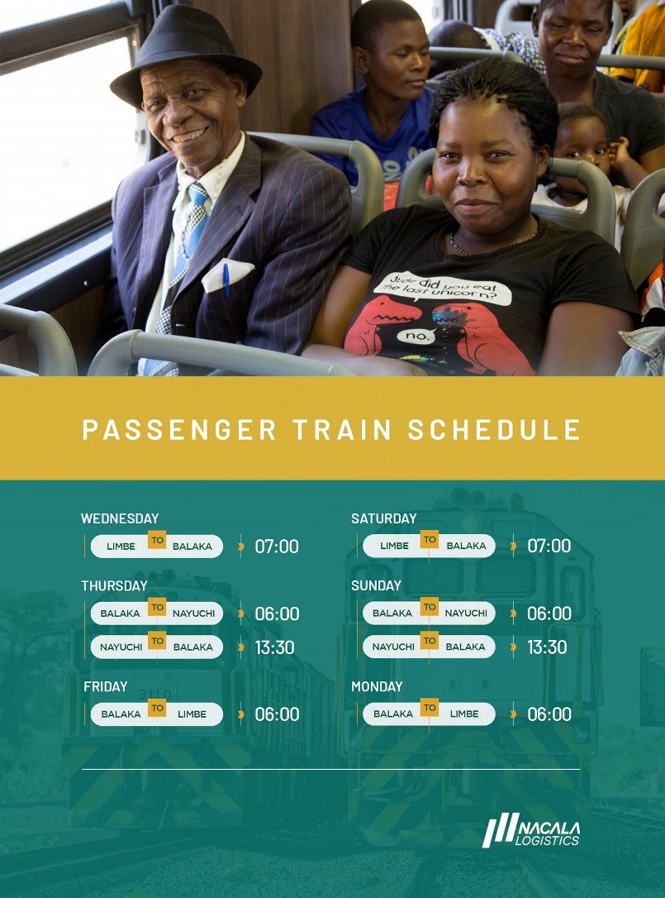

Figure 15 February 2023 service. See: <https://www.facebook.com/permalink.php?story_fbid=pfbid0W2UU45cWzCLczsAhp7W7z2MziSYgpbhgqSTTb8CCZKAjNz9BR8ZAXySGF7tohVnCl&id=100063954877127>

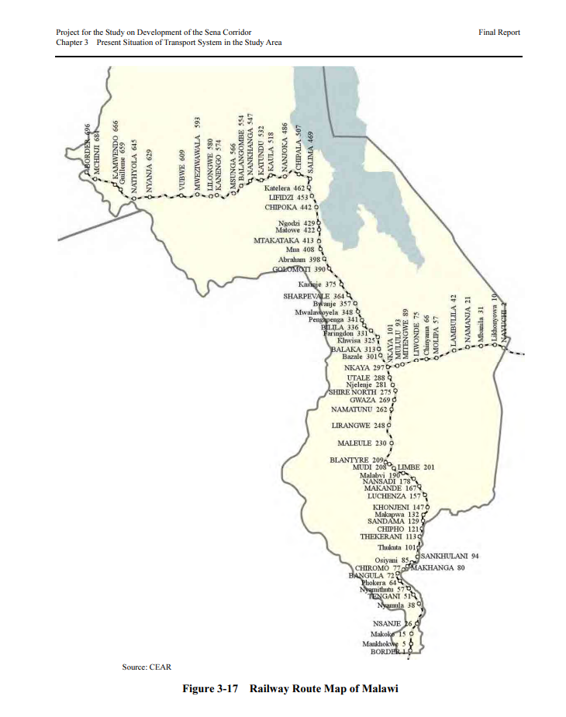

Figure from: https://openjicareport.jica.go.jp/pdf/1000004247_03.pdf