# Morocco

## Summary

### Nodes

|  |  |
| --- | --- |
| railway | count |
| null | 6671 |
| level_crossing | 1737 |
| tram_stop | 306 |
| station | 239 |
| switch | 92 |
| tram_level_crossing | 83 |
| buffer_stop | 68 |
| subway_entrance | 55 |
| platform | 41 |
| crossing | 41 |
| halt | 31 |
| tram_crossing | 8 |
| stop | 7 |
| roundhouse | 4 |
| level_crossing;tram_level_crossing | 3 |
| signal | 2 |

Railway tag value and count where name tag value is not null.

|  |  |
| --- | --- |
| railway | count |
| tram_stop | 301 |
| station | 229 |
| halt | 25 |
| subway_entrance | 18 |
| level_crossing | 8 |
| stop | 6 |
| signal | 1 |
| platform | 1 |
| crossing | 1 |

### Edges

#### All edges – status

|  |  |
| --- | --- |
| open | 6521 |
| construction | 498 |
| disused | 438 |
| abandoned | 291 |

#### All edges – type

|  |  |
| --- | --- |
| conventional | 4889 |
| other | 1412 |
| tram | 1243 |
| subway | 204 |

#### Named edges

Oujda to Zoudj Bghal (Algeria) disused 1

#### Bridge/viaduct

|  |  |
| --- | --- |
| bridge | 687 |
| platform | 174 |
| viaduct | 70 |
| turntable | 6 |
| station | 5 |

## Information

<https://en.wikipedia.org/wiki/List_of_railway_lines_in_Algeria>

<https://fr-m-wikipedia-org.translate.goog/wiki/Liste_des_lignes_de_chemin_de_fer_d'Alg%C3%A9rie?_x_tr_sl=auto&_x_tr_tl=en&_x_tr_hl=en>

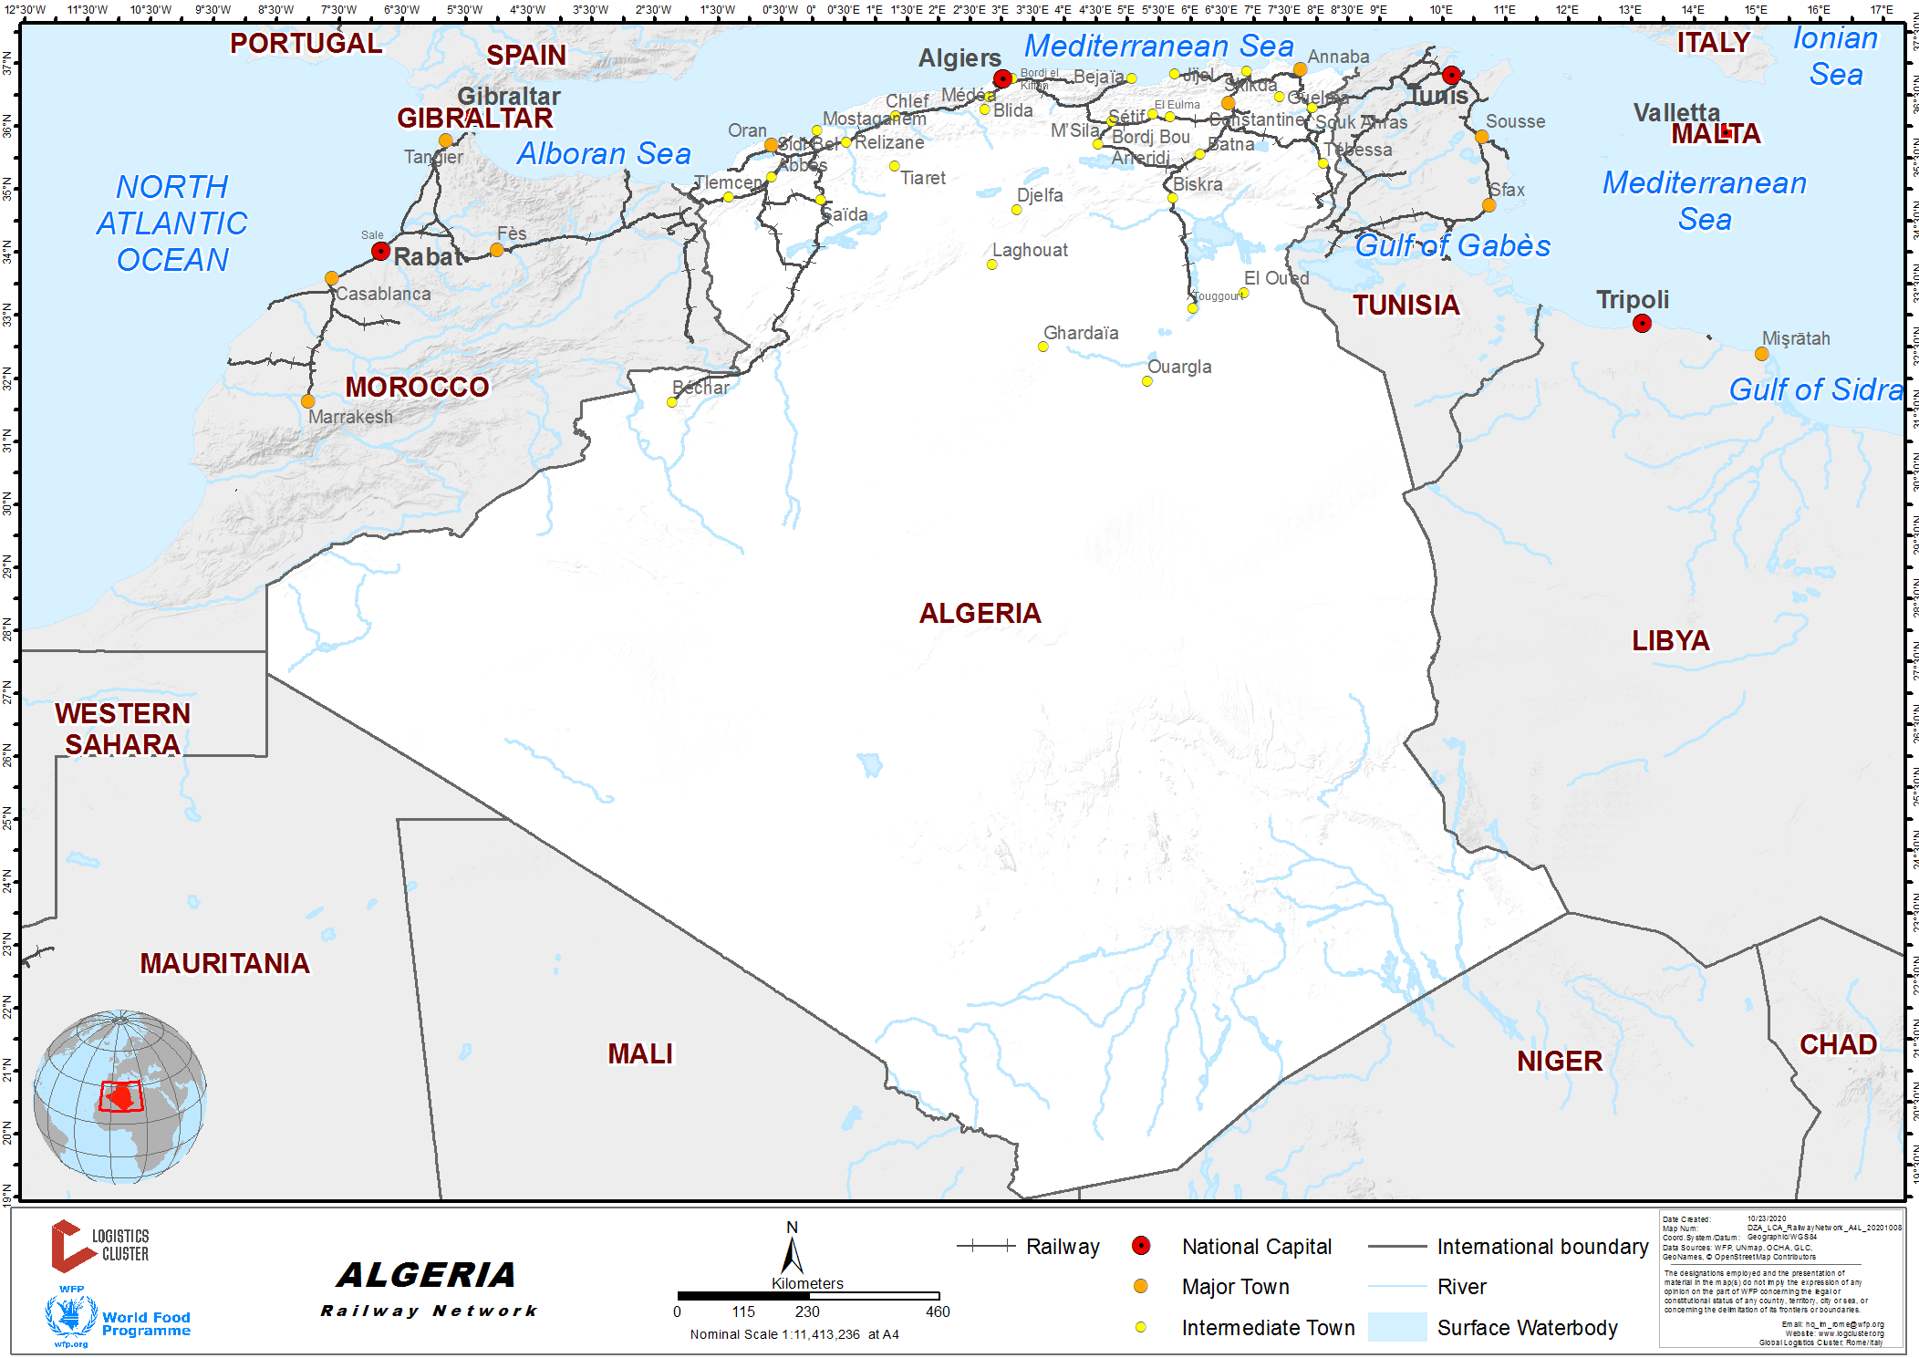

Figure 1 WFP assessment

1. Algiers – Oran
   1. 1435mm
   2. Overhead electrification Algiers to El Affroun (Wikipedia)
   3. Operating speed 90km/h. Potential to increase to 160km/h on flat double-track sections using DMUs acquired in 2008 (Wikipedia)
2. Oed Tlelat to Béchar
   1. 1435
   2. None electrified single track (<https://fr-m-wikipedia-org.translate.goog/wiki/Ligne_d%27Oued_Tlelat_%C3%A0_B%C3%A9char?_x_tr_sl=auto&_x_tr_tl=en&_x_tr_hl=en>)
   3. Branches at Tabia for Maghnia
3. Sidi Bel Abbès – seems to be errors in the OSM data here? Tramway not identified as such and doesn’t seem to be linked correctly and mixed with the heavy rail network? Map of tram network here: <https://www.urbanrail.net/af/sidi-bel-abbes/sidi-bel-abbes.htm>. New heavy rail lines under construction (?) with new station to North of city (also shown in grey at top below). Stations such as Rectorat, Institut Sciences Medicals tram stop etc seem to be on a heavy rail lines in the OSM data. From Google Earth it would see that the final tram stop is tot eh south is currently Gare Routiere Sud. See also: <https://en.wikipedia.org/wiki/Sidi_Bel_Abb%C3%A8s_tramway>

Infrastructure company – Anesrif

<https://www.anesrif.dz/index.php/fr/>

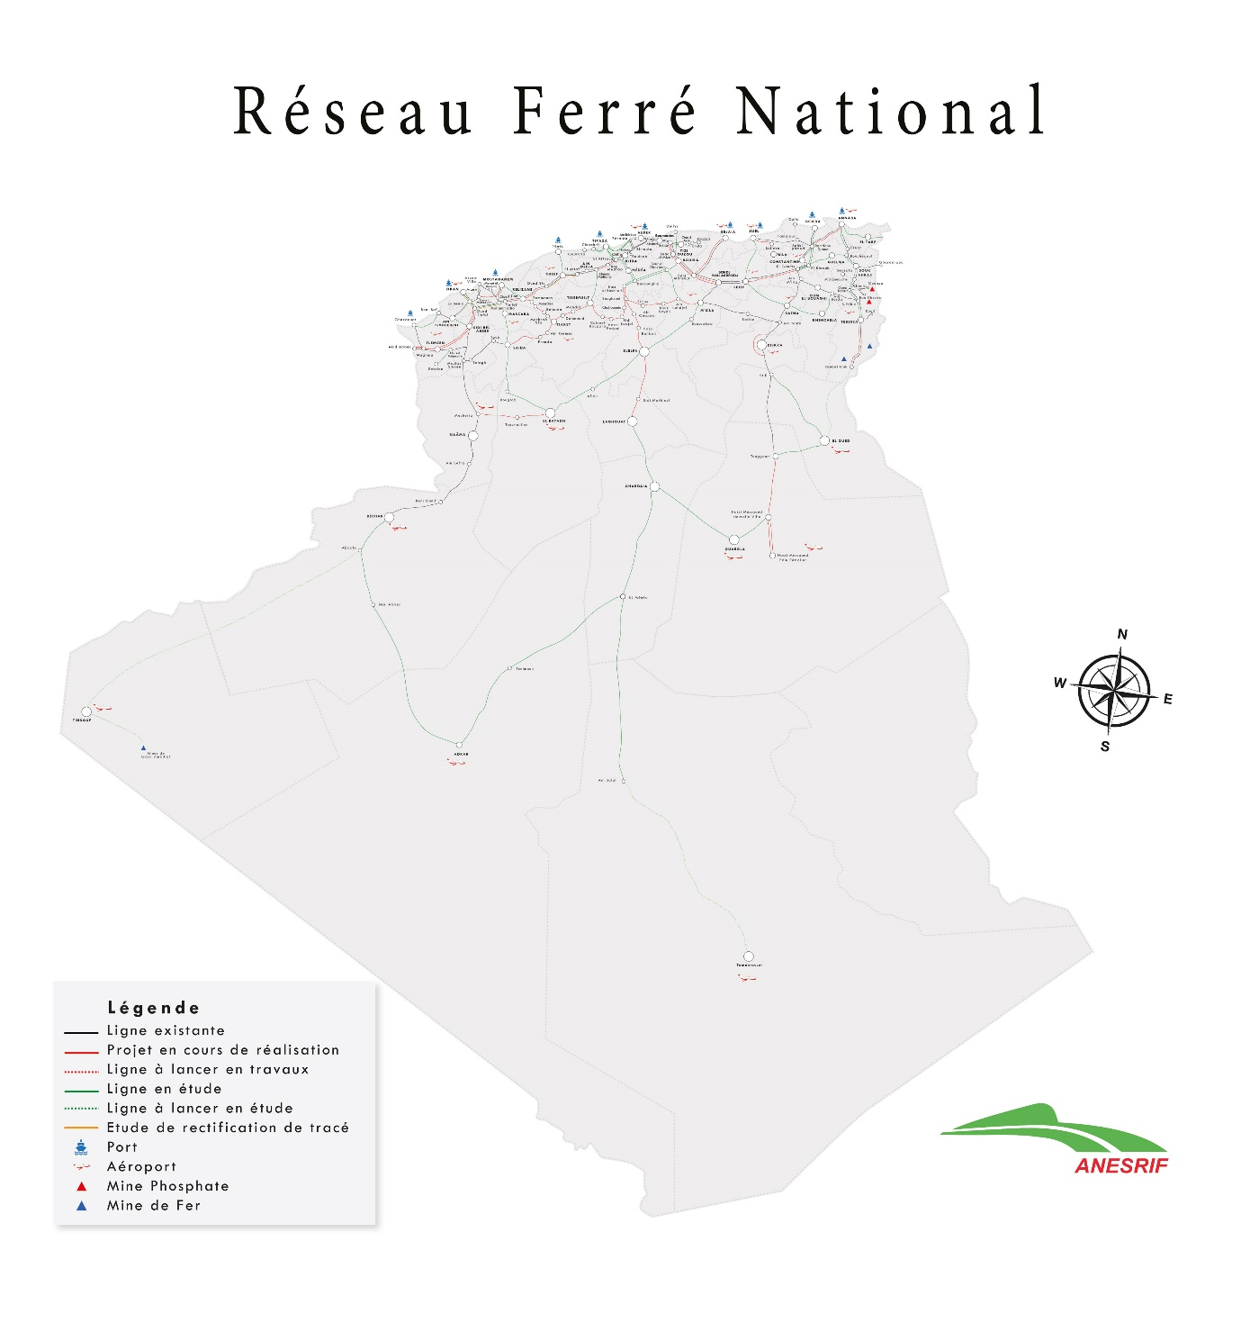

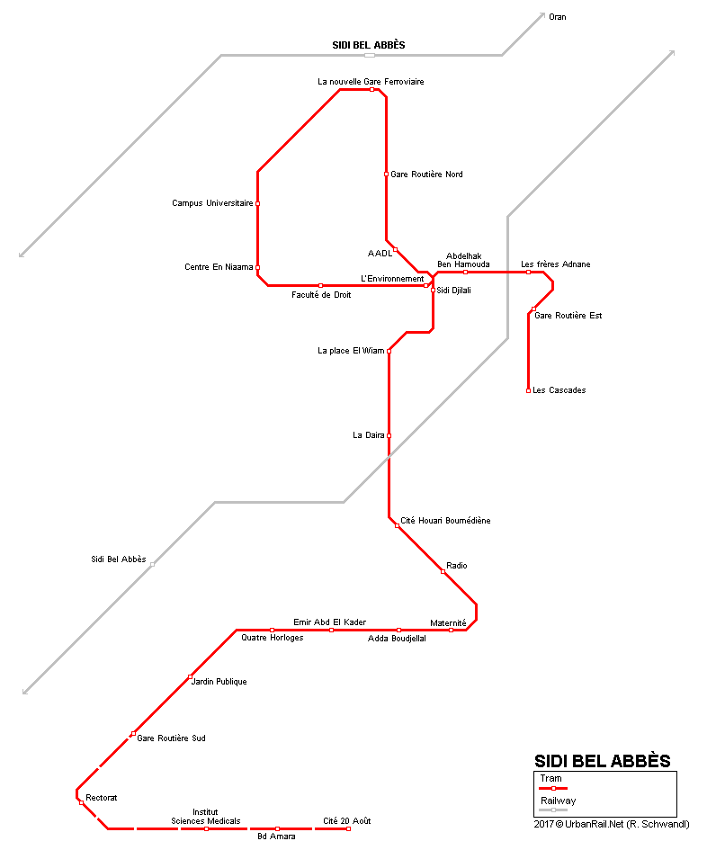

1. Maghnia to Ghazaouet – appears not to have any passenger services? No services in SNTF timetable? (<https://fr-m-wikipedia-org.translate.goog/wiki/Ligne_d%27Akid_Abbes_%C3%A0_Ghazaouet?_x_tr_sl=auto&_x_tr_tl=en&_x_tr_hl=en>). Needs further investigation. Some suggestion that passenger traffic was abandoned 1962-2009 when relaunched. But has it since been abandoned again. May be open for freight. For example, see: <https://www-portdeghazaouet-com.translate.goog/page/voie-de-communication?_x_tr_sl=auto&_x_tr_tl=en&_x_tr_hl=en>
2. There are timetabled services between Tabra and Maghnia and intermediate stations. But Akid Abbas, Ghazaouet are in the list of stations on SNTF timetable lookup.