# Morocco

## Summary

### Nodes

|  |  |  |
| --- | --- | --- |
| ‘railway’ key | count | notes |
| null | 2986 |  |
| level_crossing | 1035 |  |
| tram_stop | 226 |  |
| crossing | 156 |  |
| station | 121 |  |
| switch | 46 |  |
| platform | 41 |  |
| buffer_stop | 31 |  |
| tram_level_crossing | 23 |  |
| proposed | 9 |  |
| tram_crossing | 4 |  |
| disused_station | 1 |  |
| halt | 1 |  |
| stop | 1 |  |
| signal | 1 |  |
| tram | 1 |  |

Railway tag value and count where name tag value is not null.

|  |  |
| --- | --- |
| ‘railway’ key | count |
| tram_stop | 226 |
| station | 101 |
| null | 12 |
| proposed | 3 |
| level_crossing | 3 |
| platform | 2 |
| signal | 1 |
| halt | 1 |
| disused_station | 1 |
| stop | 1 |

### Edges

#### All edges

|  |  |
| --- | --- |
| ‘railway’ key | count |
| rail | 2296 |
| tram | 1210 |
| abandoned | 263 |
| disused | 166 |
| construction | 36 |
| platform | 26 |
| proposed | 19 |
| station | 7 |
| razed | 4 |
| planned | 2 |

#### Named edges

|  |  |  |  |
| --- | --- | --- | --- |
| ‘name’ key | Count | ‘railway’ key | notes |
| Chemin de fer Méditerranée-Niger | 91 | disused |  |
| Casablanca T4 | 58 | tram |  |
| Ligne à Grande Vitesse [LGV] Tanger - Kénitra | 57 | rail |  |
| Casablanca Tr | 49 | tram |  |
| L1 direction Hay Karima الخط الأول إتجاه حي كريمة | 25 | tram |  |
| L1 direction Madinat Al Irfane الخط الأول إتجاه مدينة العرفان | 23 | tram |  |
| L1 Direction Madinat Al Irfane الخط الأول إتجاه مدينة العرفان | 12 | tram |  |
| L1 Direction Hay Karima الخط الأول إتجاه حي كريمة | 12 | tram |  |
| ONCF railway | 4 | abandoned |  |
| محطة الرباط أكدال | 2 | construction |  |
| Hay Hassani | 2 | station |  |
| Littoral | 2 | platform |  |
| Pont Hassan II قنطرة الحسن الثاني | 2 | platform |  |
| Sidi Abderrahmane | 2 | tram |  |
| Ain Diab Plage Terminus | 2 | platform |  |
| Sidi-Taïbi | 1 | platform |  |
| viaduc du Loukkos | 1 | station |  |
| Fès-Ville فاس-مدينة | 1 | rail |  |
| pharmacie Al Qods صيدلية القدس | 1 | station |  |
| Tunnel de Gibraltar | 1 | rail |  |

#### Bridge/viaduct

|  |  |
| --- | --- |
| ‘bridge’ key | count |
| null | 3574 |
| yes | 444 |
| viaduct | 11 |

## Information

1. Run by ONCF 3,600 km – all standard gauge 1435mm. 1300km electrified. <https://en.wikipedia.org/wiki/ONCF>
2. High speed rail Casablanca -> Tangier (Al-Boraq). 323km opened 15 November 2018. Two sections:
   1. Tangier to Kenitra (new route) 186km (top speed 320 kmph)
   2. Main Tangier station is Tanger Ville – terminus of the high speed train
   3. Tanger Morora appears to be permanently closed

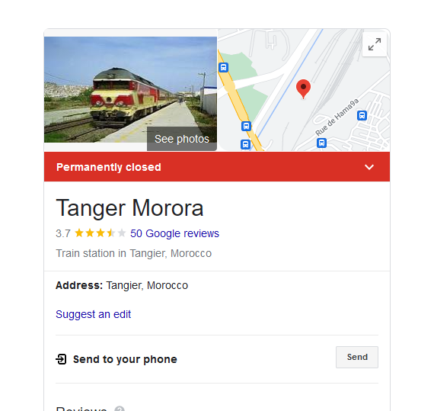

* 1. Kenitra to Casablanca (upgrade to existing) 137km (rated for 160kmph when service began, planned to upgrade to 220 kmph). Eventually track is planned to be replaced by a new route with construction due to start 2020.
  2. It’s not clear if the old line from Kenitra to Tangier via Ksar el-Kebir is still operational. According to the ONCF online timetable it appears to be (Ksar el-Kebir is the Grand Palace train station): 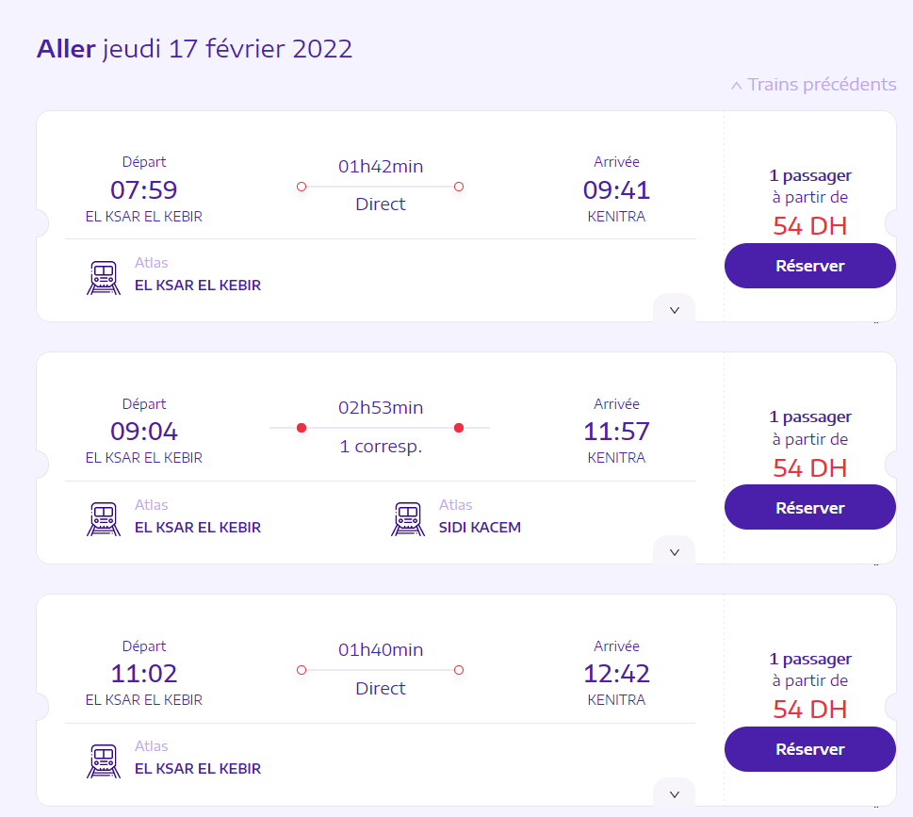

1. The main network for passenger-transport consists of a North–South link from Tangier via Rabat and Casablanca to Marrakech and the East–West connection linking Oujda in the East via Fes to Rabat. The North–South and East–West links interconnect at Sidi-Kacem.
2. Freight: According to 2012 source Oujda railway station is the last station for passengers on the East-West link. The lines south of Oudja are for freight only and until the passenger-service starts the link Tanger-Tanger MED is also only operated for freight: mainly for the Renault factory at the port. [This appears to be operational now for passengers. See: https://en.wikipedia.org/wiki/Tanger-Med]
3. The main network for passenger-transport consists of a North–South link from Tangier via Rabat and Casablanca to Marrakech and the East–West connection linking Oujda in the East via Fes to Rabat. The North–South and East–West links interconnect at Sidi-Kacem.
4. <https://www.seat61.com/train-travel-in-morocco.htm>
5. <https://www.railjournal.com/in_depth/tangier-kenitra-line>
6. ONCF online timetable: <https://www.oncf-voyages.ma/>
7. List of Railway Stations in Morocco (though not complete. E.g. doesn’t have the station at Ksar el-Kebir): <https://en.wikipedia.org/wiki/Railway_stations_in_Morocco>
8. Line from Oujda to Bouarfa is used for freight (zinc, lead, copper). Also a privately chartered tourist train called the Oreintal Desert Express (see: <https://en.wikipedia.org/wiki/Oriental_Desert_Express> and <https://www.trainmaroc.com/index.php?lalangue=en>).
9. Branch line from Oujda to Jerada which served mining area appears disused from Google Satellite view – sections covered in sand. Was open in 2010 – see: <http://www.sixbellsjunction.co.uk/00s/101006pw.htm>.

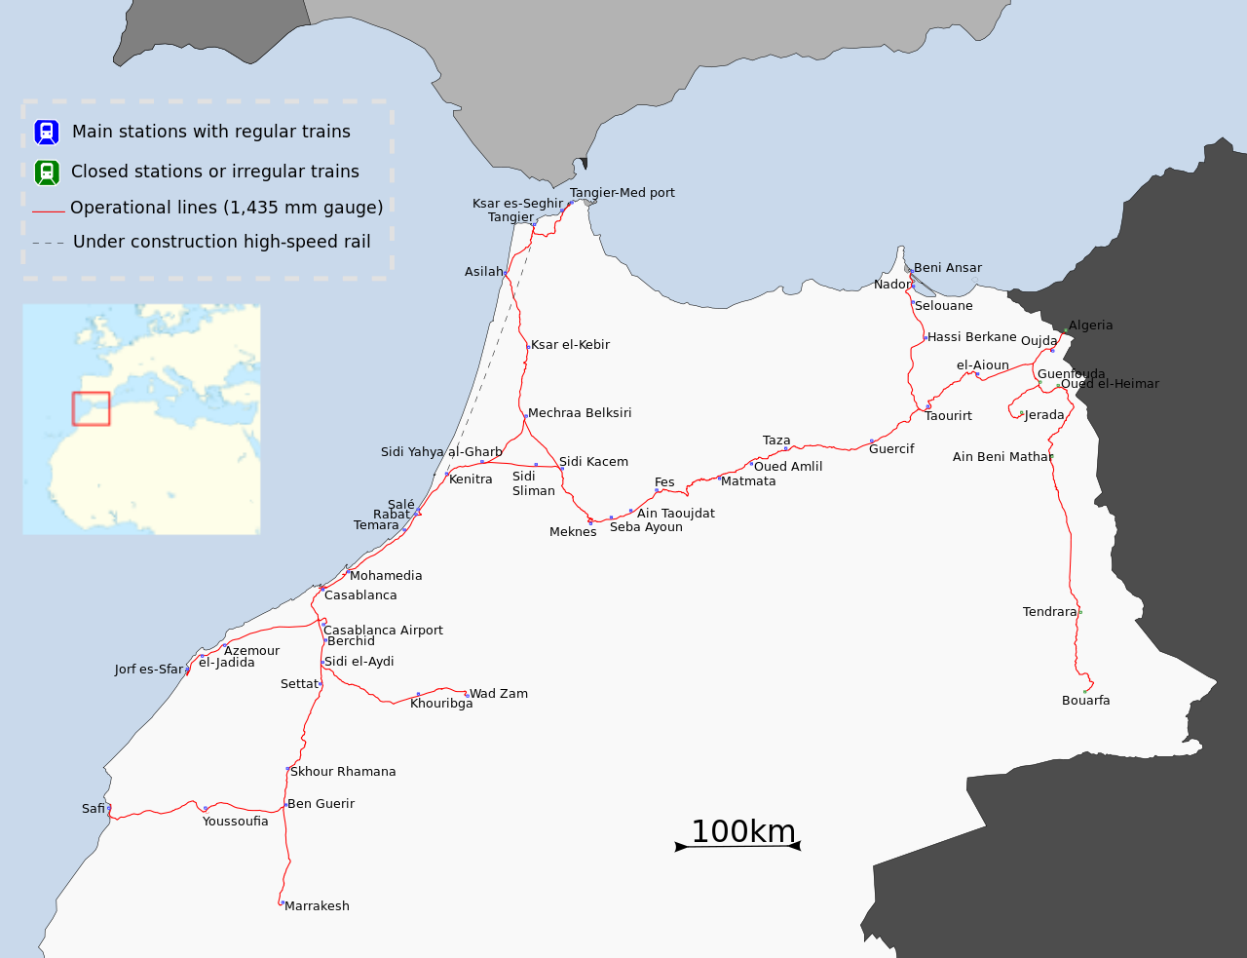

Figure 1 By Tachfin - Own work, CC BY-SA 3.0, <https://commons.wikimedia.org/w/index.php?curid=19753508>

1. Container port at Tanger Med – see https://en.wikipedia.org/wiki/Tanger-Med

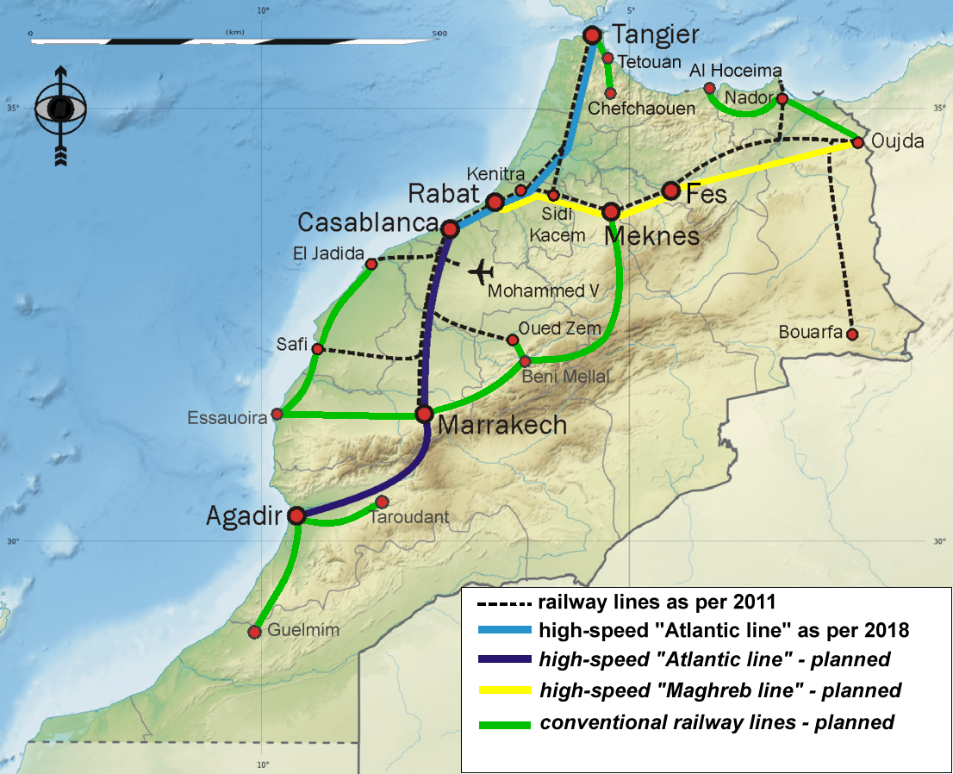

Figure 2 Wikipedia By Dogstar01 - Own work, CC BY-SA 4.0, <https://commons.wikimedia.org/w/index.php?curid=78593657>

## Urban services

* Casablanca tramway
* Rabat-Sale tramway
* Tangier tramway (proposed?)
* Marrakech Tramway (proposed?)
* Train Navette Rapid (rapid transit rail Rabat to Casablanca and on to Kenitra and Settat (200km))
  + Casablanca Airport Link (30 km)
  + Casablanca -> El Jadida 100 km

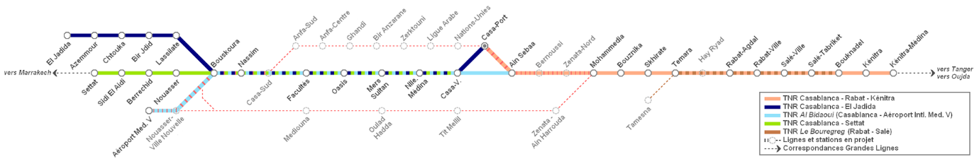

Figure 3 https://commons.wikimedia.org/wiki/File:R%C3%A9seau_TNR.PNG

* Al Bidaoui (Casablanca overground rail)
  + Casablanca RER line 63 km with 9km underground planned for 2020
* Le Bouregreg – Rabat overground rail