# Sudan and South Sudan

## Summary - Sudan

### Nodes

|  |  |
| --- | --- |
| railway | count |
| null | 1116 |
| level_crossing | 766 |
| station | 49 |
| buffer_stop | 21 |
| switch | 6 |
| crossing | 4 |
| platform | 3 |
| halt | 1 |
| stop | 1 |
|  |  |
|  |  |
|  |  |
|  |  |
|  |  |
|  |  |

Railway tag value and count where name tag value is not null.

|  |  |
| --- | --- |
| railway | count |
| station | 42 |
| level_crossing | 2 |
| stop | 1 |
|  |  |
|  |  |
|  |  |
|  |  |
|  |  |
|  |  |
|  |  |

### Edges

#### All edges – status

|  |  |
| --- | --- |
| open | 1497 |
| disused | 57 |
| abandoned | 10 |
| razed | 3 |
|  |  |

#### All edges – type

|  |  |
| --- | --- |
| conventional | 1496 |
| other | 71 |
|  |  |
|  |  |
|  |  |
|  |  |
|  |  |

#### Named edges

#### Bridge/viaduct

|  |  |
| --- | --- |
|  | 1461 |
| bridge | 105 |
| platform | 1 |
|  |  |
|  |  |
|  |  |
|  |  |

## Summary – South Sudan

### Nodes

|  |  |
| --- | --- |
| railway | count |
| level_crossing | 34 |
|  | 15 |
| crossing | 4 |
| station | 2 |
|  |  |
|  |  |
|  |  |
|  |  |
|  |  |
|  |  |
|  |  |
|  |  |
|  |  |
|  |  |
|  |  |

Railway tag value and count where name tag value is not null.

|  |  |
| --- | --- |
| railway | count |
| station | 2 |
|  |  |
|  |  |
|  |  |
|  |  |
|  |  |
|  |  |
|  |  |
|  |  |
|  |  |

### Edges

#### All edges – status

|  |  |
| --- | --- |
| disused | 48 |
| open | 5 |
|  |  |
|  |  |
|  |  |

#### All edges – type

|  |  |
| --- | --- |
| conventional | 53 |
|  |  |
|  |  |
|  |  |
|  |  |
|  |  |
|  |  |

#### Named edges

#### Bridge/viaduct

|  |  |
| --- | --- |
| null | 49 |
| bridge | 4 |
|  |  |
|  |  |
|  |  |
|  |  |

## Information

<https://en.wikipedia.org/wiki/Rail_transport_in_Sudan>

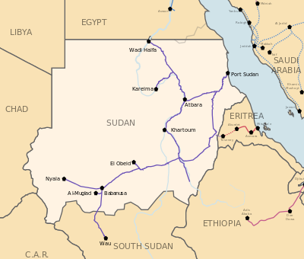

<https://www.sinfin.net/railways/world/sudan.html>

<https://rogerfarnworth.com/2022/05/31/railways-of-khartoum-part-1-the-3ft-6in-1067mm-gauge/>

<https://sudanrailways.gov.sd>

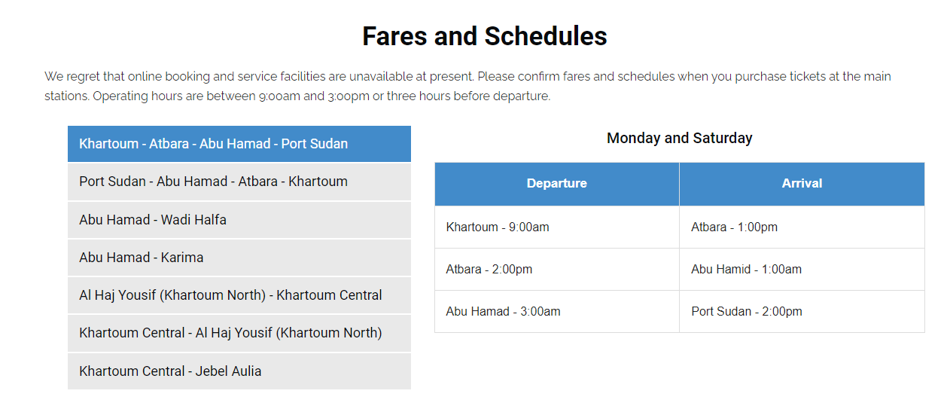It would appear that Khartoum North is the station names Bahri on OSM and Jebel Aulia (where there appears to be no line let alone station) might be Al Bagair or Almaseed.

1067mm gauge and single track

Main line from Wadi Halfa to Atbara, Khartoum, Sannar, El Obeid, Babanusa with connections to Nyala and into South Sudan (Wau). Other lines: Atbara to Port Sudan and Port Sudan to Sannar.

Appears lines in the South are out of use (but may be rehabilitated in the future - see below in ‘Proposed’)

### Proposed

<https://www.globalconstructionreview.com/sudan-plans-640m-scheme-bring-rail-network-back-us/>

“The first phase of the project will be to carry out $17m of emergency repairs to lines that are in use. The second will be to renew abandoned lines, most of which are in the south of the country. This phase will connect the cities of Madani, Kosti and Sennar, as well as Nyala in Darfur state. It will also establish a cross-border connection to Wau in the Republic of South Sudan.” A bit unclear but suggests that the southern lines may not be in use currently?

<https://www.bloomberg.com/news/articles/2021-07-16/sudan-plans-640-million-railway-revamp-as-it-relinks-with-world#xj4y7vzkg>

“Under the second phase of the railway project to be completed by 2024, Sudan plans to rehabilitate abandoned lines mainly in the country’s south. That will restore links to the cities of Madani, Kosti and Sennar, as well as Nyala in the war-torn western region of Darfur, while establishing a cross-border connection to Wau in South Sudan, according to Ahmed. Part of the financing will be from a $75 million World Bank grant, he said.”

https://www.railjournal.com/infrastructure/sudan-plans-us-643m-investment-in-rail-rehabilitation/

“The African Development Bank, China State Construction Engineering Corp and unspecified Gulf firms have expressed interest in helping restore about 2400km of unused track, Bloomberg reports, with the government initially planning to invest $US 17m in operational lines.”

### Light Rail

Gezira Light Railway serving cotton plantations (610mm gauge). Perhaps partly still in use. Unclear.

## South Sudan

Line to Wau from Sudan.

<https://en.wikipedia.org/wiki/Rail_transport_in_South_Sudan>

<https://www.sinfin.net/railways/world/ssudan.html>