# Tunisia

## Summary

### Nodes

|  |  |
| --- | --- |
| railway | count |
| null | 4030 |
| level_crossing | 1825 |
| buffer_stop | 574 |
| station | 286 |
| crossing | 146 |
| halt | 139 |
| switch | 114 |
| stop | 77 |
| platform | 57 |
| turntable | 3 |
| roundhouse | 2 |
| rail | 1 |
| depot | 1 |

Railway tag value and count where name tag value is not null.

|  |  |
| --- | --- |
| railway | count |
| station | 277 |
| null | 100 |
| stop | 70 |
| halt | 45 |
| platform | 9 |

### Edges

#### All edges – status

|  |  |
| --- | --- |
| open | 5563 |
| disused | 181 |
| abandoned | 171 |
| construction | 49 |

#### All edges – type

|  |  |
| --- | --- |
| conventional | 4167 |
| light_rail | 1083 |
| other | 697 |
| tram | 17 |

#### Named edges

#### Bridge/viaduct

|  |  |
| --- | --- |
| bridge | 487 |
| platform | 223 |
| station | 65 |
| turntable | 7 |
| viaduct | 2 |

## Information

1. National rail company: Société Nationale des Chemins de Fer Tunisiens (*Tunisian National Railway Company*) – SNCFT. Website: <https://www.sncft.com.tn/en>
2. Appears to be two gauges in use. Standard (1435) in the north (471km) and metre gauge in central and southern parts (1686 km). A small part is dual gauge (8km). Summary here: <https://www.sncft.com.tn/en/the-sncft/overview/>
3. Details of network from SNCTF: <https://www.sncft.com.tn/en/the-sncft/network/>. Includes Line numbers. Main stations listed: <https://www.sncft.com.tn/en/the-sncft/stations/>
4. Schedues: <https://www.sncft.com.tn/en/main-lines/train-schedules/>
5. SNCFT Tunis suburban line: <https://www.sncft.com.tn/en/tunis-suburbs/presentation/>. **25 km** length; including **17 km** triple tracked between Tunis and Hammam-Lif, and 8 km double tracked between Hammam-Lif and Erriadh. Linking: Tunis, Jebel Jelloud, Mégrine, Rades, Ezzahra, Hammam-Lif, Hammam-Echatt, Borj-Cédria and Erriadh. 20 minutes from Tunis to Hammam-Lif on direct trains, and 43 minutes between Tunis and Erriadh for omnibus trains.
6. SNCFT Sahel metro (serving [Sousse](https://en.wikipedia.org/wiki/Sousse) and [Mahdia](https://en.wikipedia.org/wiki/Mahdia) and Monastir). See: <https://www.sncft.com.tn/en/sahel-suburbs/presentation/>. Also see: <https://en.wikipedia.org/wiki/Sahel_Metro>. Metre gauge.
7. Open data source of SNCFT lines in geojson: <http://data.transport.tn/group/62111085-2824-4f9f-b274-249b1747a9b1?res_format=GeoJSON> (last modified 2019). GTFS data available also: <http://data.transport.tn/dataset/horaires-du-reseau-ferre-de-la-sncft-gtfs-gtfs>. CSV files of stations with lat/lon also available.

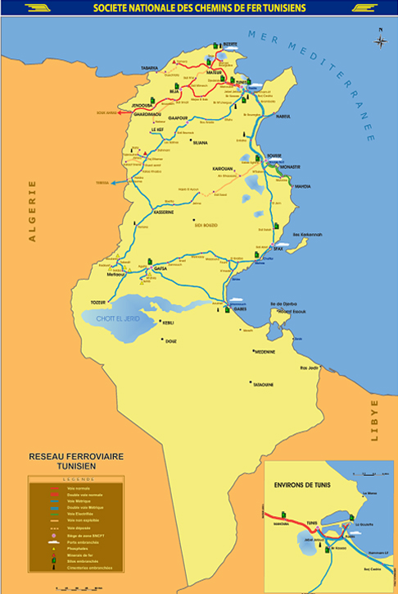

Figure https://www.sncft.com.tn/en/main-lines/presentation/

Figure https://www.sncft.com.tn/en/the-sncft/network/

1. In addition to SNCFT there is [Société des transports de Tunis](https://en.wikipedia.org/wiki/Soci%C3%A9t%C3%A9_des_transports_de_Tunis) responsible for a light rail network (Metro leger) and the Tunis-Goulette-Marsa (TGM) standard gauge ‘light rail’ line.
2. Electrified: 65 km from Sousse Bab Jadid -Monastir-Mahdia (Sahel metro) and 25 km from Tunis – Hammam LIF – Borj Cédria
3. Major SNCFT routes:

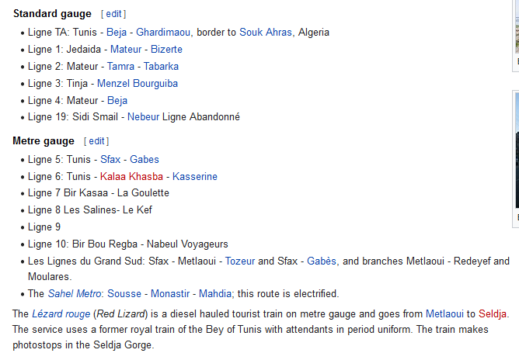

Figure From: <https://en.wikipedia.org/wiki/Soci%C3%A9t%C3%A9_Nationale_des_Chemins_de_Fer_Tunisiens>

1. Freight - the Sfax-Gafsa Railway delivers [phosphate](https://en.wikipedia.org/wiki/Phosphate) (see: <https://www.sncft.com.tn/phosphate/presentation/>) and iron ore to the harbour at [Sfax](https://en.wikipedia.org/wiki/Sfax). Also the Metlaoui - Redeyef and Moularès - Kasserine lines are for the transport of phosphate. (<https://en.wikipedia.org/wiki/Soci%C3%A9t%C3%A9_Nationale_des_Chemins_de_Fer_Tunisiens#Freight_service>)
2. Direct line between Gafsa and Gabes – some suggestion that this is Freight only (see map below).
3. A new section between Kalaa Seghira and M'Saaken enabling through Tunis - Sfax services to avoid Sousse town centre - said to have opened in 2004. Tunis – Sfax route said to have been double-tracked at this time also.
4. In 2012 Tunis - Borj Cedria line said to have been electrified.
5. Future: suggestions of a link between Libya and Tunisia - a 150 km standard gauge link from [Ras Ajdir](https://en.wikipedia.org/wiki/Ras_Ajdir) on the Libyan border to [Gabès](https://en.wikipedia.org/wiki/Gab%C3%A8s). How has this progressed? Said to have been agreed in 2008.

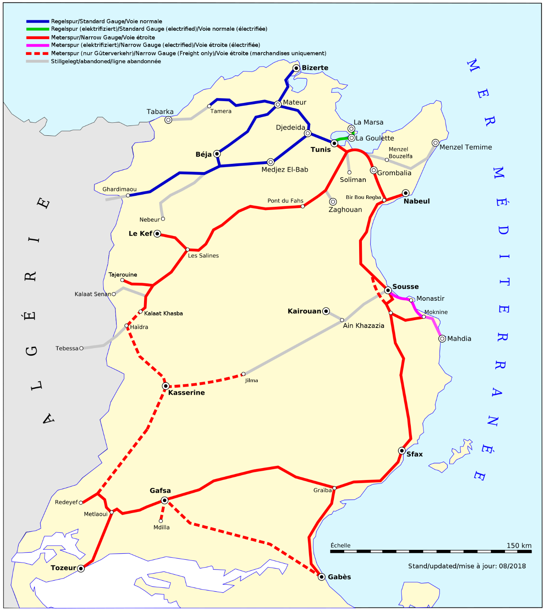

Figure https://commons.wikimedia.org/wiki/File:Reseau_cft_tunisie.svg