# West Africa (excluding Nigeria)

Mauritania

Senegal

Mali

Guinea

Sierra Leone

Liberia

Burkina Faso

Côte d'Ivoire

Ghana

Togo

Benin

# West Africa Regional Rail Integration

<https://en.wikipedia.org/wiki/West_Africa_Regional_Rail_Integration>

## Summary

Nodes – railway tag

|  |  |
| --- | --- |
| null | 3632 |
| level_crossing | 2804 |
| switch | 564 |
| crossing | 346 |
| buffer_stop | 219 |
| station | 211 |
| halt | 106 |
| platform | 46 |
| stop | 22 |
| yard | 4 |
| signal | 3 |
| engine_shed | 3 |
| turntable | 2 |
| railway_crossing | 2 |
| disused | 1 |
| service_station | 1 |
| subway_entrance | 1 |
| tram_level_crossing | 1 |
| tram_stop | 1 |

Edges – status

|  |  |
| --- | --- |
| open | 6384 |
| disused | 838 |
| abandoned | 317 |
| construction | 26 |
| dismantled | 8 |
| proposed | 3 |

Edges – type

|  |  |
| --- | --- |
| conventional | 6268 |
| other | 1284 |
| monorail | 18 |
| subway | 4 |
| tram | 2 |

Edge – structures

|  |  |
| --- | --- |
| null | 6960 |
| bridge | 528 |
| platform | 81 |
| station | 4 |
| traverser | 1 |
| turntable | 1 |
| viaduct | 1 |

## Information

### Mauritania

Single Railway line (he Mauritania Railway) linking the iron mining centre of Zouérat with the port of Nouadhibou, via Fderik and Choum. Since the closure of the Choum Tunnel, a 5 km (3.1 mi) section of the railway cuts through the Polisario Front-controlled part of the Western Sahara (<https://en.wikipedia.org/wiki/Mauritania_Railway>). Standard gauge.

Primarily for freight. Apparently, some passenger carriages, but passengers will sit on wagons transporting iron ore. And sometimes tourist trains?

The state agency Société Nationale Industrielle et Minière (National Mining and Industrial Company, SNIM - https://www.snim.com/e/index.php/operations/train.html) controls the railway line. Passengers are also occasionally transported by train; these services are managed by an SNIM subsidiary, the société d'Assainissement, de Travaux, de Transport et de Maintenance (ATTM).

<https://www.bbc.com/travel/article/20190904-an-exhilarating-train-journey-across-the-sahara>

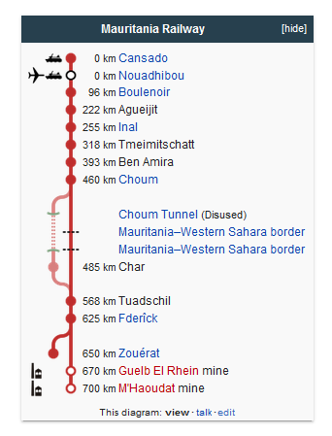

### Senegal / Mali

<https://en.wikipedia.org/wiki/Rail_transport_in_Senegal>

<https://en.wikipedia.org/wiki/Railway_stations_in_Senegal>

<https://en.wikipedia.org/wiki/Rail_transport_in_Mali>

Mainly 1000mm gauge. Some 1435mm.

Lines:

1. Dakar to Niger (river) <https://en.wikipedia.org/wiki/Dakar%E2%80%93Niger_Railway> . Note: connects through to **Koulikoro in** Mali. 1000mm gauge. Double track between Dakar and Thies; otherwise single track. Apparently line has not operated since 2010 (but see below). Is this up-to-date? Was a proposal for Chinese investment to restore the line and potentially convert to standard gauge. Apparently there are a number of branch lines including:
   1. Saint-Louis
   2. Linguère
   3. Kaolack
   4. Mbaké
   5. Baja Kunda (proposed?)

Passenger service status (2019) see: https://www.seat61.com/Senegal.htm . Said to be passenger services between Kayes and Bamako in Mali. According to World Bank in a 2109 report referring to Freight traffic (see: WB-P171122): “The Dakar-Bamako Corridor comprises three different multimodal routes: (i) the 1,288 railway connection (of which 1,057 km in Senegal, and 582 km in Mali) on which the traffic has ceased since March 2018”; There is a proposed WB rehabilitation project – status “in pipeline (proposed)”. See: <https://projects.worldbank.org/pt/projects-operations/project-detail/P171122>. It appears that the metre gauge network was upgraded between Dakar – Diamniado (as a freight line) as part of the TER (see below) project for 51km of track 1000mm track (see: https://www.railwaygazette.com/infrastructure/dakar-freight-line-rebuild-completed/56490.article and <https://www.railjournal.com/freight/senegal-freight-line-upgrading-project-completed/>). It Is not apparent that rehabilitation of the rest of the metre gauge network has begun. Agreements were signed with China Railway Construction Corp in 2016 for section between the port of Dakar and Bamako (for freight and passenger use) but funding was not in place at that time (see: <https://www.tinn.ir/Section-english-2/75371-senegal-mali-railway-modernisation-agreements-signed>). An environmental assessment was commissioned in 2019 by TYPSA (see: <https://www.typsa.com/en/proyectos/modernisation-of-the-dakar-bamako-koulikoro-railway-line/>). It appears more likely that section only as far as Tambacounda would be rehabilitated first (see: https://www.sinfin.net/railways/world/senegal.html) . A tender for this was released by Senegal in Aug 2021 with required completion date of 31/12/2027. (<https://www.globaltenders.com/tender-detail?gt_id=465000092-dakar-tambacounda-railway-reconstruction-dakar-tamba-fast-track>). Though some sources suggest this would be standard gauge, which seems at odds with the work already done at the Dakar end? However, it has also been reported that some maintenance work has occurred on the line to enable opening to freight between Dakar and Tambacounda by the end of December 2021 for freight (see: <https://www.journalducameroun.com/en/dakar-railroad-transport-to-tamba-resumes-soon/>).

1. The line from Dakar to Mékhé appears to have been constructed in 2014 to access Grande Côte (GC) sand mines. Would appear to use route of old Dakar to Saint-Louis line. Presumed freight only and stations marked on OSM for this route are surely disused? This also implies that the Line from Thies to Dakar Port is open for freight. See: <https://www.sinfin.net/railways/world/senegal.html> and <https://gco.eramet.com/en/gco/our-value-chain/mineral-sands-production/>. The branch to INDUSTRIES CHIMIQUES DU SENEGAL (ICS) Phosphate mine would also appear to be operational: https://www.indorama.com/affiliated-companies/industries-chimiques%20du-senegal.
2. Petit train de banlieue (PTB) commuter service Dakar to Thies. Opened 1987. <https://en.wikipedia.org/wiki/Petit_train_de_banlieue>. This uses the Dakar to Niger line (above) and is said to be the only passenger service on the Dakar-Niger line since 2009. Was apparently running n 2103: <https://www.rfi.fr/en/africa/20130829-little-train-suburbs-senegal-dakar-traffic-nightmare>. Operation stopped in 2016 according to <https://www-au--senegal-com.translate.goog/le-chemin-de-fer,345?lang=fr&_x_tr_sl=auto&_x_tr_tl=en&_x_tr_hl=en> . Now replaced by the new TER service.
3. Train Express Regional opened 2019. Links Dakar to Blaise Diagne International Airport. Standard gauge. <https://en.wikipedia.org/wiki/Train_Express_Regional_Dakar-AIBD>. Phase one is open and has 13 stations from Dakar to Diamniadio. The second stage is to the airport (additional 19km). Double-tracked. Technical details: <https://www.railway-technology.com/projects/dakar-regional-express-train/> 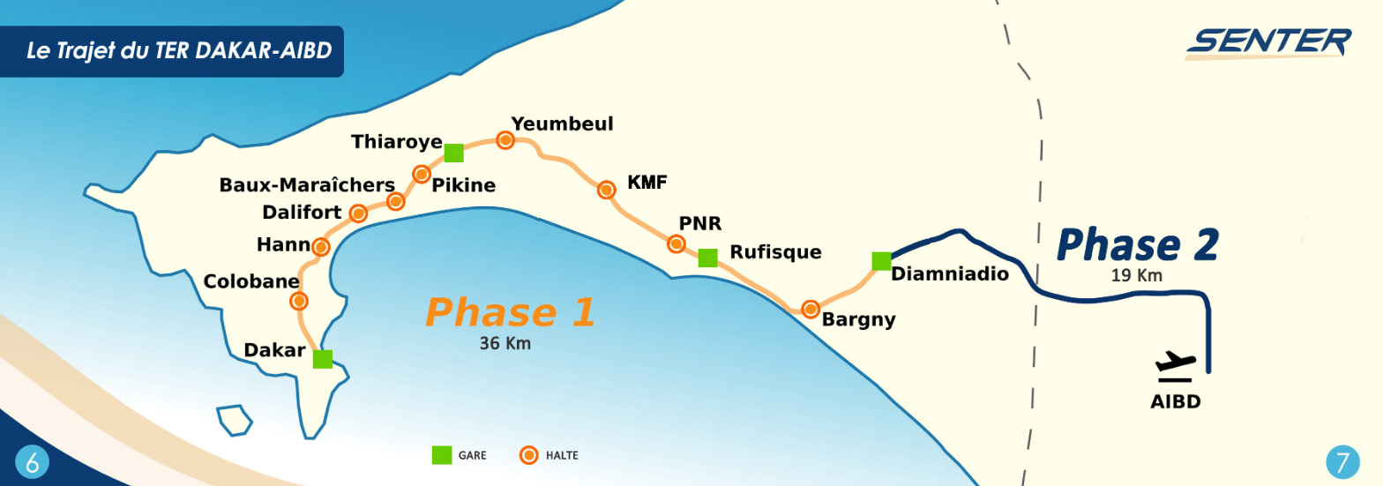
4. All services in Mali apparently ceased in 2018: <https://www.sinfin.net/railways/world/mali.html>. See also: https://www.youtube.com/watch?v=V1i_D6sJ1WA&ab_channel=AFPNewsAgency

### Guinea

### Sierra Leone

### Liberia

### Burkina Faso

### Côte d'Ivoire

### Ghana

### Togo

### Benin