Draft Innovation Capability Framework

1. Introduction
The Education Innovation department has a key objective of Cultivating Innovation Capabilities: demonstrating improved innovation capabilities within the IB. Two key results of this objective are to define a shared innovation capability framework outlining specific skills and to put in place the tools to measure it.
This document proposes a shared innovation framework with four parts: individual innovation capabilities (A), team innovation capabilities (B), innovation climate (C) and innovation performance (D). The individual capabilities describe what a person does when innovating. The team capabilities describe how a group works with ideas together. The climate describes the conditions that managers and the IB provide. The performance indicators describe what comes of that work: which ideas are acted on, and how long they take to be decided on and implemented.

2. The framework
The individual capabilities and the climate are drawn from two validated instruments (Lukeš and Stephan, 2017). The six individual capability domains (A1 to A6) describe what a person does when innovating and come from their Innovative Behavior Inventory. These are things individuals can do and get better at. Innovation climate (C) describes the conditions that managers and the organisation provide, and comes from the Innovation Support Inventory. Innovation climate is something people receive or operate within rather than do, and it is measured at two levels: the manager a person reports to (C1) and the IB as a whole (C2). Someone can be strong on all six of the individual domains, but if the conditions do not support innovation the capabilities may not show up in practice. For example, if mistakes made while trying something new are not tolerated, the organisation may not benefit from an individual’s ability to innovate. Co-creation is not a separate domain; it appears as a practice under A2, A5 and C1.
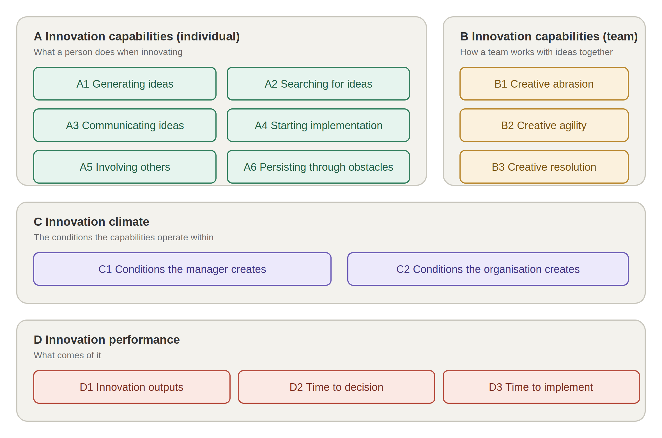
Figure 1. The innovation capability framework
A. Individual capabilities
The skills listed under each domain are the practices the department aims to build. The third column gives the reason each matters, drawn from the paper the framework is based on; the skills are the department’s proposal for how to build it.
Domain | Skills | Why it matters (Lukeš and Stephan, 2017)
A1 Generating ideas | Reframing a problem; structured ideation | Innovation starts with a new idea; generating ideas is one of the two building blocks of innovation, the other being implementation.
A2 Searching for ideas | Discovery interviews; learning from the people closest to a problem; scanning outside the IB for what already works | Innovation can start by finding ideas rather than inventing them; searching for ideas is a valid route into innovation.
A3 Communicating ideas | Testing an idea early with colleagues; making the case to a decision maker | Employees can rarely implement ideas alone and usually need permission, so communicating an idea to colleagues and managers for feedback is a distinct step.
A4 Starting implementation | Writing a scoping document; prototyping before committing; securing resources | Once an idea is approved, time, money and people have to be allocated; implementation starts with plans, anticipated problems and secured resources.
A5 Involving others | Mapping who has to say yes; getting the first meeting; co-designing with the people an idea affects | Innovation is social; others have to be persuaded of an idea’s value and their help mobilised to implement it.
A6 Persisting through obstacles | Designing a test that can fail cheaply; documenting what a failed prototype taught | The central challenge of implementation is overcoming obstacles and resistance, done by adapting the idea or the plan in response to what happens, until it is in use.
B. Team capabilities
The individual capabilities describe a person and the climate describes the conditions around them. How a team handles ideas together is a separate matter: a group of capable individuals can still smother disagreement, over-plan or settle every choice by seniority. Hill et al. (2014) describe three collective capabilities that distinguish teams able to innovate repeatedly, and the framework includes them as B1 to B3.
Capability | Definition
B1 Creative abrasion | A team’s ability to produce a range of ideas through open disagreement and debate, without the debate becoming personal.
B2 Creative agility | A team’s ability to test ideas quickly through small experiments, learn from the results and adjust.
B3 Creative resolution | A team’s ability to make decisions that combine ideas, including opposing ones, instead of letting one view win or settling on a weak compromise.
C. Innovation climate
Innovation climate is measured at two levels.
Level | Practices | Why it matters (Lukeš and Stephan, 2017)
C1 Conditions the manager creates | Inviting unfinished ideas; recognising good ideas; protecting time and resources; tolerating visible failure; securing support beyond the department; bringing problems rather than solutions, to leave room for co-design | The manager is the closest and strongest influence on whether people innovate: the nearest signal that new ideas are wanted and will be backed, and the route by which the organisation's support reaches people.
C2 Conditions the organisation creates | Recognising new ideas in how people are rewarded; setting aside resources for implementing them; giving people time to put them into practice | People innovate when they can see the organisation will recognise, resource and make time for new ideas; a manager can only back what the organisation is prepared to back.
D. Innovation performance
The three innovation performance indicators, innovation outputs (D1), time to decision (D2) and time to implement (D3), are evidence of innovation happening in practice. Outputs are the ideas that changed something and the two durations show how fast. Following the OECD’s Oslo Manual (OECD and Eurostat, 2018), an idea counts once it is in use.
Indicator | Definition
D1 Innovation outputs | Proposals that have been implemented and are in use, having changed a product, a service or a process.
D2 Time to decision | The time between a proposal being submitted and a decision on it being recorded, whether go, stop or park.
D3 Time to implement | The time between a go decision and the proposed change being in use.

3. How the framework is measured
The framework is measured in three ways. First, innovation capabilities (A, B) and innovation climate (C) are measured by survey. Second, the skills listed under each domain are assessed only where a skills building session is run. Third, innovation performance (D) is measured from the records kept as proposals move through the innovation pipeline, from intake to implementation, with the survey's output items as a second source for D1.
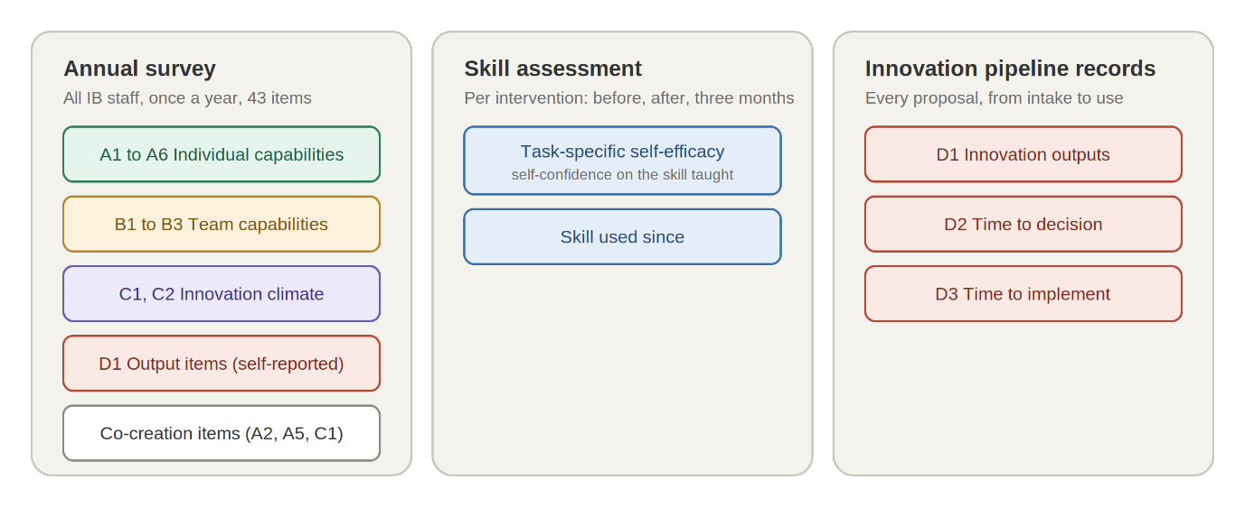
Figure 2. How the framework is measured
Measuring capabilities and climate
Once a year, all IB staff complete one survey of 43 items, around ten minutes: the adapted IBI (Appendix A), the adapted ISI (Appendix B) and the twelve supplementary items (Appendix C).
The survey gives a score on each of the six individual domains (A1 to A6), the three team capabilities (B1 to B3), the manager scale (C1), the organisation scale (C2) and the co-creation cluster. Each is reported for the IB as a whole; the manager scale is also reported for each leader.
The survey maps innovation capability and climate across the IB, and shows whether and where they are changing.
Assessing skills
The survey shows capability and climate across the IB. It does not show whether a particular intervention worked. That is assessed for each intervention, as follows.
What is measured. Task-specific self-efficacy: a person’s confidence that they could do the specific thing the intervention teaches. It is asked as a single item, worded to that task and its outcome, so each intervention has its own item.
When. Before the session, immediately after, and three months later. At three months a second question asks whether the person has used the skill since.
What is reported. The difference between the pre-test and the three-month follow-up, together with the answer to whether the skill has been used since. This is the measure of whether the session changed what people do. The difference between the pre-test and the immediate post-test is reported alongside it, to show whether the session itself raised confidence. Comparing the two tells us whether confidence held, decayed, or never rose in the first place.
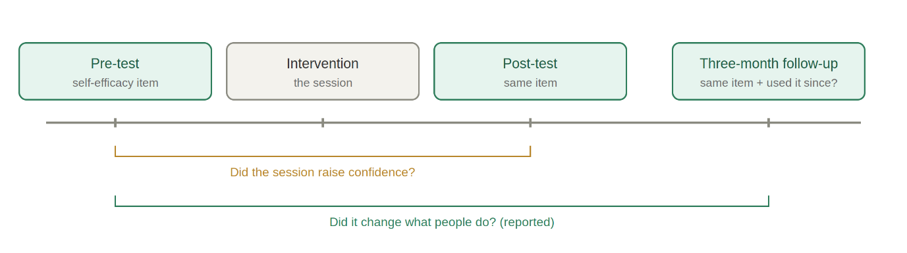
Figure 3. Skill assessment: when the self-efficacy item is asked
Example self-confidence measurement: discovery interviews
After a half-day workshop on running discovery interviews, the item reads:
How confident are you that you could run a discovery interview and come away with findings you could act on?
The same wording is used at all three points. At three months it is followed by:
Have you run a discovery interview since the workshop?

Measuring innovation performance
Every proposal that enters the innovation pipeline is recorded in an innovation database, with three dates: when it was submitted, when a decision was made on it, and when the change it proposed went into use. Innovation outputs (D1) are the proposals that made it through the pipeline and are in use. Time to decision (D2) and time to implement (D3) are calculated from the dates. Each proposal is also classified by novelty, new to the IB, new to the sector or new to the world (OECD and Eurostat, 2018), and by horizon, H1, H2 or H3, so that outputs can be reported by how novel they were and where they sit strategically for the IB.
Innovation outside the pipeline
Not every idea that changes something at the IB goes through the pipeline. The survey's three output items (Appendix A, D1) ask people whether their own ideas have been put into use, which gives a self-reported picture of innovation across the IB, including ideas that were never submitted as proposals. It is reported for the IB as a whole, alongside the pipeline count.

References
Hill, L. A., Brandeau, G., Truelove, E. and Lineback, K. (2014). Collective Genius: The art and practice of leading innovation. Boston, MA: Harvard Business Review Press.
Lukeš, M. and Stephan, U. (2017). Measuring employee innovation: a review of existing scales and the development of the Innovative Behavior and Innovation Support Inventories across cultures. International Journal of Entrepreneurial Behavior & Research, 23(1), 136–158.
OECD and Eurostat (2018). Oslo Manual 2018: Guidelines for collecting, reporting and using data on innovation, 4th edition. Paris: OECD Publishing.

Appendix A. Adapted Innovative Behavior Inventory
Twenty-three items. Published wording in brackets where an item was changed; a few others had minor grammatical smoothing only. Response scale: 1 (fully disagree) to 5 (fully agree). Reliability of the adapted scales to be checked on the first year's IB data.

A1 Generating ideas
- I try new ways of doing things at work.
- I prefer work that requires original thinking.
- When something does not function well at work, I try to find a new solution.

A2 Searching for ideas
- I try to get new ideas from colleagues, schools or partners. [was “colleagues or business partners”]
- I am interested in how things are done elsewhere in order to use those ideas in my own work.
- I search for other people’s new ideas in order to try to implement the best ones.

A3 Communicating ideas
- When I have a new idea, I try to persuade my colleagues of it.
- When I have a new idea, I try to get support for it from my manager or leadership. [was “from management”]
- I try to show my colleagues the positive sides of new ideas.
- When I have a new idea, I try to involve people who are able to collaborate on it.

A4 Starting implementation
- I develop suitable plans and schedules for the implementation of new ideas.
- I look for and secure the resources or budget needed to implement new ideas. [was “funds”]
- To implement new ideas, I search for new tools, processes or procedures. [was “technologies, processes or procedures”]

A5 Involving others
- When problems occur during implementation, I get them into the hands of those who can solve them.
- I try to involve key decision makers in the implementation of an idea.
- When I have a new idea, I look for people who are able to push it through.

A6 Persisting through obstacles
- I am able to persistently overcome obstacles when implementing an idea.
- I do not give up even when others say it cannot be done.
- I usually do not finish until I accomplish the goal.
- During idea implementation, I am able to persist even when work is not going well at the moment.

D1 Innovation outputs
- I have often been successful at work in implementing my ideas and putting them into practice.
- Many things I came up with are used in the IB. [was “in our organization”]
- Wherever I have worked, I improved something there.

Appendix B. Adapted Innovation Support Inventory
Eight items, answered about the respondent’s own manager and about the IB. Published wording in brackets where an item was changed. The published cultural support scale is not used: its items ask about most people in the respondent’s country, which does not fit a workforce spread across several countries. Response scale: 1 (fully disagree) to 5 (fully agree). Reliability of the adapted scales to be checked on the first year’s IB data.

C1 Conditions the manager creates
- My manager motivates me to come to them with new ideas.
- My manager makes sure good ideas are recognised. [was “always financially rewards good ideas”]
- My manager supports me in implementing good ideas as soon as possible.
- My manager is tolerant of mistakes and errors during the implementation of something new.
- My manager is able to obtain support for my proposals outside our department.

C2 Conditions the organisation creates
- The way people are recognised in the IB motivates them to suggest new things and procedures. [was “The way of remuneration in our organization motivates employees”]
- The IB has set aside sufficient resources to support the implementation of new ideas.
- The IB provides people with time for putting ideas and innovations into practice.

Appendix C. Supplementary items
Twelve items written by the department, not taken from a published instrument. They are answered in the same survey as Appendices A and B but scored and reported as separate clusters, not folded into the IBI or ISI scales. Response scale: 1 (fully disagree) to 5 (fully agree). Reliability, and whether the items are distinct from the A5 and C1 scales, to be checked on the first year’s IB data; items that do not hold up are revised or dropped. The nine team items are written to the three capabilities described by Hill et al. (2014), three each. Hill et al. drew the capabilities from case studies rather than from a validated instrument, so there is no published scale to adapt.

Co-creation (answered about oneself)
- I develop new ideas together with the people who will use them.
- I change my ideas in response to feedback from the people they affect.
- I test ideas with others before I am sure they will work.

B1 Creative abrasion (answered about one’s own team)
- In my team, people put forward views that go against the majority.
- In my team, we argue about ideas without it becoming personal.
- In my team, we hear an idea out before judging it.

B2 Creative agility (answered about one’s own team)
- In my team, we try small versions of ideas before planning them in full.
- In my team, we change course when something we tried does not work.
- In my team, we learn more from what we build than from what we discuss.

B3 Creative resolution (answered about one’s own team)
- When my team disagrees, we look for an option that takes something from each side.
- In my team, decisions are made without one person’s view simply winning.
- My team can agree a way forward while people still disagree.

