CPA ConnectX

Brought to you by Garry Wildt

Welcome to CPA ConnectX

There are over 326,000 individuals on a monthly basis. Searching the net for means to supplement or change their income. With something, they can do it from home. I wanted to develop an authentic possibility that benefits every person. Without all the technical headaches as well as huge upfront investments and time.

CPA ConnectX is a web application to get you started on making money online working from home or an office. With just you or many employees. The very best point is you get this completely free.

In this guide, I will attempt to teach you a little bit about how a CPA program works. After you read this getting started guide, you will want to find some CPA programs to sign-up to and start adding your affiliate links to your web application you get with CPA ConnectX.

Don’t worry its not hard to setup. You can even outsource this kind of work also at a site like [Fiverr](https://track.fiverr.com/visit/?bta=134010&nci=7416&utm_campaign=cpacx) and search for CPA ConnectX setup. You are always way better off to outsource the stuff your not good. You can find great people that will do this kind of work very inexpensively.

Your web application comes with a bunch of unique fresh Articles to help get you started with your CPA marketing. Just pick the niche and your articles will be implemented into your web application. Then all you need is to post the articles all over the Internet. In places like Short article Directories and also Blogs with links back to your section in your web application on the same topic.

If you run out of articles check out dashboard for more articles as a great source to get an endless supply of articles!

So, What is a CPA Network?

If you've been doing affiliate network marketing, you've most likely discovered some networks that manage CPA, or cost-per-action, offers. Unlike the usual affiliate offers based on pay-per-click (PPC) or sale, this variation of affiliate advertising pays the author for having a site visitor do some action on their site. That action can be a sale, but much more interestingly, it can also be to simply fill in a study, provide the marketer an e-mail address, or do something that creates a lead on their site.

That's why this kind of advertising is also known as pay-per-lead or cost per procurement; simply put, acquiring some piece of info the advertiser desires from the sales leads you to describe their website. The amount and also kind of info the advertiser is seeking can differ substantially, as can the quantity of compensation or cost the marketer agrees to pay you for the leads you generate by advertising their deal. As a whole, the more valuable a marketer assumes each lead is, the more payment they will want to pay you for each and every lead.

CPA is rapidly coming to be one of the most efficient means for authors and also advertisers alike to generate income, especially in this difficult economic duration. Extreme conditions call for brand-new and innovative methods for tackling the customer market.

Why Are CPA Networks Booming?

CPA network uses to provide benefits to both the author and also the marketer in a difficult financial environment. Several consumers aren't happy to get points as promptly as previously, as a result, pay-per-sale deals are harder to transform for writers. However, a consumer could be extra ready to give out details that an affiliate marketer can use to market to them in the future, which gives some worth to the advertiser, also. So publishers discover a CPA offer is simpler to exchange income in a financial slump and also an advertiser uncovers that he can still construct a wonderful connection with the checklist and additionally obtain site visitors additional involved in his product or services by using a CPA offer.

Allow's take a peek at a conventional online marketing method using PPC bargains, to acknowledge why CPA networks can be considered as having a higher worth. When an online marketer selects to accomplish a PPC project, they target several keywords that an online search engine like Google will take advantage of to dish out a lot of advertisements to individuals that try to find those specific terms. Those website visitors after that more than likely to a site where the advertisement is being launched, click on the internet link, as well as more than likely to the marketers' offer. The marketer does not comprehend that has clicked, has gathered no information on that particular possible customer, as well as can just want that the click converts to a sale. Even if it does not, the online marketer will definitely still have to spend for the clicks along with a number of marketers just desire a bit far more for their money.

Contribute to that the frustration of click scams as well as jobs that run over-budget with many methods to determine simply how much they affected sales, as well as you can see why some marketers are starting to opt for CPA products that cost them a lot less money as well as will, at the very least, develop a lead if not a sale.

It's not merely the marketing professionals who are getting edge advantages from the CPA network supplies. Publishers are uncovering that the deals are much easier to apply and the payments can be greater than a traditional PPC campaign At rates of $1 to $50 for a deal that creates a valid lead, as well as with conversion prices of 20%, the take for an author can be higher with a whole lot much less anxiety as well as likewise fear. That's since authors do not need to generate goal pages for a CPA offer if they do not wish to; furthermore, they do not need to research study essential phrases, get traffic to their website initially, and also after that send them on to the affiliate. Rather, they can go straight to where the biggest website traffic resources are on-line and submit a web link there directly to the CPA network offer they are advertising. The research to acquire a CPA offer up as well as running is very little when contrasted to a PPC campaign.

How Do I Apply?

CPA network gives to give benefits to both the author and also the advertiser in a challenging financial atmosphere. Numerous consumers aren't pleased to obtain points as promptly as formerly, consequently, pay-per-sale offers are harder to change for authors. However, a customer could be additionally prepared to provide information that an affiliate marketing professional can utilize to market to them in the future, which provides some worth to the online marketer, likewise. So authors situate a CPA deal is much easier to trade profits in a financial decrease and also besides a marketing expert uncovers that he can still construct a terrific link with the checklist as well as additionally obtain visitors included associated with his service or product by using a CPA deal.

Enables take a peek at a basic online marketing method using PPC offers, to identify why CPA networks can be considered as having a far better worth. When an online marketing expert picks to accomplish a PPC project, they target several key phrases that an on-line online search engine like Google will use to dish out plenty of advertisements to people that try to find those particular terms. Those web site visitors afterward more than likely to a website where the promo is being released, click the internet link, in addition to possible to the marketers' deal. The online marketer does not acknowledge that has clicked, has collected no details on that possible client, as well as can only prefer that the click converts to a sale. Even if it does not, the advertising and marketing expert will still have to spend for the clicks together with numerous on the internet marketing professionals just desire a bit far more for their cash.

Include in that the frustration of click rip-offs and also jobs that run over-budget with a couple of techniques to learn simply how much they affected sales, in addition to you can see why some marketers are starting to select CPA products that expenditure them a whole lot much less cash together with the will, a minimum of, produce a lead otherwise a sale.

However, it's not just the marketing experts who are getting fringe benefits from the CPA network provides. Publishers are uncovering that the bargains are a lot easier to apply and additionally the settlements can be greater than a standard PPC task At rates of $1 to $50 for an offer that creates a valid lead, in addition to with conversion prices of 20%, the take for an author can be much better with a good deal much less anxiety as well as anxiousness and also furthermore concern. That's because writers do not need to create goal web pages for a CPA bargain if they do not intend to; besides, they do not have to research study crucial phrases, obtain internet traffic to their website first, as well as later send them on the affiliate. Rather, they can go straight to where the biggest web traffic sources are on the web as well as send an internet web link there directly to the CPA network bargain they are advertising. The study to get a CPA offer as well as running is marginal when contrasted to a PPC project.

Cross-Checks And Double-Checks

Now that you understand the process a bit more, let us review the items you need to make sure are consistent and accurate on your application form.

Your web application address you place that where they are asking for the website. This will have you listed as the owner and they will be able to verify this as much.

Your Country of Origin They will certainly examine your IP address to make certain it is originating from the country of origin you are asserting you stay within. If you contract out the application process, make certain it is to a person within the same nation where you live. Otherwise, it will look extremely questionable, and also do not question that they will decline you based on that alone.

Your Contact Information Throwaway email addresses are an automatic turn down. Unlike traditional affiliate programs, you can anticipate getting a telephone call from an affiliate supervisor of the CPA network making use of the telephone number you supplied. Be available to take the call, as they do not call two times, and they will certainly reject your application if you do not address them. They will additionally inspect the area code to make sure it goes to the state of residency you assert on the application. See to it matches.

Insufficient Applications Don't uncheck boxes that they've examined, like a box normally claiming rewards for your advertising approach. It's their hint that's what they desire you to use.

The Single Most Important Question

Expect to be examined on just how you mean to promote or drive traffic to the affiliate provides if you are registering to be a publisher. This is the single most important concern and also your answer will greatly affect whether your application is approved or not. If you do not have a clear suggestion, it will only verify to the affiliate supervisor that you are not a useful affiliate partner to consist of in their network. Make sure you have a great answer to this inquiry. If you require aid in addressing this inquiry feel free to request assistance from your dashboard

Many individuals have made a right away favorable impact by suggesting they are doing PPC to CPA deals. There are a lot more stringent guidelines for people that are making use of Google Adwords projects to publish affiliate marketing links, yet it's still practical. There are 2 URLs you can include an Adwords project; one is a location URL, as well as the various other, is the screen URL. The screen URL currently needs to match the destination of the website. To put it simply, you can't mask the offer showing one URL to the client that takes them to a different location than what they were expecting. Together with that, there are limitations on the landing page location URL; it needs to have the very same domain name as the display URL. This can be hard to do if your affiliate CPA deal doesn't want you to permit the publication of their top-level domain in the deal. A lot of the advertisers understand since they do have to create landing pages on their sites to conquer this new policy, as well as this will possibly come back to benefit both publishers as well as advertisers. Your internet application makes this possible with convenience. Thus, you can still utilize PPC-to-CPA methods, but you will certainly require to be mindful of which supplies you attempt this with and also keep to the plans instituted by Google.

If you are unsure concerning just how you are most likely to attract website traffic to offers, take a look at our frequently asked questions in the dashboard for some real-world instances. You do not need to be brilliant at Adwords campaigns and even know much regarding Internet advertising and marketing to make this job. Don't be frightened by this inquiry, simply have an answer prepared that verifies you know what you're doing.

What If I Get Rejected?

Even if you don't get a call the same day you submit your application, don't assume you've been rejected. It can take up to three days (or more) for an affiliate manager of the CPA network to contact you by phone, especially if you submitted your application over a weekend or during a holiday. They typically do try to make contact within the first 24 hours, but this is not always possible. If you haven't heard anything after three days your application may have been rejected, so you need to be proactive to see what types of problems might have been spotted on your application and work to overcome those objections.

First, you will need to know what affiliate manager has been assigned to you; look for their name in the email notification you receive when you first apply online. Once you know whom to contact, you can email them based on the email addresses on your CPA network website or use Facebook Messenger. They are interested in getting people who can provide value to their advertisers on board, so don't hesitate to make contact and ask the status of your application.

If they say it is denied, find out why. In many cases, they may accept additional proof or documentation to reverse their decision and grant you approval to join them. Even if you get turned down, use it as a learning experience. There are hundreds of CPA networks out there, and one of them is bound to say yes. Just put your best foot forward and be available to answer any questions they might have about your application.

Selecting The Right Offer

Many aspects make a CPA supply the ideal one for you. You are bound to see excellent deals that many other people are shouting to publish, but this does not necessarily mean they will benefit you. Among the biggest issues is that the audience you are marketing to can be considerably various than any individual else audience; if this holds then the deal requires to be ideal for your unique particular niche if you are likely to market it successfully. To put it simply, do not follow the crowd; rather, examine your placement on the net as well as look for to make use of the traffic that's at your fingertips.

Demographics And Niches

Whether you are write-up advertising or answering inquiries on a discussion forum, you have a special understanding that draws in individuals to your postings. This is your specific niche. Your specific niche will likely draw in people of a specific demographic to your posts, so a lot more you know about these people a lot more highly targeted you can make your CPA offers. Someone senior is not going to be interested in the latest electronic video games, so match the demands as well as interests of the demographic to the deals you choose to make.

You can establish various websites for different specific niches, or try to construct target markets for specific particular niches by concentrating on one subject over an additional in a forum. Just be clear about each site's group so you can have a much better suggestion of which niches could be effective there and which are most likely to fail.

If you have actually simply started and also do not have a team following you currently, you can just choose to focus on extremely hot particular niches up until a group normally cluster around it. Today, warm particular niches include repossession avoidance, financial debt consolidation or removal, Internet advertising, and marketing, as well as prudent subjects. Utilize the Google Keyword Tool to research study prominent keywords as well as possible brand-new particular niches.

Hunting Down Those Great Offers

To locate great deals that will certainly provoke individuals to take the activity required by the vendor so you can get repayment into your account, location on your own in the visitor's footwear. What are they looking for? What problems are they having difficulty addressing? What will they agree to do or not do? Compare that to the ordinary earnings-per-click that is released for the deal to see if it is worth your energy and time market the offer.

Right here are the components needed to review, to identify the value of any CPA deal to your bottom line:

Revenues Per Click (EPC) Initially you may be tempted to go only for the highest paying deals, however, this can be a blunder. Just how well an offer converts to a paying activity is what identifies whether the offer is suitable for your advertising and marketing objectives. Have a look at the EPC for the deal, however, do not allow that to be the only factor in your decision. An EPC of $50 isn't much better than one for $5, as an example, if no one follows through to do the activity asked for.

Size of Forms If the activity is to fill out a type after that see if it is a short or a long-form. Typically, forms requesting less info transform much better than longer form demands.

Request for Credit Cards If the deal calls for that a visitor input their charge card info, bear in mind that most individuals are not happy to do that right upfront. These sorts of offers normally do not transform well, no matter what the EPC could be.

Exclusive Offers If a deal is exclusive to a network as well as you handle to be accepted because of the network, then there will certainly be much less competition online for that deal. A unique offer is usually far better for you as a publisher than a non-exclusive deal.

A Little More On EPC

Simply considering the EPC for a particular deal can be a little bit misleading. For one point, the published EPC is not always the only EPC for that deal; it may be provided on numerous CPA networks for various EPC. If the offer is exclusive you can be positive in the uploaded EPC, however, if it is not special after that you may find yourself competing with other authors whose deals may have various EPC. The factors for this can differ, from inattention on the part of the advertiser to varying projects to see what works finest. Either way, don't believe you're always likely to rack up with a high EPC if there is an opportunity that the offer is structured differently on various other networks, making it much easier to market or convert for the same product or service.

The EPC additionally has a particular time frame in which it is calculated. When a new offer initial goes out it could have an excellent typical conversion for the first seven days and also after that go down off as competitors become stiffer. However, if the EPC is only revealed for that first seven-day amount of time it can be misleading; again, you could end up making much less per click than the uploaded standard. The very best thing to do is seek EPCs that are based upon a longer period, like a month. By doing this you get a clear concept of exactly how well the deal is converting and also just how much you can safely presume you will make with it.

Recognizing these intricacies, the basic guideline is to choose reduced EPC provides that will certainly tend to convert at a higher rate; this may be because they call for much less info to be input, the desired activity is less complex, or something comparable. Do not allow yourself to be persuaded by high EPC deals because they do not always transform far better. Constantly look for offers with money settlements as well as then try out a few to see how they go.

Finding CPA Networks

Several of the features you wish to contrast are:

Payment Minimum The lower the payment minimum, the faster you can reach it as well as earn money.

Payout Schedule Are they on a weekly, Net 15, or monthly routine? For how long is as well lengthy to wait on your income?

Referral Bonuses Do you get paid for referring to other people? Just how much is it as well as does it count to your minimum payout?

Reference Programs Is the program multi-tiered, paid in cash or credit report, and also how much time do you make a payment on sub-affiliate payouts?

Groups Are your classifications or niches stood for in the CPA network or do you require to go elsewhere?

Here are some to start with Advendor, FireAds and CPALead. There are more in your Dashboard.

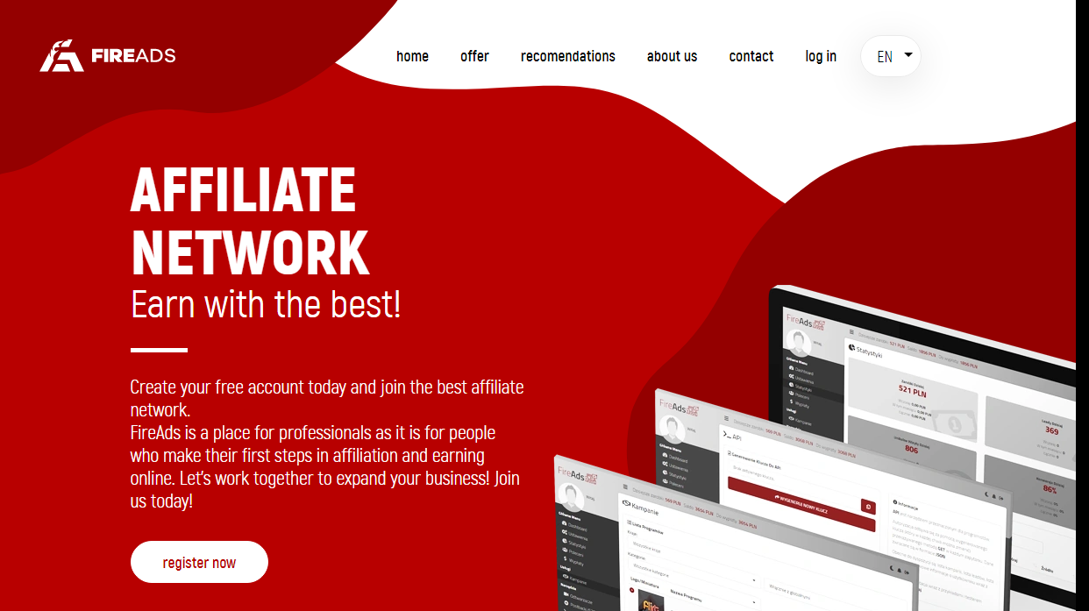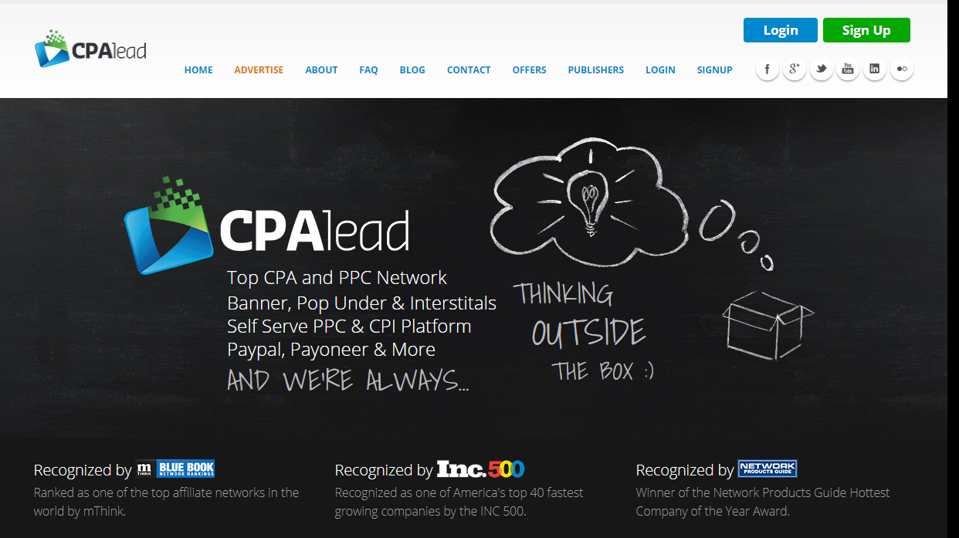

Final Thoughts

The reward for this sort of attention to detail is that you will begin to realize making money is not as tough as you once thought it was. It's just a matter of placing your focus on the important things that generate favorable outcomes as well as decreasing things that lower those outcomes. Enhance your income and also lower your expenses as well as you will wind up rich. It's that easy, as well as when you have the best system in place it can function immediately in your place to get to the purpose of financially safe and secure life for you as well as your family members. This is what makes all the effort you take into knowing and creating your special system well worth every moment you invested. You will certainly quickly discover that enhancing a wide range is just a matter of relocating those objectives continually up until you develop the lifestyle that you desire through effort and also perseverance. To everyone else, however, it will resemble you've amazingly developed cash out of slim air. In the end, that's specifically what it will certainly seem like as well.

Now go to [GoConnectX](https://www.goconnectx.com/) and pick the standard plan and use the code CPACONNECTX this will give you one year free so you can build up your business a savings of $1700.00.