**FTASK**

**Team Member:**

* **Nguyễn Minh Trí** SE140329
* **Nguyễn Nhật Hào** SE140742
* **Trần Văn Kiên** SE130720
* **Phạm Thanh Long** SE140136

**USER GUIDE**

**App Information:**

**Requirement:**

* Android Studio
* Android SDK 30
* Android Virtual Device
* Database: SQLite

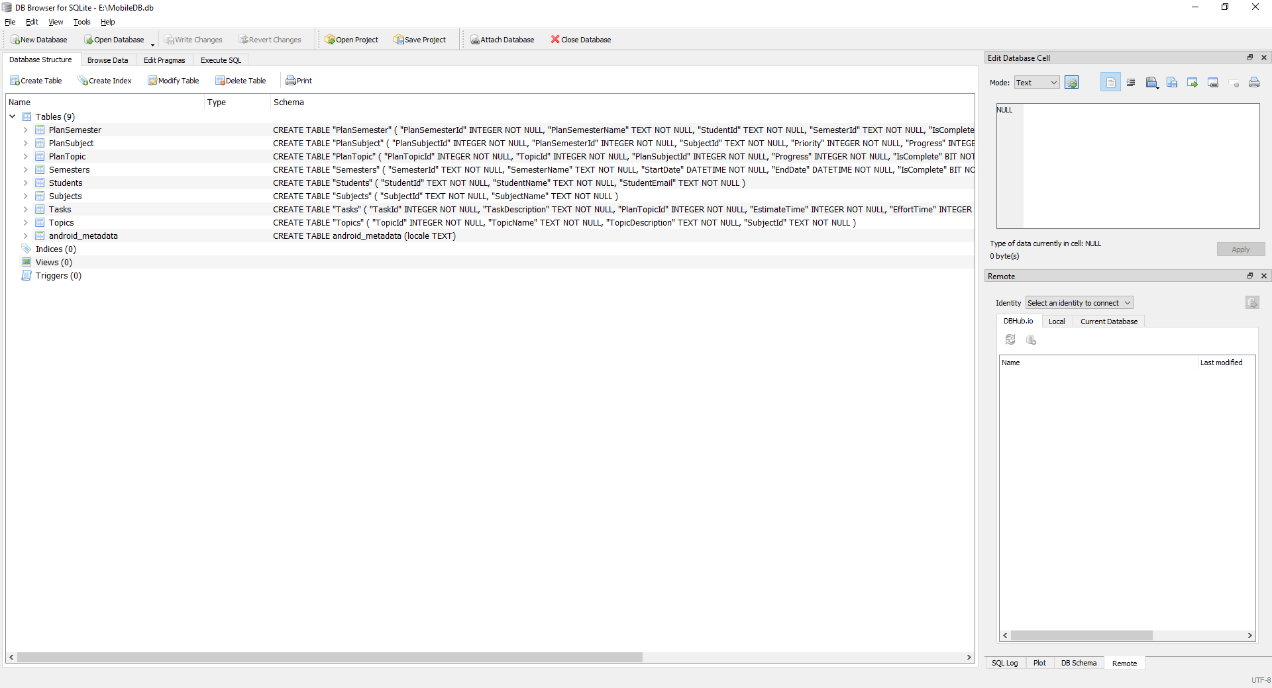

**Screen List**

1. **Login Screen**:

* Login with FPT Gmail account to proceed to **“Subjects Screen”**.

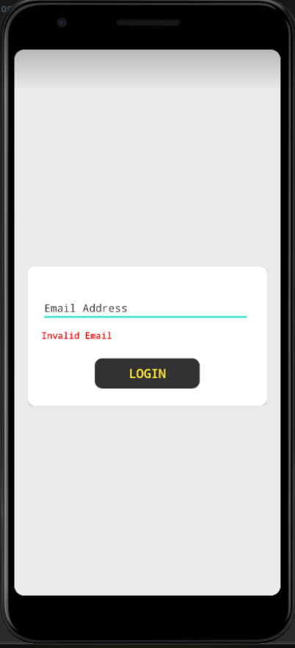

1. **Subjects Screen**:

* Display added subjects in each semester.
* Click (+) button to proceed to **“3. Search Subject Sreen”** in order to add more subject to semester (only available for the currently ongoing semester)
* Select an added Subject to proceed to **“5. Added Subject Screen”**

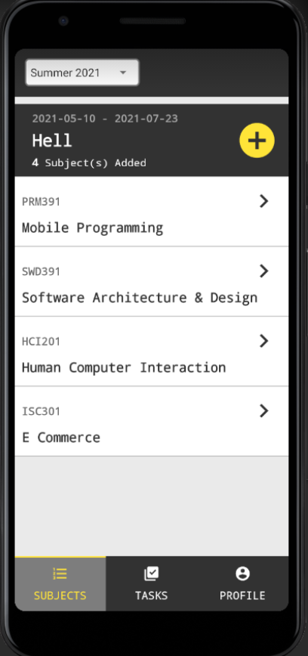

1. **Search Subject Sreen**

* Search subject to add to the current semester.
* Search criteria:

- By Subject Id

- By Subject Name

* Selected a Subject to proceed to **“4. New Subject Screen”**

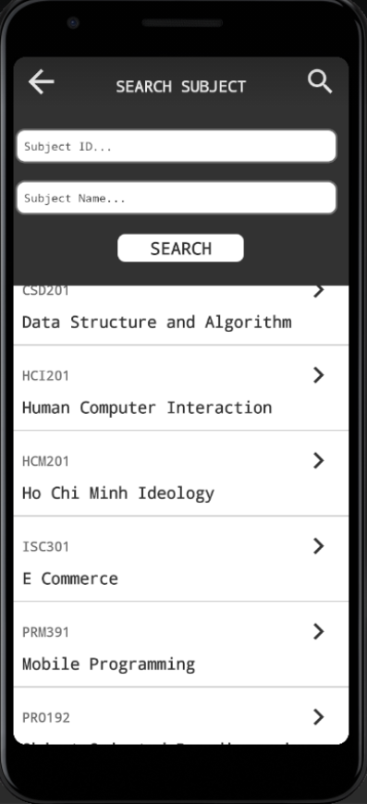

1. **New Subject Sreen**

* Display Subject Detail including all subject’s topics
* If the subject has not been added to the current semester, the (Add) button will be clickable
* Click (Add) button and confirm to add the subject to the current semester and return to the **“2. Subjects Screen”**

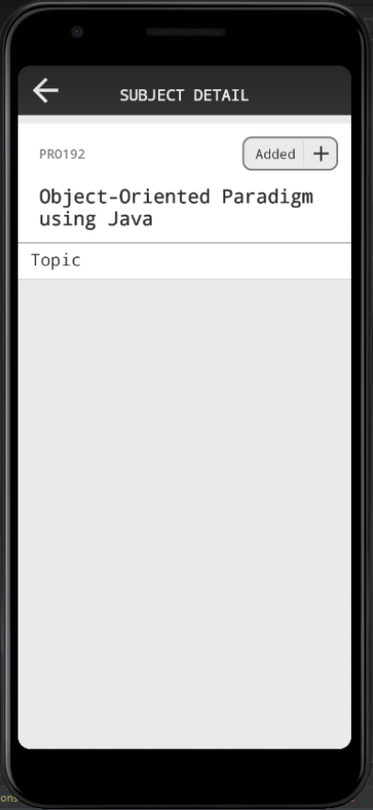 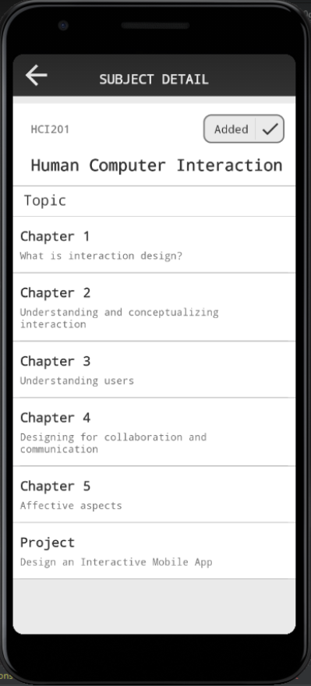

1. **Added Subject Screen**

* Display detail for added subjects including all subject’s topics
* Click a topic to see all created tasks for that topic.
* Click (Add Task) button to proceed to **“6. Task Detail Screen”** to add a new task to this subject (only available for subject in the currently ongoing semester)
* Click a task in the clicked topic to button to proceed to **“6. Task Detail Screen”** to update or delete the task.

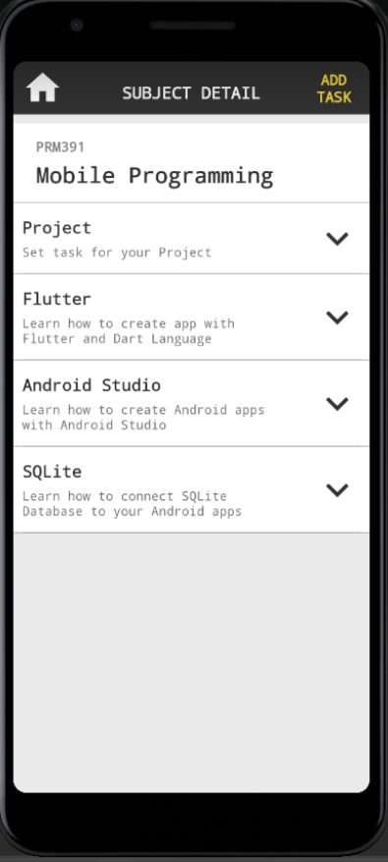 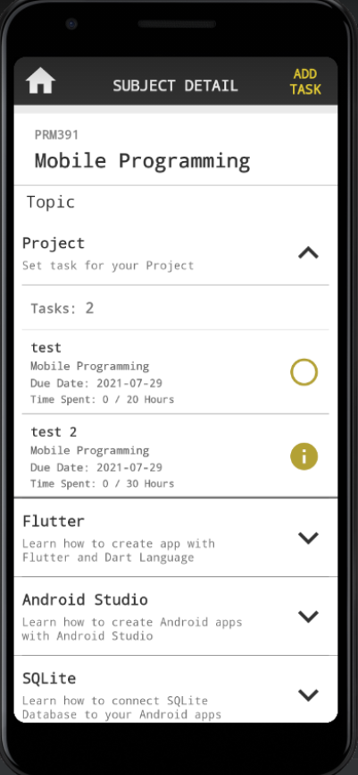

1. **Task Detail Screen**

Update or Delete and created task (State 1)

* Click Update and confirm to update task detail and return to the **“5. Added Subject Screen”**
* Click Delete and confirm to delete the task and return to the **“5. Added Subject Screen”**

Add a new Task (State 2)

* Click Add and confirm to add a new task to the selected Subject and Topic and return to the **“5. Added Subject Screen”**

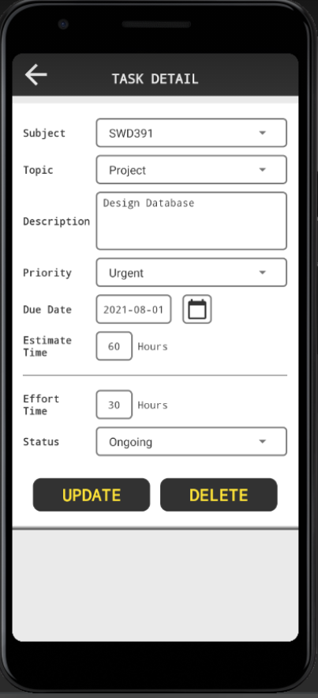 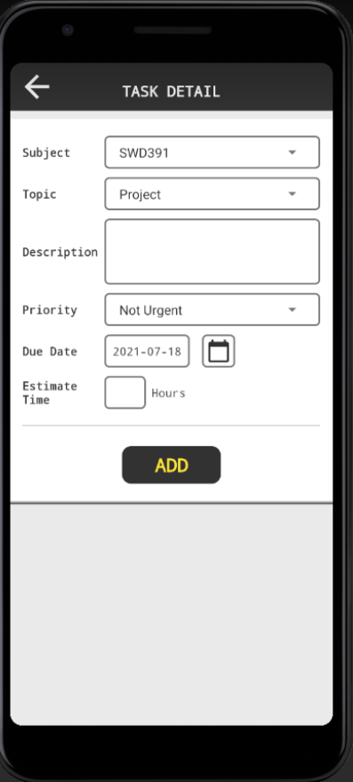

(State 1) (State 2)

1. **Search Tasks Screen**

* Search all created Task.
* Search criteria:

- By Priority

- By Status

- By Task Description

* Selected a Task to proceed to **“4. Task Detail Screen”**

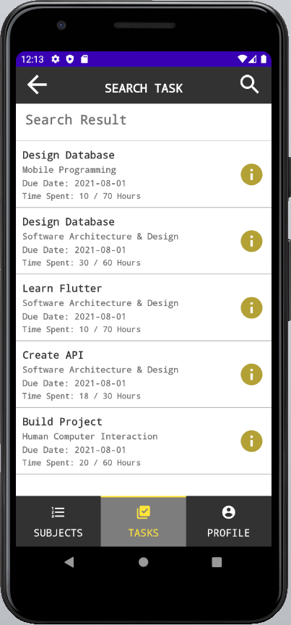 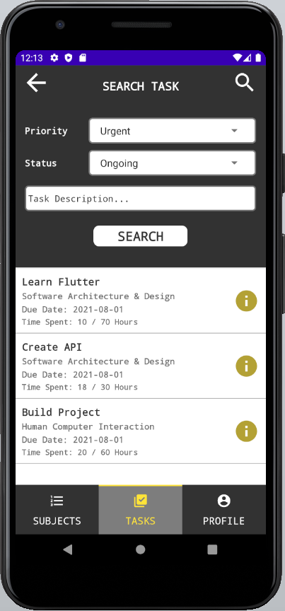

1. **Profile Screen**

* Display Student Information
* Click Sign out to sign out of the app and return to the **“1. Login Screen”**

