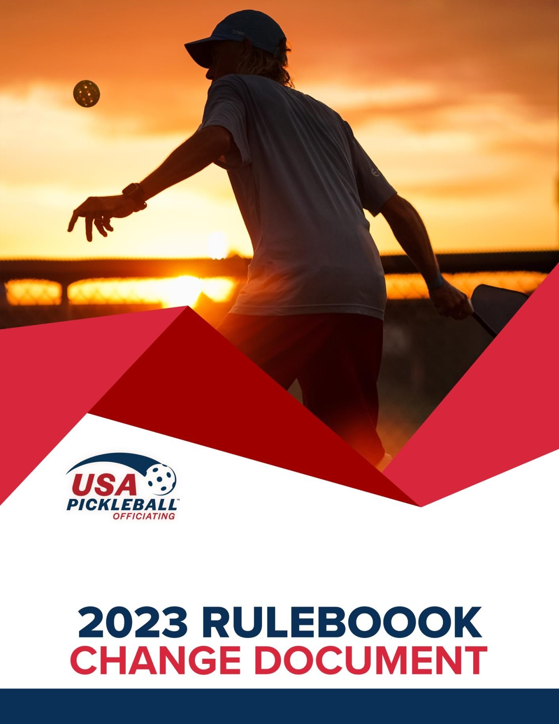

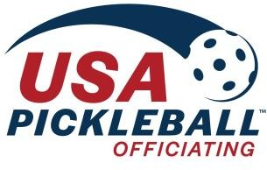

2023 USA Pickleball

Official Rulebook Change Document

# Section 1

**The Players:**

**New**: *Players avoid wearing clothing that closely matches the ball color.*

**Reason**: This guideline was designed to encourage players to not wear clothing that could be distracting during play. The intent is to promote sportsmanship.

**New**: *A player should not question or comment on an opponent’s call, although any player may appeal a rally-ending line call to the referee before the next serve occurs.*

**Reason**: This guideline was designed to diminish on-court disputes in favor of sportsmanship. With a referee, a player has a manner to appeal calls with which they disagree. Note the words “*rally-ending”* were inserted to reinforce that players can’t “rewind the tape” and question shots that were committed earlier in the rally.

# Section 2

1. **Rule 2.G.1**

**Existing:** Safety and Distraction: A player may be required to change garments that are inappropriate.

**New**: *Safety and Distraction: A player may be required to change apparel that is inappropriate, including that which approximates the color of the ball.*

**Reason**: This rule was changed to more strongly reinforce that a player who is wearing apparel, which closely resembles the color of the ball, may be required to change said apparel. Additionally, if an apparel change is needed, it is performed with a referee timeout; i.e., it is not charged to the player. See Rule 2.G.4.

**Note:** This rule regarding the inappropriateness of apparel includes shoes, but in the case of shoes the issue of appropriatenss relate to black soles that leave a mark on the court or not wearing appropriate court shoes. In other words, in tournament play, black marking shoes, flip

flops and bare feet are generally not considered appropriate for tournament play. It is not the intent of this rule to prevent players from wearing shoes that closely match the color of the ball. Please refer to Section 1 of the Rulebook under “Players” where we make it clear that ‘clothing’ is the objective of the color approximation concern.

# Section 4

1. **Rule 4.A.5.**

**New**: *The serve shall be made with only one hand releasing the ball. While some natural rotation of the ball is expected during any release of the ball from the hand, the server shall not impart manipulation or spin on the ball with any part of the body immediately prior to the serve. Exceptions: Any player may use their paddle to perform the drop serve (see Rule 4.A.8.a). A player who has the use of only one hand may also use their paddle to release the ball to perform the volley serve.*

**Reason**: During the approval of the 2022 Rulebook, we allowed the retention of pre-serve spin by one hand for several reasons, explained in detail in the 2022 Rulebook Change Document. We also said, at the time, that we would adopt a ‘wait and see’ approach. We thought it important to observe how wide and deep the one-handed spin serve penetrated the sport. A primary consideration at the time was that while the serve posed some difficulty for some players to return, over time, if the serve became widely adopted, that players would learn to adapt and be able to ‘read’ the serve.

The decision to eliminate all pre-serve spin in the 2023 Rulebook was based on several factors. First, we didn’t see the depth or breadth of adoption we expected might occur. This was especially true with female players. Even with male players, the one-handed spin serve was not as widely adopted as we expected. For that reason, the rationale that players across the skill spectrum would see it often enough to ‘read’ it – especially at the recreational play level - just didn’t materialize. The low adoption rates, especially by women, definitely impacted our decision. That inherent difference was a decided disadvantage for women when playing mixed doubles against the limited number of men who had developed an advanced expertise with the serve.

Second, we interviewed several pro players who used the one-handed spin serve, some of them to great advantage. Our input on the spin serve was concentrated on the pros where the pre-serve manipulation was allowed. While the feedback and interviews of them wouldn’t pass the scrutiny of a scientific survey or poll, there was a clear message from those pro players to eliminate the one- handed spin serve. Keep in mind, these are pros, who used the spin serve to sometimes great advantage, advising us to eliminate it because they saw first-hand the impact it had on the game.

That was extremely meaningful to us.

Third, there was a safety element to this that we didn’t predict, but which became evident. Many recreational and even some high-profile tournament venues have courts that are tennis court conversions. The most common conversion creates four pickleball courts from a single tennis court. The players who were the most successful with the one-handed spin serve could easily cause a ball to bounce on the court and move significant and measurable distances left or right. Some of those courts have fences separating the courts and others do not. The ability of receivers to safely play those balls on courts with such short distances was, at times, compromised.

We fully understand that this decision will be unpopular in some quarters, especially for players who spent considerable time and, in some cases money, learning how to perfect this particular serve. But we are also sensitive to two rule-writing principles, namely #7 and #8 found in the Appendix to the USA Pickleball Official Rulebook, dealing with the desire to provide a certain amount of innovation in the sport, but at the same time not allowing one shot or type of play to dominate the sport. While many will not agree with our conclusion, the one-handed spin serve, for a subset of players, almost all of whom are men, became a shot that in many cases was dominant.

# Rule 4.A.7 - Volley Serve

**New**: **Replay or Fault** (Found in Rule 4.A.9). *In officiated matches, the referee may call for a replay if the referee is not certain that one or more of the requirements of the serve (in Rules 4.A.7.a - 4.A.7.c) has been met. The replay must be called before the return of serve. The referee shall call a fault if they are certain that one or more of the requirements of the serve (in Rules 4.A.7.a - 4.A.7.c), and other than Rule 4.A.6, has not been met. In non-officiated matches, if the receiver determines that manipulation of spin has been imparted prior to the serve, or the release of the ball is not visible, the receiver may call for a replay before the return of serve. In non-officiated matches, the receiver has no authority to call for replays or faults for service motion violations.*

**Reason**: This addition allows for the referee to have the server replay the serve if any of the service motion criteria of 4.A.7.a – 4.A.7.c are in question. While the service motion criteria are clearly spelled out in the rules, different body types coupled with clothing make it difficult to determine with certainty when some of the criteria are not met. Hence, there is range of subjectivity which decreases accuracy and consistency when being applied by referees and players. Because of this range of subjectivity, the referee is now empowered to call for a serve replay when one or more of the elements of the service motion are questionable. The intent of this rule is to provide players that have questionable serves an opportunity to modify their serve before it clearly becomes illegal.

**Note:** The replay option relates to the service motion rules, not the placement of the feet , described in Rule 4.A.4.

**Scenario A:** The server performs a volley serve and at the moment the serve occurs, the referee is uncertain there was upward arc on the serve. The referee stops play and says, “Stop play.

Questionable whether swing was an upward motion. Re-serve. I will recall the score.” The rally is replayed.

**Scenario B:** The server performs a volley serve and the moment the serve occurs, the referee is uncertain if the contact point was above the waist. The referee stops play for a re-serve BEFORE the ball lands out of bounds. The rally is replayed.

**Note**: If the referee has determined the serve was ‘questionable, then the play was dead the instant the ball was served. The decision to have a re-serve has already been made so it doesn’t matter where the ball lands or when. Of note is the same principle applies if the serve was clearly illegal; referees and players don’t wait to see where the ball lands when the referee has determined the serve was illegal. And, the same applies if a ball from an adjacent court comes onto the court. As soon as ‘ball on’ hinder is called, it doesn’t matter what happens to the ball in play on the court.

**Scenario C:** A receiver is becoming frustrated because they believe the server is faulting on the serve and the referee has only called for a questionable re-serve. When the receiving team gets the

serve on the next side out, the referee sees with certainty that the next serve was illegal and calls a service fault. The player argues that it should only be a re-serve because the referee has called for a re-serve on the opponent several times. The referee explains that only serves in question are called for a re-serve and that serves that are, without question a fault, will be called appropriately.

# Rule 4.A.8 – Drop Serve

**New**: ***Replay or Fault*** (Found in Rule 4.A.9). *In officiated matches, the referee may call for a replay if the referee is not certain that one or more of the requirements of Rules 4.A.8.a or 4.A.8.b are met. The replay must be called before the return of serve. The referee shall call a fault if they are certain that one or more of the requirements of Rules 4.A.8.a or 4.A.8.b are not met. In non-officiated matches, if the receiver determines that manipulation of spin has been imparted prior to the serve (4.A.5), or the release of the ball is not visible (4.A.6), the receiver may call for a replay before the return of serve. There is no fault if the release is not visible to the referee or receiver. In non-officiated matches, the receiver has no authority to call faults in the case of Rules 4.A.8.a or 4.A.8.b.*

**Reason**: Same as #3

# Rule 4.B.8

**Existing:** Before the serve occurs, any player may ask the referee for the score, correct server or receiver, correct player position, and may challenge/confirm the called score. Any player may ask any one or more of these questions.

**New**: *Before the serve occurs, any player may ask the referee who is the correct server or receiver or whether any player is in an incorrect position. A generic question such as “Am I good?” may be asked and shall be considered to encapsulate both the correct server question and the correct position question if asked by the serving team. For non-officiated play, a player may ask the opponent the same questions and the opponent shall respond with the appropriate information*

**Reason**: This simplification of the rule removes the need for the serving team to ask multiple questions in order to serve from the proper position with the proper server. It is a consolidation of all the questions a player is allowed to ask and simplifies the “are we good to go” aspect when preparing to serve. This rule was changed to implement a smoother flow to the game.

**Scenario A:** The correct server is about to serve from the wrong position. The server’s partner asks, “Ref, are we good?”. The referee corrects the server’s position and proceeds to recall the score.

**Scenario B:** The incorrect server is about to serve. The server’s partner is the correct server but is in the wrong position. The server asks, “Ref, am I good?” The referee identifies both the correct server and the correct server’s position and proceeds to recall the score.

# Rule 4.K

**Existing:** Wrong Score Called. If the server or referee calls the wrong score, once the serve is made, play shall continue to the end of the rally and the correction made before the next serve. After the serve is made, a player who stops play based solely on an incorrect score call, will have committed a fault and shall lose the rally.

**New**: *If the wrong score is called, the referee or any player may stop play before the return of serve to correct the score. The rally shall be replayed with the correct score called. After the return of serve, play shall continue to the end of the rally and the score correction made before the next serve. After the return of serve, a player who stops play to identify or ask for a score correction will have committed a fault and shall lose the rally. A player who stops play to identify or ask for a score correction when the score was correctly called will have committed a fault and shall lose the rally.*

**Reason**: This change extends the timeframe for players to question whether or not a score was called correctly and simplifies how an incorrect score call will be handled. It better clarifies the conditions under which a player will be penalized when they stop a live rally based on concerns over the called score. The rule further explains that a player who “stops play” based on a score call concern will be faulted if the score was called correctly.

# Discussion:

A key underlying principle remains with this rule change; players are always better served by playing out a rally and questioning the score after the rally is over. With that said, however, the rule allows players to “stop play” to question a score call by their opponent (in non-officiated or rec play) or the referee in officiated play any time before the return of serve. How a player can “stop play” is the purpose for most of what follows.

How does a player “stop play” before the return of serve? Players can certainly catch the ball or physically stop the ball.

**Note:** Some may argue that if a player physically stops play to question a score call that they have violated Rule 7.I. Rule 4.K has been written to allow players to intentionally stop play to question a score call. The referee is empowered to discern the difference between a player intentionally stopping the ball to question a score call and a player who intentionally (or unintentionally) stops a live ball for any other reason.

Players also have a wide range of things they can say to actually “stop play”, including, but not limited to the following:

“Wait”, “Hold on”, “Hey ref”, “Stop”, “I have a question”, “Our score is four, not three”, “That is not the right score”, “They are in the wrong position”

To simplify this rule and the reactions of referees, players can say just about anything to get the attention of the referee (or their opponent in non-officiated play) for the purpose of “stopping play” to question a score call, providing of course that they do it before returning serve. Almost no matter what the player says, the referee will assume the player wants to question a score call and will stop play and address the reason why the player “stopped play”.

**Scenario A:** The referee calls the incorrect score and the server serves. Just before the receiver returns the serve, the receiver’s partner says, “Ref, there’s a problem.” The referee stops play and asks the receiver’s partner to clarify their comment. The receiver’s partner says, “Well, either you called the wrong score or the serving team is out of position.” The referee validates that yes; in fact, the serving team was in the correct position, but the referee mistakenly called the wrong score. The referee calls for a ‘referee correction’ and recalls the score correctly, starting a new ten second clock.

**Scenario B:** The referee calls the incorrect score and the server serves. The referee does not realize they have called the incorrect score and therefore doesn’t stop play on their own before the return of serve. The receiver returns the ball across the net, and the receiver then says, “Hey Ref, you called the wrong score”, after which the server catches the ball. The referee confirms they called the incorrect score, but upholds the fault by the receiver because they questioned the score after the serve was returned.

**Scenario C:** With all players in the correct positions, the referee calls the correct score and the server starts their service motion. The receiver says, “Wait, wait” as the server is serving.

**Note:** Some may think this qualifies as a potential distraction fault because the server was making a play on the ball. This rule, however, allows for the referee to stop play when a player, in this case the receiver, attempts to get the referee’s attention.

The referee stops play. The receiver says they could not hear the referee and therefore did not know if the correct score was called. The referee tells both teams what their scores are and then recalls the official score, starting a new ten second clock.

**Scenario D:** All players are in the correct position and the referee calls the correct score. After the serve, but before the return of serve, the receiver says, “Hold it”. The referee stops play, again, assuming the player has a question about the score. The referee asks the receiver why they stopped play. The receiver tells the referee they did not stop play, the referee did. The receiver says they were merely communicating with their partner to *hold* their position and not shift sides of the court. In this case, after questioning the receiver, the referee realizes the player did not stop play to question the score, so the referee calls a referee correction and recalls the score to start a new ten second clock.

**Note:** Some will argue that this should be a fault on the receiver, in violation of Rule 7.I. Without a plausible explanation for why the receiver said, “Hold it”, that might be the appropriate outcome.

But, once the receiver explained why they said, “Hold it”, it became obvious they were not questioning, challenging, or otherwise asking for a score correction and therefore should not be faulted for the act of communicating with their partner.

# Rule 10.D

**Existing:** Equipment Time-Outs. Players are expected to keep all apparel and equipment in good playable condition and are expected to use regular time-outs and time between games for adjustments and replacement of equipment. If a player or team is out of time-outs and the referee determines that an equipment change or adjustment is necessary for fair and safe continuation of the match, the referee may award an equipment time-out of up to 2 minutes. Rule 10.A.5 will be used to continue play.

**New: *Equipment Time-Outs.*** *Players are expected to keep all apparel and equipment in good playable condition. If the referee determines that an equipment change or adjustment is necessary for*

*fair and safe continuation of the match, the referee may award an equipment time-out of reasonable duration. Rule 10.A.5 will be used to continue play. In non-officiated matches, players will work out a reasonable accommodation among themselves for equipment malfunctions.*

**Reason:** Because most equipment time-outs involve situations outside of a player’s control, it was inconsistent with a sense of fair play to require players to use their normal timeouts before being eligible for an equipment time-out.

# Rule 11.E.

**Existing:** Broken or Cracked Ball. If a referee is present, players may appeal to the referee before the serve occurs to determine if a ball is broken or cracked. If the appeal is before the serve occurs, the referee will stop play, inspect the ball, and either replace it or return it into play. The referee will recall the score. In non-officiated matches, players may replace a cracked ball before the serve occurs. If any player suspects the ball is or becomes cracked after the serve, play must continue until the end of the rally. If, in the judgment of the referee, a broken or cracked ball impacted the outcome of a rally, the referee will call for a replay with a replacement ball. In non-officiated play, if the players do not agree that a cracked ball impacted the outcome of the rally, the rally stands as played.

**New**: ***Broken or Cracked Ball.*** *If any player suspects the ball is or becomes cracked after the serve, play must continue until the end of the rally. In officiated matches, players may appeal to the referee before the next serve occurs to determine if a ball is degraded, soft, broken or cracked. If, in the judgment of the referee, a broken or cracked ball impacted the outcome of a rally, the referee will call for a replay with a replacement ball. If both teams agree that the ball is degraded or soft, the ball will be replaced, but there is no replay of the prior rally. In non-officiated matches, if both teams agree, players may replace a degraded, soft, broken, or cracked ball before the next serve occurs. In only the case of a cracked ball, if the players agree the cracked ball impacted the prior rally, a replay occurs. If the players do not agree that a cracked ball impacted the outcome of the prior rally, the prior rally stands as played.*

**Reason**: This change gives more latitude to the referee when determining if a ball should be replaced in cases when the ball is neither broken or cracked. The determination to replace the ball remains under the judgment of the referee. This change is not intended to create more debates concerning the replay of a rally. The referee retains judgment to replay the rally if they believe the outcome was impacted by a cracked or broken ball.

**Scenario A:** A rally is in progress and a player catches the ball and states that the ball is out of round. The referee calls a fault on the player who caught the ball. The player shows the ball to the referee and the referee agrees that the ball is definitely out of round. The players then says that if the referee agrees that the ball is degraded and demands a replay. The referee stands firm on the fault call and states that, by rule, play must continue to the end of the rally. The referee asks all players if they want to replace the ball and all players agree. The referee replaces the ball.

**Note:** A replay shall ONLY occur if the referee determines a cracked or broken ball impacted the outcome of the rally. Just being soft or out of round may result in a ball replacement, but not a replay.

# Rule 12.C.3

**New**: *Round Robin. All players or teams play each other. Games may use any of the approved tournament scoring options. (See Rule 12.B.) The winner is determined based on number of matches won. If two or more teams are tied, ties shall be broken in accordance with 12.C.3.a. through*

*12.E.3.e. Once a tie has been broken, any subsequent ties in the bracket shall be broken by going back to 12.C.3.a. and continuing through each successive tie-breaker until a winner is determined.*

**Reason**: This rule changes how tie-breakers are determined. Before 2023, once three or more teams were tied in their head to head matchups, the next tie-breaker (total point differential) was used to determine all three winners; gold, silver and bronze. This change allows the total point differential to determine the gold medal winner, but silver and bronze winners can be determined by their head to head results. For example, in head to head match-ups, if Team A beats Team B, and Team B beats Team C, and Team C beats team A, then there is a three-way tie. The next tie breaker is total point differential. If Team A is the clear gold medal winner with the highest point differential, silver and bronze are not determined by the total point differential of Teams B and C, which is how it was determined in 2022. The silver medal winner would be Team B, because they beat Team C in their head-to-head matchup. This method was determined to be fairer, even if Team C had a better point differential than Team B.

# Rule 12.C.3.a

**New**: *Players/Teams that have withdrawn from the bracket are not eligible to be considered when going to a tie-breaker. Any team that has withdrawn from the bracket shall only have their record of matches won considered. (e.g., Team A has 3 wins, Team B has 3 wins and Team C has 3 wins.*

*However, Team C withdrew from their last match. Because Team C has withdrawn from a match in their bracket, only their 3 wins will be considered in their finishing placement and they will not be considered for any additional tiebreaker. Team A beat Team B in their head to head match up, therefore Team A is awarded first place, Team B is awarded second place and Team C is awarded third place.)*

**Reason**: This change stipulates that if a team withdraws from a round-robin bracket, any remaining matches not played will be counted as a loss for the team that withdrew and a win for the opponent. It ensures that an opponent who does not have the chance to play a withdrawn team still receives credit for the win.

# 11. 13.D.2.b

**New:** In the spirit of good sportsmanship, players are expected to call faults on themselves as soon as the fault is committed or detected. The fault call must happen before the next serve occurs.

**Reason:** Previously, this rule only existed under non-officiated play. This new rule makes this element of sportsmanship applicable to officiated play as well.

# 12. 13.D.1.a

**NEW:** In the spirit of good sportsmanship, players are expected to call any type of fault on themselves as soon as the fault is committed or detected. The fault call must happen before the next serve occurs.

**Reason:** The previous rule could have been interpreted as only being applicable to line calls. This makes it clear that players are expected to call any type of fault on themselves.

**Note:** The heading on Section 13 makes it seem like these sportsmanship elements only apply to tournament play. These sportsmanship elements apply to recreational play as well.