# Title

## Section

### Sub-section

#### Sub-sub-section (let's not get carried away)

Here is a section line break (using three of underscores, but you can use three or more dashes or asterixes too):

This is just a normal text block with some typewriter text inserted.  
This is just a normal text block with some *italic text* inserted.  
This is just normal text with some **bold text** inserted.  
This is just normal text with some ***bold italicised text*** inserted.  
(You must end a line with two or more spaces.)

<script type="text/javascript" src="http://charts.silverprice.org/silver-price.js"></script>  
<script type="text/javascript" src="http://charts.silverprice.org/silver-price.js"></script>

*a quote can be generated using > space and italics*

#### Below is a code chunk

## here is a code chunk  
x <- c(1:30)  
y <- 1.2  
m <- matrix(data = x, nrow = 10, ncol = 3)  
m

## [,1] [,2] [,3]  
## [1,] 1 11 21  
## [2,] 2 12 22  
## [3,] 3 13 23  
## [4,] 4 14 24  
## [5,] 5 15 25  
## [6,] 6 16 26  
## [7,] 7 17 27  
## [8,] 8 18 28  
## [9,] 9 19 29  
## [10,] 10 20 30

#### Below is the exact same code chunk, showing only the output

## [,1] [,2] [,3]  
## [1,] 1 11 21  
## [2,] 2 12 22  
## [3,] 3 13 23  
## [4,] 4 14 24  
## [5,] 5 15 25  
## [6,] 6 16 26  
## [7,] 7 17 27  
## [8,] 8 18 28  
## [9,] 9 19 29  
## [10,] 10 20 30

The sum of all the values of m is 465.  
The mean of all the values of x is 15.5.  
The standard deviation of x is 8.8034084.

Here is a bullet list, it requires a * and 1 space:

* First dot point
* Second dot point
  + A subpoint (requires 4 spaces, followed by * or +)
* Third dot point

Here is a numered list:

1. Item 1
2. Item 2
3. Item 3
   * Item 3a
   * Item 3b

#### Here is how you can get subscripts:

$H_{0}$: Some null hypothesis here. $H_{1}$ 
: Some alternative hypothesis here.

Here is an equation: $PV=FV*(1+r)/t$  
Display equation:

$$PV=FV*(1+r)^{−t}$$

Note the superscript is *something* or in an equation $R^{2}$  
While we are at it, subscript is $y_{i,t}$

#### Let's try a few real formulas:

Formula for mean is $\frac{1}{n}\sum_{i=i}^{n}{x_{i}}$  
Formula for fixed effects model is $y_{i,t}=α_{i}+βx_{i,t}+ϵ_{i,t}$

And here is an inline equation: $A=π*r^{2}$

#### Below is a chart. I've set the size and hidden the source code.

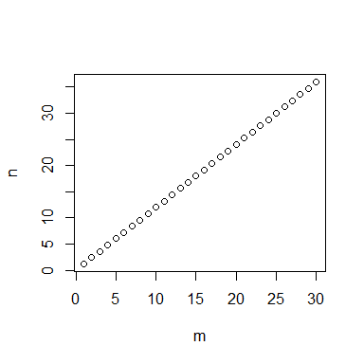

[Here is a link to ABS key indicators](http://abs.gov.au/AUSSTATS/abs@.nsf/mf/1345.0)  
[Here is a link to RBA cash rate](http://www.rba.gov.au/statistics/cash-rate)

Here is some text with a footnote.[1]  
Here is some other text with another footnote.[2]

#### Finally a table:

|  |  |  |  |
| --- | --- | --- | --- |
| Header | Column 1 | Column 2 | Column 3 |
| 1. Row | is | is | is |
| 2. Row | left | nicely | right |
| 3. Row | aligned | centered | aligned |

#### Bonus trick, a faked formatted table:

|  |  |  |  |
| --- | --- | --- | --- |
| Header | Column 1 | Column 2 | Column 3 |
| 1. Row | is | is | is |
| 2. Row | left | nicely | right |
| 3. Row | aligned | centered | aligned |

|  |  |  |  |
| --- | --- | --- | --- |
| Var | Sum of .. | Mean of .. | SD of .. |
| 1. x | 465 | 15.5 | 8.8034084 |
| 2. n | 558 | 18.6 | 10.5640901 |

1. The linked footnote appears at the end of the document.
2. The linked footnote appears at the end of the document.