Modelling EU sugar market scenarios with a modified Armington appoach
Peter Witzke, Marcel Adenaeuer, Wolfgang Britz, Thomas Heckelei
Bonn University

Introduction
Several studies are available on trade effects of different options for the EU sugar market CMO (Mensbrugge et al 2003, Frandsen et al 2003, Cernat et al. 2003, Adenaeuer et al 2004, Witzke, Kuhn 2004, Kerkelä, Huan-Niemi 2005, Gohin, Bureau 2005 and earlier studies). Those addressing the particular problem of preferential trade in sugar usually rely on the Armington approach as the underlying modelling concept.
A well known problem in the application of the Armington approach to spatial trade modelling is the situation of zero observations for trade flows in the base year. Zero demand quantities cannot be represented by CES preferences which is the usual (sub-) utility function used to aggregate domestically produced quantities and foreign quantities from different origins. This is due to the marginal utility approaching infinity as consumption goes to zero. As a consequence researchers usually replace zero trade flows with small positive numbers if the expect nonzero trade flows as an outcome of certain simulations. This is certainly unsatisfactory because the actual number chosen (1.0?, 0.1?, 0.01?) will have a crucial impact on simulation results.
However, another drawback of this simple solution is that trade flows calibrated to small quantities are hardly increasing even in case of considerable price drops with plausible elasticities of substitution (say σ < 10). To tackle this problem researchers have sometimes used very high substitition elasticities (Frandsen et al 2003, fn 5) or addressed the problem with pragmatic solutions (Cernat et al 2003: 17).
More critisicm of the Armington approach has been reviewed for example by Abler 2005. It relates to the constancy of the elasticity of substitution as well as to the homotheticity and separability assumptions incorporated in the typical CES aggregator functions.
This criticism is well known among users of the Armington approach but a key counter argument is that homotheticity is required for two-stage budgeting (Hertel 1999: 27). We will argue that two-stage budgeting in the strict sence may be abandoned and still retain its most attractive property which is parsimony in parameters.
Our generalisation uses a non-homothetic version of the CES aggregator similar to the well known Linear Expenditure System. This type of non-homothetic CES preferences has been used in other papers as well but to our knowledge not for the aggregation of different origins in a large scale trade model.
The specification will be helpful to obtain plausible responses of exports to the EU in a full liberalisation scenario for the EU sugar market relying on a version of the CAPRI model. This scenario is chosen mainly for illustrative purposes but the recent WTO panel decision on complaints put forward by Brazil, Australia and Thailand may force the EU to move closer to full liberalisation than was intended a few years ago.
The simulations will be carried out using a special version of the of the CAPRI market model distinguishing 14 regions beyond the EU25 Member States (+ Bulgaria and Romania): (1) Rest of Europe, (2) India, (3) China, (4) Australia and New Zealand, (5) Mercosur, (6) USA, (7) Asian, Caribic and Pacific developing countries which are not in the LDC group, (8) Mediterrean countries, (9) Japan, (10) Canada, (11) Rest of South America, (12) Mexico, (13) Least developed countries (LDC), (14) Rest of the World. Under a liberalisation we may expect significant exports to the EU from Mercosur (including Brasil and Thailand) and also from the Australia – New Zealand aggregate. The quantitative importance of these effects will be a key issue in our analysis.
Following recent improvements the supply module of the CAPRI system also incorporates a number of details which are usually omitted from large scale modelling efforts. Sugar beet production is driven by an expected profit maximisation framework acknowledging yield uncertainty. Additional motives to supply C sugar beets (true risk aversion, expectations) are incorporated in implicit form through a translation of the expected profit function during the calibration of the model (Adenaeuer et al 2004).

Modified form of Armington approach
Consider the following generalisation of the standard CES utility function:
 | 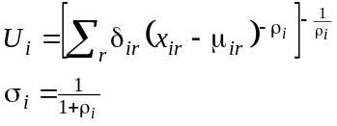 | (1)
where ρ_{i} is the substitution parameter related to the substitution elasticity σ_{i} steering the substitution among the different varieties of product i originating in regions r, δ_{ir} > 0 is a so called distribution parameter attached to imports for product i from region r and μ_{ir} is a committment parameter (positive or negative) related to this import flow. In the application in CAPRI, imports from different regions are first aggregated to an import aggregate which is combined with consumption of domestic origin on a second level but this complication may be neglected here. Consider the problem to mimimise expenditure on product i given a certain level of aggregate consumption of product U_{i} :
 | 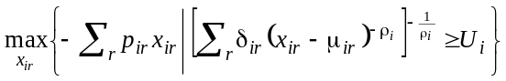 | (2)
gives among the first order conditions
(3)
where λ_{i} is the Lagrangean multiplier related to the constraint to achieve certain (subutility) level of consumption of product i. In case of very high prices for certain origins, for example due to prohibitive tariffs, the nonnegativity constraint may be binding. In this case it is useful to define the shadow price w_{ir} as
 | 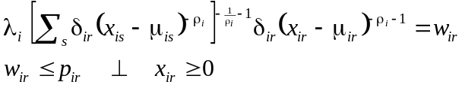 | (4)
With standard CES preferences consumption of all varieties will be positive, at least slightly, because the marginal utility goes to infinity as imports x_{ir} approach zero in case of μ_{ir} = 0. Consequently no ‘choke price’ can possibly exceed marginal utility at consumption levels close to zero. Nonzero commitments essentially translate the origin of indifference curves in goods space, such that marginal utility rises beyond any bounds at other limiting values but at zero consumption marginal utility may be finite such that it may be exceeded by high prices. In the two good case this may look as follows:
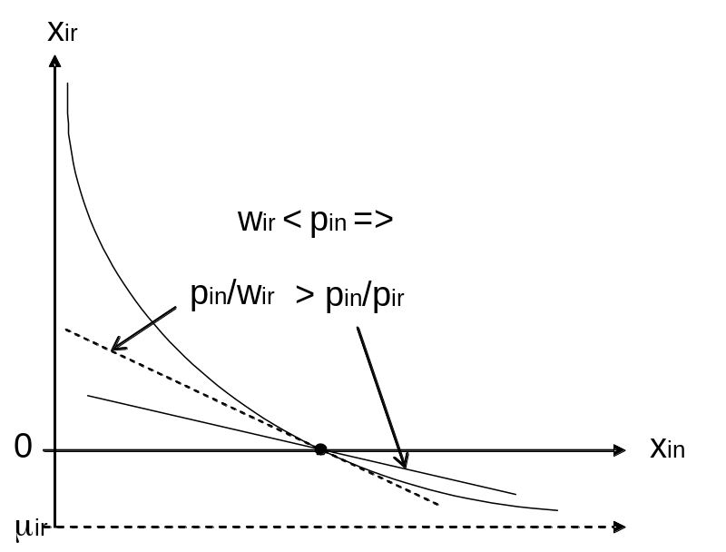
Figure 1: consumer equilibrium with zero consumption from region r
Figure 1 shows the case of a binding nonnegativity constraint for imports from region r such that the shadow price making the constraint just binding is strictly smaller than the observed price (w_{ir} < p_{ir}) whereas for the other origin n we have w_{in} = p_{in}. We have assumed that (negative) commitments will be introduced only for the variety with near zero consumption such that μ_{in} = 0, μ_{ir} < 0. In the application we have furthermore assumed that non negativity contraints are just binding such that w_{ir} = p_{ir} ∀r. Alternatively, some hypothesis may be formed about the water in the tariff for this import flow.
Using shadow prices w_{ir} in place of p_{ir} we may neglect the inequality constraint. In terms of shadow prices expenditure minimising demand for imports from origin r is:
 | 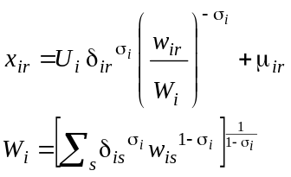 | (5)
Equation (5) reveals once more from a different angle that standard CES preferences are inconsistent with zero consumption: With positive and finite prices w_{ir}, positive parameters δ_{ir} and a positive aggregate consumption U_{i}, consumption is evidently strictly positive. With negative μ_{ir}, on the other hand, demand from origin r may be zero at sufficinetly high prices. Indeed, the equation may hold even for negative x_{ir} which requires to take care of the nonnegativity constraint during simulations.
The expenditure function for expenditure on product i from all origins following from (5) is:
 | 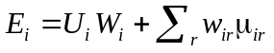 | (6)
Consider now the top level problem to minimise expenditure on all goods entering some general utility function :
 | 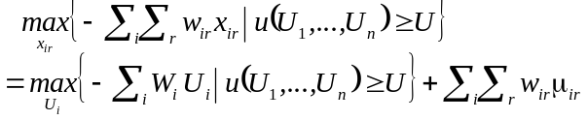 | (7)
Two-stage budgeting in the strict sence (see Deaton, Muellbauer 1980) does not work for total expenditure because knowledge of aggregate prices W_{i} alone does not permit to calculate minimal expedtiture. The total value of committments has to be added. On the other hand if this committed expenditure is added to uncommitted expenditure (or substracted for Marshallian demands from income), the hierarchical structure of preferences is preserved: the top level determines consumption in terms of goods, the lower level gives the composition in terms of origins. While the top level problem now has to consider the value of committed consumption additional parameters in comparison to a standard Armington approach are only these committments μ_{ir} which need not be introduced for all goods. A further complication is that the parameters related to the top level demand system now refer to uncommitted consumption only. Elasticity expressions and parameter calibration may be more complicated but this is unlikely to be relevant if committments are not introduced for all import flows.
It should be noted that non-homothetic preferences regarding the substiution between domestic and foreign goods are far from being a novelty. They are discussed in the general trade theory and in particular in the literature on the gravity model to explain the volume of trade (e.g. Harrington 2002, Anderson, Wincoop 2004). Some empirical applications have relied on the above commitment version of a CES aggregator (Tchamourliyski 2002), others have achieved a nonhomothetic Armington approach in different ways (e.g. Yang, Koo 1993).
Furthermore, the commitment version of CES preferences has been used before, for example, in the MIRAGE general equilibrium model (Behir et al. 2001, Bouet et al 2004), but there it was on the top level describing substitution among goods where more general demand systems are quite common. However, our application is apparently new in the use of a non-homothetic CES aggregator for substitution between different origins.

Illustration with a two good example
In this section we will illustrate the proposed CES generalisation with a numerical two goods example. Without loss of generality we may set δ_{in} = 1 for the numeraire good and in accordance with Figure 1 μ_{in} = 0 as well. The assumed base year data, parameters and calibration prices and shares are shown in the following table.
Table 1: Example data for standard and generalised CES demand systems
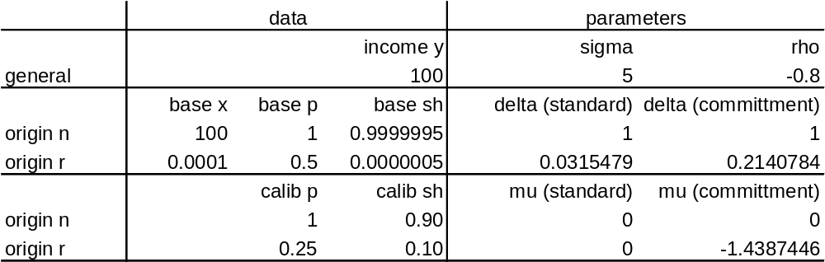
In the base year consumption from origin r is essentially zero (x_{ir} = 0.0001). To permit a comparison with standard CES preferences x_{ir} has not been set strictly to zero. The substitution elasticity is set rather high but not excessively large (σ = 5). In a typical Armington problem zero trade will occur for several trade flows but others will be clearly nonzero. If all these are combined in a single (sub-)utility function, it will be impossible to set σ = 100, for example, because this would imply an exaggerated subsitutability for the most relevant trade flows.
The parameters δ_{ik} have been calculated in line with equation (5) using the base year quantities (‘base x’) and base year prices (‘base p’) from Table 1. The CES version with committments requires an additional condition (or a priori information) to specify parameter μ_{ir}. While there is certainly a multitude of conditions conceivable we will pick the following, as a starting point to address the low responsiveness problem mentioned in the introduction: For a prespecified drop in the price of imports from origin r (to 0.25 = 50% * base p) we expect that imports should attain a certain calibration share of, say, 10%, in expenditure on good i or in aggegate consumption, starting from a level close to zero. For a price drop as strong as 50% this is meant to be moderate share but future applications of the modified Armington approach may show that other conditions are more suitable.
With a calibation budget share of 10% the condition implicitly defined a negative committment of μ_{i}.= −1.4387 as given in the table above.
The demand functions calibrated to the base year data from the standard and generalised CES system are depicted in the next figure.
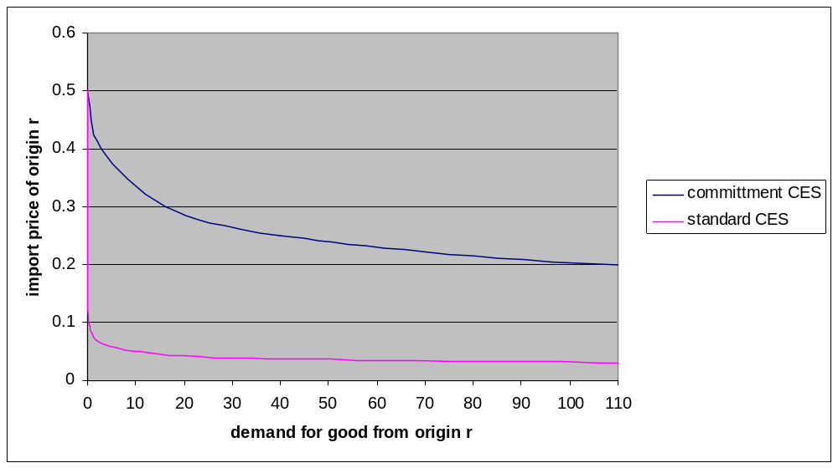
Figure 2: Demand functions from standard and committment versions of CES systems
It is evident from Figure 2 that the standard CES demand function has the drawbacks mentioned in the introduction: A demand close to zero will remain close to zero unless the price drop is extraordinarily strong. In this example a sizeable response only begins at about 10% of the base year price, a level which is usually not attained in serious simulations. The committment version, on the other hand, shows an increase of consumption to a quantity of x_{i} = 40 at a price of 0.25 (50% drop). This gives a budget share of 0.25 * 40 /100 = 10%, as required.

Empirical approaches to tackle problems resulting from the Armington approach
The inherent problems of the Armington appoach have been adressed in different ways in the literature. The key problem may be visualised as follows.
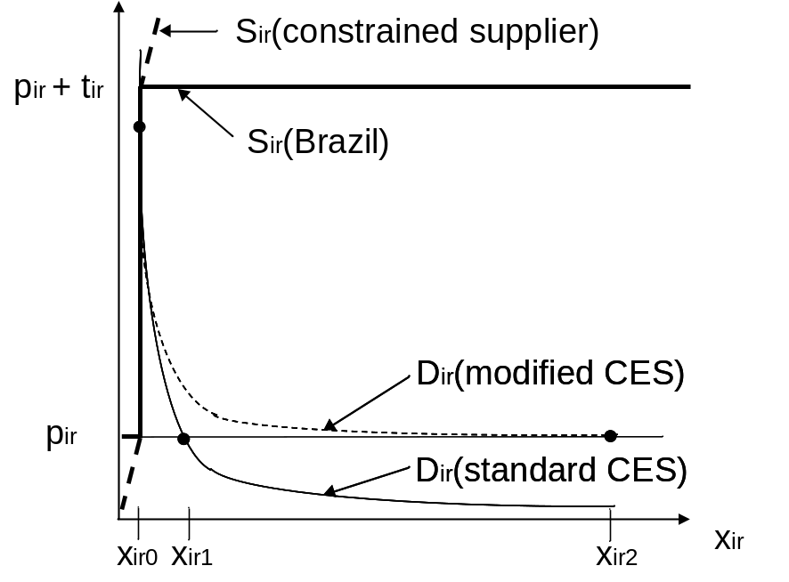
Figure 3: Liberalisation of TRQ protection with different behavioural functions
Imports from many origins are zero or close to zero, sometimes because the corresponding supply prices are raised by prohibitive over quota (or MFN) tariffs. The standard CES derived import demand would give a rather modest increase in imports to the EU because initial imports are quite low. This holds even in the case of very high supply resonsiveness in Brazil (infinitely elastic in Figure 3). With the modified Armington approach it is possible to calibrate the import demand function in such a way that it would predict a more plausible outcome. Less competitive suppliers may be represented with more inelastic supply functions as shown with dotted lines and/or with a low initial period quota rent (not shown).
The difficulties with the standard Armington approach evidently extend to scenarios involving extensions of existing TRQs or the introduction of new ones such as those implied by the ‘Everything but Arms’ initiative of the EU. If initial imports from the beneficiary countries are close to zero (EU sugar imports from Mozambique) a standard Armington approach would predict that the resulting imports from competitive suppliers remain quite low even with rather free market access (see Table 5 in Kerkelä, Huan-Niemi 2005).
These problems are not always equally urgent in empirical analysis of the EU sugar market regime. First of all it may be neglected if the analysis does not focus on bilateral trade flows and their corresponding trade barriers such that sugar may be considered a perfectly homogenous good. While this is certainly quite close to reality for sugar it completely neglects differences in timing, reliability, shipping volumes and quality of sugar supplies which might introduce some heterogeneity in spite of an apparently homogenous commodity. The assumption may be quite helpful for modelling efforts confined to the EU market (Gohin, Bureau 2005). In pragmatic modelling approaches some heterogeneity may be expressed as needed using export supply and import demand functions for relevant regions (Sheales at al. 1999).
A partial return to the homogenous goods assumption is also proposed in Gohin et al. 2002, mainly in view of cereal markets. They propose to augment the domestic origin part of the import aggregator function with perfectly substitutable imports which kick in if import protection is completely dismantled:
 | 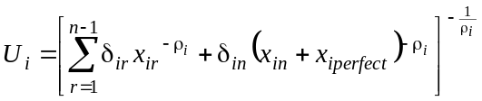 | (8)
The existence of perfectly substitutable imports triggers an increased response of imports to a full liberalisation in their model because the domestic market price will be the lower of domestic marginal cost and the border price of perfectly substitutable imports.
It is clear that the ‘zero trade problem’ only occurs in disaggregate modelling, both in terms of products as well as regions. If countries are aggregated to larger groups, initial period trade flows will usually be far enough from zero to avoid clearly implausible simulation results. This aggregation effect has been exploited in Cernat et al 2003 ( p 17) when they let LDC exportes first export to an artificial ‘world market region’ which serves a channelling device in an otherwise standard GTAP application.
A quite disaggregated modelling effort has been presented recently in Kerkelä, Huan-Niemi 2005. Results of a full liberalisation scenario were considered implausible because the additional imports were clearly related to initial period exports to the EU resulting in full liberalisation imports from the Central American / Caribean region to the EU being higher than from Brazil. This has been tackled in another scenario where ‘virtual tariffs’ have been used to bring the supply response in line with expectations based on differences in production costs between countries.
Finally it may be mentioned that implausible simulation results had also been obtained in intermediate simulations for Witzke , Kuhn 2004 which led to implausibly low price effects in the EU following a complete liberalisation. In that simulation study the Armington approach was considered to provide at best a local approximation to trade relationships such that for drastic policy changes as a full liberalisation of the EU sugar market regime it was acceptable to recalibrate the Armington parameters to represent the expected drop in EU prices. This is admitted to be a rather ad hoc solution.

Counterfactual illustration: Complete liberalisation of the EU sugar market
A challenging simulation to test the modification of the standard Armington approach is a complete abolition of border protection in the EU

Conclusion
This paper offers a parsimonious in parameters generalisation of CES preferences to tackle the problem of zero base year quantities as it occurs, for example, in trade modelling using the Armington approach. The demand system is at the same time a generalisation of the LES system. It is capable to heal one of the most serious drawbacks of the Armington approach, namely that trade flow observed zero in the base period are almost sure to remain close to zero in simulations based on CES preferences.
It has been shown to be helpful in a sugar market liberalisation scenarion with CAPRI. Additional numerical difficulties related to the imposition of the nonegativity constraints turned out manageable but it has to be admitted that the new modification has been introduced very selectively. Nonetheless the modification appear to offer a promising solution to a widely cited criticism of the Armington approach without loosing its main attractive ness namely parsimony in parameters.

References
Armington (19..):
Cernat, L., Laird, S., Monge-Roffarello, L., Turrini, A. (2003): The EU’s Everything But Arms Initiative and the Least-developed Countries, Discussion paper 2003-47, World Institute for Development of Economics Research, United Nations University, http://www.wider.unu.edu/publications/dps/dps2003/dp2003-047.pdf (15.02.2005).
Witzke, H.P., Kuhn, A. (2004): Assessing Reform Options for the Sugar Common Market Organisation - Quantitative Analyses with Interlinked Models, in: J. Zeddies, S. Dabbert, W. Großkopf, F. Heidhues (eds.), Perspektiven in der Landnutzung - Regionen, Landschaften, Betriebe - Entscheidungsträger und Instrumente, Münster-Hiltrup: Landwirtschaftsverlag.
Borrell, B., Pearce, D. (1999): Sugar: The Taste of Trade Liberalisation, Centre for International Economics (CIE), Canberra: Centre for International Economics (CIE).
Devadoss, S., Kropf, J. (1996): Impacts of Trade Liberalisations under the Uruguay Round on the World Sugar Market, Agricultural Economics (15), pp. 83-96.
Frandsen, S.E., Jensen, H.G., Yu, W., Walter-Jorgensen, A. (2003): Reform of EU Sugar Policy: Price Cuts Versus Quota Reductions, European Review of Agricultural Economics (30), pp. 1-26.
Mensbrugghe, D. van der, Beghin, J.C., Mitchell, D. (2003): Modeling Tariff Rate Quotas in a Global Context: The Case of Sugar Markets in OECD Countries, CARD Working Paper 03-WP 343, Ames, Iowa.
Poonyth, D., Westhoff, P., Womack, A., Adams, G. (2000): Impacts of WTO Restrictions on Subsidised EU Sugar Exports, Agricultural Economics (22), pp. 233-245.
Sheales, T., Gordon, S., Hafi, A., Toyne, C. (1999): Sugar International Policies Affecting Market Expansion, ABARE Research Report 99.14, Canberra.
Adenaeuer, Louhichi , Frahan, Witzke, 2004, ECOMOD
Koji Shimomura, A simple proof of the Sato proposition on non-homothetic CES functions, Economic Theory, 1999, vol. 14, issue 2, pages 501-503

