PES UNIVERSITY

B.TECH, SEMESTER: 3
SUBJECT: INTRODUCTION TO DATA SCIENCE

REPORT ON LIFE EXPECTANCY DATASET

SUBMITTED BY:
ANANYA JOSHI (PES1201800170)
N. TRIAMBAKA (PES1201800225)
J. SIVANJALI (PES1201801926)

-SECTION:H

ABOUT THE DATA SET

We were assigned the ‘Life Expectancy’ dataset. This dataset was found on Kaggle.com. It gives the comparison of Life Expectancy in developed and developing countries by considering various factors that might affect the life expectancy.

The dataset had 22 columns initially with 2938 rows of data, and after cleaning the number of rows and columns were reduced to 1987 and 21 respectively.

ABSTRACT

The purpose of this assignment was to enhance our data analyzing abilities by enabling us to work on a dataset and explore the good/bad insights that could be made. It also helped us determine what visualizations was appropriate for the type of data provided. The dataset assigned to us was ‘Life Expectancy’.
This had details regarding the average life expectancy of various developed and developing countries for different years.
During the course of the project, we had to drop 1 column due to highly noisy data.

EXPLORATORY ANALYSIS

Data cleaning

Numerical Columns
- The Life Expectancy Dataset chosen did not have a lot of NaN values, so it was to be replaced by mean of the column. However, since the dataset did contain a lot of outliers the NaN values now had to be replaced by median.
- Despite our efforts to clean the dataset, the number of rows after we tried to remove the outliers were reduced to 624 from 2938.
- After thorough examination of the dataset, we noticed the presence of multiple 0s in columns where the presence of 0s didn’t make sense such as Life Expectancy Column itself.
- Windorising the columns seemed like the appropriate choice to ensure a clean dataset as it windsorizes the interpolated columns leaving it with 0 outliers.
- During the course of windsorizing, we realized that windsorization alters a large percentage of the data, which may not give better results. Therefore, the Measles column which had a lot of outliers was dropped.

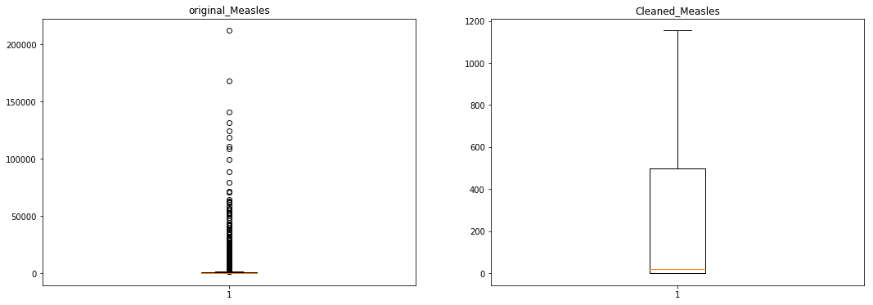

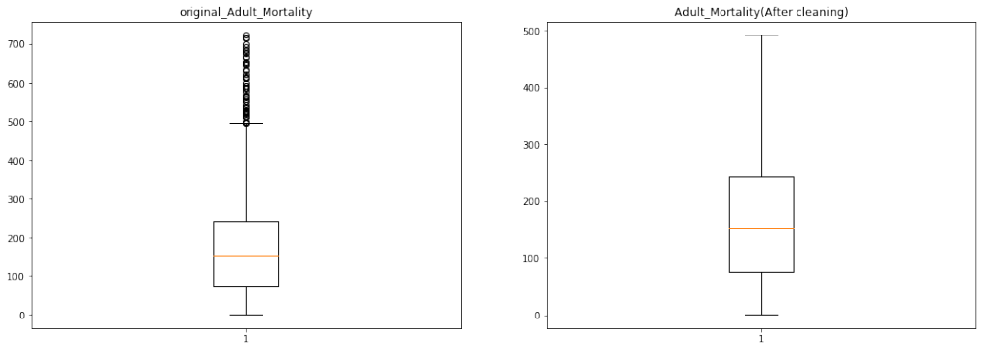

Categorical Columns
- Since there wasn’t any occurrence of NaN values in the categorical columns, we decided to manually edit the columns and replace existing values with NaN and then interpolate to fill it.

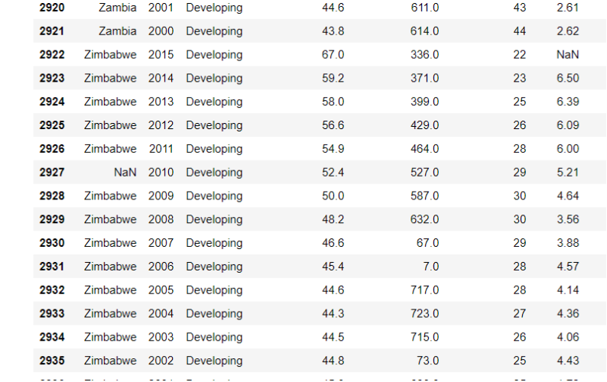

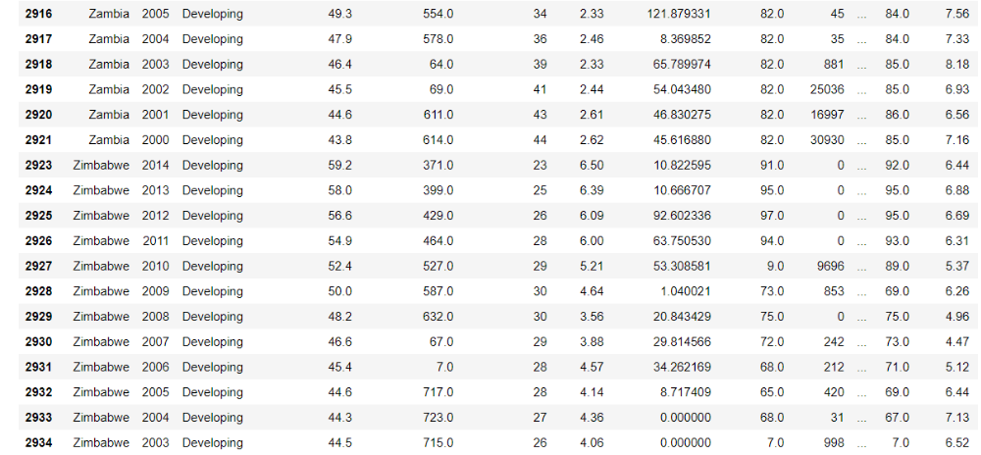

Standardization

Standardizing a dataset involves rescaling the distribution of values so that the mean of observed values is 0 and the standard deviation is 1.
Since all the values in various columns have are on either extremes( too low or too high), standardizing/normalising the dataset would make it look uniform.
This process makes the analysis easier too.
So we changed all the values in the dataset by assuming the mean of that column to be zero and standard deviation to be one.

Correlational Matrix
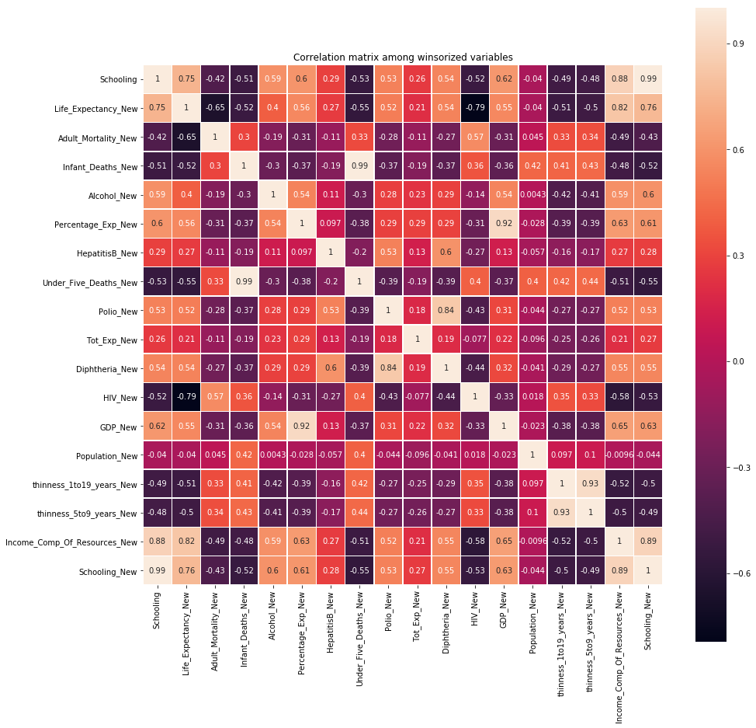

Hypothesis Testing

According to the bar graph obtained on plotting life expectancy with respect to developed and developing countries the inference is that life expectancy of developed countries is much greater compared to that of developing countries (no doubt due to better education and way of living, infrastructure and so on..). So the null hypothesis states that there is no difference between the means of life expectancy of developed and developing countries (which we will go on to reject) and the alternate hypothesis suggests that the average life expectancy of developed countries is greater than that of developing countries.

Let X1 be the mean of average life expectancy of (sample taken ) of developing countries and X2 be the mean of average life expectancy of developed countries.
Let sd1 and sd2 represent the standard deviations for developing and developed countries.

NULL HYPOTHESIS:
H0: X1-X2=0
ALTERNATE HYPOTHESIS:
H1:X1-X2!=0

The procedure followed is that samples of a certain size are taken for both developing and developed countries and the means and standard deviations for those samples are noted.
Then z score is calculated as (X2-X1-0)/sqrt((sd1^2/n+sd2^2/n))
Based on the z score we calculate p value and if it is lesser than 0.05 we reject H0.

VISUALISATIONS

BAR GRAPGH:

- The bar graph of developed and developing countries vs life expectancy shows that life expectancy of developed countries is greater than that of developing countries.
- The life expectancy has increased with every passing year, being lowest at 2000 and greatest at 2015.
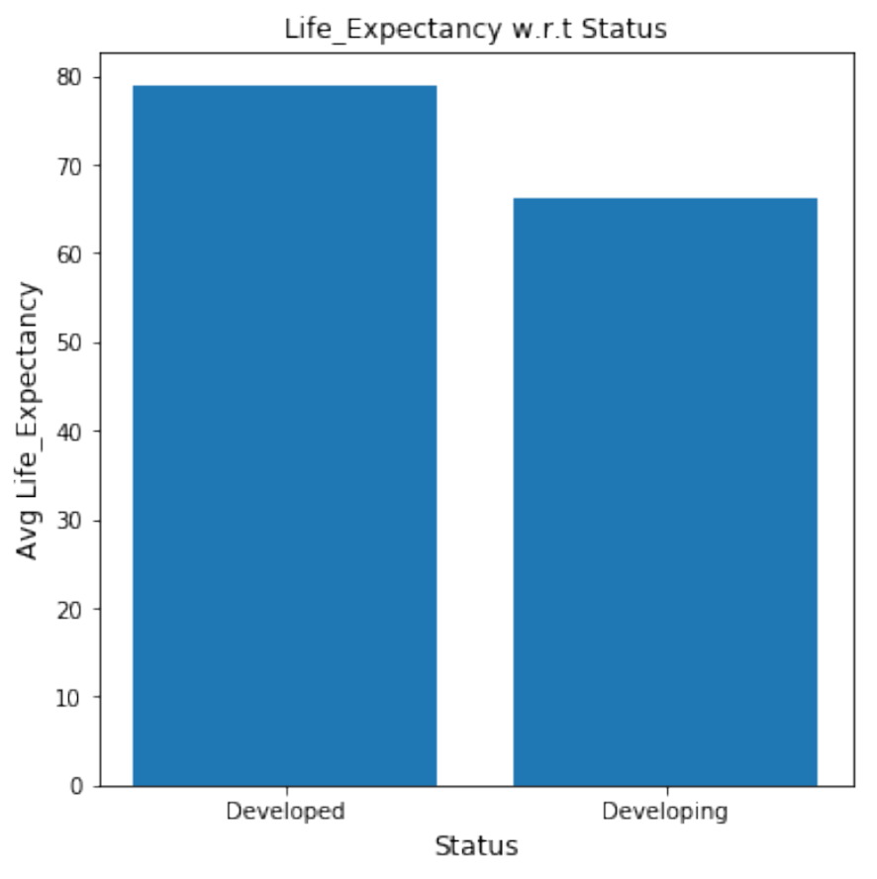
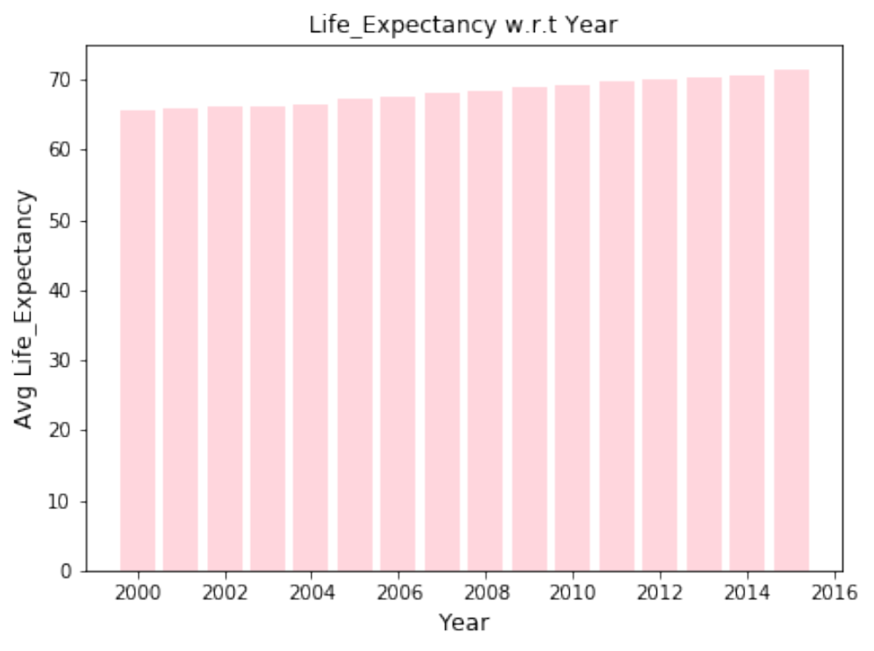

SCATTER PLOT:

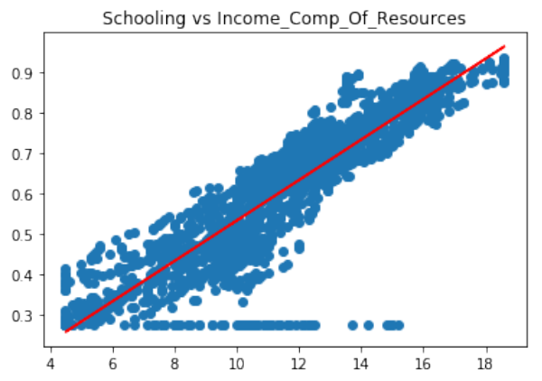

For Schooling vs Income
1) From the scatter plot , schooling has an almost linear relationship with income
2) Between 2000-2015 , it has been seen that the higher the educational qualification of a person is, the more he earns.

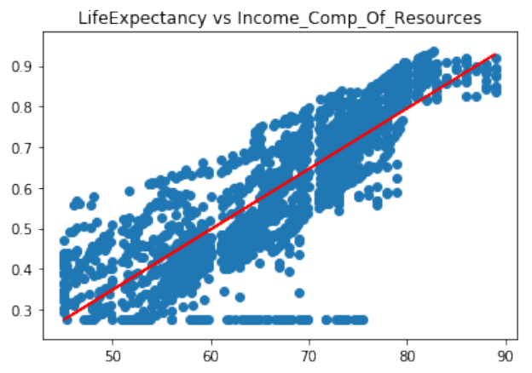

For LE vs income
1) LE and income to an extent follow a linear relationship
2) The plot shows that the more the income and access to resources is, the higher the life expectancy of the person is. Needless to say, a person who earns more would have access to better resources and could get proper medical treatment (could afford them) and hence has a longer life expectancy than the one who earns less

HISTOGRAM:

1. The histogram for the life expectancy is plotted for both developed and developing countries. It is seen that the life expectancy has a normally distributed curve when developed countries are taken into consideration.

2. The histogram is slightly skewed to the leftt in the case of developing countries. This implies that the average life expectancy is not contributed by all the data. Instead there are values of both the extremes present.

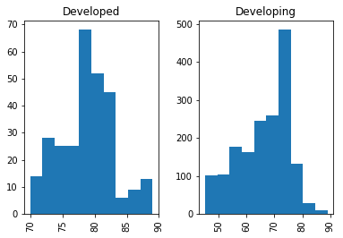

CONCLUSION

It was the first time that we worked with a dataset as large as the one assigned to us. We spent a good amount of time cleaning the dataset because there were many fields with junk values. We had to debate over how to clean - to delete the entry or replace with a dummy value.

Secondly, we realised the importance of sampling. Be it for testing our code or plotting graphs, most of the time, we needed a smaller representative data to work with. It wasn’t enough to iterate through the first ‘x’ number of rows because that wasn’t giving us a reliable representation of the actual dataset.

Having done the above steps, we moved on to plotting relevant graphs for the same.
With the help of the correlational matrix, we found that the life expectancy had close relation with factors like schooling, resources etc. We also were able to figure out how the other columns of the dataset are related to each other.

We then moved on the hypothesis testing. We understood the importance of choosing a right hypothesis. Although the results of the hypothesis testing our favour, we still got to learn quite a lot of things from the procedure.

The biggest takeaway for us was that we understood how much easier and more meaningful visual representation is. When we went through the CSV file initially, we had made a lot of assumptions, most of which turned out to be true when we plotted the graphs. We also saw how much easier data is to interpret and analyse when it is graphical.

