1. Which equation below represents the quadratic formula?

*a. $\frac{-b±\sqrt{b^{2}-4ac}}{2a}$ = x

b. $a^{2}+b^{2}=c^{2}$

c. $f\left(x\right)=a_{0}+\sum_{n=1}^{∞}{\left(a_{n}\cos{\frac{nπx}{L}}+b_{n}\sin{\frac{nπx}{L}}\right)}$

1. Which of the following represents a set of parallel lines?

a. Option one

b. Option two

*c. Option three

1. What is the definition of an obtuse angle?

*a. an angle ***greater than*** 90°

b. an angle ***equal to*** 90°

c. an angle ***less than*** 90°

1. Which formula below represents the area of a circle?

a. $A=2πr$

*b. $A=πr^{2}$

c. $A=π^{2}r$

d. $A= √π$

1. What geometric term is represented by the image below?

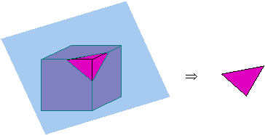

a. a corner

*b. a cross-section

c. the circumference

d. the perimeter

11. Using the data in the table below, calculate the mean, or average, number of points scored by Player B.

|  |  |  |  |  |  |
| --- | --- | --- | --- | --- | --- |
|  | **Game 1** | **Game 2** | **Game 3** | **Game 4** | **Game 5** |
| **Player A** | 13 | 12 | 9 | 11 | 13 |
| **Player B** | 12 | 11 | 15 | 20 | 12 |

*a. 14

b. 11.5

c. 13

d. 13.67

1. This instrument is commonly used by surveyors. It measures horizontal and vertical angles to determine the location of a point from other known points at either end of a fixed baseline, rather than measuring distances to the point directly. What is it called?

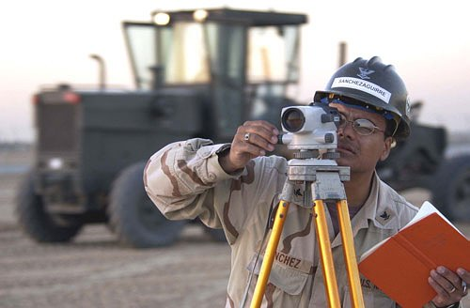

a. triangulator

b. binocular

c. tripod

*d. theodolite

1. What is the name of the missing shape in the flowchart below?

a. Acute

b. Obtuse

*c. Isosceles

d. Right

1. What category includes **all of the items** on the list below?

* Square
* Rectangle
* Rhombus
* Parallelogram
* Trapezoid
* Pentagon

a. Quadrilaterals

b. Triangles

c. Ellipses

*d. Polygons

1. Determine the area of the shaded portion in the diagram below.

A B

C D

* ABCD is a square
* ABCD touches the circle at 4 points
* The length of one side of the square ABCD is 2 cm

a. $π$– 4

*b. 2 – 4  
c. 3 2 – 4  
d. 4 3 – 4  
e. 5 – 4