Client: Rijkswaterstaat/RIZA

ROB

RIZA OpenMI Buffer

Authors: A. Hoekstra
P.W. Dirksen
J. Ansink

Update : june 2005 R. Terveer, introduction Quantityset, Quantity Properties, Default value

Contents
1 Summary 3
1.1 OpenMI 3
2 Technical design of RIZA OpenMI Buffer 4
2.1 How OpenMI communicates with computational core 5
2.2 Details of the technical design 5
2.2.1 Entity Relationship Diagram (ERD) of the Exchange-item 7
2.3 RIZA Engine OpenMI Buffer detailed description 8
2.3.1 How to define an exchange-item 8

List of figures
Figure 1 OpenMI Architecture 4
Figure 2 Communication between OpenMI and DM 5
Figure 3 Entity Relationship Diagram (ERD) of the Exchange-item 9

Summary
RIZA has a number of model systems that are to be migrated towards OpenMI. All models will be migrated by implementing a wrapper based on the OpenMI Smartwrapper. The existing models are mainly programmed in C or Fortran. As all wrappers need to communicate with the computational core, a subroutine library has been developed to support this communication. Since this project was the first RIZA project migrating a computational core towards OpenMI, the development of this library was part of the project.

OpenMI
OpenMI is the result of a European project, which aims at defining a standard for data exchange between model systems, databases, etc. This standard allows quick and easy linking of computational models to form integrated modelling systems.
OpenMI is in fact just a standard on paper, but the project defining this standard (HarmonIT) also delivers a Windows implementation of the standard including utilities like a GUI.
The HarmonIT project will deliver a set of migrated modelling systems and generic tools.
“Migrated models” means that the models have been adapted to work within the OpenMI framework and can easily be connected to other models or tools.
Migration of an existing model consists of two phases:
- Basic adaptation of the computational core such as rerouting of output from screen to file and recompilation to a Dynamic Link Library (DLL).
- Implementing a wrapper that follows the OpenMI standard and facilitates communication with the adapted model DLL.

This report describes both phases.
HarmonIT is a research project funded by the European Commission aiming at the development and implementation of a European Open Modelling Interface and Environment (OpenMI) that will simplify the linking of hydrology related models. The establishment of the OpenMI will support and assist the strategic planning and integrated catchment management required by the Water Framework Directive.

Technical design of RIZA OpenMI Buffer
This chapter describes the way OpenMI (the smartwrapper) communicates with the computational core, in this case the RIZA OpenMI Buffer(DM). The next figure shows the architecture of the implementation.

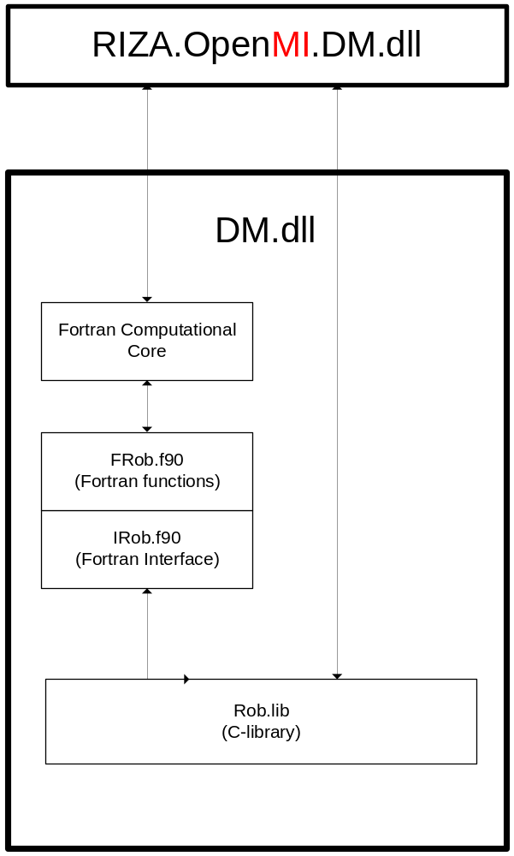
Figure 1 OpenMI Architecture

The Rob.lib contains the RIZA OpenMI Buffer and the functions for definition of Exchange-items and storage of Exchange values. These functions are written in C.

Because the computational core is written in Fortran a module with functions is developed for calling the functions in Rob.lib from Fortran code. The name of this module is Frob.f90. FRob.f90 uses module Irob.f90, which contains only the interfaces to the C-library and some convenience constants. Frob.f90 and Irob.f90 are independent of the computational core and therefore can be used in any Fortran computational core.

OpenMI (the wrapper) can use the functions in Rob.lib directly because they are exported.

How OpenMI communicates with computational core
The next figure demonstrates how OpenMI communicates with the computational core.

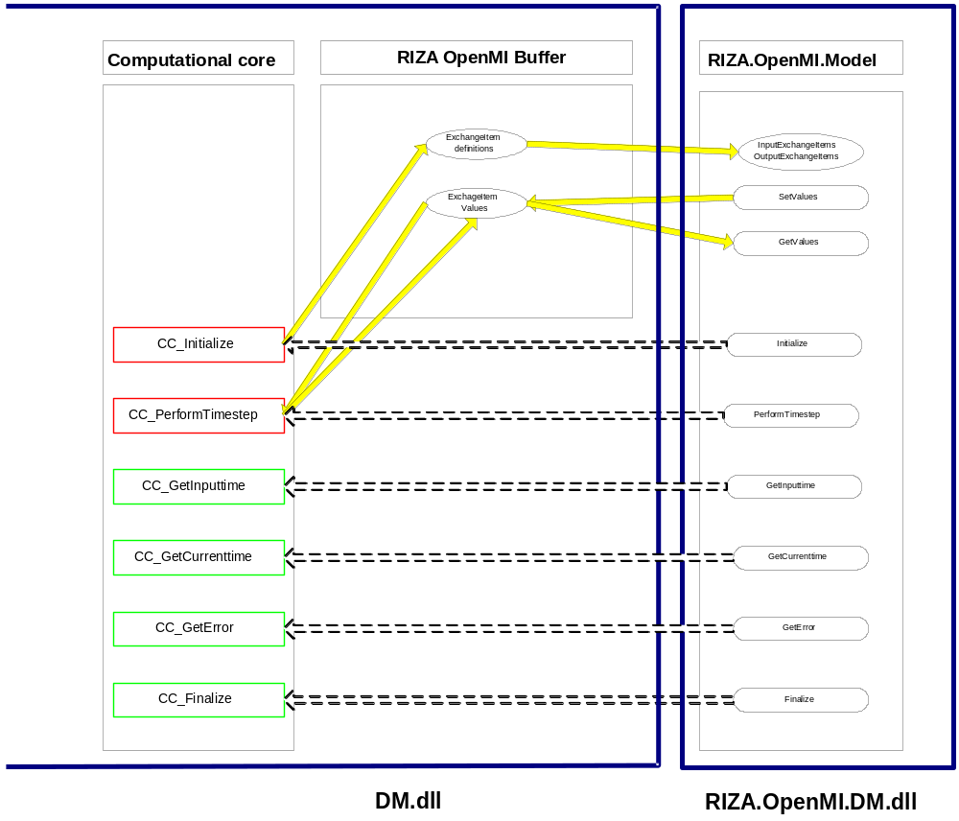
Figure 2 Communication between OpenMI and computational core

Details of the technical design
The communication between OpenMI and a computational core is done with an exchange item. Below is a list of all entities, used to define an exchange item (attributes in italics uniquely identifies an item).

Exchange entity
Attribute | description
ModelID | Model identification string
quantityID | Quantity identification string
elementsetID | Element set identification string
nElements | Number of elements
Values | Double array with values
Role | Providing or Accepting role

Model entity
Attribute | description
ModelID | Model identification string
modelDescription | Model description string

Property entity
Attribute | description
properttylID | Property identification string
propertyValue | Property value string

Quantity entity
Attribute | Description
quantityID | Quantity identification string
quantityDescription | Quantity description string
UnitID | Unit identification string
Quanties | List of (other) Quantities describing the Quantity
Properties | List of properties

Note
Quantitysets are a proposed extension to the OpenMI standard. A Quantityset is a Quantity described by one ore more other Quantities (attribute “Quantities”). A single Quantity becomes a Quantityset after adding another Quantity to it.
Also proposed as extension to the standard are Properties for Quantities (attribute “Properties).

Unit entity
Attribute | Description
UnitID | Unit identification string
UnitDescription | Unit description string
ConversionFactor | Conversion factor
ConversionOffset | Conversion offset

Element set entity
Attribute | Description
ElemensetID | Elementset identification string
elementsetDescription | Elementset description string
ElementType | Elementset type
ElementID | Element identification string

Element entity
Attribute | description
ElementID | Element identification string

Entity Relationship Diagram (ERD) of the Exchange-item
(To do : add Quantityset & Properties)

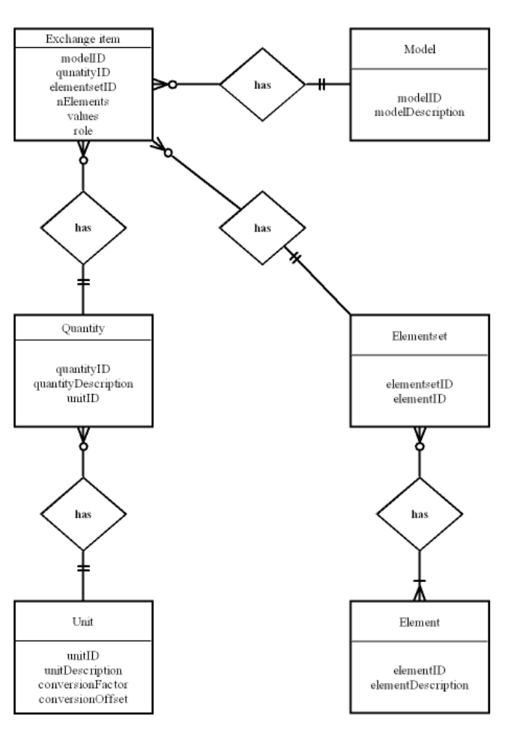

Figure 3 Entity Relationship Diagram (ERD) of the Exchange-item

RIZA Engine OpenMI Buffer detailed description
This chapter describes the function library with functions for communication between OpenMI and the computational core. This chapter describes interfaces of each function.

In the Fortran-interface a lot of input parameters are strings. The maximum length of these strings is ROBIDLEN (now 255 characters, defined in Irob.f90).

Also defined is a default value for data in the ExchangeItem’s buffer. This value is described by the parameter MISSING_VALUE, defined in both “General,h” and “IRob.f90” currently as the maximum number for a “double” (“C”) or the corresponding “real(kind=8)” (Fortran)

How to define an exchange-item
During initialization every computational core has to define it’s exchange-items. This is done by using the functions from Rob.lib. An exchange-item must be defined as follows:

- define a model (ID and description)
- define one or more units (ID, description, conversion factors)
- define one or more quantities (ID, description and UnitID)
- Optionally, by adding quantities to quantities, define Quantitysets
- define one or more elements (ID, description, type)
- define one or more elemetsets (ID and 1 or more elementID’s)
- define an exchange item, uniquely identified by modelID, quantityID and an ElementsetID

Module usage
The Fortran computational core cannot directly use the C-function in Rob.lib. For that purpose FRob.90 has been developed. This module contains the same functions as in Rob.lib but the function names are pre-fixed with the letter F.

FORTRAN: use Frob

The following functions are available (remark; in Frob the names are pre-fixed with an F):

Initialize/cleanup
RobInitialize | Initialize Rob
RobDump | Dump all to a file
RobFinalize | Cleanup and close Rob

Define Units, ElementSets, Quantities, ExchangeItems
RobUnitAdd | Add a unit to the buffer
RobQuantityAdd | Add a quantity to the buffer
RobQuantityAddQuantity | Add a Quantity to another (create/extend a Quantityset)
RobQuantitysetRemoveQuantity | Remove a specific Quantity from a Quantityset
RobQuantitysetRemoveAllQuantities | Remove all Quantities from a Quantityset
RobQuantityAddProperty | Add a property to a Quantity
RobQuantityPropertySetValue | Set value of existing property
RobModelAdd | Add a model to the buffer
RobElementsetAdd | Add an elementset (no elements yet) to the buffer, specifying the description and the elementtype
RobElementsetAddElementIDBased | Add an ID-Based element to an (ID-Based) elementset
RobElementsetAddIDBasedMultiple | Add an elementset to the buffer, specifying the description, and providing an array of elementID’s, thus implicitly specifying the elementtype as ID-Based
RobElementsetAddIDBasedSingle | Add an elementset to the buffer, specifying elementset ID and the description, thus implicitly specifying the elementtype as ID-Based; one element will be created, with the same ID as the elementset
RobExchangeItemAdd | Add an exchange item to the buffer
RobExchangeItemsTrim | Adjust all Exchangeitem’s buffer size (after changes in Quantitysets)

Retrieve info on Units, ElementSets, Quantities, ExchangeItems
RobUnitGetInfo | Get info of a specific unit
RobQuantityGetInfo | Get info of a specific quantity
RobIsQuantityset | Quantity is described by one or more other Quantities (or not)
RobQuantityPropertyGetValue | Get a property value from a Quantity
RobQuantitysetGetQuantityID | Retrieve the ID of a Quantity in a Quantityset
RobModelCount | Get number of models
RobModelGetInfo | Get info of a specific model
RobElementsetGetInfo | Get info of a specific elementset
RobEchangeItemCount | Get number of Exchange items
RoExchangeItemGetInfo | Get info of a specific Exchange item

Put / Get values
RobPutInt | Put integer value for an ExchangeItem
RobPutReal | Put real value for an ExchangeItem
RobPutDouble | Put double value for an ExchangeItem
RobGetDouble | Get double value for an ExchangeItem

Miscellaneous
RobExchangeItemsTrim | Adjust the buffer size in exchangeItems after changing (add/remove) the contents of a Quantityset
RobDumpModels | Debug function (C only), write the model entity(ies) to file
RobDumpUnits | Debug function (C only), write the unit entity(ies) to file
RobDumpQuantities | Debug function (C only), write the quantity entity(ies) to file
RobDumpElements | Debug function (C only), write the element entity(ies) to file
RobDumpElementSets | Debug function (C only), write the elementset entity(ies) to file
RobDumpExchangeItems | Debug function (C only), write the exchangeitem entity(ies) to file

Interface details:

Below is a description of the interface details. The name of the functions should be pre-fixed with an F when called from (Frob.f90) (for example: FRobInitialize form Fortran or RobInitalize form C or C#).
The variable type is described as a Fortran type. The relation between a Fortran type and C type is given in the table below.

Fortran type | I/O | C-type
Integer | I | Int
integer array | I | Int *
integer | O | Int *
real(4) | I | Float
real(4) array | I | float *
real(4) | O | float *
real(8) | I | Double
real(8) array | I | Double *
real(8) | O | Double *
real(8) array | O | Double *
character(len=*) | I | const char *
character(len=*) | O | char *

FUNCTION RobInitialize () result (rv)
Return value | Type | I/O | Description
Rv | integer | (I/O) | 0: success

SUBROUTINE RobFinalize ()
Return value | Type | I/O | Description
void

SUBROUTINE RobDump (dumpFile)
Arguments | Type | I/O | Description
DumpFile | character(len=*) | I | Name of the dumpfile

FUNCTION RobUnitAdd (unitID, unitDescription, conversionFactor, conversionOffset) result (rv)
Return value | Type | I/O | Description
Rv | Integer | (I/O) | 0: success  1: unit already exists

Arguments
UnitID | character(len=*) | I | Unit identification string
unitDescription | character(len=*) | I | Unit description string
conversionFactor | real(8) | I | Unit conversion factor
conversionOffset | real(8) | I | Unit conversion offset

FUNCTION RobQuantityAdd (quantityID, quantityDescription, unitID) result (rv)

Note : add a Quantity to the list of Quantities

Return value | Type | I/O | Description
Rv | Integer | (I/O) | 0: success  1: quantity already exists  -1: unit with unitID does not exist

Arguments
QuantityID | Character(len=*) | I | Quantity identification string
quantityDescription | character(len=*) | I | Quantity description string
UnitID | Character(len=*) | I | Unit identification string of an existing unit (see function RobUnitAdd)

FUNCTION RobQuantityAddQuantity (QuantitysetID, quantityID, quantityDescription, unitID) result (rv)

Note : by adding a Quantity to another one for the first time, it becomes a Quantityset. If not already existing within the Quantityset’s (private) list of Quantities, the new quantity will be created and added to that list.

Return value | Type | I/O | Description
Rv | Integer | (I/O) | 0: success  -1: Quantityset (or quantity to become a set) does not exists  -2: unit with unitID does not exist  -3 : quantity already exist in Quantityset  -4 : memory allocation failure

Arguments
QuantitysetID | Character(len=*) | I | Quantity(Set) identification string
QuantityID | Character(len=*) | I | Quantity identification string
quantityDescription | character(len=*) | I | Quantity description string
UnitID | Character(len=*) | I | Unit identification string of an existing unit (see function RobUnitAdd)

FUNCTION RobQuantitysetRemoveQuantity (QuantitysetID, quantityID) result (rv)

Note : If the quantity exists in the Quantityset’s private list of quantities, it will be removed from that list. Allocated memory will be freed. After removing the last quantity from a Quantityset’s list of quantities, a “single” quantity remains.

Return value | Type | I/O | Description
Rv | Integer | (I/O) | 0: success  -1: Quantityset does not exists  -2: quantity does not exist in Quantityset

Arguments
QuantitysetID | character(len=*) | I | Quantity(Set) identification string
QuantityID | character(len=*) | I | Quantity identification string

FUNCTION RobQuantitysetRemoveAllQuantities (QuantitysetID) result (rv)

Note : After removing all quantities from a Quantityset’s list of quantities, a “single” quantity remains.

Return value | Type | I/O | Description
Rv | Integer | (I/O) | 0: success  -1: Quantityset does not exists

Arguments
QuantitysetID | character(len=*) | I | Quantity(Set) identification string

FUNCTION RobQuantityAddProperty (QuantitysetId, quantityID, propertyID, PropertyValue) result (rv)

Note : If the value for the parameter “QuantitysetID” is NULL (“C”) or it is an empty string (Fortran), the specific quantity with the ID “quantityID” will be searched in the list containing all quantities and Quantitysets. If not NULL or empty that quantity will be searched for in the private list of quantities for the Quantityset with the ID “QuantitysetID.

Return value | Type | I/O | Description
Rv | Integer | (I/O) | 0: success  -1: quantity does not exist or Property already exists

Arguments
QuantitysetID | character(len=*) | I | Quantityset identification string (NULL or empty string to add a property to a Quantity that is no part of a Quantityset)
QuantityID | Character(len=*) | I | Quantity identification string
PropertyID | character(len=*) | I | Property identification string
PropertyValue | character(len=*) | I | Property’s value

FUNCTION RobQuantityPropertySetValue (QuantitysetId, quantityID, propertyID, PropertyValue) result (rv)

Note : If the value for the parameter “QuantitysetID” is NULL (“C”) or it is an empty string (Fortran), the specific quantity with the ID “quantityID” will be searched in the list containing all quantities and Quantitysets. If not NULL or empty that quantity will be searched for in the private list of quantities for the Quantityset with the ID “QuantitysetID.

Return value | Type | I/O | Description
Rv | Integer | (I/O) | 1: success  0 : quantity or Property doesn’t exists

Arguments
QuantitysetID | character(len=*) | I | Quantityset identification string (NULL or empty string to set a property’s value to a Quantity that is no part of a Quantityset)
QuantityID | Character(len=*) | I | Quantity identification string
PropertyID | character(len=*) | I | Property identification string
PropertyValue | character(len=*) | I | Property’s value

FUNCTION RobModelAdd (modelID, modelDescription) result (rv)
Return value | Type | I/O | Description
Rv | integer | (I/O) | 0 : success  1 : model already exists

Arguments
ModelID | character(len=*) | I | Model identification string
modelDescription | character(len=*) | I | Model description string

FUNCTION RobElementsetAdd (modelID, elementsetID, elementsetDescription, elementType) result (rv)

Return value | Type | I/O | Description
Rv | integer | (I/O) | 0: success  1: elementset already exists  -1: model with id modelId does not exist  -2: elementType not yet implemented
Arguments
modelID | character(len=*) | I | Model identification string
ElementSetID | character(len=*) | I | Elementset identification string
ElementSetDescription | character(len=*) | I | Elementset description string
ElementSetType | constant | I | one of the following values:  IDBASED  XYPOINT  XYLINE  XYPOLYLINE  XYPOLYGON  XYZPOINT  XYZLINE  XYZPOLYLINE  XYZPOLYGON  XYZPOLYHEDRON

FUNCTION RobElementsetAddElementIDBased (modelID, elementsetID, elementID) result (rv)

Return value | Type | I/O | Description
Rv | integer | (I/O) | 0: success  -1: elementset modelID / elementsetId does not exist  -2: elementset not ID-Based
Arguments
modelID | character(len=*) | I | Model identification string
ElementSetID | character(len=*) | I | Elementset identification string
ElementID | character(len=*) | I | Element identification string of element to be added

FUNCTION RobElementsetAddIDBasedMultiple (modelID, elementsetID, elementsetDescription, elementIDs) result (rv)

Return value | Type | I/O | Description
Rv | integer | (I/O) | 0: success  1: elementset already exists  -1: model with id modelId does not exist
Arguments
modelID | character(len=*) | I | Model identification string
ElementSetID | character(len=*) | I | Elementset identification string
ElementSetDescription | character(len=*) | I | Elementset description string

FUNCTION RobElementsetAddIDBasedSingle (modelID, elementsetID, elementsetDescription) result (rv)

Return value | Type | I/O | Description
Rv | integer | (I/O) | 0: success  1: elementset (combination of elementsetID and elementID) already exists  -1: element with elementId does not exist  -2: elementType not yet implemented
Arguments
modelID | character(len=*) | I | Model identification string
ElementSetID | character(len=*) | I | Elementset identification string
ElementSetDescription | character(len=*) | I | Elementset description string
ElementIDs | character(len=*), dimension(elementCount) | I | Element identification strings

FUNCTION RobExchangeItemAdd (modelID, quantityID, elementsetID, role) result (rv)

Note : After creation of the ExchangeItem, the values in the data storage are set to MISSING_VALUE.

Return value | Type | I/O | Description
rv | Integer | (I/O) | 0: success  1: elementset (combination of modelID , quantityID and elementsetID) already exists  -1: model with modelID does not exist  -2: quantity with quantityID does not exist  -3: : elementset with elementsetID does not exist

Arguments
modelID | character(len=*) | I | Model identification string af an existing model (see RobModelAdd)
quantityID | character(len=*) | I | Quantity (or Quantityset) identification string of an existing quantity(set) (see function RobQantityAdd)
elementsetID | character(len=*) | I | ElementsetID af an existing elementset (see RobElementstAdd)
role | constant | I | either PROVIDING or ACCEPTING

FUNCTION RobUnitGetInfo (unitID, unitDescription, conversionFactor, conversionOffset) result (rv)
Return value | Type | I/O | Description
rv | Integer | (I/O) | 0: success  -1: unit with unitID does not exist

Arguments
UnitID | character(len=*) | I | Unit identification string of an existing unit
unitDescription | character(len=*) | O | Unit description string
conversionFactor | real(8) | O | Unit conversion factor
conversionOffset | real(8) | O | Unit conversion offset

FUNCTION RobQuantityGetInfo (quantityID, quantityDescription, unitID, NumberOfQuantities) result (rv)
Return value | Type | I/O | Description
rv | Integer | (I/O) | 0: success  -1: quantity with quantityID does not exist

Arguments
quantityID | character(len=*) | I | Quantity identification string of an existing quantity
quantityDescription | character(len=*) | O | Quantity description string
unitID | character(len=*) | O | Unit identification string
NumberOfQuantities | integer | O | The number of Quantities describing the Quantity (Size of Quantityset. For a default Quantity 0, for a Quantityset > 0)

FUNCTION RobIsQuantityset (quantityID) result (rv)
Return value | Type | I/O | Description
rv | integer | (I/O) | 0 : not a Quantityset  1 : Quantityset
quantityID | character(len=*) | I | Quantity(Set) identification string

FUNCTION RobQuantityPropertyGetValue (QuantitysetID, quantityID, propertyID) result (rv)

Note : If the value for the parameter “QuantitysetID” is NULL (“C”) or it is an empty string (Fortran), the specific quantity with the ID “quantityID” will be searched in the list containing all quantities and Quantitysets. If not NULL or empty that quantity will be searched for in the private list of quantities for the Quantityset with the ID “QuantitysetID.

Return value | Type | I/O | Description
QuantitysetID | character(len=*) | I | Quantityset identification string (NULL or empty string for a Quantity that is no part of a Quantityset)
QuantityID | character(len=*) | I | Quantity identification string
PropertyID | Character(len=*) | I | Property identification string
Rv | character (len=*) | (I/O) | Property’s value or, if not a property, empty string (NULL string in “c implementation”)

FUNCTION RobQuantitysetGetQuantityID (QuantitysetID, OrderNr) result(quantityID)

Note : The function returns the ID for the “n’th” quantity in a Quantityset (n >0).

Return value | Type | I/O | Description
QuantitysetID | character(len=*) | I | Quantityset identification string
OrderNr | Integer | I | Ordernumber in set
QuantityID | character(len=*) | I | Quantity identification string

FUNCTION RobModelCount () result (rv)
Return value | Type | I/O | Description
rv | integer | (I/O) | number of defined models

FUNCTION RobModelGetInfo (index, modelID, modelDescription)) result (rv)
Return value | Type | I/O | Description
rv | integer | (I/O) | 0: success  -1: index out of bounds
Arguments
index | integer | I | index number of model (1 to number of models, see function RobModelCount)
modelID | character(len=*) | O | Model identification string
modelDescription | character(len=*) | O | Model description string

FUNCTION RobElementsetElementCount (elementsetID) result (rv)
Return value | Type | I/O | Description
rv | integer | (I/O) | number of defined elements in an elementset
Arguments
elementsetID | character(len=*) | I | Elementset identification string of an existing element

FUNCTION RobElementsetGetInfo (elementsetID, elementsetDescription, elementsetType, nElements) result (rv)
Return value | Type | I/O | Description
rv | Integer | (I/O) | 0: success  -1: no elementsets available
Arguments
elementSetID | character(len=*) | I | Elementset identification string
elementDescription | character(len=*) | O | Elementset description string
elementType | constant | O | one of the following values:  IDBASED  XYPOINT  XYLINE  XYPOLYLINE XYPOLYGON  XYZPOINT  XYZLINE  XYZPOLYLINE  XYZPOLYGON  XYZPOLYHEDRON
nElements | integer | O | Number of elements

function RobElementsetGetElement (elementsetID, index, elementID) result (rv)
Return value | Type | I/O | Description
rv | integer | (I/O) | 0: success  -1: index out of bounds  -2: elementType not implemented yet
Arguments
elementSetID | character(len=*) | I | Elementset identification string
index | integer | I | index number of element (1 to number of elements, see function RobElementsetElementCount )
elementID | character(len=*) | O | Identification

function RobExchangeitemCount (modelID) result (rv)
Return value | Type | I/O | Description
rv | integer | (I/O) | number of defined exchange items for the given model
Arguments
modelID | character(len=*) | I | Model identification string of an existing model

function RobExchangeitemGetInfo (modelID, index, quantityID, elementsetID, role) result (rv)
Return value | Type | I/O | Description
rv | integer | (I/O) | 0: success  -1: index out of bounds

Arguments
modelID | character(len=*) | I | Model identification string of an existing model (see RobModelAdd)
index | integer | I | index number of an exchange item (1 to number of exchange items, see function RobExchangeitemCount)
quantityID | character(len=*) | O | Quantity identification string
elementsetID | character(len=*) | O | Elementset identification string
role | constant | O | either PROVIDING or ACCEPTING

function RobPutInt (modelID, QuantitysetID, quantityID, elementsetID, role, nElements, iValues) result (rv)

Note : If the value for the parameter “QuantitysetID” is NULL (“C”) or it is an empty string (Fortran), the specific quantity with the ID “quantityID” will be searched in the list containing all quantities and Quantitysets. If not NULL or empty that quantity will be searched for in the private list of quantities for the Quantityset with the ID “QuantitysetID.

Return value | Type | I/O | Description
Rv | integer | (I/O) | 0: success

Arguments
ModelID | character(len=*) | I | Model identification string
QuantitysetID | character(len=*) | I | Quantityset identification string (NULL or empty string if Quantity is not a Quantityset)
QuantityID | character(len=*) | I | Quantity identification string
elementsetID | character(len=*) | I | Elementset identification string
Role | constant | I | either PROVIDING or ACCEPTING
Nelements | integer | I | number of values in array iValue
Ivalues | integer array | I | an array with one or more (nElements) integer values. If nElements=1, all elements of the elemetset of this Exchange item will receive this value.

function RobPutReal (modelID, QuantitysetID, quantityID, elementsetID, role, nElements, fValues) result (rv)

Note : See RobPutInt

Return value | Type | I/O | Description
Rv | integer | (I/O) | 0: success

Arguments
ModelID | character(len=*) | I | Model identification string
QuantitysetID | character(len=*) | I | Quantityset identification string (NULL or empty string if Quantity is not a Quantityset)
QuantityID | character(len=*) | I | Quantity identification string
elementsetID | character(len=*) | I | Elementset identification string
Role | constant | I | either PROVIDING or ACCEPTING
Nelements | integer | I | number of values in array fValue
Fvalues | real(4) array | I | an array with one or more (nElements) real(4) values. If nElements=1, all elements of the elemetset of this Exchange item will receive this value.

function RobPutDouble (modelID, QuantitysetID, quantityID, elementsetID, role, nElements, dValues) result (rv)

Note : See RobPutInt

Return value | Type | I/O | Description
Rv | integer | (I/O) | 0: success

Arguments
ModelID | character(len=*) | I | Model identification string
QuantitysetID | character(len=*) | I | Quantityset identification string (NULL or empty string if Quantity is not a Quantityset)
QuantityID | character(len=*) | I | Quantity identification string
elementsetID | character(len=*) | I | Elementset identification string
Role | constant | I | either PROVIDING or ACCEPTING
Nelements | integer | I | number of values in array dValue
Dvalues | real(8) array | I | an array with one or more (nElements) real (8)values. If nElements=1, all elements of the elemetset of this Exchange item will receive this value.

function RobGetDouble (modelID, QuantitysetID, quantityID, elementsetID, role, nElements, dValues) result (rv)

Note : If the value for the parameter “QuantitysetID” is NULL (“C”) or it is an empty string (Fortran), the specific quantity with the ID “quantityID” will be searched in the list containing all quantities and Quantitysets. If not NULL or empty that quantity will be searched for in the private list of quantities for the Quantityset with the ID “QuantitysetID.

Return value | Type | I/O | Description
Rv | integer | (I/O) | 0: success

Arguments
ModelID | character(len=*) | I | Model identification string
QuantitysetID | character(len=*) | I | Quantityset identification string (NULL or empty string if Quantity is not a Quantityset)
QuantityID | character(len=*) | I | Quantity identification string
elementsetID | character(len=*) | I | Elementset identification string
Role | constant | I | either PROVIDING or ACCEPTING
NElements | integer | I | number of values in array dValue
DValues | real(8) array | O | an array with one or more (nElements) real (8)values.

Function RobExchangeItemsTrim()

Note : after changing the contents (add/remove Quantities) of Quantitysets, the data buffer in related ExchangeItems needs to be adjusted. The function performs this action for all Quantitysets at once when needed. Existing values in ExchangeItems related to changed Quantitysets will be set to default.

Return value | Type | I/O | Description

Appendices

Appendix A: Example of Exchange-item definitions
Below is a part of the code from DM with the definition of Exchange-items.

! Quantites
character(len=ROBIDLEN),parameter :: UnitID1 = 'm'
character(len=ROBIDLEN),parameter :: UnitID2 = 'm³/s'
character(len=ROBIDLEN),parameter :: UnitID3 = 'kg/s'
character(len=ROBIDLEN),parameter :: UnitID4 = 'g/m³'

character(len=ROBIDLEN),parameter :: Quantity_Level = "Water level"
character(len=ROBIDLEN),parameter :: Quantity_SaltLoad = "Concentration"
character(len=ROBIDLEN),parameter :: Quantity_Flow_Demand = "Flow Desired"
character(len=ROBIDLEN),parameter :: Quantity_Flow_Allocated = "Flow Allocated"
character(len=ROBIDLEN),parameter :: Quantity_Boundary_Limit = "Boundary Limit"

function defineExchangeitems() result(rv)

use frob
use Nodes

implicit none

character(len=ROBIDLEN) :: ElementID
character(len=ROBIDLEN) :: ElementsetId
integer :: rv
Type(tNode),pointer :: pN
integer :: nodeType
character(len=10) :: s

rv = FRobModelAdd (modelID, modelDescription)
!
! Create the units
!
rv = FRobUnitAdd (UnitID1, 'meter', 1.0D0, 0.0D0 )
rv = FRobUnitAdd (UnitID2, 'cubic meter per second', 1.0D0, 0.0D0 )
rv = FRobUnitAdd (UnitID3, 'kilogram per second', 1.0D0, 0.0D0 )
rv = FRobUnitAdd (UnitID4, 'gram per cubic meters per second', 1.0D0, 0.0D0 )

!
! Create the quantities
!
rv = FRobQuantityAdd (Quantity_Level, Quantity_Level,UnitID1)
rv = FRobQuantityAdd (Quantity_SaltLoad, Quantity_SaltLoad, UnitID3)
rv = FRobQuantityAdd (Quantity_Flow_Demand, Quantity_Flow_Demand, UnitID2)
rv = FRobQuantityAdd (Quantity_Flow_Allocated, Quantity_Flow_Allocated, UnitID2)
rv = FRobQuantityAdd (Quantity_Boundary_Limit, Quantity_Boundary_Limit, UnitID2)

!
! For each node create the Exchangeitems
!
pN=>firstNode()
do while(associated(pN))
nodeType = getNodeType(pN)
ElementID = getNodeName(pN);
ElementsetId = ElementID

rv = FRobElementsetAdd(ElementSetID,ElementSetID)

rv = FRobExchangeitemAdd (modelID, Quantity_SaltLoad, elementsetId, ACCEPTING_ROLE)
rv = FRobExchangeitemAdd (modelID, Quantity_Flow_Demand, elementsetId, ACCEPTING_ROLE)

if(isRiverNode(pN)) then
rv=FRobExchangeitemAdd (modelID,Quantity_Flow_Allocated,elementsetId, PROVIDING_ROLE)
endif

if(.not. isBoundaryNode(pN) .or. isRiverNode(pN)) then
rv = FRobExchangeitemAdd (modelID, Quantity_SaltLoad, elementsetId, PROVIDING_ROLE)
endif

if (hasLvlc(pN)) then
rv = FRobExchangeitemAdd (modelID, Quantity_Level, elementsetId, PROVIDING_ROLE)
else
rv = FRobExchangeitemAdd (modelID, Quantity_Level, elementsetId, ACCEPTING_ROLE)
endif

pN=>nextNode(pN)
end do

end function

Appendix B: Example of Exchange-item creation

Below is a sample of creating Exchange-items from RIZA OpenMI Buffer in the RIZA.OpenMI.DM module.

/// <summary>
/// Create all exchangeitems
/// </summary>
internal void CreateExchangeItems()
{
int role = 0;

int nEchangeitems = RobExchangeitemCount(_componentId);
if ( nEchangeitems <= 0)
{
throw new Exception( _componentId + ": number of exchangeitems = " + nEchangeitems );
}

for (int i = 1; i <= nEchangeitems; i++)
{
StringBuilder quantityID = new StringBuilder(new string(' ',255));
StringBuilder elementsetID = new StringBuilder(new string(' ',255));

int rv = RobExchangeitemGetInfo(_componentId, i, quantityID, elementsetID, ref role);
if (rv == 0)
{
createExchangeItem(quantityID.ToString().Trim(), elementsetID.ToString().Trim(),
role);
}
}
}

/// <summary>
/// Create a exchangeitem
/// </summary>
/// <param name="quantityID">quantity identification string</param>
/// <param name="elementsetID">elementset identification string</param>
/// <param name="role">exchangeitem role, accepting or providing</param>
private void createExchangeItem(string quantityID, string elementsetID, int role)
{
StringBuilder quantityDescription = new StringBuilder(new string(' ',255));
StringBuilder unitID = new StringBuilder(new string(' ',255));

CheckedCall(RobQuantityGetInfo(quantityID, quantityDescription, unitID));

StringBuilder unitDescription = new StringBuilder(new string(' ',255));
double conversionFactor=-1.0;
double conversionOffset=-1.0;

CheckedCall(RobUnitGetInfo(unitID.ToString().Trim(),
unitDescription,
ref conversionFactor, ref conversionOffset));

Unit unit = new Unit(unitID.ToString().Trim(),
conversionFactor,
conversionOffset,
unitDescription.ToString().Trim());

Quantity quantity = new Quantity(unit, quantityDescription.ToString().Trim(), quantityID);

CheckedCall (RobElementsetGetInfo( elementsetID, i, elementID ));

int nElements = RobElementsetElementCount(elementsetID);
for (int i = 1; i <= nElements; i++)
{
StringBuilder elementID = new StringBuilder(new string(' ',255));

StringBuilder elementDescription = new StringBuilder(new string(' ',255));
int elementType=0;

CheckedCall (RobElementGetInfo( elementID.ToString().Trim(),
elementDescription,
ref elementType ));

ElementSet elementSet = new ElementSet(elementDescription.ToString().Trim(),
elementsetID,
(ElementType)elementType,
new SpatialReference());

switch (role)
{
case 1:

DMOutputExchangeItem outputExchangeItem = new DMOutputExchangeItem ();
outputExchangeItem.Quantity = quantity;
outputExchangeItem.ElementSet = elementSet;
_outputExchangeItems.Add (outputExchangeItem);
break;

case 2:
DMInputExchangeItem inputExchangeItem = new DMInputExchangeItem ();
inputExchangeItem.Quantity = quantity;
inputExchangeItem.ElementSet = elementSet;
_inputExchangeItems.Add (inputExchangeItem);
break;

}
}
}

Appendix C : Example of Quantityset usage
#include <stdio.h>
#include <stdlib.h>
#include <string.h>
#include "general.h"

// Test
void main( int argc, char *argv[] )
{
char *ModelID = "RobTest";
char *Quantity[] = {"q1","q2","q2_1", "q2_2","q2_3"};
char *Description[] = {"q1_description","q2_description","q2_1_description", "q2_2_description", "q2_3_description"};
char *Unit[] = {"m3/s","kg/m3","m"};
char *ElementID[] = {"Element1","Element2","Element3"};
FILE *fp=fopen("test.txt","w");
int n,j,k,m;
char *s;
double D0,D1;
double *pD0, *pD1;

n = RobModelAdd (ModelID, ModelID);

// Add som Units
for (j=0;j<3;j++)
{
n = RobUnitAdd(Unit[j], "Unit description", (double) 1., (double)2.);
}

// Quantities (with properties)
fprintf(fp,"\nAdd properties to first two quantities");
for (j=0;j<2;j++)
{
n= RobQuantityAdd ((const char*)Quantity[j] , (const char*) Description[j], (const char*)Unit[0]);
n = RobQuantityAddProperty(NULL,Quantity[j],"Property 1", "Property Value 1");
n = RobQuantityAddProperty(NULL,Quantity[j],"Property 2", "Property Value 2");
}
RobDumpQuantities(fp);

// Get the value for some properties
s = RobQuantityPropertyGetValue(NULL,"q1","Property 1");
s = RobQuantityPropertyGetValue(NULL,"q1","Property 2");

fprintf(fp,"\nCreate Quantityset and add properties to first two quantities in set");
// Create a Quantityset by adding Quantities to an existing Quantity
n= RobQuantityAddQuantity ((const char*)Quantity[1], (const char*)Quantity[2] ,(const char*) Description[2], (const char*)Unit[1]);
n= RobQuantityAddQuantity ((const char*)Quantity[1], (const char*)Quantity[3] ,(const char*) Description[3], (const char*)Unit[2]);
n= RobQuantityAddQuantity ((const char*)Quantity[1], (const char*)Quantity[4] ,(const char*) Description[4], (const char*)Unit[2]);

// Add properties to Quantities in set
for (j=2;j<4;j++)
{
n = RobQuantityAddProperty(Quantity[1],Quantity[j],"Property 1", "Property Value 1");
n = RobQuantityAddProperty(Quantity[1],Quantity[j],"Property 2", "Property Value 2");
}
RobDumpQuantities(fp);

// Set a new value for property
fprintf(fp,"\nChange property value for the second quantities in the set");
n = RobQuantityPropertySetValue("q2",Quantity[3],"Property 2","New Property Value");
s = RobQuantityPropertyGetValue("q2",Quantity[3],"Property 2");
fprintf(fp,"\nValue now \"%s\"",s);

// Remove second, first & last Quantity
fprintf(fp,"\nRemove : %s\n",Quantity[3]);
n = RobQuantitysetRemoveQuantity(Quantity[1],Quantity[3]);
RobDumpQuantities(fp);

fprintf(fp,"\nRemove : %s\n",Quantity[2]);
n = RobQuantitysetRemoveQuantity(Quantity[1],Quantity[2]);
RobDumpQuantities(fp);

fprintf(fp,"\nRemove : %s\n",Quantity[4]);
n = RobQuantitysetRemoveQuantity(Quantity[1],Quantity[4]);
RobDumpQuantities(fp);

// (Re)Create the Quantityset
n= RobQuantityAddQuantity ((const char*)Quantity[1], (const char*)Quantity[2] ,(const char*) Description[2], (const char*)Unit[1]);
n= RobQuantityAddQuantity ((const char*)Quantity[1], (const char*)Quantity[3] ,(const char*) Description[3], (const char*)Unit[2]);
n= RobQuantityAddQuantity ((const char*)Quantity[1], (const char*)Quantity[4] ,(const char*) Description[4], (const char*)Unit[2]);

fprintf(fp,"\n\nRecreated Set :\n");
RobDumpQuantities(fp);

// Create an ElementSet
n = RobElementsetAdd(ModelID, "TestSet ID", "TestSet Description", IDBASED);
for (j=0;j<3;j++)
{
n = RobElementsetAdd(ModelID, "TestSet ID", ElementID[j]);
}
fprintf(fp,"\nElementSets :\n");
RobDumpElementsets(fp);

// Create the ExchangeItems for the Quantity and Quantityset
for(k=0;k<2;k++)
{
n = RobExchangeitemAdd (ModelID, Quantity[k], "TestSet ID", PROVIDING);
n = RobExchangeitemAdd (ModelID, Quantity[k], "TestSet ID", ACCEPTING);
}

fprintf(fp,"\nExchangeItems (empty) :\n");
RobDumpExchangeitems(fp);

// Check RobPutDouble (single Quantity)
D0 = 10.;
D1 = 20.;

fprintf(fp,"\nRobPutDouble :\n");
n = RobPutDouble(ModelID, NULL, Quantity[0],"TestSet ID", PROVIDING, 1, &D0 );
fprintf(fp,"RobPutDouble (all elements same value) : Quantity %s ElementID %s PROVIDING %f\n",Quantity[0],"TestSet ID",(float) D0);
n = RobPutDouble(ModelID, NULL, Quantity[0],"TestSet ID", ACCEPTING, 1, &D1 );
fprintf(fp,"RobPutDouble (all elements same value) : Quantity %s ElementID %s ACCEPTING %f\n",Quantity[0],"TestSet ID",(float) D1);
fflush(fp);

// Check RobPutDouble (QuantitySet)
n= RobElementsetElementCount("TestSet ID");
pD0 = (double*) malloc(sizeof(double) * n);
pD1 = (double*) malloc(sizeof(double) * n);

for (j=2;j<4;j++)
{
for ( m=0;m<n ;m++ )
{
pD0[m] = m*10 + m+1 * j+1;
pD1[m] = 2*pD0[m];
}

m = RobPutDouble(ModelID, Quantity[1], Quantity[j], "TestSet ID", PROVIDING, n, pD0 );
fprintf(fp,"RobPutDouble : Quantityset %s Quantity %s ElementID %s PROVIDING ",Quantity[1],Quantity[j], "TestSet ID");
for(m=0;m<n;m++) { fprintf(fp,"%6.1f ", (float)pD0[m]);} fprintf(fp,"\n");

m = RobPutDouble(ModelID, Quantity[1], Quantity[j], "TestSet ID", ACCEPTING, n, pD1 );
fprintf(fp,"RobPutDouble : Quantityset %s Quantity %s ElementID %s ACCEPTING ",Quantity[1],Quantity[j], "TestSet ID");
for(m=0;m<n;m++) { fprintf(fp,"%6.1f ", (float)pD1[m]);} fprintf(fp,"\n");
}
fflush(fp);

fprintf(fp,"\nExchangeItems :\n");
RobDumpExchangeitems(fp);

// Check RobGetDouble (single Quantity)
fprintf(fp,"\nRobGetDouble :\n");
m = RobGetDouble(ModelID, NULL, Quantity[0],"TestSet ID", PROVIDING,n, pD0 );
fprintf(fp,"RobGetDouble Quantity %s ElementID %s PROVIDING ",Quantity[0],"TestSet ID");
for(m=0;m<n;m++) { fprintf(fp,"%6.1f ", (float)pD0[m]);} fprintf(fp,"\n");

m = RobGetDouble(ModelID, NULL, Quantity[0],"TestSet ID", ACCEPTING, n, pD1 );
fprintf(fp,"RobGetDouble Quantity %s ElementID %s ACCEPTING ",Quantity[0],"TestSet ID");
for(m=0;m<n;m++) { fprintf(fp,"%6.1f ", (float)pD1[m]);} fprintf(fp,"\n");
fflush(fp);

// Check RobGetDouble (QuantitySet)
for (j=2;j<4;j++)
{
m = RobGetDouble(ModelID, Quantity[1], Quantity[j], "TestSet ID", PROVIDING, n, pD0 );
fprintf(fp,"RobGetDouble Quantityset %s Quantity %s ElementID %s PROVIDING ",Quantity[1], Quantity[j],"TestSet ID");
for(m=0;m<n;m++) { fprintf(fp,"%6.1f ", (float)pD0[m]);} fprintf(fp,"\n");

m = RobGetDouble(ModelID, Quantity[1], Quantity[j], "TestSet ID", ACCEPTING, n, pD1 );
fprintf(fp,"RobGetDouble : Quantityset %s Quantity %s ElementID %s ACCEPTING ",Quantity[1],Quantity[j],"TestSet ID");
for(m=0;m<n;m++) { fprintf(fp,"%6.1f ", (float)pD1[m]);} fprintf(fp,"\n");
}

fprintf(fp,"\nChange all values for quantity : %s (PROVIDING) in quantityset %s\n",Quantity[3], Quantity[1]);
D0 = 22.;
m = RobPutDouble(ModelID, Quantity[1], Quantity[3], "TestSet ID", PROVIDING, 1, &D0 );
RobDumpExchangeitems(fp);

// Remove a Quantity from the Quantityset and adjust ExchangeItems buffer
fprintf(fp,"\nRemove & trim : %s\n",Quantity[3]);
n = RobQuantitysetRemoveQuantity(Quantity[1],Quantity[3]);
RobExchangeitemsTrim();
RobDumpExchangeitems(fp);

free(pD0); free(pD1);
RobFreeQuantities();
fflush(fp);
fclose(fp);
}

