E-retail factors for customer activation and retention:

A case study from Indian e- commerce customers

Submitted By

TRIBENI SUBUDHI

Intern at FLIPROBO

**ACKNOWLEDGMENT**

I have taken efforts in this project. However, it would not have been possible without the kind support and help of many individuals and organizations. I would like to extend my sincere thanks to all of them.

I am highly indebted to Flip Robo Technologies Bangalore for their guidance and constant supervision as well as for providing necessary information regarding the project & also for their support in completing the project.

I want to thank my SME Miss. Srishti Maan for providing the Dataset and helping us to solve the problem and addressing out our queries in right time. I would like to express my gratitude towards my parents & members of Flip Robo for their kind co-operation and encouragement which help me in completion of this project.

I would like to express my special gratitude and thanks to industry persons for giving me such attention and time.

# INTRODUCTION

Customer satisfaction has emerged as one of the most important factors that guarantee the success of online store; it has been posited as a key stimulant of purchase, repurchase intentions and customer loyalty. A comprehensive review of the literature, theories and models have been carried out to propose the models for customer activation and customer retention.

Five major factors that contributed to the success of an e- commerce store have been identified as: service quality, system quality, information quality, trust and net benefit. The research furthermore investigated the factors that influence the online customers repeat purchase intention. The combination of both utilitarian value and hedonistic values are needed to affect the repeat purchase intention (loyalty) positively.

# Conceptual Background of the Domain Problem

The data is collected from the Indian online shoppers. Results indicate the e-retail success factors, which are very much critical for customer satisfaction.

Five major factors that contributed to the success of an e- commerce store have been identified as: service quality, system quality, information quality, trust and net benefit. The research furthermore investigated the factors that influence the online customers repeat purchase intention.

# 

# Motivation for the Problem Undertaken

Our main objective of doing this project is to analyze whether the users are shopping products from e- commerce websites, how did they give feedbacks to these websites on the basis of several positive and negative factors and also the details of the users on basis of factors like age, gender, etc.

# Diagrammatic Representation of Customer Retention

The Hedonic value consists of factors like Gratification, Role, Best Deal, Social and Adventure. The Utilitarian value consists of factors like Product Offerings, Convenience, Product Information and Monetary Savings. Customer Retention is based on 3 factors, according to the above diagram. They are: Perceived Risk, Hedonic value and Utilitarian value.

# Data Sources and their formats

# The data is been given by a highly-confidential company and they gave it to us in an excel file. They also had Role, Best Deal, Social and Adventure. The Utilitarian value consists of factors like Product Offerings, Convenience, Product Information and Monetary Savings. Customer Retention is based on 3 factors, according to the above diagram. They are: Perceived Risk, Hedonic value and Utilitarian value.

# Data Sources and their formats

The data is been given by a highly-confidential company and they gave it to us in an excel file. They also had provided the problem statement by explaining what they need from us and also the required criteria to be satisfied. Let’s check the data now. Below I have attached the snapshot below to give an overview.

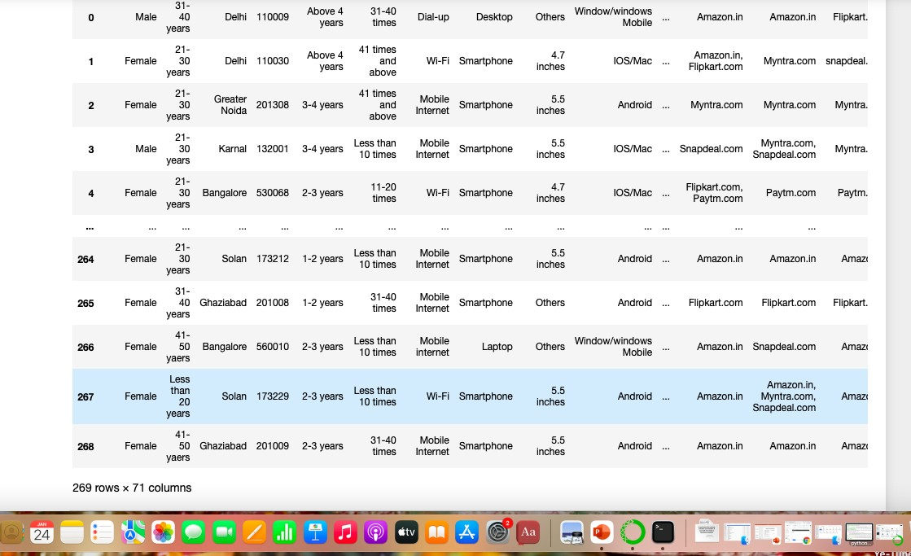

There are totally 269 rows and 71 columns in this dataset

-> Our objective is to find the insights of the data and to do thorough data analysis.

# Hardware and Software Requirements and Tools Used

For doing this project, the hardware used is a laptop with high end specification and a stable internet connection. While coming to software part, I had used anaconda navigator and in that I have used **Jupyter notebook** to do my python programming and analysis.

For using an excel file, Microsoft excel is needed. In Jupyter notebook, I had used lots of python libraries to carry out this project and I have mentioned below with proper justification:

* Pandas- a library which is used to read the data, visualization and analysis of data.
* NumPy- used for working with array and various mathematical techniques.
* Seaborn- visualization tool for plotting different types of plots.
* Matplotlib-It provides an object-oriented API for embedding plots into applications.

# Data Analysis

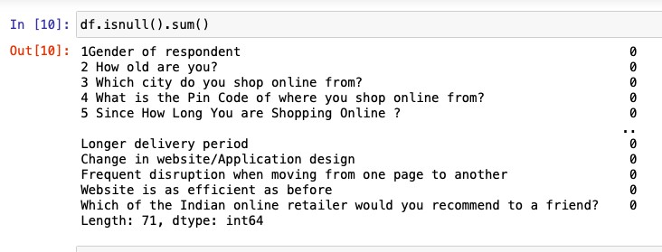.

There are no null values in this dataset and 70 columns are of object datatype and only 1 column is of int data type.

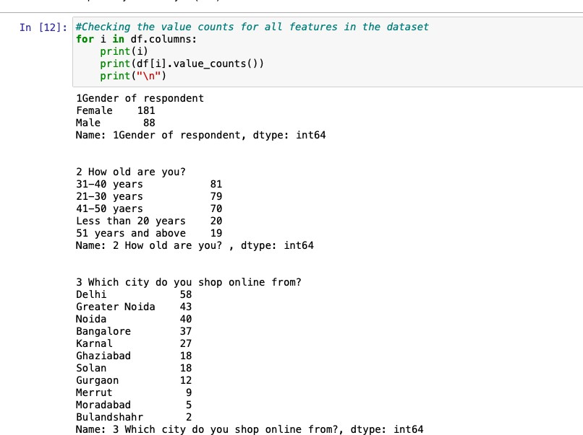

We checked the value counts of all 71 columns above and we iterated using a for loop. We can see some value counts of the columns like gender, age, city, etc. Below I had attached the value counts of other columns.

# Analysis of website feedbacks obtained

We can see that after column 47, there are both positive and negative feedbacks of the websites, which are given by the correspondents. We will analyze those data by using data analysis process.

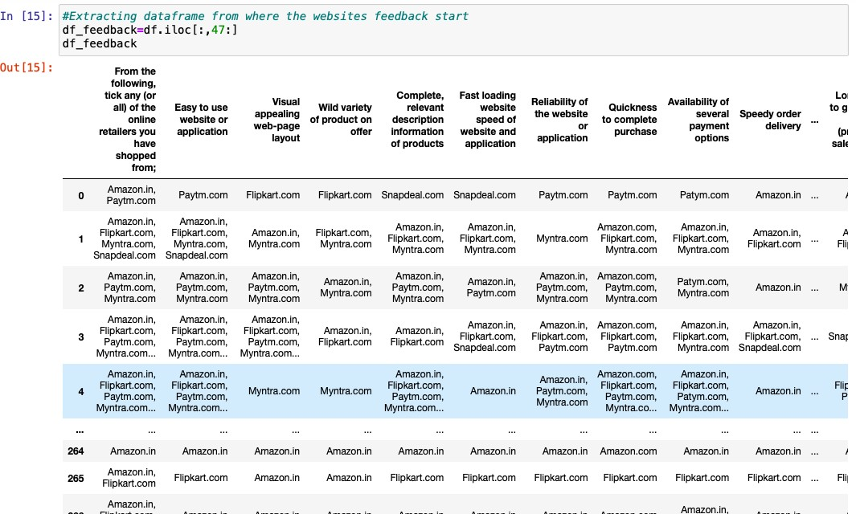

First, we will extract only the feedbacks data and then save it in a new data frame, which will be used for further process.

#A separate dataframe for displaying the positive feedback dfnew1=df_feedback.drop(["Longer time to get logged in (promotion, sales period)",

"Longer time in displaying graphics and photos (promotion, sales period)",

"Late declaration of price (promotion, sales period)", "Longer page loading time (promotion, sales period)", "Limited mode of payment on most products (promotion, sales period)",

"Longer delivery period", "Frequent disruption when moving from one page to another"], axis=1)

# A separate dataframe for displaying the negative feedback

dfnew2=df_feedback[["Longer time to get logged in (promotion, sales period)",

"Longer time in displaying graphics and photos (promotion, sales period)",

"Late declaration of price (promotion, sales period)", "Longer page loading time (promotion, sales period)", "Limited mode of payment on most products (promotion, sales period)",

"Longer delivery period", "Frequent disruption when moving from one page to another"]]

Now, we will analyse the negative feedbacks first by checking the count of websites and the type of feedbacks given to each website. Then, we will save the obtained data in a new data frame and rename the column names.

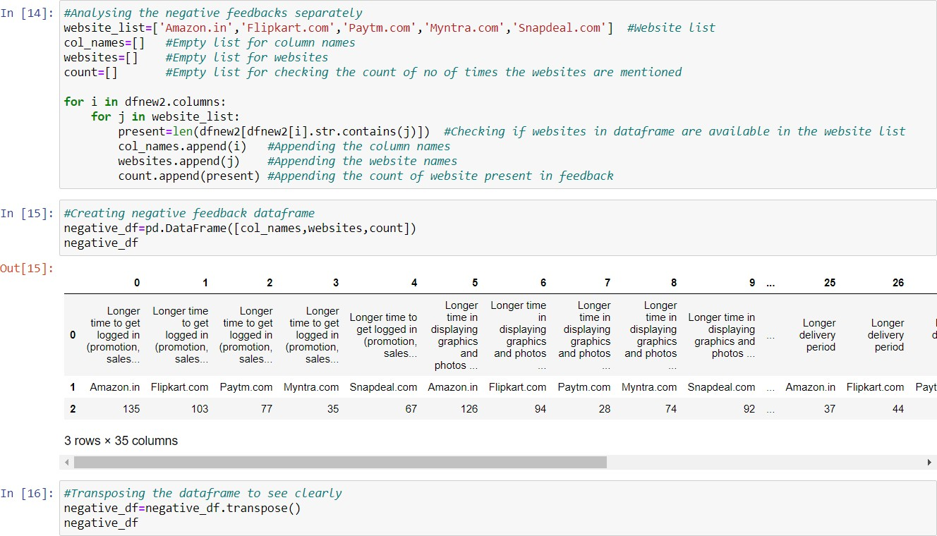

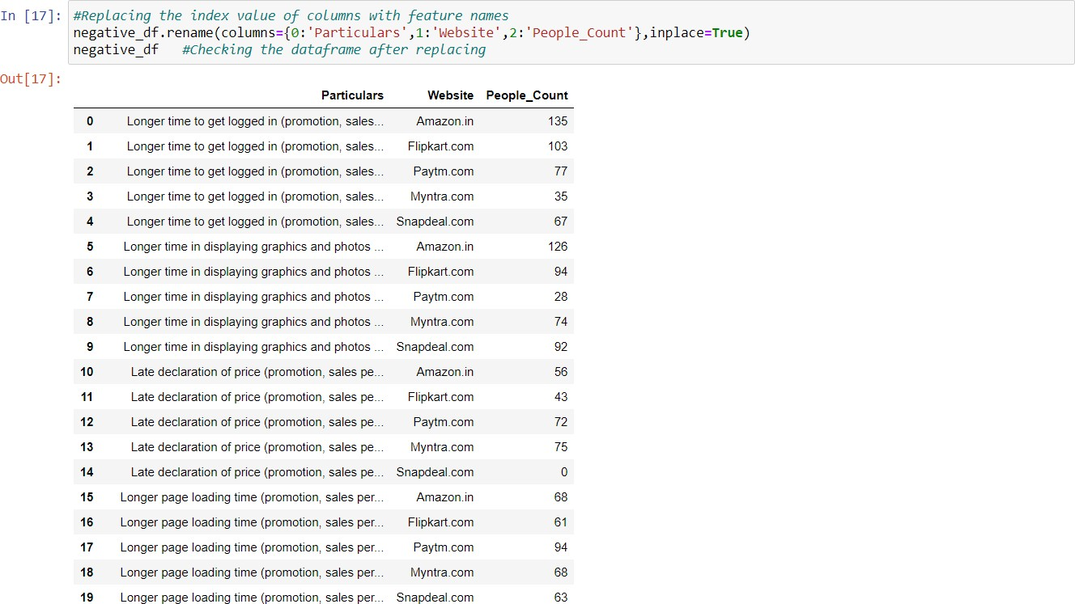

Now, we will analyze the positive feedbacks by checking the count of websites and the type of feedbacks given to each website. Then, we will save the obtained data in a new data frame and rename the column names.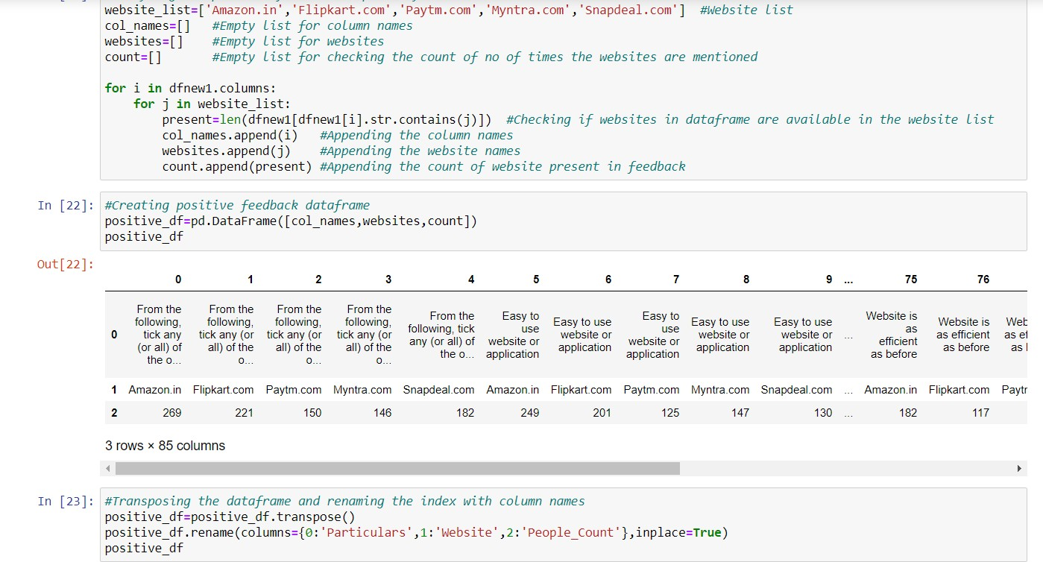

# Calculating the percentage wise feedback analysis

Now, we will calculate the percentage of people giving the feedbacks to the website for both positive and negative data.

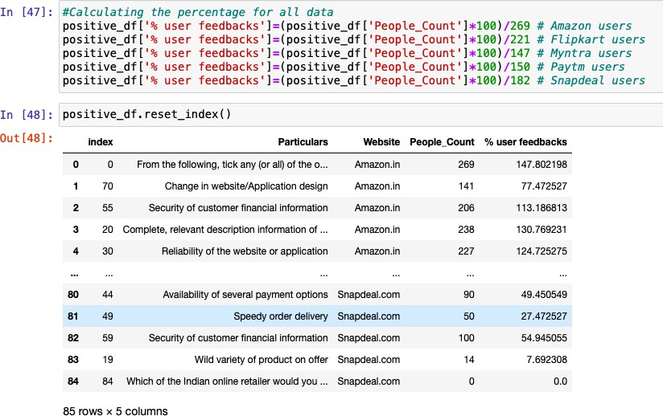

# Observations:

1. Amazon and Flipkart rank about 90% in satisfying customers, followed by Myntra.
2. The maximum percentage Paytm and Snapdeal could score here is 83 and 71 respectively.
3. No one is willing to refer Snapdeal to their contacts as it has the less percentage among all websites.
4. On an average, Snapdeal and Paytm scores are less when compared to amazon, Flipkart and Myntra.

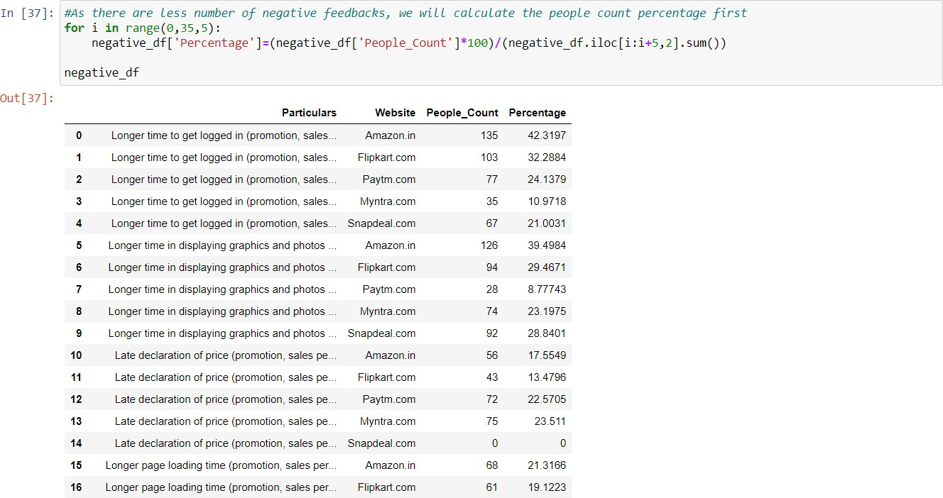

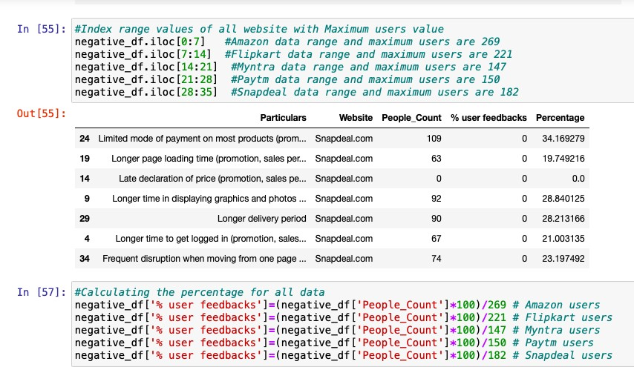

# Observations:

1. Around 65% of Paytm customers are not happy with their delivery period and longer term in loading pages.

Approx. 60% of Snapdeal customers are not happy about their limited mode of payment and nearly 50% of people are not satisfied in longer time of displaying graphics.

1. We can observe that even though with count wise, Amazon and Flipkart showed more negative reviews. When we take percentage, in top 10, Amazon has appeared only once and Flipkart has not even appeared even one time.

The highest percentage Myntra got is 51, whereas Flipkart's highest percentage is 46. However, other websites like Paytm, snapdeal.com have got highest percentage for negative reviews around 60-67%.

1. In terms of less dissatisfaction, myntra.com and Flipkart are better, followed by amazon.

# Visualizations

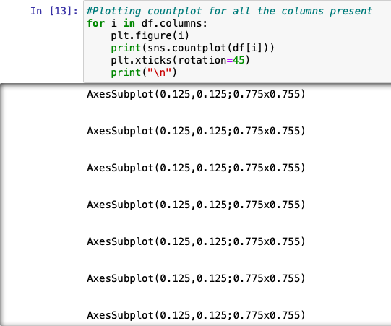Now, we will see the different plots done with this dataset in order to know the insight of the data present. Below are the codes given for the plots and the output obtained:

Below are some of the outputs obtained after running the above code:

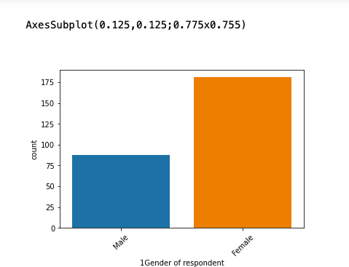

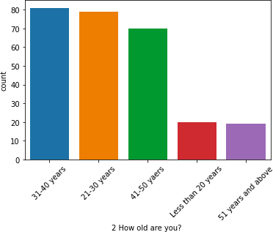

# Observations from the count plot:

* + There are more women respondents than men. It could be that data collection is mainly focused on women.
  + Amongst the respondents, the major class targeted is between 21-40 years, followed by 41-50 and less than 20 years. We can understand that the correspondents are mostly from working class.
  + The respondents are majorly residing in cities like Delhi, Greater Noida, Noida and Bangalore.
  + Majority are shopping online for more than 4 years. There are considerable people who are shopping online since less than one year and also it shows that many new customers are being added every year.
  + We can observe that many have shopped less than 10 times in the past year.
  + Many of them use mobile to shop online, followed by laptop, desktop and tablet.
  + Windows constitute the major OS of the customer device, followed by Android and Mac.
  + Google Chrome is majorly used to access the shopping website.
  + People are becoming customers of their favourite stores by using the search engine. Content marketing or display advertisements are not that impactful when coming to online marketing. So, companies should spend more on advertising on search engines.
  + For repeated visits, people use search engine first, followed by app and direct URL. We can see that difference between app and search engine is small.
  + Majority of the people spend more than 15 minutes before making a purchase, followed by 6-10 minutes.
  + The major payment method used by all is credit/debit cards, followed by COD and e-wallets.
  + People have mentioned that sometimes they would leave the cart without purchasing and the major reason they have mentioned is that they are finding some better alternative offer. It means that people are comparing from many online websites before making any purchase.
  + Customers strongly agree that content of website must be easy to read and understandable.
  + Majority of customers want information of similar products to make purchase.
  + Majority of the customers want complete information on listed sellers and their products being offered.
  + Customers want all relevant information on the listed products and very less customers disagree to that.
  + The customers wanted the websites to be easily navigated.
  + Majority of the customers wanted high loading and processing speed, user friendly interface of website,

convenient payment method, high trust on website, empathy towards customers, guarantee privacy of customers, responsiveness-availability of several communication channels, etc.

* + People feel that online shopping provides monitory benefits and discounts.
  + Customers also feel that shopping online is convenient and flexible.
  + Return policy is important for deciding the product purchase to many customers.
  + Many customers find shopping through online helps them financially because of cost and discount factors.
  + When it comes to certain factors like gratification, social status enhancement because of shopping, or whether shopping online gives a thrill or adventure, customers are more indifferent to these. So, there is an ample scope in giving more enhanced experienced to customers in this regard.

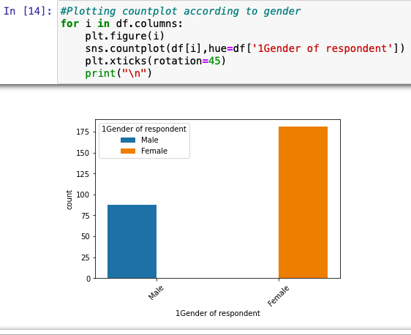

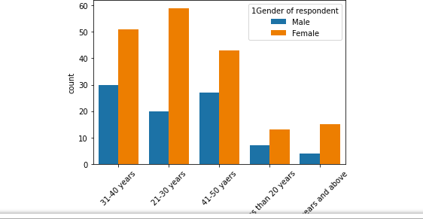

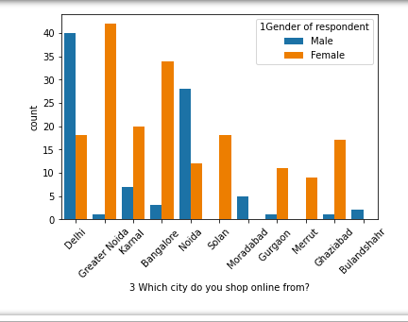

# Observations:

* + Above 41-50 years and less than 20 years, female and male respondents count difference is not much.
  + From Bangalore and Greater Noida, many respondents are female.
  + From Noida and Delhi, many respondents are male.
  + Both men and women shopping from desktop count are almost same. However, more women shop from either smartphone or laptop.
  + Most of the women come back to shopping website by using search engine.
  + Many women prefer to use search engine or app, rather than direct URL. However, men prefer to use search engine and URL and app little less. So, we can understand that women use app more than men.
  + Women spend more time than men during online shopping and the time is mostly more than 15 mins, followed by 11-15 mins.
  + Women too compare the products with other websites and is one of the reasons to leave the cart without shopping.
  + Women prefer more loyal points than men.
  + More women disagree that online shopping is a kind of adventure. So, websites need to work towards giving real time experience as this can be a big marketing strategy.
  + Women don’t feel that online shopping fulfils certain roles.
  + Rest of all other observations are similar as observed in the before count plots.

# Website vs People count:

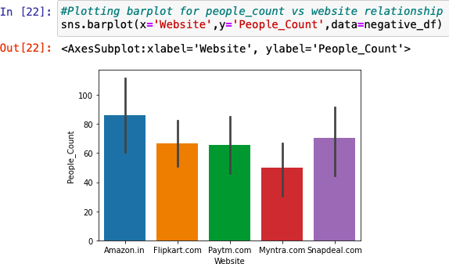

During the promotion time, Amazon has received more negative feedback from customers followed by Snapdeal, Flipkart and Paytm.

We can note that difference between negative feedbacks of the websites is not very huge and it needs to be improved in order to handle such situations.

#Taking a list of numbers import numpy as np b=np.array(range(17)) b=b*5

b=list(b)

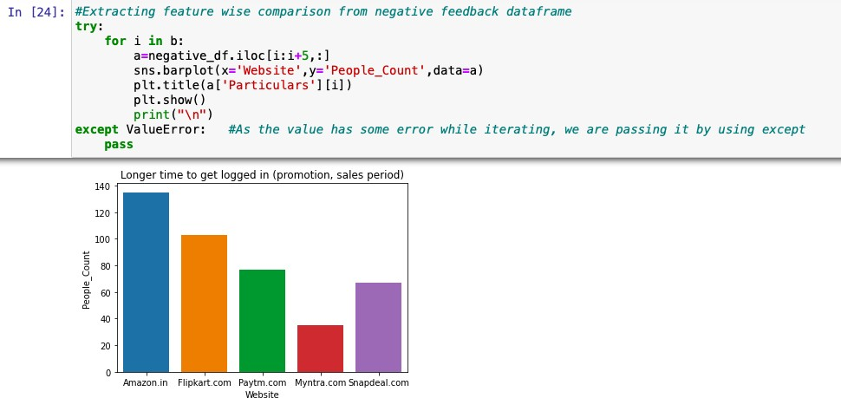

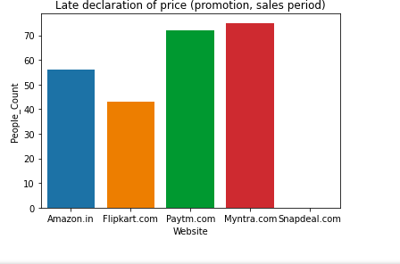

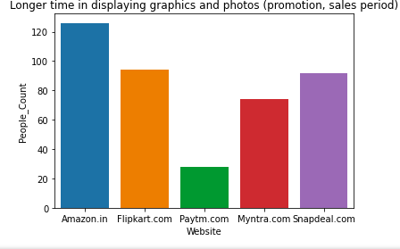

# Observations:

1.Amazon takes longer time to get logged in during promotion, followed by Flipkart, Paytm and Snapdeal.

2.Amazon takes longer time in displaying graphics and photos followed by Flipkart and snapdeal.com.

3.Myntra and Paytm makes late declaration of price during promotion.

4.Paytm takes longer time to load the page during promotion.

5.Snapdeal and Amazon have limited mode of payment on most of products during promotion.

6.Paytm and Snapdeal take a longer delivery period, whereas Myntra and Amazon takes lesser delivery period.

7.Amazon, Snapdeal and Myntra have frequent discrepancies, when moving from one page to another.

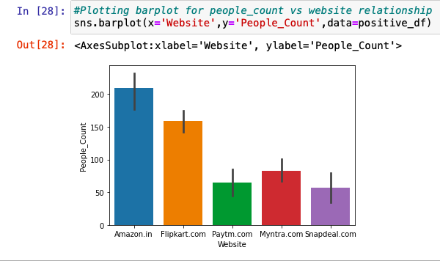

# Plotting pie-chart for website vs people count:

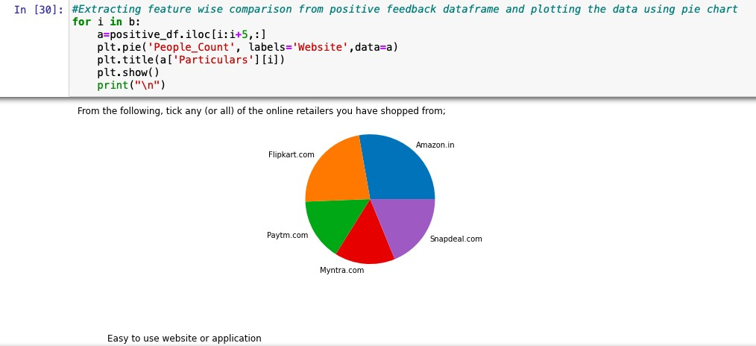

Flip kart com

Paytm co m

Snapdeal.com

Myntra.com

Visual appealing web-page layout

Amazon.in

Flipkart. com

Snapdeal

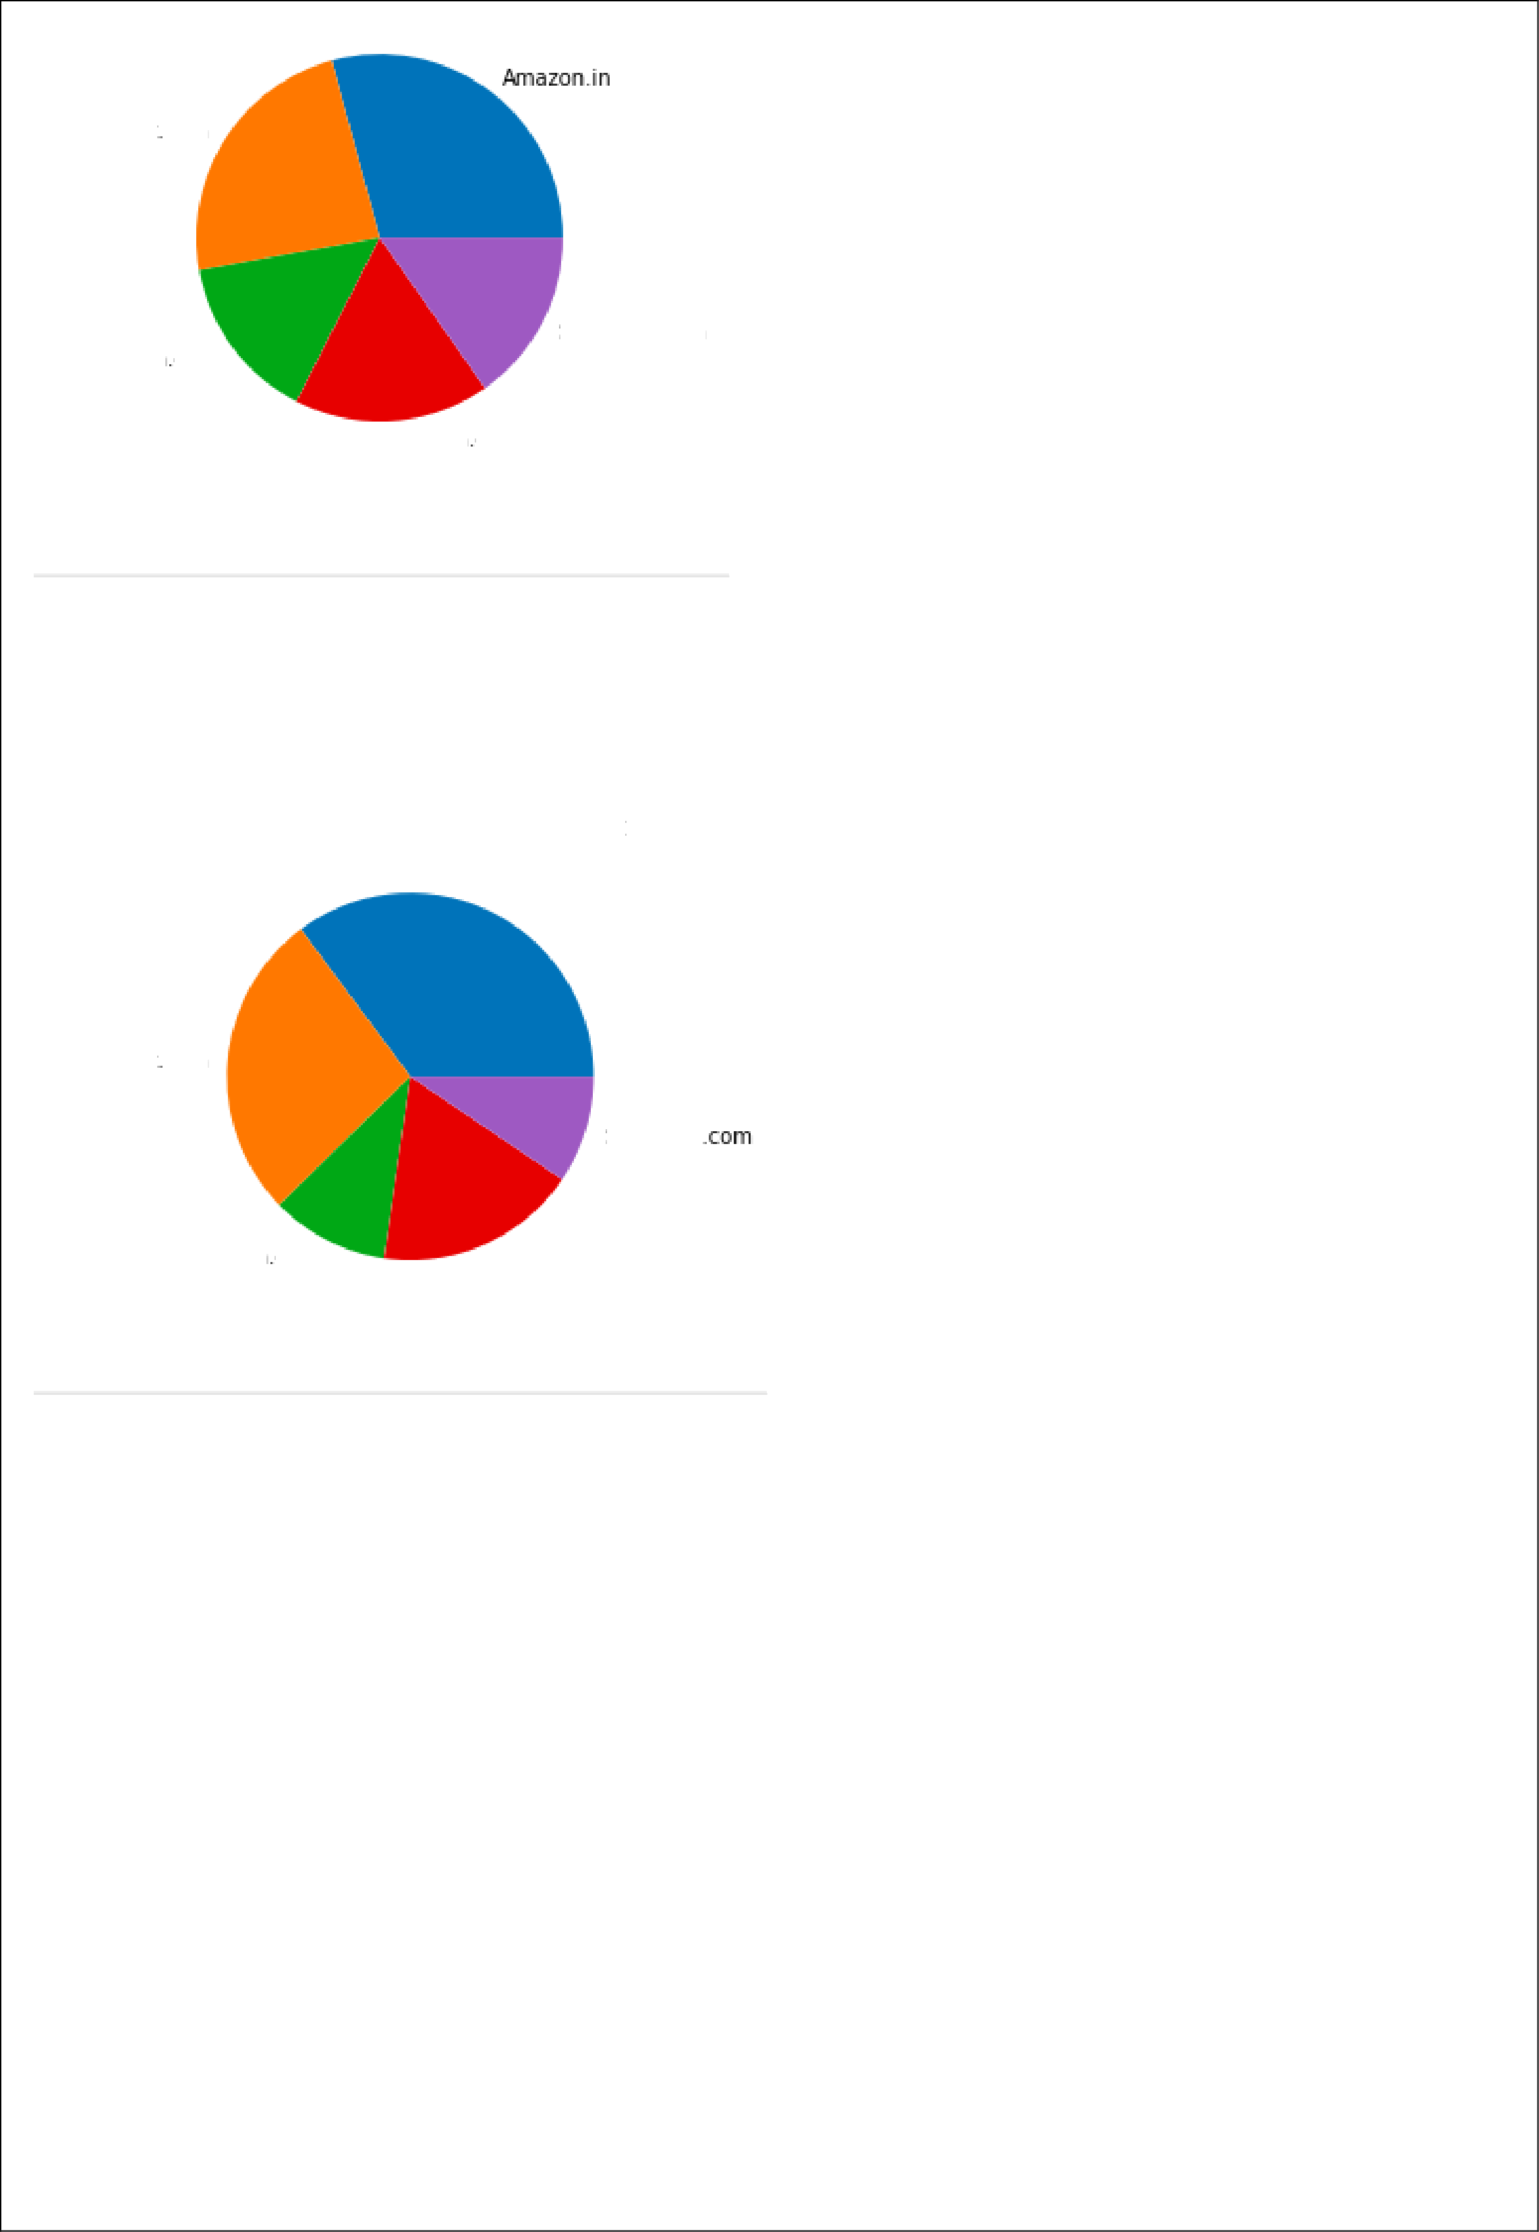Paytm

Myntra.com

# Feature wise comparison from positive feedback data frame and plotting bar plot:

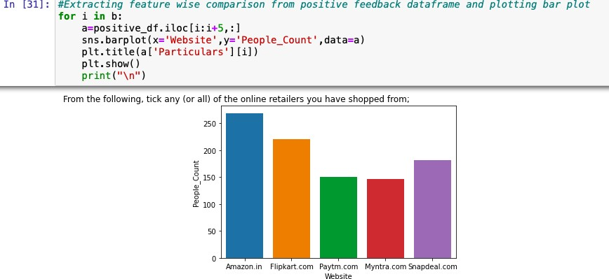

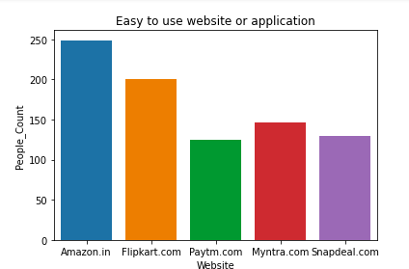

**Observations:**

1. Many customers have shopped from Amazon and Flipkart.

2. Amazon and Flipkart have been named most as easy to use website

3. Amazon and Flipkart have been named as the most visually appealing web page layout and also having wild variety of products.

4. Paytm and Snapdeal had not been given more marks on availability of wild variety of

5. Amazon and Flipkart have got more positive feedbacks than other websites with relevant to 6. Complete, relevant description information of products, Fast loading of websites, Reliability of website, quickness to complete purchase, availability of several payment options, speedy order delivery, privacy of customers information, security of customer financial information, etc.

7.Paytm has got less feedbacks in perceived trustworthiness, presence of online assistance through multi-channel, speed order delivery.

8. Snapdeal.com has got a smaller number of feedbacks in change of website/application design.

9. Myntra has got the least feedbacks in website as efficient as before, followed by Snapdeal.

Only one person has recommended Snapdeal.com overall.

# CONCLUSION

**Key Findings and Conclusions of the Study**

**1. Amazon.com:**

***To be improved:***

1.During promotions, try to give a disturbance free shopping experience to customers.

1.Give more payment options to customers.

2.Try to give price early during promotion.

3.Reduce the delivery time of the products.

***Positive feedback summary:***

1.Convenient to use and also a good website for shopping.

2.Fast delivery of products.

3.Availability of complete information of the products.

4.Presence of online assistance through multi-channels.

5.Reliable website or app, perceived trustworthiness.

**2. Flipkart.com**

***To be improved:***

1.During promotions, try to give a disturbance free shopping experience to customers.

2.Give more payment options to customers.

3.Try to give the price early during promotion.

4.Reduce the delivery time of the products.

5.Flipkart and Amazon almost share the same feedbacks with varying percentages as the only difference

***Positive feedback summary:***

1.Convenient to use and also a good website for shopping.

2.Fast delivery of products.

1. Availability of complete information of the products.
2. Presence of online assistance through multi-channels.
3. Reliable website or app, perceived trustworthiness.
4. Wild variety of products to offer.

**3. Myntra.com**

***To be improved:***

1. During promotions, try to give a disturbance free shopping experience to customers.
2. Try to give the price early during promotions.
3. Reduce the delivery time of the products during promotions.

***Positive feedback summary:***

1. Convenient to use and also a good website.
2. Availability of several payment options.
3. Faster products delivery.
4. Complete information of products available.
5. Reliable website or app, perceived trustworthiness.
6. Wild variety of product to offer

**4. Paytm.com**

***To be improved:***

1. Reduce the delivery time of the products during promotions.
2. Try to give the price early during promotion.
3. During promotions, try to give a disturbance free shopping experience to customers.
4. Late declaration of price and discounts.
5. Frequent disturbance is occurring while moving from one page to another.

***Positive feedback summary***

1. Convenient to use and a good website.
2. Quickness to complete a purchase.
3. About 64% of the customers feel that either web or app is reliable.
4. Around 20% of the customers believe that Paytm has a wild variety of products on offer.
5. **Snapdeal.com**

***To be improved:***

* Reduce the delivery time of the products during promotions.
* Try to give the price early during promotion.
* During promotions, try to give a disturbance free shopping experience to customers.
* Late declaration of price and discounts.
* No one has expressed to recommend Snapdeal to a contact as it has the most negative feedbacks among all other websites.

***Positive feedback summary:***

1. Convenient to use.
2. 54% of the customers are happy about the availability of financial information security.

# General suggestions and recommendations to all the e- commerce websites

1. Improve the experience of shopping for customers, as there is a lot of scope in enhancing the shopping experience to the customers using AI.
2. Continue giving more financial benefits like coupons, cashbacks, etc. as customers are very much attracted to it.
3. Trustworthiness and approachability through various channels are still highly rated by customers.
4. Majority of the customers are working class women and their age is between 20-40. Always bring variety of products targeting them.
5. Provide more customer friendly approach like fast delivery, complaint resolution, etc.

Therefore, we had analyzed the given dataset by using various data analysis process and also, we had concluded the analysis by observing the positive and negative feedbacks obtained. We recommended some suggestions for the websites to improve further in the future.