question1

@tribetect

July 21, 2015

storms4 <- readRDS("partial_output/storms4_clean.RDS")   
require(ggplot2)

## Loading required package: ggplot2

require(reshape2)

## Loading required package: reshape2

humancost <- melt(tapply(storms4$HUMANCOST, INDEX = storms4$EVGROUP, FUN = "sum"))  
  
gghuman <- ggplot(data = humancost, mapping = aes(x = Var1, y = value))  
  
gghuman + geom_bar(stat = "identity")+ ylab("Human Cost - Death and Injury") + xlab ("Event Type Group") + theme(axis.text.x = element_text(angle = 90, hjust = 1))

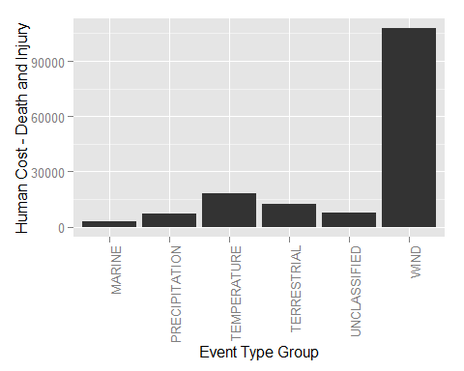

econdmg <- melt(tapply(storms4$ECONDMG, INDEX = storms4$EVGROUP, FUN = "sum"))  
  
ggecon <- ggplot(data = econdmg, mapping = aes(x = Var1, y = value))  
  
ggecon + geom_bar(stat = "identity")+ ylab("Crop and Property Damage") + xlab ("Event Type Group") + theme(axis.text.x = element_text(angle = 90, hjust = 1))

