# 

# Algorithm

A limited set of exact instructions, usually used to carry out calculations or solve a certain category of issues.

## Properties of Algorithm

defined input

defined output

Definiteness.

Effectiveness.

Finiteness.

### Advantage of the algorithm

* It is simple to understand because a solution to a specific problem is presented step by step.
* An algorithm follows a specific protocol.
* It is not based on any programming language, making it simple to understand even for those without a background in programming.
* An algorithm is simple to troubleshoot since each step has its own logical sequence.
* The problem is divided into smaller components or steps using an algorithm, making it simpler for programmers to turn the problem into a working software.

Disadvantage of the algorithm

* + Time-intensive algorithms.
  + It's challenging to demonstrate looping and branching in algorithms.
  + It is challenging to incorporate large jobs into algorithms.

Process of developing application

Idea and conceptualization

Planning and research

Design

Testing

Prototype

Developing

Release

Maintenance

Define an algorithm

A method for completing a computation or solving a problem is called an algorithm. In either hardware-based or software-based routines, algorithms function as a detailed sequence of instructions that carry out predetermined operations sequentially(Gillis, 2022).

<https://www.techtarget.com/whatis/definition/algorithm>

Draw out flowchart

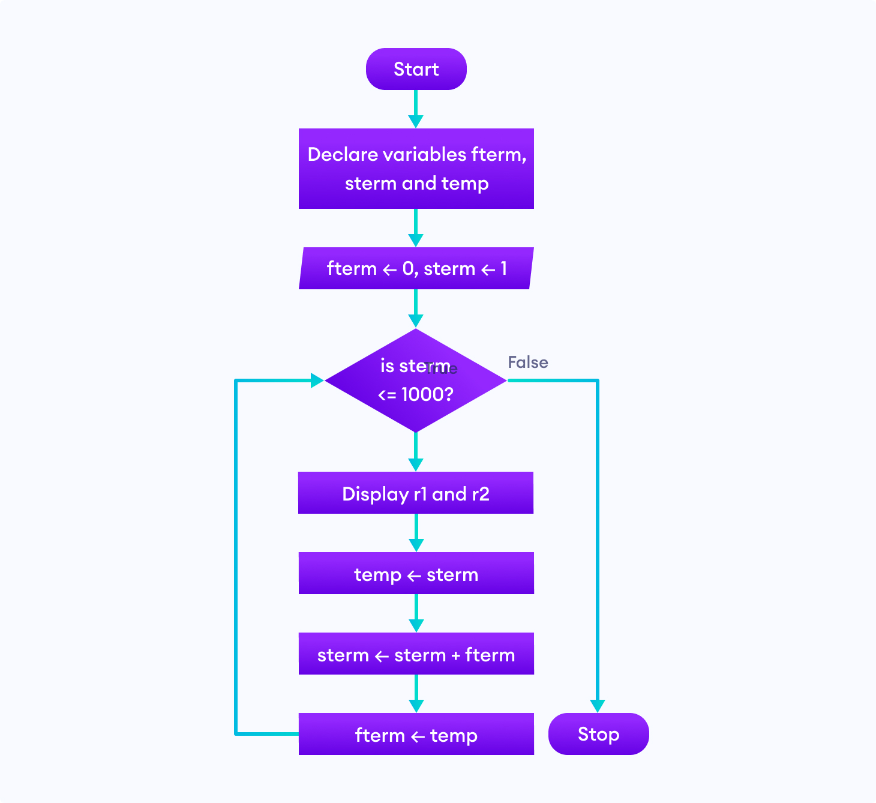

<https://www.google.com/search?q=flowchart&rlz=1C5CHFA_enNP1021NP1021&sxsrf=AJOqlzWsmXopf5jUTYdNr-KKyHgyPT0sAw:1675269149496&source=lnms&tbm=isch&sa=X&ved=2ahUKEwjo87v03_T8AhWZTWwGHQhLCBMQ_AUoAXoECAEQAw&biw=1440&bih=719&dpr=2#imgrc=3gBpw-wz27aBRM>

Choose platform

Integrated development environment

A program's various components can be consolidated by programmers using an IDE, or integrated development environment.

By merging common software development tasks such as editing source code, creating executable files, and debugging into a single program, IDEs boost programmer productivity.

<https://www.codecademy.com/article/what-is-an-ide>

Visual studio code

For Windows, Linux, and macOS, Microsoft created Visual Studio Code, sometimes known as VS Code[10], a source-code editor. It uses the Electron Framework. [11] Included in the features are support for debugging, syntax highlighting, intelligent code completion, snippets, code refactoring, and embedded Git. The theme, keyboard shortcuts, options, and extensions that offer more functionality can all be changed by users.

Seventy percent of the 82,000 respondents to the Stack Overflow 2021 Developer Survey identified Visual Studio Code as the most used developer environment tool.

C, C#, C++, Fortran, Go, Java, JavaScript, Node.js, Python, and Rust are just a few of the programming languages that may be utilized with Visual Studio Code, a source-code editor. It is founded on the Electron framework.

The software can be used as a free option for web development because Visual Studio Code comes with a variety of FTP extensions. Without requiring any further software downloads, code may be synchronized between the editor and the server.

Users of Visual Studio Code can choose the programming language, newline character, and code page in which the active document will be saved. As a result, it can be used with any programming language, on any platform, and in any location.

Microsoft receives utilization information from Visual Studio Code, however this feature can be turned off.

Since the application is open-source, anyone may view the telemetry code and see exactly what data is gathered.

<https://en.wikipedia.org/wiki/Visual_Studio_Code>

Low level language

Programming languages that deal with a computer's hardware and limitations are referred to as low-level languages. It works to control a computer's operational semantics and has little to no abstraction (if any) in relation to computers.

The entire hardware and instruction set architecture of a computer can be operated and handled directly by low-level languages.

Languages with a low level of abstraction are thought to be more computer-like. To put it another way, their main job is to manage, operate, and manipulate the computer hardware and components. The computing hardware may directly execute programs and applications written in a low-level language without any emulation or translation.

Popular low-level languages include machine language and assembly language.

<https://www.techopedia.com/definition/3933/low-level-language>

High level language

High-level programming languages are those used to provide computer instructions that are simple to understand and closely resemble human language. Developers design high-level languages so that programmers do not have to be proficient in extremely challenging low level/machine languages. High-level languages are highly similar to human language, so programmers can learn them quickly. In contrast, programming in low level programming languages is done in a way that is connected to the hardware ( or we can say Hardware).

To be succinct, As opposed to low-level programming languages, which are difficult to learn because they are linked to machine language and require that every instruction we pass be in binary format, such as 0 or 1, high-level programming languages are associated with human understandability.

<https://medium.com/@rsk.saikrishna/what-is-high-level-programming-language-24571649cd6f>

Preprocessor

A preprocessor (or precompiler)[1] is a computer science term for a program that transforms the data it receives as input into output that is then utilized as input by another program. The output is referred to as a preprocessed version of the input data, which is frequently employed by some following programs like compilers. The type of preprocessor used determines the quantity and type of processor that may be executed; some preprocessors are limited to very simple textual substitutions and macro expansions, while others have the power of full-fledged programming languages.

<https://en.wikipedia.org/wiki/Preprocessor#:~:text=In%20computer%20science%2C%20a%20preprocessor,some%20subsequent%20programs%20like%20compilers>

Compiler

A piece of software that compiles source code written using a high-level language (such as C++) into a compilation of instructions that can be read by the CPU of a digital computer. Compilers are highly complicated programs with features like error-checking. Some compilers convert high-level languages into intermediate assemblies, which are then processed (assembled) into machine code by an assembly program or assembler. Certain compilers actually generate machine language.

<https://www.britannica.com/technology/compiler>

Assembler

The symbolic program code that is most similar to machine language in both form and content is called assembler. When you require precise control over your software down to the byte or even bit tier, the assembly language is advantageous.

When a function is not supported by another symbolic programming language, such as COBOL, Fortran, or PL/I, you must build a subroutine to perform the task.

Statements in the assembler language can either be considered comments or instructions. The working part of the language is composed of the following three groups of instruction statements:

* instructions for a machinery
* assembly guidelines
* macro directives

<https://www.ibm.com/docs/en/zos/2.2.0?topic=SSLTBW_2.2.0/com.ibm.zos.v2r2.asma400/asmr102112.html>

Linker

A system software called a linker, also referred to as a link editor or binder, integrates object modules into a single object file. In most cases, linking is carried out by a program, which uses one or more object files that the compiler produces to accomplish this task. And after that, you join these files to create an executable file. The many parts of code that are produced in programming languages are referred to as modules. A method called linking aids in assembling and maintaining several pieces of code into an executable or single file. A customized package is also linked into the system library with the aid of a linker.

<https://www.javatpoint.com/what-is-a-linker>

Loader

A component of the operating system is a loader. As it loads the program into memory and prepares it ready to run it is necessary for beginning any application. In order to load applications as soon as possible, the loader is permanently stored in memory.

The operating system must be loaded into system memory before the computer can start up. This is the task of the boot loader, a specialized kind of loader. A loader may or may not be used by embedded systems. This is frequently the case for low-level machines that execute code straight from storage media, frequently EEPROM or flash memory, and are devoid of operating systems.

<https://www.technipages.com/what-is-a-loader>

Reference

Gillis, A.S. (2022) *What is an algorithm? - definition from whatis.com*, *WhatIs.com*. TechTarget. Available at: https://www.techtarget.com/whatis/definition/algorithm (Accessed: February 2, 2023).