**README.md**

**PROJECT TITLE**

* GOODS TRANSPORTATION SERVICE is committed to provide best freight services for transportation of goods in the industry delivering full truck road all over India.
* A person can register himself as a dealer or driver by filling out some basic information.
* A dealer asks for the truck in the required state and city and all the drivers going through that route will be displayed on the dashboard.
* And for the driver the details will be showed on the dashboard that who has booked his truck on which date and for which state.
* **Deployement Link:** https://goods-transport-system.herokuapp.com/

**SCREENSHOT**

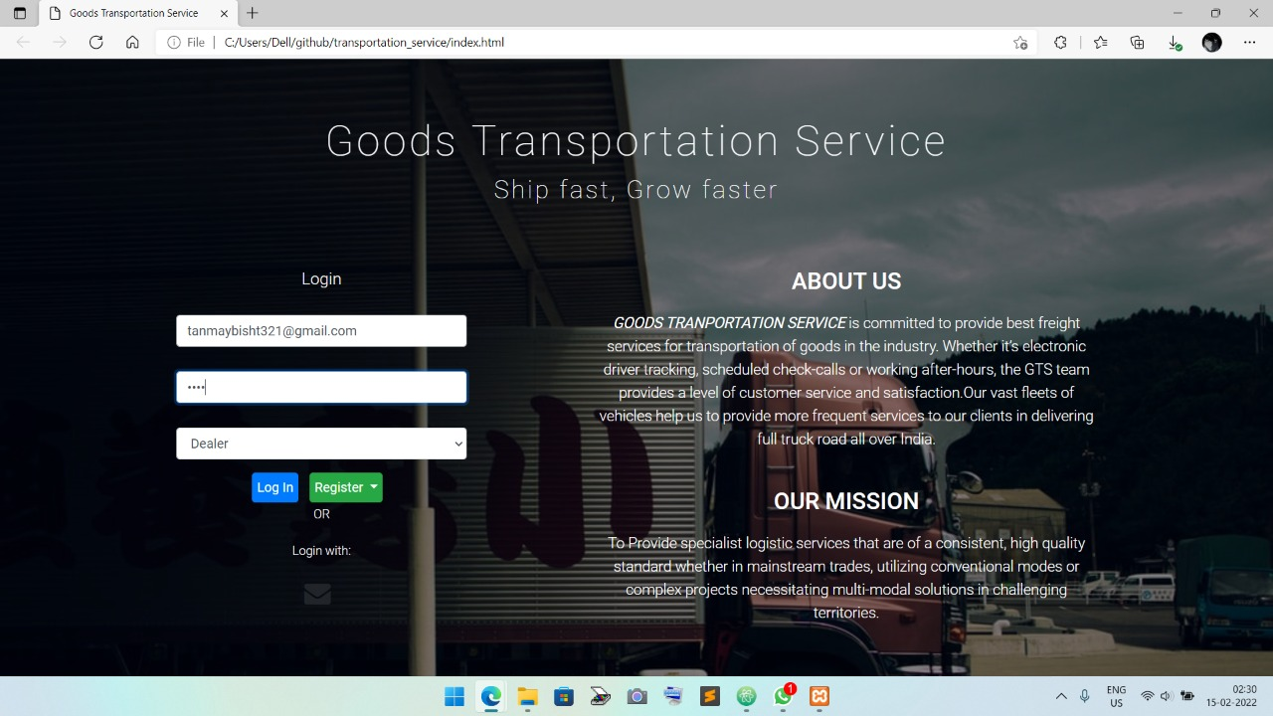

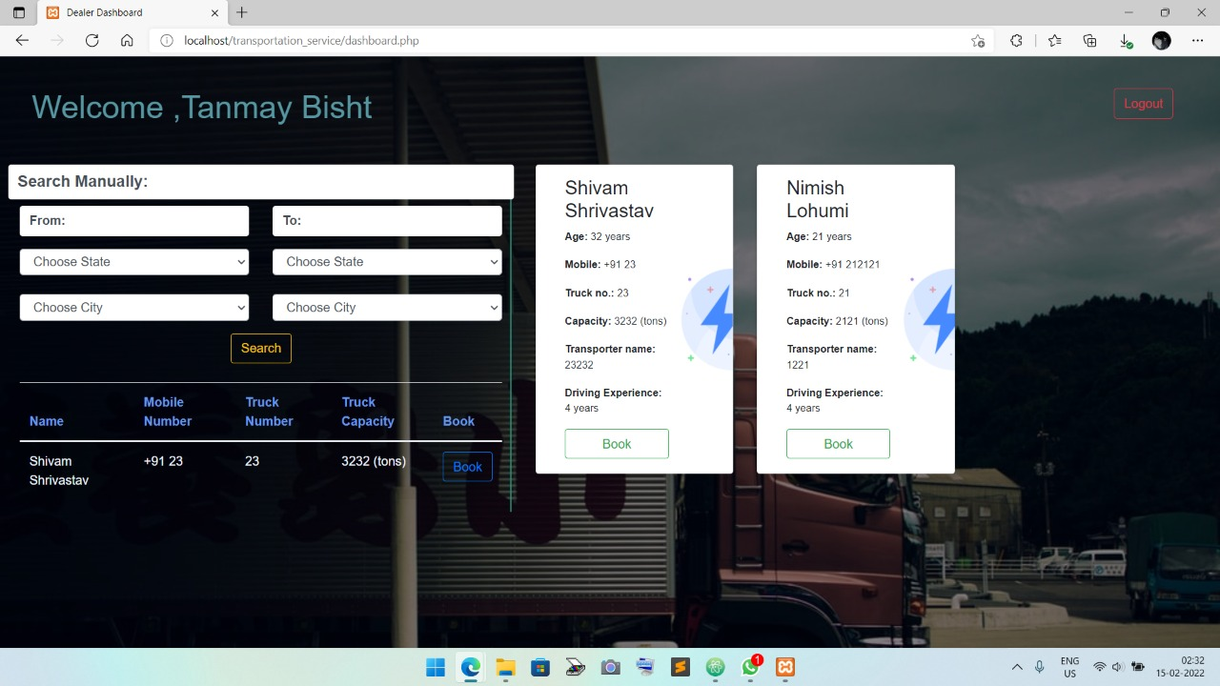

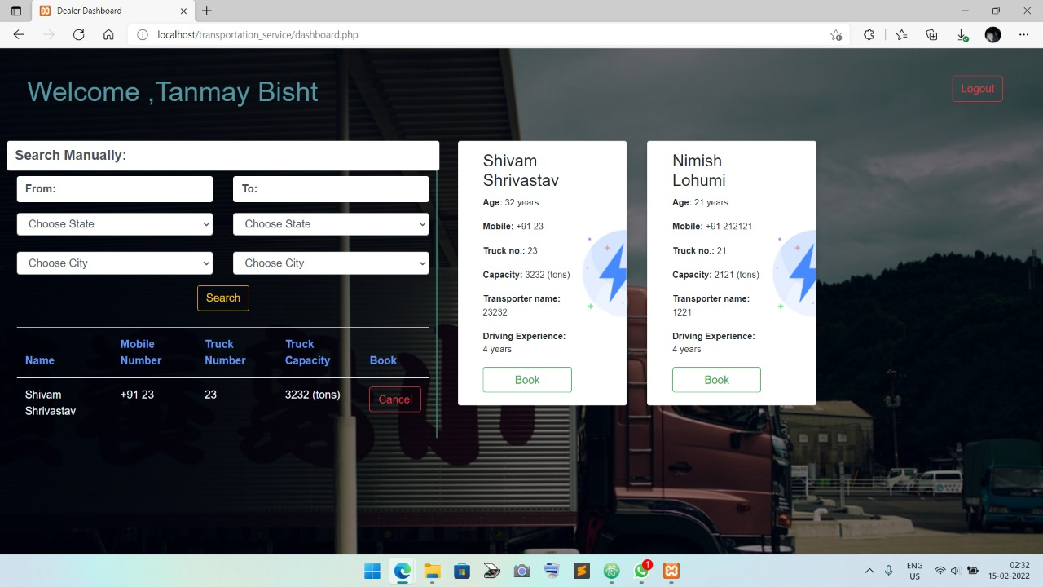

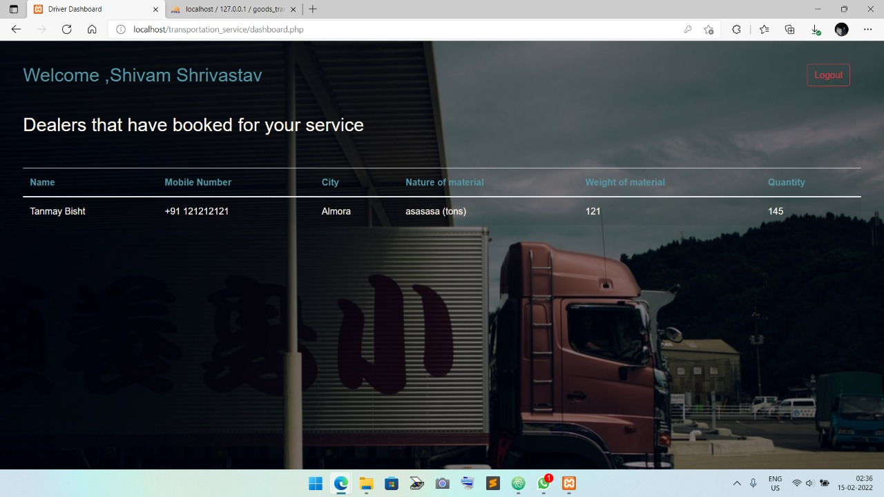

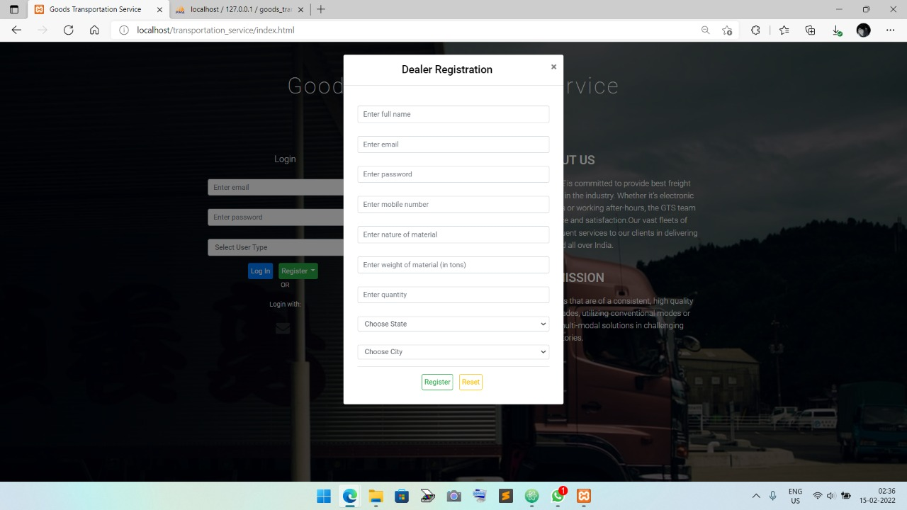

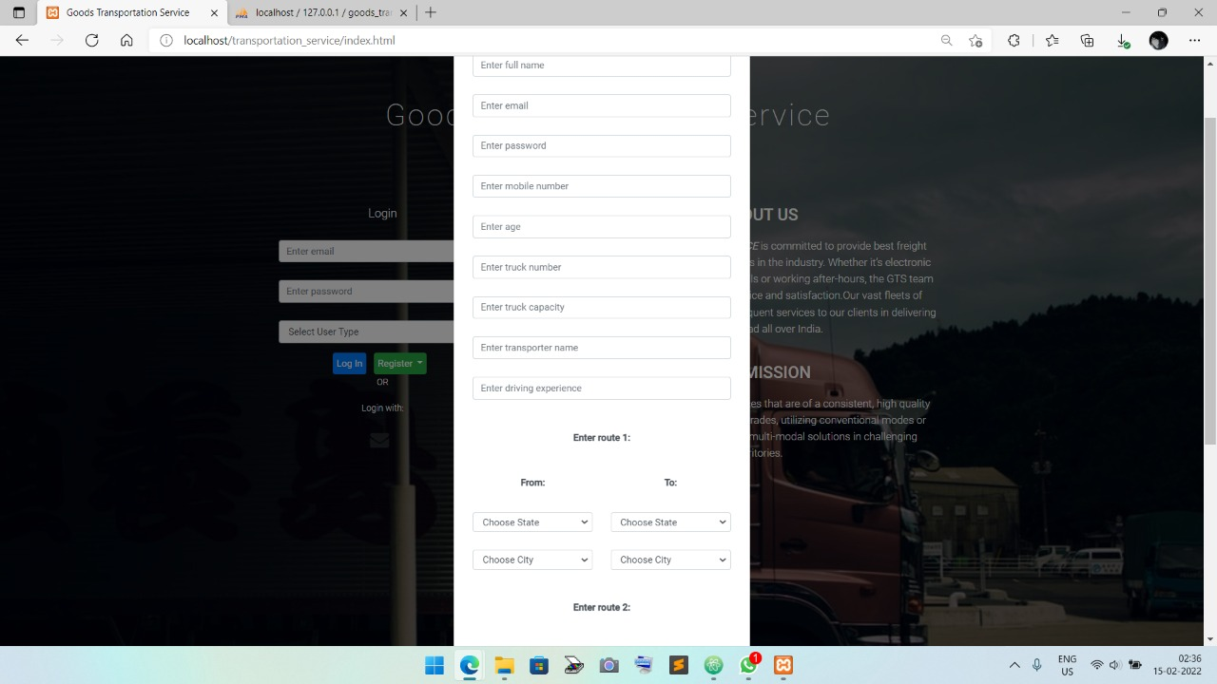

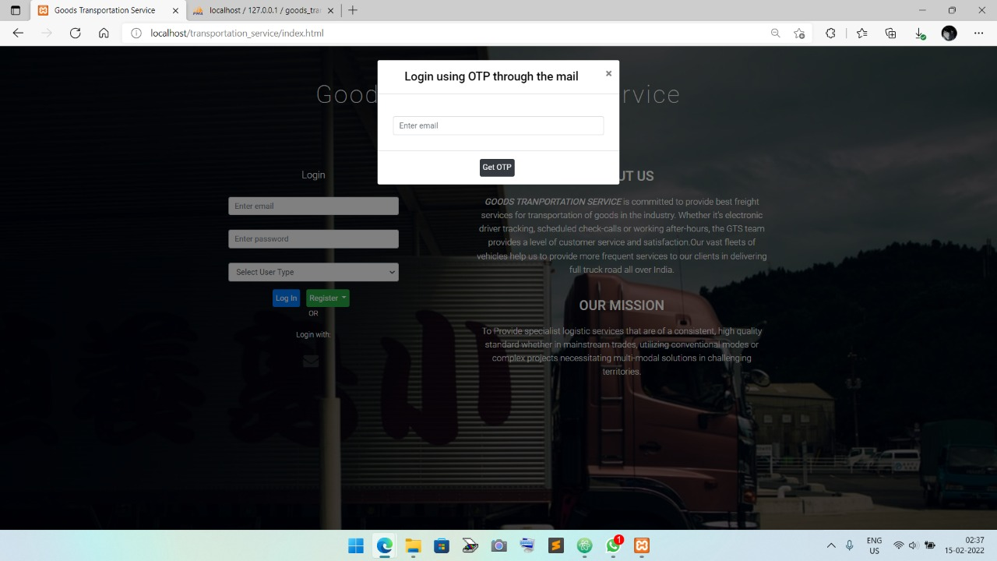

**TECH/FRAMEWORK USED**

**HTML** - It describes the structure of the Website.

**CSS** - It describes how HTML elements should be displayed.

**BOOTSTRAP** - Faster stylesheet, more responsive and smooth overhaul for the website.

**Javascript** - It is the programming language of the Web.

**MySQL** - It is a standard language for storing, manipulating and retrieving data in databases.

**PHP** - scripts are executed on the server

**HOW TO USE?**

* First you need to install xampp on your laptop/desktop. XAMPP helps you to test its website via laptops before releasing it to the main server. It is a platform that furnishes a suitable environment to test and verify the working of projects based on MySQL database and PHP through the system of the host itself.
* Then you have to extract the zip file provided by us in your local drive in the format C:\xampp\htdocs create a database named as goods_transportation_service in xampp and import the SQL file.
* Now paste the url- http://localhost/transportation_service-main in your browser and proceed further.

**LICENSE**

Apache