**GAME THEORY**

Need to make decision which development tool to use in project.

2 options:

|  |  |
| --- | --- |
| ICE | SPRINT |
| Well proven | Latest development |
| Can be shipped immediately | Should be released very soon |
| Low performance, development costs may be high | May substantially reduce the development costs |

Which one to choose to minimize the development costs?

Decision not obvious if the situation is

1) Not fully under control

2) Input information incomplete

- Will product be delivered strictly on time as promised?

- Will provide substantially better performance as claimed?

How to choose strategies "rationally" when outcomes

1) Depend on decisions made by others

2) Input information incomplete

- Better to cooperate to get mutual gain?

- Act aggressively to seek maximum gain?

Game theory

- Mathematical approach to study human behaviour when people interact directly

- Addresses serious interactions using metaphor of game

- Founded by the great mathematician John von Neumann

To make decision according to game theory, need to create a pay-off table

- ICE used, profitability 5%

- SPRINT delayed, profitability 2%

- SPRINT on time, profitability 10%

- SPRINT not delivered on time, supplier liable to compensate loses -3%, total profit of supplier 20 – 3 = 17%

- SPRINT delivered on time, supplier get losses due to OT pay to contactors -12%, total profit 20 – 12 = 8%

|  |  |  |  |
| --- | --- | --- | --- |
|  |  | Sprint supplier | |
|  |  | On time | Delay |
| You | yes | 10 \ 8 | 2 \ 17 |
| no | 5 \ -12 | 5 \ 0 |

What is the best strategy for SPRINT?

What is the best strategy for you?

Zero-Sum table

Completely opposite interests

- Any combination sum is 0

- aka Zero-Sum games

- 1 winner, no cooperation

|  |  |  |  |
| --- | --- | --- | --- |
|  |  | Player | |
|  |  | Head | Tail |
| You | Head | 1 \ -1 | -1 \ 1 |
| Tail | -1 \ 1 | 1 \ -1 |

Symmetric table

Similar strategies have the same payoff

- If table symmetric, game aka Symmetric Game

|  |  |  |  |
| --- | --- | --- | --- |
|  |  | Player | |
|  |  | Left | Right |
| You | Left | 1 \ 1 | 0 \ 5 |
| Right | 5 \ 0 | 1 \ 1 |

2 companies: AMM VS CBN for same market.

Sell $2 or $4 per item

|  |  |  |  |
| --- | --- | --- | --- |
|  |  | AMM | |
|  |  | Price=$2 | Price=$4 |
| CBN | Price=$2 | 0 \ 0 | 2M \ -2M |
| Price=$4 | -2M \ 2M | 0 \ 0 |

According to pay-off table, CBN should choose $2 per item to split profit evenly or get 2M if AMM does not cut to $2.

Thus, cutting price to $2 is a dominant strategy.

What is a dominant strategy for AMM?

e.g. Show a pay-off table that describes Rock-Paper-Scissors game

|  |  |  |  |  |
| --- | --- | --- | --- | --- |
|  |  | Player 2 | | |
|  |  | R | P | S |
| Player 1 | R | 0 \ 0 | -1 \ 1 | 1 \ -1 |
| P | 1 \ -1 | 0 \ 0 | -1 \ 1 |
| S | -1 \ 1 | 1 \ -1 | 0 \ 0 |

**MANAGING DIFFICULTY ADAPTIVE BALANCING**

• Attempts to adapt difficulty to dynamically evaluated player’s level of skill

- Crimson Skies: allows players to skip mission after 3 failures (not adaptive balancing of difficulty)

- Crash Bandicoot: offers extra shields against attack if player failed to get through certain section too many times

- Max Payne: auto adjust enemy strength& amount of auto-aim assistance based on player performance

- Burnout 2: change performance of AI drivers to keep them near player’s car

• Obviously subject to much debate

- Hard to detect player’s ability and can be tricked

- Cannot accurately predict how quickly a player wants his experience to improve

• Suggestions when trying this approach

- Don’t use as substitute for ordinary difficulty levels

- Optional, less prone to problems, can always switch off

- Use to make game harder but not easier

**MEASUREMENT OF DIFFICULTY**

• Difficulty of game levels commonly expressed as subjective judgment using vague terms such as “easy”, “medium”, “hard”

• Accurate management of game difficulty requires measurable values based on objective evaluations

• Generic method hardly found due to diversity of game genres and gameplay elements

e.g. Puzzle games – difficulty mostly associated with number of possible combinations

Action games – difficulty mostly associated with number and strengths of opponents, inventory shortfalls, etc

• Due to chance factor most appropriate metrics are probabilistic

e.g. Action game at level 1 requires player to destroy 3 traps to advance to next level. There is a chance to destroy a trap if a fireball is used properly and timely. 3 fireballs provided.

Feedback from testers indicate that beginner can destroy 1 trap with probability 70%.

What is the probability that beginners can move to the next level?

How many times (on average) they may need to replay this level?

To pass level, destroy all 3 traps:

T1 & T2 & T3

• These events are independent

Thus, P(pass) = P(T1)*P(T2)*P(T3) = 0.7*0.7*0.7 = 0.34

Probability that beginners can move to the next level is 34%.

On average, may need to replay it 3 times.

How the difficulty of proceeding to the next level is affected if 4 fireballs are provided?

To pass level, destroy all 3 traps:

T1 & T2 & T3 by fireballs

+ indicates a successful use of a fireball

- indicates unsuccessful use of a fireball

Pass if:

+ + + P1 = 0.7*0.7*0.7 = 0.34

or - + + + P2 = 0.3*0.7*0.7*0.7 = 0.1

or + - + + P3 = 0.7*0.3*0.7*0.7 = 0.1

or + + - + P4 = 0.7*0.7*0.3*0.7 = 0.1

(Independent Mutually exclusive)

Thus, P(pass) = P1 +P2 + P3 + P4 = 0.64 (64%)

In combat games, difficulty expressed as probability of damage from enemies

• Data about damage from every enemy collected by testers and due to its probabilistic nature, can be described by Probability Density Function

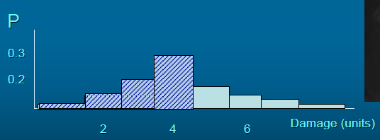

What is the probability that the level of damage is less than 5?

• 3 enemies sequentially placed in level layout. Each enemy described by probability density function.

Enemy A is more likely to inflict damage around 2

Enemy B is more likely to inflict damage around 3

Enemy C is more likely to inflict damage around 5

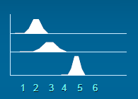

What is probability density of total damage at end of this level?

If damage is accumulated and because damage from every enemy is a random number, total damage is also a random number with its own probability density:

Pt(d) = PA(d) * PB(d) * PC(d)

• Calculation of convolution of several probability density functions is rather complex

• Probability density of total damage can be accurately approximated based upon Central Limit Theorem:

Sum of random numbers with various probability densities has a Gaussian distribution

Mean value μ of resulting distribution is equal to sum of mean values of random numbers.

Variance σ is equal to sum of variances of random numbers.

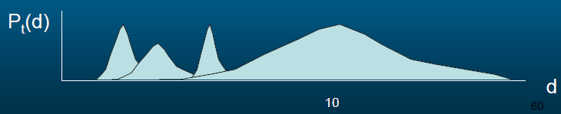

• Obtained probability density of total damage can be used to select threshold for max damage

and tune more accurately the parameters affecting the damage from enemies

Probability that total damage will be less than 5?

Probability that total damage will be less than 12?

