# User testing

## Step 1: The Usability Test

User Feedback: Explain here in detail

1. The usability of the website is good. Everything is very clear and it is hard for the user to get lost
2. The layout could potentially be more aesthetic, it will help with user retention
3. Maybe the search bar can be its own thing then keep the categories (food, etc.) as another thing to avoid confusion

## Step 2: Revision

Explanation of changes made

1. Add a search bar on every page
2. Make the pages more detailed
3. Add color and pop

Sketch with changes

< 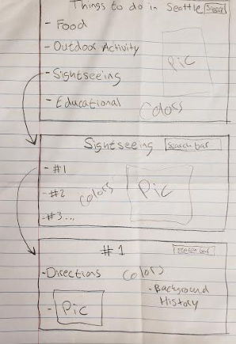>

## Step 3: Second Usability Test

User Feedback: Explain here in detail

1. Add what other people did
2. Add more search filters on second page
3. Add drop down menu on first page

Proposed Changes as a result of feedback

1. Going to add a most popular choice and comments
2. Add a drop down menu of first page to clean it up
3. Add more detail on second page (search filters)

## Step 4: Revision

Explanation of changes made

1. I added the reviews part so that people can see what’s popular and what they like
2. I added the drop down menu so that the first page would be cleaner
3. I added the search filters on the second page so that it would be easier for the users

< 