1.Compare the advantages and disadvantages of a process-based DO/S.

Ad:

A process-based DO/S provides process management through the use of client/server processes that are synchronized and linked together through messages and ports (the ports are also known as channels or pipes). The major emphasis is on processes and messages, and how they provide the basic features essential to process management, such as process creation, scheduling, pausing, communication, and identification, to name a few. Dis:

a system managed by a DO/S handles this same example differently. If one site has a process that requires resources at another site, then the task is presented to the DO/S as just another process. The user acquires no additional responsibility

dis:

The issue of how to provide these features can be addressed in several ways. The pro-cesses can be managed from a single copy of the operating system, from multiple coop-erating peers, or from some combination of the two. Operating systems for distributed computers are typically configured as a kernel on each site. All other services that are dependent on particular devices are typically found on the sites where the devices are located.

2.Compare the advantages and disadvantages of an object-based DO/S.

Ad:

An object-based DO/S has a different way of looking at the computer system than a process-based DO/S. Instead of viewing the system as a collection of individual resources and processes, the system is viewed as a collection of objects. An object can represent a piece of hardware

3.Give at least two advantages of installing a NOS instead of a DO/S for a small business. If it’s necessary to make assumptions about the small business for your answer, be sure to state them.

Dis:

Objects are viewed by the operating system as abstract entities—data types that can go through a change of state, act according to set patterns, be manipulated, or exist in relation to other objects in a manner appropriate to the object’s semantics in the system.

4.List three benefits of data redundancy as described in this chapter.

Data redundancy (the essence of RAID configurations discussed in Chapter 7) can make files much faster and easier to read.

Data redundancy also has beneficial aspects from a disaster recovery standpoint because, if one site fails, operations can be restarted at another site with the same resources.

The failed site can be reinstated by copying all the files that were updated since the failure

5.The process control blocks (PCBs) we discussed in Chapter 4 were used in non-networked systems. In a distributed operating system, what additional information needs to be noted in the PCB in order for the Processor Manager to successfully manage processes correctly?

The kernel is the entity that controls and operates the CPU and manages the queues used for states of execution, although upper-level system policies direct how process control blocks (PCBs) are stored in the queues and how they’re selected to be run

6.If your NOS had four nodes, how many operating systems would it have? Explain your reasons for your answer.

1.Log on to the local network.

2.Instruct the local system to migrate the process or data to the remote site.

3.Send a request to the remote site to schedule the process on its system.

7.If your DO/S had four nodes, how many operating systems would it have? Explain your answer.

mov-ing a process from memory in one site to memory at another site; reorganizing a site’s memory allocation; reorganizing a site’s READY, RUNNING, and WAIT queues; and initiating the scheduled process

8.Explain, in your own words, the steps a DO/S File Manager uses to open a file, read data from it, update that data, and close the file. Do these steps change if the data is not changed? Describe the reasons for your answer.

1.The user’s File Manager places a copy of the file in the DO/S spooler directory.

2.The spooler selects the file from the spooler directory and initiates an OPEN request to the DO/S File Manager.

3.When the OPEN request is satisfied, the spooler initiates another OPEN request to a networked line printer’s device driver.

4.When the second OPEN request is satisfied, the spooler sends the file to the printer’s input buffer. This can be accomplished through a direct message transfer or through a packet transfer, as described in Chapter 9.

5.When printing is complete, the DO/S File Manager deletes the copy of the file from the spooler.

6.Finally, the device is reset and closed.

9.Several levels of file access were discussed in this chapter, including read/write, read-only, execute-only, and no access. If you are maintaining a database con-taining confidential patient information and need to restrict UPDATE to only 5 individuals, allow only 15 others to view the database, and disallow all data-base access to any other users, which access level would you assign to the three groups of people? For each of the three groups describe every type of access granted to each one.

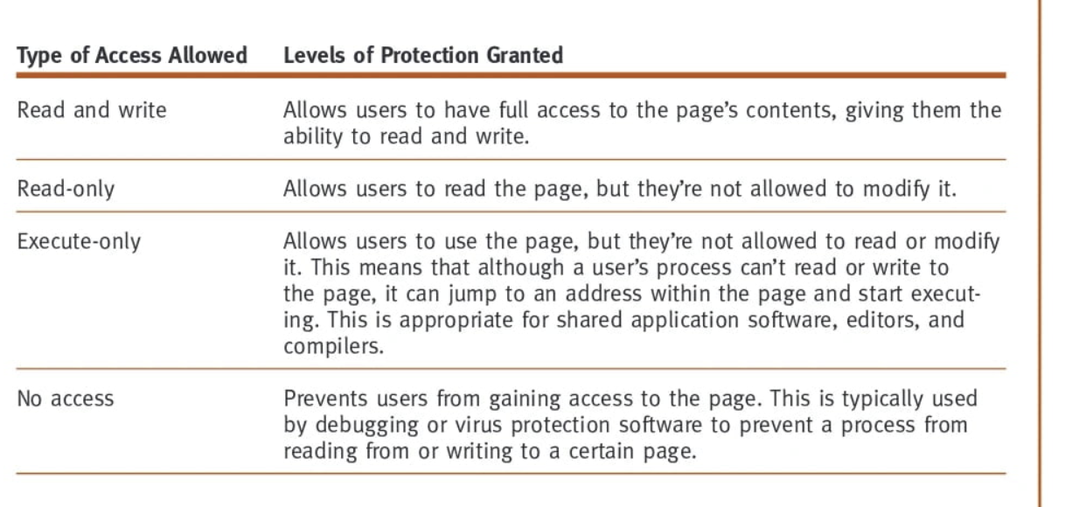

10.Describe in detail how a DO/S protects a file from access or modification by an unauthorized user. Compare it to NOS file protection.

Denial of service (DoS) attacks are synchronized attempts to deny service to authorized users by causing a computer (usually a Web server) to perform a task (often an unpro-ductive task) over and over, thereby making the system unavailable to perform the work it was designed to do

11.Describe how the DO/S Processor Manager attempts to prevent deadlock in the network. Then describe how it tries to avoid them and, if necessary, recover from a deadlock.

To detect circular waits, the system uses directed resource graphs and looks for cycles.

• To prevent circular waits, the system tries to delay the start of a transaction until it has all the resources it will request during its execution.

• To avoid circular waits, the system tries to allow execution only when it knows that the transaction can run to completion.

• To recover from a deadlock caused by circular waits, the system selects the best victim—one that can be restarted without much difficulty, and one that, when ter-minated, will free enough resources so that the others can finish. Then the system kills the victim, forces that process to restart from the beginning, and reallocates its resources to other waiting processes.

12.Explain, in your own words, why process synchronization is critical in network process management.

Because we want request form user have to synchronize with the system.