PE_PRN231_FA23_665511 Note
Please read the instructions carefully before doing the questions.
- You are NOT allowed to use any device to share data with others.
- You must use Visual Studio 2019 or above, MSSQL Server 2012 or above for your development tools.

IMPORTANT – before you start doing your solution, MUST do the following steps:
- Create Solution/Project in Visual Studio named PRN231PE_FA23_665511_StudentCode.
- Create your MS SQL database named SilverJewelry2023DB by running code in script SilverJewelry2023DB.sql.
- Set the default Client application for your project as Login page
- You are not allowed to connect direct to database from ASP.NET Core Web API, every database connection must be used with Repository and Data Access Objects.
- The database connection string must get from appsettings.json file.
- Note: Please check before you submit your work, no syntax error(s) in the submitted PE. If there are syntax errors or compilation errors in your PE program, you will not pass the PE requirements, the mark will be 0.

Implement a part of Silver Jewelry Store Application. The below Figure is a part of SilverJewelry2023DB database.
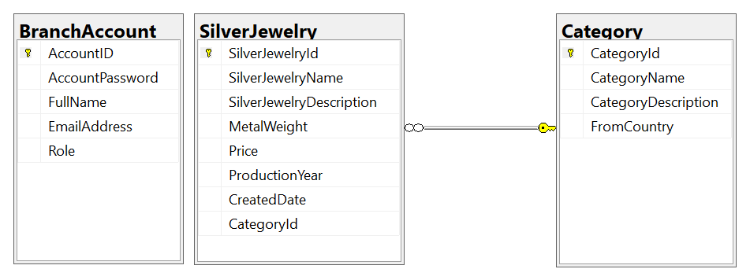
Note that: Member role: Administrator = 1; Staff = 4; Member = 2, Manager=3. A Category will have many silver jewelries, one jewelry will belong to only one category.

