PE_PRN231_SU23_TrialTest
SUMMER 23
Subject: PRN231
Duration: 90 minutes

INSTRUCTIONS
Please read the instructions carefully before doing the questions.
- You are NOT allowed to use any device to share data with others.
- You must use Visual Studio 2019 or above, MSSQL Server 2012 or above for your development tools.

IMPORTANT – before you start doing your solution, MUST do the following steps:
- Create Solution/Project in Visual Studio named PRN231PE_SU23_PracticalExam_StudentCode.
- Create your MS SQL database named StudentGroup2023DB by running code in script StudentGroup2023DB.sql.
- Set the default Client application for your project as Login page
- You are not allowed to connect direct to database from ASP.NET Core Web API, every database connection must be used with Repository and/or Data Access Objects.
- The database connection string must get from appsettings.json file in ASP.NET Core Web API project
- Note: Please check before you submit your work, no syntax error(s) in the submitted PE. If there are syntax errors or compilation errors in your PE program, you will not pass the PE requirements, the mark will be 0.

Implement a part of Pet Store Management System. The below Figure is a part of StudentGroup2023DB database.
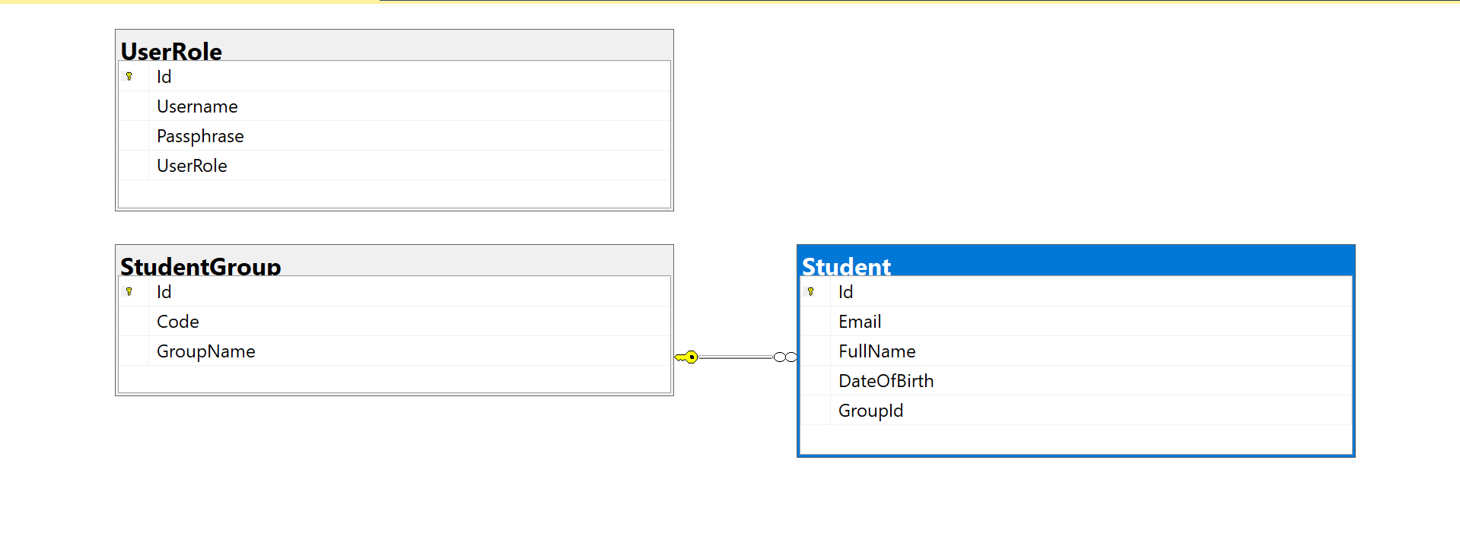
Note that: Account role: Administrator = 1; Staff = 2; Member = 3. A group will have many pets, one pet will belong to only one group.

Part 01 (7.0 points). Create an API using ASP.NET Core Web API with Entity Framework Core. A MS SQL Server database will be created to persist the data and it will be used for reading and managing data.

You must use OData or resources-based Web API to implement the ASP.NET Core Web API with requirements as below:
- Implement authentication and authorization with JWT (2 points)
- Authentication (1 point)
  - Login endpoint take username/password as inputs
  - Return JWT token if username and password correct
  - Return 401 status code if login fail
- Authorization (1 point)
  - All of the other endpoints in this practical exam, only Staff role is allowed to call.
  - Return Http status code 401-Unauthorized when the client provides no credentials or invalid credentials.
- API documentation with Swagger (1 points)
- Implement CRUD actions with Student table (4 points)
- Create Student with HTTP Post with validation conditions (1 points)
  - Email valid
  - Age of student in range [18;100]
  - Full Name: includes a-z, A-Z. Each word in name must begin with the capital letter.
- Delete Student by Id with Http DELETE (0.5 point)
- Update Student with Http PUT (1 point)
- Get Student detail information with Id (0.5 point)
  - Get all fields of Student.
  - Get GroupName of this Student
- Get list of Students with query strings: GroupId, MinBirthYear, MaxBirthYear (1 points)
  - GroupId: get students in same group.
  - MinBirthYear-MaxBirthYear: get students have birthdate in range min-max
  - PageSize, PageIndex for paging

Part 02 (3.0 marks).
Student can choose one of these options for client application
- Postman test cases
- GUI client app
- Option 1: Postman test cases
Using Postman application to write and test auto endpoint in API.
- Each testcase have 3 basic steps:
  - Send Http request to API endpoint
    - Add JWT token in header
    - Fill parameter for request
    - Use correct HTTP verb
  - Get Http response and check
    - Return status code
    - Message body return
  - Return pass/fail result of test case
- You have to write 6 test cases (0.5 point/testcase)
  - Login successful/Login failed
  - Create Student
  - Update Student
  - Delete Student
  - Get Student by Id
  - Get list of Students by GroupID and DateOfBirth in range
- Option 2: GUI client app
Student can choose one of these technology for client application
- ASP.NET Core Web App with MVC
- ASP.NET Core Razor Pages
- Windows Forms
- Windows Presentation Foundation
Client application call API endpoints in Part1 and provide UI for users with functions:
- Login
- View list of Students and search by Group and DateOfBirth
- View Student detail information
- Add new Student
- Update Student information
- Delete Student by Id

