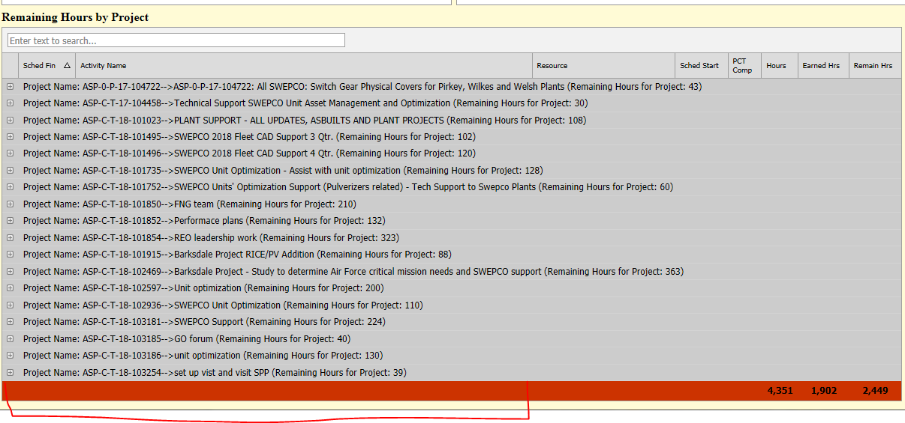

Would like Grand Totals here

ASPX

<dx:ASPxGridView ID="ASPxGridActvPlant" runat="server"

DataSourceID="sqlPlantActivities" KeyFieldName="Project Name" Width="1200px"

AutoGenerateColumns="False" >

<SettingsPager AlwaysShowPager="True" Visible="False">

</SettingsPager>

<SettingsAdaptivity>

<AdaptiveDetailLayoutProperties ColCount="1"></AdaptiveDetailLayoutProperties>

</SettingsAdaptivity>

<SettingsPager PageSize="100">

</SettingsPager>

<Settings ShowGroupedColumns="true" ShowGroupPanel="False" ShowFooter="True" />

<SettingsSearchPanel Visible="True" />

<EditFormLayoutProperties ColCount="6">

</EditFormLayoutProperties>

<Columns>

<dx:GridViewDataTextColumn FieldName="Project Name" Visible="False" GroupIndex="1" SortOrder="Ascending" VisibleIndex="0" Width="370px" >

<HeaderStyle Font-Size="X-Small" Wrap="False" />

<CellStyle Font-Size="X-Small" Wrap="False" >

</CellStyle>

</dx:GridViewDataTextColumn>

<dx:GridViewDataDateColumn FieldName="Sched Fin" SortOrder="Ascending" VisibleIndex="1" Width="30px" >

<HeaderStyle Font-Size="X-Small" />

<CellStyle Font-Size="X-Small">

</CellStyle>

</dx:GridViewDataDateColumn>

<dx:GridViewDataTextColumn FieldName="Activity Name" VisibleIndex="2" Width="570px">

<HeaderStyle Font-Size="X-Small" />

<CellStyle Font-Size="X-Small" Wrap="True">

</CellStyle>

</dx:GridViewDataTextColumn>

<dx:GridViewDataTextColumn FieldName="Resource" VisibleIndex="3" Width="170px">

<HeaderStyle Font-Size="X-Small" />

<CellStyle Font-Size="X-Small">

</CellStyle>

</dx:GridViewDataTextColumn>

<dx:GridViewDataDateColumn FieldName="Sched Start" VisibleIndex="4"

Width="30px">

<HeaderStyle Font-Size="X-Small" />

<CellStyle Font-Size="X-Small">

</CellStyle>

</dx:GridViewDataDateColumn>

<dx:GridViewDataTextColumn FieldName="PCTComp" VisibleIndex="5" Width="30px" >

<PropertiesTextEdit DisplayFormatString="P0">

</PropertiesTextEdit>

<HeaderStyle Font-Size="X-Small" Wrap="True" />

<CellStyle Font-Size="X-Small">

</CellStyle>

</dx:GridViewDataTextColumn>

<dx:GridViewDataTextColumn FieldName="Hours" VisibleIndex="6" Width="30px" >

<PropertiesTextEdit DisplayFormatString="N0">

</PropertiesTextEdit>

<HeaderStyle Font-Size="X-Small" />

<CellStyle Font-Size="X-Small">

</CellStyle>

</dx:GridViewDataTextColumn>

<dx:GridViewDataTextColumn FieldName="EarnedHrs" VisibleIndex="7" Width="30px" >

<PropertiesTextEdit DisplayFormatString="N0">

</PropertiesTextEdit>

<HeaderStyle Font-Size="X-Small" />

<CellStyle Font-Size="X-Small">

</CellStyle>

</dx:GridViewDataTextColumn>

<dx:GridViewDataTextColumn FieldName="RemainHrs" VisibleIndex="8" Width="30px" >

<PropertiesTextEdit DisplayFormatString="N0">

</PropertiesTextEdit>

<HeaderStyle Font-Size="X-Small" />

<CellStyle Font-Size="X-Small">

</CellStyle>

</dx:GridViewDataTextColumn>

</Columns>

<GroupSummary>

<dx:ASPxSummaryItem SummaryType="Sum" FieldName="RemainHrs" ShowInColumn="Project Name"

DisplayFormat="Remaining Hours for Project: {0:N0}" />

</GroupSummary>

<TotalSummary>

<dx:ASPxSummaryItem SummaryType="Sum" FieldName="Hours" DisplayFormat="{0:N0}" />

</TotalSummary>

<TotalSummary>

<dx:ASPxSummaryItem SummaryType="Sum" FieldName="EarnedHrs" DisplayFormat="{0:N0}" />

</TotalSummary>

<TotalSummary>

<dx:ASPxSummaryItem SummaryType="Sum" FieldName="RemainHrs" DisplayFormat="{0:N0}" />

</TotalSummary>

<Styles>

<AlternatingRow BackColor="#CCFFFF">

</AlternatingRow>

<GroupRow BackColor="#CCCCCC">

</GroupRow>

<Footer BackColor="#CC3300" Font-Bold="True" HorizontalAlign="Center">

</Footer>

</Styles>

</dx:ASPxGridView>