* Cheese cake

Original Cheesecake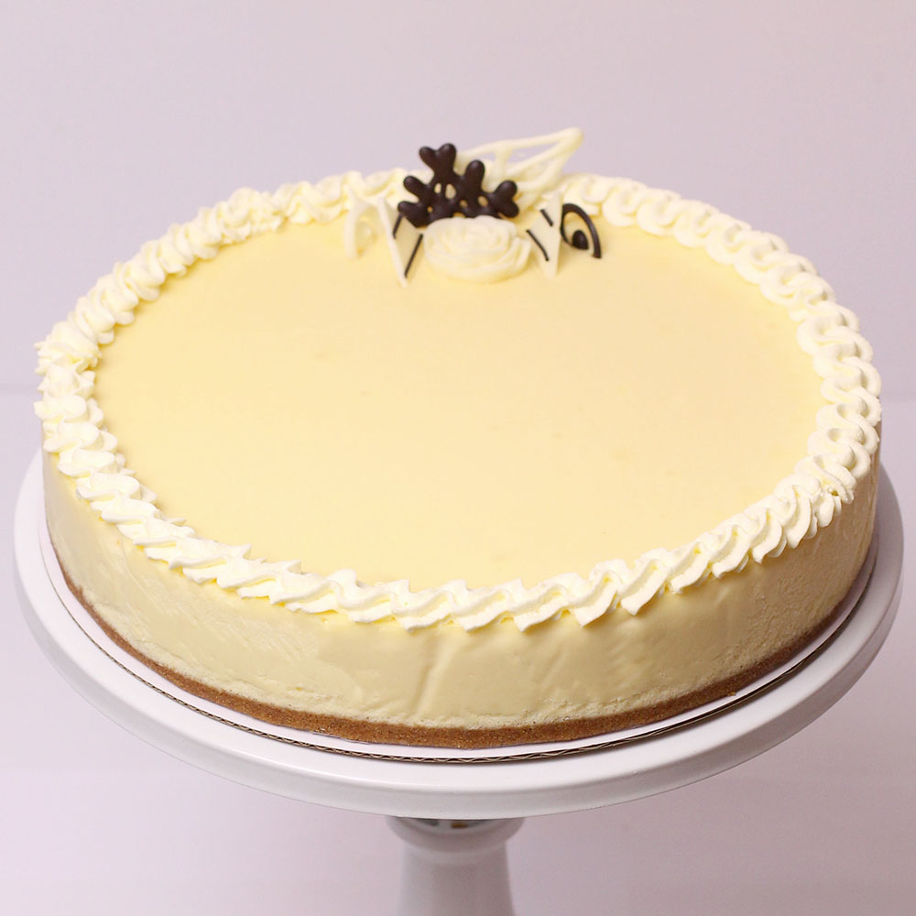

American, Cafe, Coffee And Tea, Desserts,

The Original Cheesecake is where it all began, the perfect combination of creamcheese, sugar and vanilla. The Original has a very smooth texture but still has the denses cheesecake taste finished off with a hint of vanilla. Choice of Slices, Small size 16cm x 4cm (4-6 people), Regular size 23cm x 4cm (10-12 people), Large size 23cm x 6cm (12-14 people) and more. Ingredients: cream cheese, cream, sugar, flour, egg, vanilla, butter, marie biscuit, gelatin.

75.000 vnđ – 649.000 vnđ

Passion Fruit Cheesecake

American, Cafe, Coffee And Tea, Desserts,

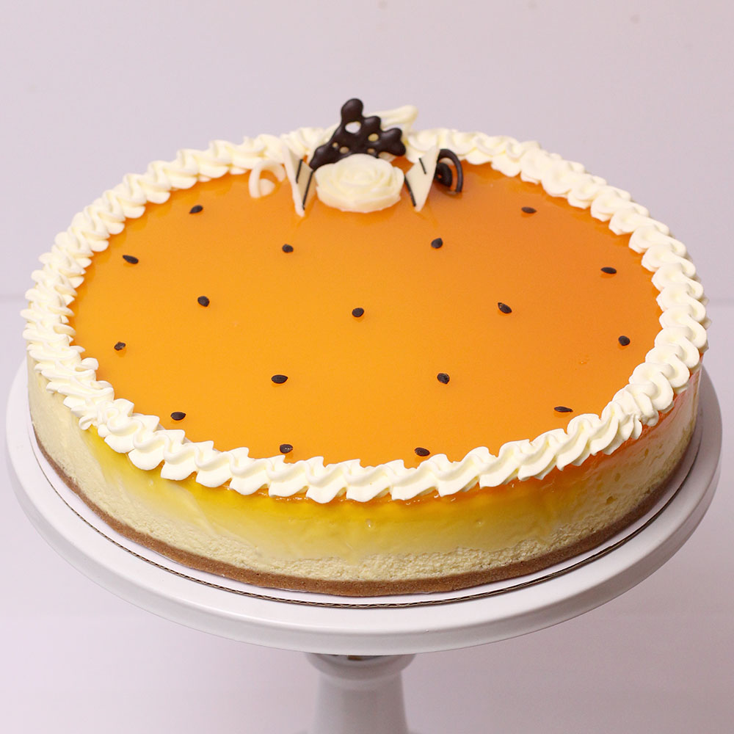

The combination of the sour passion fruit with the richness of cheesecake creates a delightful but not overpowering delicious flavour. Topped off with a passion fruit sauce made from 100% real passion fruit sourced locally. Passion is one of our most popular cakes. Choice of Slices, Small size 16cm x 4cm (4-6 people), Regular size 23cm x 4cm (10-12 people), Large size 23cm x 6cm (12-14 people) Ingredients: cream cheese, cream, sugar, flour, egg, vanilla, butter, marie biscuit, passion fruit, gelatin.

* Brownie

Chocolate Walnut Brownie

American, Cafe, Coffee And Tea, Desserts,

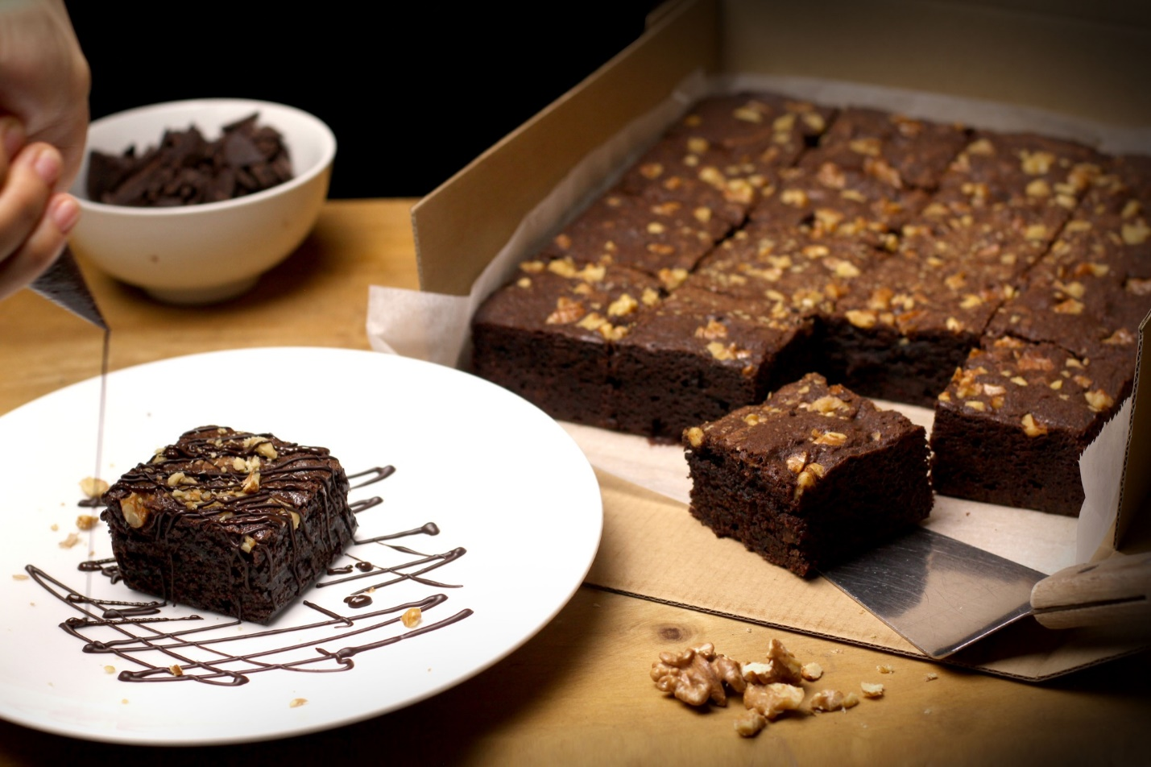

Our traditional chocolate fudge brownie is perfect for an afternoon snack or anytime really. Made with rich dark chocolate and chucky walnuts it has a fudge center but still a nutty crunch.

49.000 vnđ – 399.000 vnđ

* Cupcake

Rainbow Cupcake

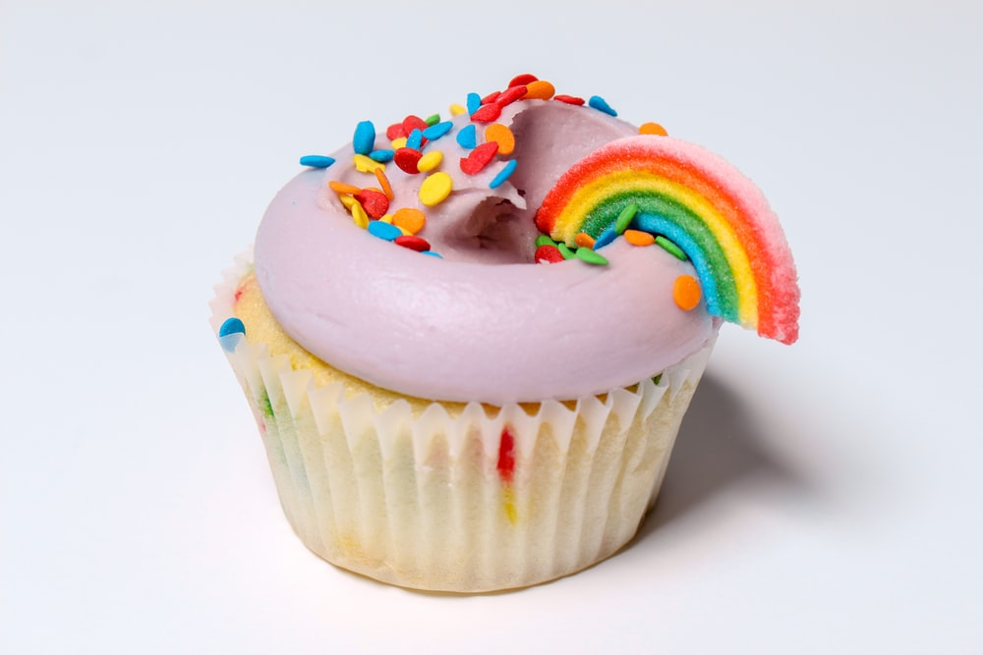

Summer is just around the corner! These cupcakes just scream spring season. It`s made with the finest ingredients to pass your messages of love and devotion during the season of love or on any other special occasion .

75.000 vnđ – 255.000 vnđ

Chocolate Cupcake

These ***chocolate cupcakes*** pack TONS of chocolate flavor in each cupcake wrapper! Made from simple everyday ingredients, this easy cupcake recipe will be your new favorite. For best results, use natural cocoa powder and buttermilk. These chocolate cupcakes taste completely over-the-top with [*chocolate buttercream*](https://sallysbakingaddiction.com/favorite-chocolate-buttercream/)!

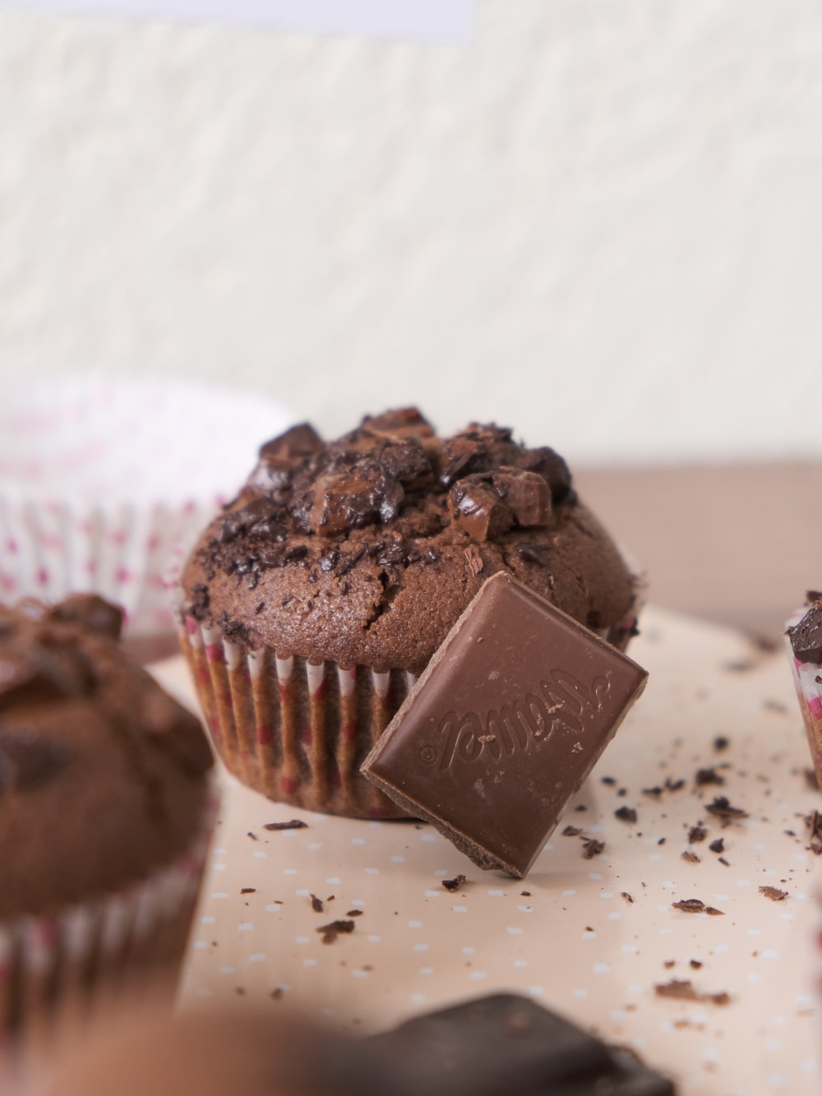

75.000 vnđ – 255.000 vnđ

* Bread

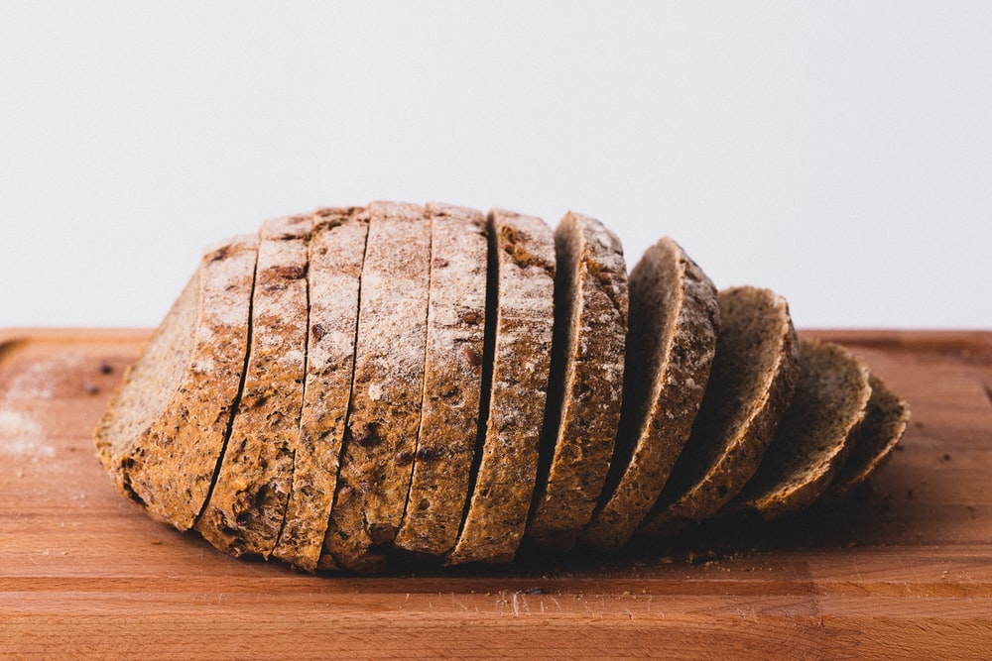

Bread is made from whole wheat silage, its chewy texture is delicious, the mild sour aroma of the well brewed yeast is very pleasant and especially beneficial for the digestive system.

In addition, whole wheat flour has a high nutrient content, lower gluten content than regular flour, strengthens bones, boosts the immune system, lowers cholesterol, supports diet and especially helps control blood sugar. good.

The bread is perfect to go with all kinds of food from vegetarian to savory, for a strange taste that is hard to find in other breads!

15.000 vnđ – 125.000 vnđ

* Chocolate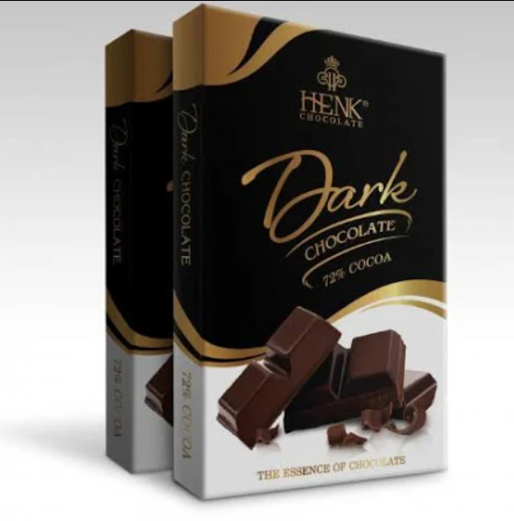

Henk dark chocolate has a bitter taste (72% chocolate) but is not strict for all ages, the product is canned in a compact, convenient and beautiful manner, easy to gift for relatives ...  
24.000 vnđ\