4. Clock
Has happened before:
If a and b are events in the same process and a comes before b, then a→ b
If a is the sending of a message by a process and b its receipt by another process then a→b
If a →b and b→c then a→c.
< disadvantage of logical clocks over physical clocks>
Logical clocks exhibit anomalous behaviors in the presence of outside interactions.
<Logical clock> A clock that orders event without measuring the flow of time as a physical clock would do.
<Home → School (20min)
School → Home (15 min) >
home computer can run at most 20 minutes faster or at most 15 minutes slower than the clock of your computer at school.
<physical clock conditions>
There is a constant k << 1 such that for all i: 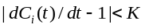
which means that the clocks are reasonably accurate, and
There is a constant such that for all i, j: 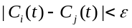,
which means that the clocks are not too far apart from each other.
5. CSP
<Guarded commands and alternative commands>
Explicit naming of sender and receiver processes, non-buffered sends and receives (blocking send, blocking receive)
<guarded command essential>
CSP use blocking receives and requires the receiver process to specify the name of the sender process in its receive (<source_process>?<target value>). Other message passing mechanism use indirect naming and require the receiver process to specify a mailbox or a port.
<which problem…other programming language>
Guarded commands and alternative commands were introduced to allow a process to do multiple blocking receives in parallel. This was needed because a CSP process doing a receive must specify the identity of the sender process. Other programming languages avoid the problem because nearly all communication packages allow processes to do a blocking receive for the first message they will receive on a specific port.
< main advantage of adding an alternative command to C?>
Adding an alternative command to C would allow C programs to execute more than one blocking receive() command in parallel. This property is essential in CSP because it uses direct naming and requires each receive() to specify a unique sender. BSD sockets use indirect naming, which means that a process doing an accept() can receive connection request from many senders. In addition, UNIX offers the option of specifying non-blocking read() and receive().
CSP program consists of a sequence of commands. Command specifies the behavior of a device executing the command.
I/O Commands
Input: <source>?<target value>
Output:<destination>!<value>
Input and output commands are blocking.(never buffered)
An input command will fail when its source process terminates
An output command will fail when either
its destination process terminates
the value it attempts to send becomes undefined
Guarded Commands:
v>0; client?P() -> v:=v-1
The execution of a guarded command is delayed until either the guard succeeds or fails
Alternative Commands:
list of one or more guarded commands
separated by “||”
surrounded by square brackets
Specifies the execution of exactly one of its components. Order of components does not matter.
Repetitive command: Alternative command preceded by an asterisk
<Harvard, MIT>
If both Harvard and MIT accept her, she will say yes to both.
Remove the star so that the repetitive command will become an alternative command.
6. Kerberos
CRYPTOGRAPHY (I): (conventional) Uses same key for coding and encoding
We now use much more complex schemes and much bigger keys
Major problem is key distribution: Difficult without of a trusted channel
CRYPTOGRAPHY (II):
Uses two keys:
(a) a public key to encode: Kp
(b) a secret key to decode: Ks
Not possible to compute Ks knowing Kp
The function Kp = f ( Ks ) is said to be hard to invert
{ { cleartext }Kp }Ks = cleartext
Requires very long keys
Cannot pick an arbitrary secret key
Much slower than conventional cryptography
Assume A knows K(p,b) and B knows K(p,A)
A can send to B a secret message:
{ text } K(p,b)
A can send to B a message that is signed:
A, { text } K(s,A)
A can send to B a signed secret message:
{ A, { text }K(s,A) } K(p,b)
Kerberos: Authentication server using conventional keys
The Kerberos server has
the key of each user
the key of the ticket granting service (TGS)
Authentication is a two-step process
-get from Kerberos a ticket for the TGS
-get from TGS the ticket for a given server
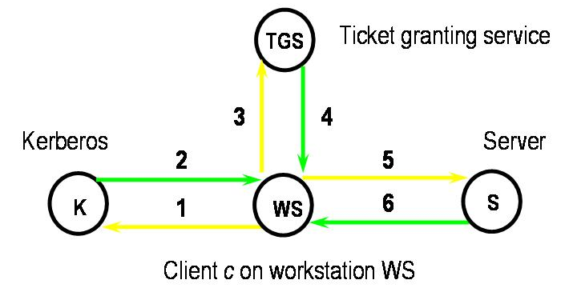
Assumption:
Cannot trust the network
Can trust the time service (clock)
Can trust WS on which she is logged on.
1. c→WS (ID), WS→ K, ID,Ttgs (Ticket for TGS)
2. K→WS: {Kc,tgs , {Tc,tgs}Ktgs}Kc
c→ WS: password
key = fn (password)
WS gets Kc,tgs (session key)
Ticket contains c,tgs,address,timestamp,life,Kc,tgs
3. WS → TGS: s(name of service), {Tc,tgs}Ktgs, {Ac,tgs}Kc,tgs
Authenticator
Ac,tgs = c, address, timestamp
Purpose is to fight replay
To detect replays of authenticators, TGS Rejects authenticators that are too old
Keeps track of all recently received authenticators
Authenticator provides proof that WS was able to obtain the session key Kc,tgs by decrypting message number 2 using the right client key KC
To detect replays of authenticators, TGS
Rejects authenticators that are too old(say, by more than five minutes)
Keeps track of all recently received authenticators
4. TGS→WS: {Kc,s , {Tc,s}Ks}Kc,tgs
5. WS→S: {Tc,s}Ks , {Ac,s}Kc,s
Ac,s = c, address, timestamp
6. S→ WS: {timestamp-1}Kc,s
<…function…defeat…>
Authenticators associate a timestamp with ticket submitted by a client. This allows the server to detect, and reject, replays of previous requests sent by intruders. Their purpose could be defeated by rolling back the clock of the server to which the credentials are sent.
<…vulnerability…>
It would be vulnerable to replay attacks because Kerberos would not be able to distinguish between legitimate requests and replays of previous requests by intruders
<an intruder knows…>
Session keys are primarily used to create authenticators. The intruder will only have to get the user’s ticket Tc,tgs to be able to access all the user’s resources.
The victim of the penetration will not have to change his or her password because the stolen ticket (and its associated session key) will ultimately expire.
<adv and disadv … single entity>
The system would be faster because the protocol would require three messages instead of five but also less secure because the Kerberos server would be more complex and thus harder to secure
<Limitation> Client must trust the workstation on which she is logged in.
<What is replay?...>
A replay is a retransmission of a legitimate message transmitted by an intruder that does not understand its contents. Kerberos detects replays by asking clients to include authenticators in their messages. These authenticators contain among other things a timestamp and are encrypted with a session key shared between the service and the user. Since the intruder does not know this session key, it cannot create new authenticators and can only resent them.
Kerberos detects previously sent authenticators by keeping track of the timestamps of recent authenticators and rejecting older ones.
<denial of service attack>
I would try to set the clock of the ticket granting service well ahead of the other clocks: the TGS will reject user requests as their timestamps will appear to it to be to old to be accepted.
< Kerberos server, because if it is compromised, all user passwords are lost. If it is unavailable, nobody will be able to log in.>
<What actions should be…>
a) The security of the ticket granting server has been compromised.
Kerberos should invalidate all tickets issued by its TGS and change all the keys it shares with other services (Ks,tgs)
The end user will have to login again to obtain a new ticket
b) The security of the Kerberos system has been compromised.
Kerberos should shut down and require users to get new accounts with new passwords.
The end user will have to get a new account with a new password
7. Confinement
<untrusted program…>
The untrusted program should encode some confidential information in the billed price
<example of covert channel>
a)A rogue server program can leak data in the bill rendered for the service. b) It can transmit information by locking and unlocking some shared files.
c) It can transmit information by varying its ratio of computing to input/output or its paging rate.
8. Totem
Provides reliable totally-ordered multicasting of messages over LANs.
Agreed Delivery: Guarantees that a processor will not deliver a message before it has delivered all prior messages
Safe Delivery: Further guarantee that a processor will not deliver a message unless all processors in its configuration have received it (everyone or nobody).
Delivery guarantees: Extended virtual synchrony ensures that these guarantees are honored within every configuration
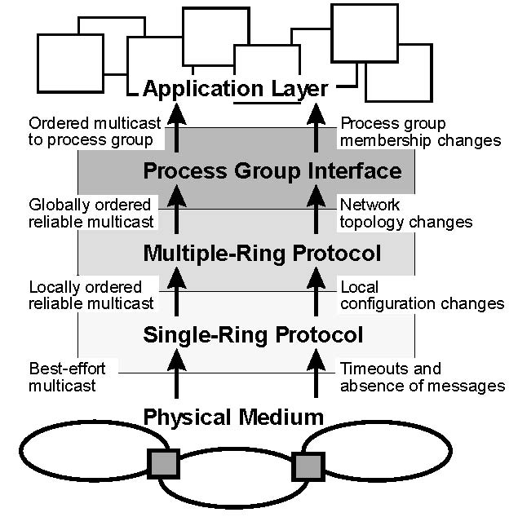
Ordering of messages: born-ordered
Each message includes a time-stamp
Relative order of messages is determined by the message themselves as created by their senders
Single-ring protocol
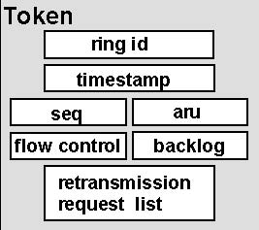
<order messages within the same ring>
Totem uses a circulating token that contains the sequence number of the last message that was sent on the ring. Processes that want to send a message must wait for the arrival of the token. They can then assign an new sequence number to their message and update the token.
Only the processor that holds the token can send a message
An aru field with the sequence number of the last message that has been received by all processors, aru field used to implement safe delivery:
Tells processors which messages have been received by every processor in the ring
Token also provides information about the aggregate message backlog of the processors on the ring
Local membership protocol: Consensus, termination
Multiple-ring protocol:
Uses Lamport’s timestamps and delivers messages in timestamp order
<conditions before multiple-ring totem can deliver an agreed delivery message>
a)The process must have delivered all prior messages that have been issued by processors in the current configuration and have time-stamps within the duration of that configuration.
b)All other processors in the configuration have received it.
When a gateway forwards a message from one ring to another, it gives to the message a new sequence number for the new ring
Processor faults and network partitions are detected by the single-ring protocol
<Guaranteed vector messages>
Ensure that a processor can continue to deliver message as agreed message even if no processor on some ring has recently originated a message. Also report which messages have been received on a ring from each of the other rings (without guaranteed vector messages, there will be very long delay in accepting messages.)
<Totem always delivers messages in the order specified by their timestamps. Each time a message is forwarded from a ring to another ring, it gets a new sequence number>
<Message Delivery>
Each processor maintains recv_msgs list of received but not yet delivered messages for each ring
A processor will deliver a message as an agreed message as soon as
-Message has the lowest time stamp of all messages in its recv_msgs lists
-None of these list is empty
We could wait forever for rings that have no messages to send but for guaranteed vector message.
9.RAID
Main purpose is to build fault-tolerant file systems that do not need backups.
Two motivation :
1.increasing disk throughput allowing parallel access
2. Eliminate disk backup
RAID1: Mirroring-easier to update
RAID2:Error Correction Code → bad idea, disk drives either work correctly or do not work at all.
RAID3:Omission Correction Code
Require N+1 drive, N drive contains data(1/N of each data block), Parity drive contains exclusive or of these N fragments
p[k] = b[k,1]xor b[k,2]xor...b[k,N].
(+) simplicity.
RAID4:N drives contain data (individual block), Parity drive contains exlusive or of N blocks in stripe.
parity drive is involved in every write.
RAID5: distribute the parity block among . N+1 drives. If n blocks, each disk contains (n-1)/n % data 1/n parity, (+) for higher parallelism.
Small write problem
1) Native solution
Read N-1 other blocks in stripe, Recompute p[k]=b[1]xor …b[k+N-1], 2 wirte (new block parity block)
N-1 reads, 2 write(new block and parity block)
2) Smarter solution
2 read (old value old parity),
p[k]=new b[m] xor old b[m] xor old p[k]
2 write (new block and parity block)
Ex) RAID-5 with four data block per stripe(b0,b1,b2,b3)
1)How much for parity block? 20%
2)minimum # of drive: 5
3)update block b3?
Read block(s) old block b3 and old parity block p
Compute new parity block = old block b3 xor new block b3 xor old parity block p
Write new block b3 and new parity block p
<RAID1 and RAID-5>
1)RAID1: 8 drives
2) update a single block in either With the RAID-1 system, it would take _0_ reads and _2_ writes
With the RAID-5 system, it would take _2_ reads and _2_ writes
3) i) It would require much less disk space than a RAID-1 organization.
ii) It would implement large reads and large writes in an efficient fashion.
<LFS 3> INTRODUCTION
*Processor speeds and Main memory sizes increase at an exponential rate
*Disk capacities are improving rapidly
*Disk access times have evolved quite slowly
Consequences
*Larger memory sizes mean larger caches
*Key issue is to increase disk write performance by eliminating seeks
Workload considerations
*Disk system performance is strongly affected by workload
*Office and engineering workloads are dominated by accesses to small files
- Many random disk accesses
- File creation and deletion times dominated by directory and i-node updates
- Hardest on file system
Limitations of existing file systems
*They spread information around the disk
- I-nodes stored apart from data blocks
- less than 5% of disk bandwidth is used to access new data
*Use synchronous writes to update directories and i-nodes: 1) Required for consistency 2) Less efficient than asynchronous writes
KEY IDEA
*Write all modifications to disk sequentially in a log-like structure: 1) Convert many small random writes into large sequential transfers 2) Use file cache as write buffer
Main advantages
1) Replaces many small random writes by fewer sequential writes. 2) Faster recovery after a crash
2-1.All blocks that were recently written are at the tail end of log. 2-2. No need to check whole file system for inconsistencies
*Like UNIX and Windows 95/98 do
THE LOG
1) Only structure on disk 2) Contains i-nodes and data blocks 3) Includes indexing information so that files can be read back from the log relatively efficiently 4) Most reads will access data that are already in the cache
Index structures
*Inode map maintains the location of each i-node
- Blocks at various location on disk
- Active blocks are cached in main memory
*A fixed checkpoint region on each disk contains the addresses of all inode map blocks
Segments :
1) Must maintain large free extents for writing new data 2) Disk is divided into large fixed-size extents called segments(512kb Sprite LFS) 3) segments are always written sequentially from one end to the other 4) Old segments must be cleaned before they are reused
Segment cleaning (I) :
1) Old segments contain 1-1 live data 1-2 “dead data” belonging to files that were deleted
2) Segment cleaning involves writing out the live data 3) Segment summary block identifies each piece of information in the segment
Segment cleaning (II)
*Segment cleaning process involves : 1.Reading a number of segments into memory 2.Identifying the live data 3.Writing them back to a smaller number of clean segments
*Key issue is where to write these live data
- Want to avoid repeated moves of stable files
Write cost
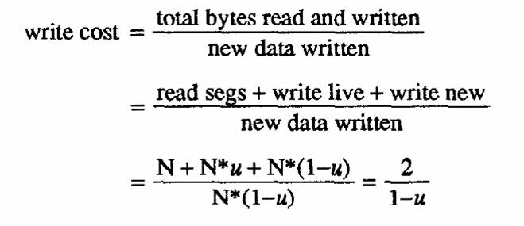
Segment Cleaning Policies
1. Greedy policy: always cleans the least-utilized segments 2. Cost-benefit policy: selects segments with the highest benefit-to-cost ratio
Copying life blocks
1. Age sort: 1-1 Sorts the blocks by the time they were last modified. 1-2 Groups blocks of similar age together into new segments. 2. Age of a block is good predictor of its survival
Simulation results (I)
*Consider two file access patterns. 1) Uniform
2) Hot-and-cold: (100 - x) % of the accesses involve x % of the files 90% of the accesses involve 10% of the files (a rather crude model)
Greedy policy:
1. Write cost is very sensitive to disk utilization
1-1. Higher disk utilizations result in more frequent segment cleanings. 1-2. Will also clean segments that contain more live data
Segment utilizations
1. Locality causes the distribution to be more skewed towards the utilization at which cleaning occurs. 2.Segments are cleaned at higher utilizations
Using a cost-benefit policy :: Cost benefit policy works much better
Sprite LFS :
1). Outperforms current Unix file systems by an order of magnitude for writes to small files. 2). Matches or exceeds Unix performance for reads and large writes. 3). Even when segment cleaning overhead is included. 3-1 .Can use 70% of the disk bandwidth for writing. 3-2.Unix file systems typically can use only 5-10%
Crash recovery (I)
*Uses checkpoints
- Position in the log at which all file system structures are consistent and complete
*Sprite LFS performs checkpoints at periodic intervals or when the file system is unmounted or shut down
*Checkpoint region is then written on a special fixed position; contains addresses of all blocks in inode map and segment usage table
Crash recovery (II)
*Recovering to latest checkpoint would result in loss of too many recently written data blocks
*Sprite LFS also includes roll-forward
- When system restarts after a crash, it scans through the log segments that were written after the last checkpoint
- When summary block indicates presence of a new i-node, Sprite LFS updates the i-node map
SUMMARY
*Log-structured file system
- Writes much larger amounts of new data to disk per disk I/O
- Uses most of the disk’s bandwidth
*Free space management done through dividing disk into fixed-size segments
*Lowest segment cleaning overhead achieved with cost-benefit policy
<BSD-LFS>
Overview
*Paper presents a redesign and implementation of the Sprite LFS
*BSD-LFS (+) Faster than conventional UNIX FFS (the “fast” file system of the early 80’s)
(-) Not as fast as and enhanced version of FFS with read and write clustering
Historical Perspective
*Early UNIX FS used small block sizes and did not try to optimize block placement
*The UNIX FFS: 1) Increased block sizes
2) Placed related information on same or nearby cylinders. 3) Incorporated rotational disk positioning to reduce delays when accessing sequential blocks
Limitations of FFS
*Synchronous file deletion and creation
- Makes file system recoverable after a crash
*Same result can be achieved through NVRAM hardware or logging software
*Seek times between I/O requests for different files
- Has most impact on performance whenever vast majority of files are small
- FFS does not address the problem
Log-Structured File Systems
*Attempt to address both limitations of FFS
*Store all file system data in a single, continuous log
*Optimized for 1) All writes 2) Writing files written in their entirety over a short period of time
3) Accessing files that were created or modified at the same time
General Organization
*Disk is partitioned into segments
- Writes are always sequential within a segment
*Segment cleaner maintains a pool of empty (“clean”) segments through disk compaction
- “Live” data existing in a a set of segments are regrouped in a smaller subset of segments
Overview
Task | FFS | LFS
Allocate disk address | Block creation | Segment Write
Allocate i-node | Fixed location | Appended to log
Map anode numbers into disk addresses | Static address | Lookup in  i-node map
Maintain free space | Bitmap | CleanerSegment usage table
LFS Data Structures
*Superblock:
- Same function as one used by FFS
*I-node map:
- Maps i-node numbers into disk addresses
*Segment usage tables:
- Show number of live bytes in a segment and last modification time
*Checkpoints:
- Created every time system does a sync()
Limitations of Sprite LFS
*Recovery does not verify the consistency of the file system directory structure
*LFS consumes “excessive amounts” of main memory [ by 1993 standards]
*Write requests are successful even if there is insufficient disk space
*Segment validation is hardware dependent
*All file systems use a single cleaner and a single cleaning policy
*No measure of the cleaner overhead
Recovery (I)
*Two major aspects
- Bringing the file system to a physically consistent state
- Verifying the logical structure of the file system
*FFS achieves both goals through fsck
- Rebuilds the whole file system
- Verifies the directory structure and all block pointers
Recovery (II)
*Sprite LFS uses a two-step recovery process:
- Initializes first all the file structures from the most recent checkpoint
- “Roll forward” to incorporate all subsequent modifications
*Done by reading each segment in time order after the last checkpoint
Recovery (III)
*Standard LFS recovery does not verify the directory structure
- Weakness to be addressed in BSD-LFS
Memory Consumption
*Sprite LFS reserves “large amounts” of main memory including four half-megabyte segments and many buffers
*BSD-LFS:
- Does not use special staging buffers
- Does not reserve two read-only segments that can be reclaimed without any I/O
- Implements cleaner as a user-level process
Block Accounting
*Sprite LFS maintained a count of disk blocks available for physical writing
- Blocks written to the cache but not written to disk do not affect that count
*What if a block is “successfully” written to the cache but the disk becomes full before the blocks are actually written?
*BSD-LFS keeps a separate count of disk blocks that are not yet committed to any dirty block in the cache
Segment Structure (I)
*Sprite LFS places segment summary blocks at the end of the segment
- Write containing the segment summary validates the whole segment
*Makes two incorrect assumptions
- Controller will not reorder write requests
- Disk will always write the contents of a buffer in the order presented
Segment Structure (II)
*BSD-LFS
- Does not make these assumptions
*Segment blocks can be written in any order
- Segment summary is in front of each partial segment and contains a checksum of four bytes of every block in the partial segment
*Partial segments constitute the atomic recovery units of BDS-LFS
File System Verification
*BSD-LFS offers two recovery strategies
- Quick roll forward from last checkpoint
- Complete consistency check of the file system
*Recovers lost or corrupted data
*Same functionality as FFS fsck()
*Takes a long time to run
*Can be run in the background
CONCLUSIONS
*A LFS operates best when it can write out many dirty buffers at once
- Requires more buffer space in main memory
*Delayed allocation of BSD-LFS complicates accounting of available free space
- Issue was not correctly handled by Sprite-LFS
*Cleaner might sometimes consumes more disk space than it frees
- Must reserve additional disk space
<JOURNALING> INTRODUCTION
* Improving the performance of metadata operation and recovery:1.Journaling 2.Soft Updates
*Journaling systems record metadata operations on an auxiliary log (Hagmann)
*Soft Updates uses ordered writes (Ganger & Patt)
Metadata Operations
*Metadata operations modify the structure of the file system -- Creating, deleting, or renaming files, directories, or special files
*Data must be written to disk in such a way that the file system can be recovered to a consistent state after a system crash
Metadata Integrity
*FFS uses synchronous writes to guarantee the integrity of metadata
- Any operation modifying multiple pieces of metadata will write its data to disk in a specific order
- These writes will be blocking
*Guarantees integrity and durability of metadata updates
Deleting a file (I)
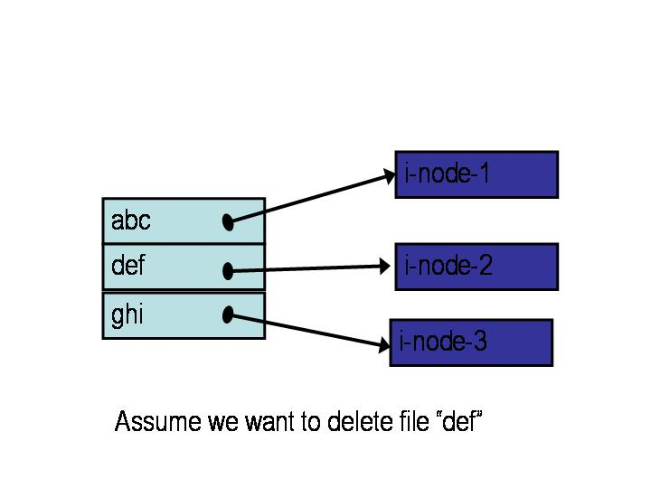
Deleting a file (II)
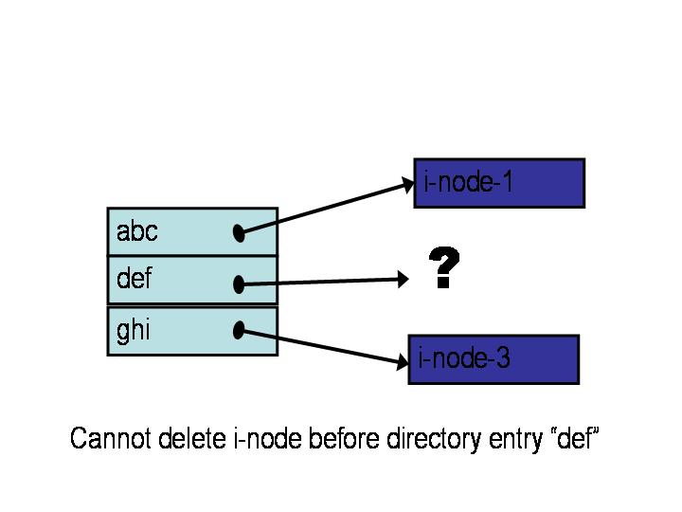
Cannot delete i-node before directory entry “def”
Deleting a file (III)
*Correct sequence is
1. Write to disk directory block containing deleted directory entry “def”
2. Write to disk i-node block containing deleted i-node
*Leaves the file system in a consistent state
Creating a file (I)
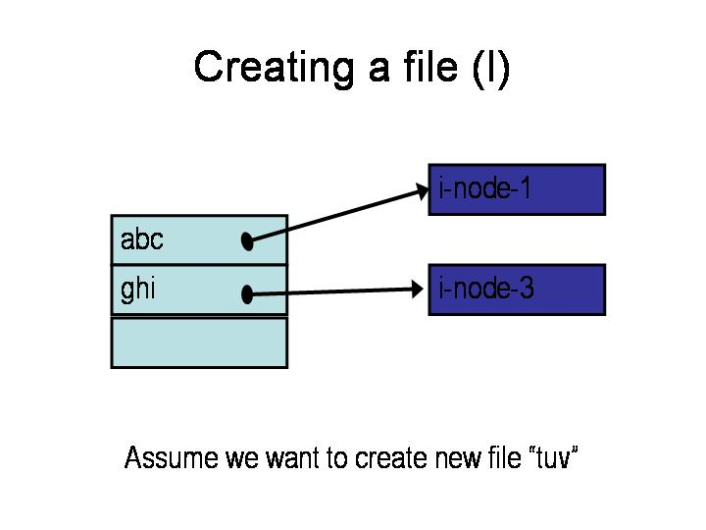
Assume we want to create new file “tuv”
Creating a file (II)
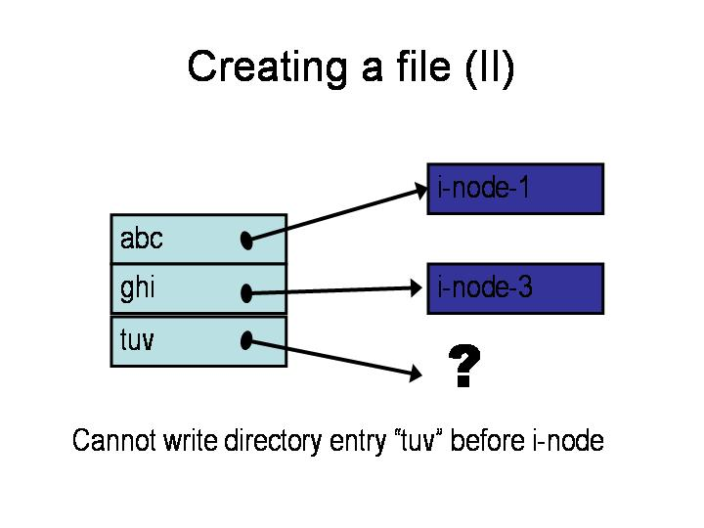
Cannot write directory entry “tuv” before i-node
Creating a file (III)
*Correct sequence is
1. Write to disk i-node block containing new i-node
2. Write to disk directory block containing new directory entry
*Leaves the file system in a consistent state
Synchronous Updates
*Used by FFS to guarantee consistency of metadata:
- All metadata updates are done through blocking writes
*Increases the cost of metadata updates
*Can significantly impact the performance of whole file system
SOFT UPDATES
*Use delayed writes (write back)
*Maintain dependency information about cached pieces of metadata:
- This i-node must be updated before/after this directory entry
*Guarantee that metadata blocks are written to disk in the required order
First Problem
*Synchronous writes guaranteed that metadata operations were durable once the system call returned
*Soft Updates guarantee that file system will recover into a consistent state but not necessarily the most recent one
- Some updates could be lost
Second Problem
*Cyclical dependencies:
- Same directory block contains entries to be created and entries to be deleted
- These entries point to i-nodes in the same block
Example (I)
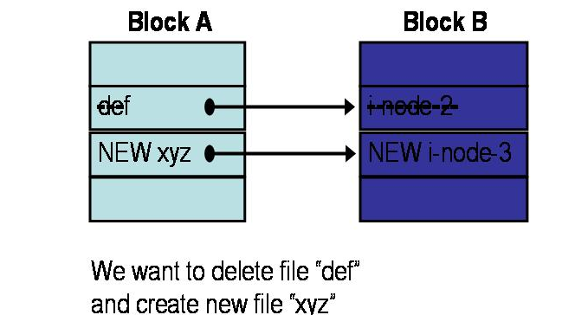
Example (II)
*Cannot write block A before block B:
- Block A contains a new directory entry pointing to block B
*Cannot write block B before block A:
- Block A contains a deleted directory entry pointing to block B
The Solution (I)
Roll back metadata in one of the blocks to an earlier, safe state
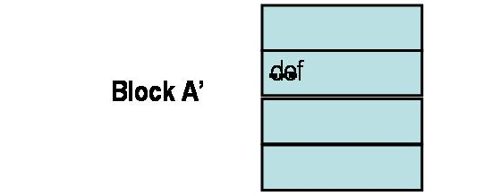
(Safe state does not contain new directory entry)
The Solution (II)
1.Write first block with metadata that were rolled back (block A’ of example)
2.Write blocks that can be written after first block has been written (block B of example)
3.Roll forward block that was rolled back
4.Write that block
5.Breaks the cyclical dependency but must now write twice block A
JOURNALING (I)
*Journaling systems maintain an auxiliary log that records all meta-data operations
*Write-ahead logging ensures that the log is written to disk before any blocks containing data modified by the corresponding operations.
- After a crash, can replay the log to bring the file system to a consistent state
JOURNALING (II)
*Log writes are performed in addition to the regular writes
*Journaling systems incur log write overhead but
- Log writes can be performed efficiently because they are sequential
- Metadata blocks do not need to be written back after each update
JOURNALING (III)
*Journaling systems can provide
- same durability semantics as FFS if log is forced to disk after each meta-data operation
- the laxer semantics of Soft Updates if log writes are buffered until entire buffers are full
*Will discuss two implementations
- LFS-File - LFS-wafs
LFS-File (I)
*Maintains a circular log in a pre-allocated file in the FFS (about 1% of file system size)
*Buffer manager uses a write-ahead logging protocol to ensure proper synchronization between regular file data and the log
LFS-File (II)
*Buffer header of each modified block in cache identifies the first and last log entries describing an update to the block
*System uses
- First item to decide which log entries can be purged from log
- Second item to ensure that all relevant log entries are written to disk before the block is flushed from the cache
LFS-File (III)
*LFFS-file maintains its log asynchronously
- Maintains file system integrity, but does not guarantee durability of updates
LFS-wafs(I)
*Implements its log in an auxiliary file system:
Write Ahead File System (WAFS)
- Can be mounted and unmounted
- Can append data
- Can return data by sequential or keyed reads
*Keys for keyed reads are log-sequence-numbers (LSNs) that correspond to logical offsets in the log
LFS-wafs(II)
*Log is implemented as a circular buffer within the physical space allocated to the file system.
*Buffer header of each modified block in cache contains LSNs of first and last log entries describing an update to the block
*LFFS-wafs uses the same checkpointing scheme and the same write-ahead logging protocol as LFFS-file
LFS-wafs(III)
*Major advantage of WAFS is additional flexibility:
- Can put WAFS on separate disk drive to avoid I/O contention
- Can even put it in NVRAM
*LFS-wafs normally uses synchronous writes
- Metadata operations are persistent upon return from the system call
- Same durability semantics as FFS
LFFS Recovery
*Superblock has address of last checkpoint
- LFFS-file has frequent checkpoints
- LFFS-wafs much less frequent checkpoints
*First recover the log
*Read then the log from logical end (backward pass) and undo all aborted operations
*Do forward pass and reapply all updates that have not yet been written to disk
OTHER APPROACHES (I)
*Using non-volatile cache (Network Appliances)
- Ultimate solution: can keep data in cache forever
- Additional cost of NVRAM
*Simulating NVRAM with
- Uninterruptible power supplies
- Hardware-protected RAM (Rio): cache is marked read-only most of the time
OTHER APPROACHES (II)
*Log-structured file systems
- Not always possible to write all related meta-data in a single disk traNFSer
- Sprite-LFS adds small log entries to the beginning of segments
- BSD-LFS make segments temporary until all metadata necessary to ensure the recoverability of the file system are on disk.
CONCLUSIONS
*Journaling alone is not sufficient to “solve” the meta-data update problem
- Cannot realize its full potential when synchronous semantics are required
*When that condition is relaxed, journaling and Soft Updates perform comparably in most cases
<NFS>
What is NFS?
*First commercially successful network file system:
- Developed by Sun Microsystems for their diskless workstations
- Designed for robustness and “adequate performance”
- Sun published all protocol specifications
Many many implementations
Paper highlights
*NFS is stateless
- All client requests must be self-contained
*The virtual filesystem interface
- VFS operations for whole FS
- VNODE operations for individual file
*Performance issues
- Impact of tuning on NFS performance
Objectives (I)
*Machine and Operating System Independence
- Could be implemented on low-end machines of the mid-80’s
*Fast Crash Recovery
- Major reason behind stateless design
*Transparent Access
- Remote files should be accessed in exactly the same way as local files
Objectives (II)
*UNIX semantics should be maintained on client
- Best way to achieve transparent access
* “Reasonable” performance
- Robustness and preservation of UNIX semantics were much more important
*Contrast with Sprite and Coda
Basic design
*Three important parts 1) The protocol 2) The server side 3) The client side
The protocol (I)
*Uses the Sun RPC mechanism and Sun eXternal Data Representation (XDR) standard
*Defined as a set of remote procedures
*Protocol is stateless
- Each procedure call contains all the information necessary to complete the call
- Server maintains no “between call” information
Advantages of statelessness
*Crash recovery is very easy:
- When a server crashes, client just resends request until it gets an answer from the rebooted server
- Client cannot tell difference between a server that has crashed and recovered and a slow server
*Simplifies the protocol
- Client can always repeat any request
Consequences of statelessness
*Read and writes must specify their start offset
1) Server does not keep track of current position in the file 2) - User still use conventional UNIX reads and writes 3) Open system call translates into several lookup calls to server
*No NFS equivalent to UNIX close system call
The lookup call (I)
*Returns a file handle instead of a file descriptor
- File handle specifies unique location of file
*lookup(dirfh, name) returns (fh, attr)
- Returns file handle fh and attributes of named file in directory dirfh
- Fails if client has no right to access directory dirfh
The lookup call (II): One single open call such as
fd = open(“/usr/joe/6360/list.txt”)
will be result in several calls to lookup
lookup(rootfh, “usr”) returns (fh0, attr)
lookup(fh0, “joe”) returns (fh1, attr)
lookup(fh1, “6360”) returns (fh2, attr)
lookup(fh2, “list.txt”) returns (fh, attr)
The lookup call (III)
*Why all these steps? : 1.Any of components of /usr/joe/6360/list.txt could be a mount point
2. Mount points are client dependent and mount information is kept above the lookup() level
Server side (I)
*Server implements a write-through policy
- Required by statelessness
- Any blocks modified by a write request (including i-nodes and indirect blocks) must be written back to disk before retuning from the call
Server side (II)
*File handle consists of
- Filesystem id identifying disk partition
- I-node number identifying file within partition
- Generation number changed every time
i-node is reused to store a new file
*Server will store
- Filesystem id in filesystem superblock
- I-node generation number in i-node
Client Side (I)
*Provides transparent interface to NFS
*Mapping between remote file names and remote file addresses is done a server boot time through remote mount
- Extension of UNIX mounts
- Specified in a mount table
- Makes a remote subtree appear part of a local subtree
Client Side (II)
*Provides transparent access to
- NFS
- Other file systems (including UNIX FFS)
*New virtual filesystem interface supports
- VFS calls, which operate on whole file system
- VNODE calls, which operate on individual files
*Treats all files in the same fashion
File consistency issues
*Cannot build an efficient network file system without client caching
- Cannot send each and every read or write to the server
*Client caching introduces consistency issues
Example
*Consider a one-block file X that is concurrently modified by two workstations
*If file is cached at both workstations
- A will not see changes made by B
- B will not see changes made by A
*We will have
- Inconsistent updates
- Non respect of UNIX semantics
UNIX file access semantics (I)
*Conventional timeshared UNIX semantics guarantee that
- All writes are executed in strict sequential fashion
- Their effect is immediately visible to all other processes accessing the file
*Interleaving of writes coming from different processes is left to the kernel discretion
UNIX file access semantics (II)
*UNIX file access semantics result from the use of a single I/O buffer containing all cached blocks and i-nodes
*Server caching is not a problem
*Disabling client caching is not an option: 1) Would be too slow 2) Would overload the file server
NFS solution (I)
*Stateless server does not know how many users are accessing a given file
- Clients do not know either
*Clients must
- Frequently send their modified blocks to the server
- Frequently ask the server to revalidate the blocks they have in their cache
NFS solution (II) →better to propagate my updates and refresh my cache.
Implementation
*VNODE interface only made the kernel 2% slower
*Few of the UNIX FS were modified
*MOUNT was first included into the NFS protocol
- Later broken into a separate user-level RPC process
Hard Issues (I)
*NFS root file systems cannot be shared:
- Too many problems
*Clients can mount any remote subtree any way they want:
- Could even have different names for same subtree by mounting it in different places
- NFS uses a set of basic mounted filesystems on each machine end let users do the rest
Hard Issues (II)
*NFS passes user id, group id and groups on each call
- Requires same mapping from user id and group id to user on all machines
- Achieved by Yellow Pages (YP) service
*NFS has no file locking
Hard Issues (III)
*UNIX allows removal of opened files
- File becomes nameless
- Processes that have the file opened can continue to access the file
- Other processes cannot
*NFS cannot do that and remain stateless
- NFS client detecting removal of an opened file renames it and deletes renamed file at close time
Hard Issues (IV)
*In general, NFS tries to preserve UNIX open file semantics but does not always succeed
- If an opened file is removed by a process on another client, file is immediately deleted
Tuning (I)
*First version of NFS was much slower than Sun Network Disk (ND)
*First improvement
- Added client buffer cache
- Increased the size of UDP packets from 2048 to 9000 bytes
*Next improvement reduced the amount of buffer to buffer copying in NFS and RPC (bcopy)
Tuning (II)
*Third improvement introduced a client-side attribute cache
- Cache is updated every time new attributes arrive from the server
- Cached attributes are discarded after
*3 seconds for file attributes
*30 seconds for directory attributes
*These three improvements cut benchmark run time by 50%
My Conclusion
*NFS succeeded because it was 1) Robust
2) Reasonably efficient 3) Tuned to the needs of diskless workstations
<EVOLUTION NFS> SINCE 1985
*Close-to-open file consistency
*Automounter
*Performance improvements: 1. Nvram 2. Dynamic retry 3. Improved retry cache heuristics
4. Client-side disk caching
Close-to-Open File Consistency
*With earlier versions of NFS, updates made on one NFS client might not show up on another client for a few seconds.
*NFS client now : 1-1 writes all modified file data to the server at close time. 1-2 checks with the NFS server that any locally cached data are up-to-date at open time
*Result is “close-to-open” consistency: if you update a file and then close it on one NFS client, any process that will open it on another client will see your updates : Idea borrowed from AFS/Coda
*Change did not require any modification to the NFS protocol
Automounter
*NFS requires each client to specify in its /etc/fstab all its remote mount points
- Uniformity of file name space was achieved by keeping these files identical on all clients
*NIS and automounter allow to manage a corporate-wide name space in a centralized fashion
Performance Improvements (I)
*NVRAM
- NFS requires blocking writes at server
- NVRAM allows servers to respond to write requests without waiting for the completion of their own write request
*Dynamic Retry
- Client can adjust its retry timeouts to promptness of the server
Performance Improvements (II)
*Improved Retry Cache Heuristics
- In some cases the server can tell that a client's retry request is probably redundant
- Will then ignore the request
*Client-Side Disk Caching
- "CacheFS" feature introduced in SunOS 2.4
NFS v. 3 CHANGES (I)
*Large file support
- 64-bit file sizes
*Large block traNFSers
- Eliminated 8-KB limit
- 32KB for 10 and 100-Mbps networks
- 48-KB in HiPPI environments
NFS v. 3 CHANGES (II)
*Safe asynchronous writes:
- New Commit operation lets clients check with the server that it actually has written the data
- Client must keep its own copy of the written data until the Commit succeeds
- If the Commit fails, the client must resend its copy of the written data
- Mitigates need for NVRAM in the server
NFS v. 3 CHANGES (III)
*Improved Attribute Returns
- In NFSv2, some operations return less information than they should
- Resulted in additional lookups
- In NFSv3, operations return additional information as appropriate
NFS v. 3 CHANGES (IV)
*Readdirplus
- Returns both directory names and file attributes
- "ls -l" could be handled with just one Readdirplus operation
- Speeds up recursive tree-walking commands like "find"
OTHER CHANGES (I)
*NFS over TCP
*Kerberized NFS:
- Usually considered in high-security environments, or when operating over a WAN
- Not yet widely available
*RSA encryption
OTHER CHANGES (II)
*WebNFS:
- Allow an nfd prefix in URLs
*None of these changes would affect the protocol
CONCLUSIONS
*NFS is flexible:
- Adopted ideas from the research community: AFS, Sprite, Spritely NFS, NQ-NFS, etc.
*AFS impact includes: - Close-to-open file consistency - Network-wide name space
- Large block traNFSers - Client-side disk caching

