Wireless Sensor Network and Practical Embedded Operating System
Modern Wireless Sensor Network (WSN) was developed at the late 1990s in the United States; it is involved with multiple modern technologies, such as semi technology, micro-system technology, communication technology and computer technology. It blooms in the early 2000s. A lot of Universities begin research in this new field and achieved fruitful results, such as University of California, Berkley, University of California, Los Angles, and Cornell University et al. In 2003, it was identified as one of 10 emerging technologies that will change the world by Technology Review's editors.
Wireless Sensor Network (WSN) is composed by a large number of low-cost micro-sensor nodes, which are deployed in the interesting region to cooperatively monitor physical or environmental conditions, such as temperature, sound, vibration, pressure, motion or pollutes. Through wireless communication, nodes form a multi-hop, self-organizing network system. Sensors, Targets and Observers are three key points of the WSN. WSN could help people to observe the physical world directly, thus the existing network functions will be greatly expanded by the introduction of WSN. Especially nowadays, Internet has become humanity’s greatest treasure house of knowledge; WSNs will be the new important data and knowledge resources of the Internet.

Section 1：Overview
1.1 Architecture of the Wireless Sensor Network
1.1.1 Network Architecture of WSN
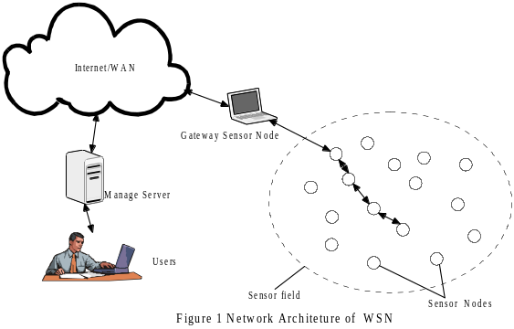As shown in figure 1, WSN includes a large amount of sensor nodes, gateway sensor nodes and manage server. The sensor nodes are randomly deployed in the sensor field, which could form network in multi-hop, self-organizing mode. The data collected by one sensor node could be transferred and even handled by other sensor nodes. One by one the data are transferred to gateway sensor node. Finally through Internet/WAN, the data are collected by the manage server and could be provided to users. The users also could configure the whole network system and publish instructions to collect the wanted data through manage node.
Sensor node is usually running a miniature embedded system. The processor of the node, storage ability and communication ability of the node are usually weak. One reason is that the nodes are small and could not integrate too many functions. The other reason is the node is powered by the battery coming with itself and in most time the battery is unchangeable. In addition to the collection and processing of local data, each node might need to store, process, to fuse and transmit the data received from other nodes in order to complete the complex task. Complexity, Stability and Durability requirements, limited battery power make the sensor nodes the most interesting and hot part of the whole WSN research. In the second section of this article, we will discuss the embedded operating system used in the sensor nodes which meat the above requirements.
Practically, the gateway sensor node is more powerful, even it could be a computer which has all the abilities as your desktop. It connects the Internet and the sensor nodes network, completes the conversion between two communication protocol stacks.
1.1.2 Architecture of the Sensor Nodes
Wireless Sensor nodes are constituted by sensor module, processor module, wireless communication module and power module, as shown in Figure 2. Data are collected from sensor field and sent to AC/DC to do the analog-digital conversion, then sent to the processor module. The processor module could receive data both from the local sensor module and from other nodes through the wireless network. It controls the operation of the whole sensor, stores and processes data, and sends the data to wireless communication module. Wireless communication module provides the node ability to communicate with other nodes. It contains its own hierarchical protocol stacks. Power module provides power to other modules.
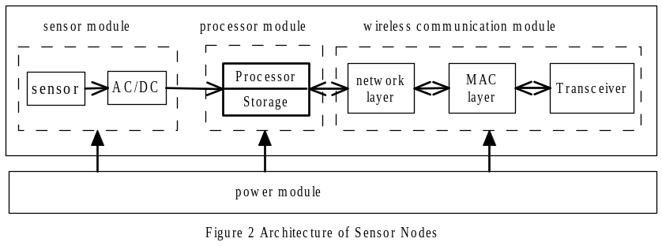
1.1.3 Hierarchical Network Protocol Stacks
In [IWY 2002], the authors provide an example network protocol stacks used by the sensor nodes, which consists of physical layer, data link layer, network layer, transport layer and application layer. In addition, the network protocol stacks also include power management plane, mobility management plane, and task management plane. The target of those management planes is to make those sensors work together in an energy efficient way. The network protocol is not the focus of this article. You could refer [ESH 2001][ AWD 2001][ KSO 2000] for details.

1.2 Characteristics of Wireless Sensor Network
1.2.1 Difference between WSN and Mobile ad-hoc network
“A mobile ad-hoc network (MANET) is a kind of wireless ad-hoc network, and is a self-configuring network of mobile routers (and associated hosts) connected by wireless links. The routers are free to move randomly and organize themselves arbitrarily; thus, the network's wireless topology may change rapidly and unpredictably. Such a network may operate in a standalone fashion, or may be connected to the larger Internet.” The purpose of MANET is to provide multimedia information service which enable Qos protection. Usually, the nodes are continuously power supplied.
WSN and MANET have many similarities, such as the ad-hoc and self-organization. However, the differences between WSN and MANET are obvious. First, the total amount of WSN nodes is usually much larger; the distribution of WSN nodes is more intensive. Second, the WSN nodes are easier to fault because of the influence of environment and the running out of the battery. Thus the topology of the network is easier to change because of the fault of the nodes. More important, computation ability, storage ability and communication ability of WSN nodes are practically limited, and the energy surpply of WSN nodes is also limited and finit. Thus the first design principle of WSN is energy efficient. This is also the most distinct difference between the WSN and MANET. In the next section, you will see that the operating system is required to work in energy efficient mode.
1.2.2 Limitations of WSN nodes
a) Limited power supply
In 1.2.1, we mention that the environment might make the nodes not work. In addition, WSN is often deployed in remote or hostile environments such as virgin forests, battle fields. Often the nodes are deployed once and could not be accessed and maintained in the future. Thus, the nodes could not have continuous power supply, are often battery driven. To make the WSN work energy efficient and maximize of the whole life of WSN is the biggest challenge of WSN research.
In Figure 2, you could see that the sensor module, processor module and wireless communication module will consume the power provided by the power manage module. In practice, communication between sensor nodes consumes most of the available power. [DEB 2002] shows the power consumption of node subsystems as in Figure 3. The radio module consumes the most part of the available energy, far more than sensors and CPU modules.
In wireless communication module, there are four different statuses, TX (sending data), RX(receiving data), idel and sleep. Energy consuming relationship between those four statuses is: 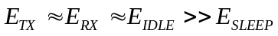. To eliminate the unnecessary data transferring and shut off the radio when the radio module enter the idle mode as soon as possible is the key point which should be kept in mind when design the operating system and the application for the nodes.
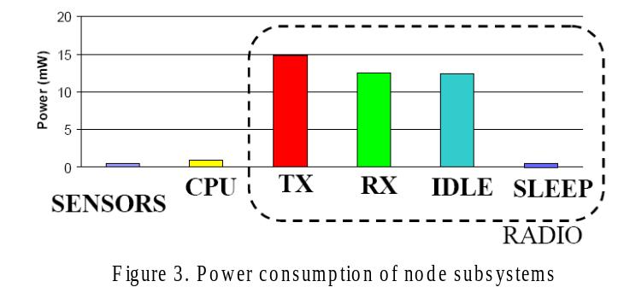
b) Limited communication ability
Two aspects of facts limit the ability of the WSN node. The first one is the limited energy. The other is environment. As mentioned above, the WSN nodes are often deployed in the remote or even hostile environments. Adverse natural environment often makes the nodes not to work. The topology of the WSN is always changing. These facts all limit the communication ability of the WSN network.
c) Limited computational power and storage
Sensor nodes are micro-embedded devices. They were required low cost and low energy consuming. The processors coming with them are always weak and have limited computational power. For the same reason, the storages of the nodes are also limited.
1.2.3 Features of WSN
a) Large-scale network
Sensor nodes are often deployed in a large area region. For example, WSN is deployed in virgin forests to monitor the environment and alert fire. A huge amount of sensors are needed to cover the large region. On the other hand, sensors are often deployed in an intensive way. A small region may contain a large amount of nodes. The large-scale WSN have many advantages. Information gained from the network have high signal noise ratio. Thus, the dependence on single node accuracy is greatly reduced. Otherwise, the accuracy may be improved by distributed processing. In addition, the existence of large number of redundant nodes makes the whole system fault-tolerance. This will resist to the node fault caused by complex environmental factors.
b) Self-organized network
WSN is typically self-organized network. Usually sensor nodes are not installed in a fix point. They are randomly deployed in the interesting region. The neighborhood relationships between nodes are impossible to know before deploying. Furthermore the neighborhood is always changing. For example, large amount of nodes are sown virgin forests by airplanes. Sensor nodes are not accessible and have no maintenance after deploying. Some nodes will not work with time passed, and some nodes will be added into the existing WSN system to replace the invalid nodes. The number of nodes in the WSN system is always changing, and the topology of the WSN network is also changing frequently. All these required the WSN network have the strong self-organized ability.
c) Dynamic network topology
The topology of WSN could be changed by the following factors. First, some sensor nodes become failure because of the environment impact or running out of the energy. Secondly, the wireless communication may be influenced by the environment, even some wireless links will interrupt temporally. Thirdly, the position of the sensors may change. Last, some new nodes are added into the existing WSN.
d) Reliable network
Sensor nodes need adapting to all kinds of adverse environment. The network should have the ability to self-organize. Otherwise, the security and integrity of the WSN are also important. The software and hardware of WSN network are required Robustness and fault-tolerant.
e) Application driven network
WSN is used to monitor the physical world. Each specific WSN monitors specific physical variables, may be different from other WSN system. The design of WSN is required to be involved around the specific application. The different application backgrounds require the different hardware; the software and network protocols are also different from each other. It’s hard to unify the client sides and communication protocols used by WSN, such as what have been done to the PC and Internet. For each application, different design principle and technologies are used to adapt the requirement. The more specific, less common is the obvious feature in the WSN design and implementation.
f) Data centric network
Internet is network built on address. Each device in the network has its unique IP address. The transferring, exchanging of information depend on the IP address to locate the position of the resources. WSN network is distinctly different from the classical network. WSN network collect and gather information through task. There’s no reason to fetch data from a particular node. So it’s nonsense to talk about a specific node in the WSN system. When the user wants to query the WSN system, the query task is announced to the whole WSN network instead of to a particular node. WSN collect the related data and response to the user. The queries focus on the data itself instead of where and how to get the data. For example, in an anti-intrusion WSN system, we only care about what time and where the intruders enter the monitoring field. We don’t care about which sensor node detect the intruder.

1.3 Hot research topics and challenges about WSN
1.3.1 Topology control
Topology control, an underlying process even below the traditional layer structure, is especially important to the WSN. It’s used to generate the proper network topology and make the WSN self-organizing and self configuring network.
1.3.2 Security
Applications decide the security requirements when design the specific WSN system. For example, in military field, WSN nodes are distributed into an adversary’s territory enables the detection and tracking of enemy soldiers and vehicles; for home or office monitoring, sensors are used to detect the intruder. In these applications, security is a key concern. The characteristics of WSN make the methodologies and techniques applied in WSN different from classical network architectures, such as Internet. The computing resources of sensor nodes are limited, which influences the strength of the security algorithms. Security design is a compromise of the security requirements and the choosing of energy efficient security algorithms.
Security is always an interesting topic in application. [CKM 2000] discussed the threats to WSN and the requirements for WSN security. [WAS 2002] analyzed various kinds of denial-of-service (Dos) attacks against WSN. [PSW 2004] is a good summary for other threats for WSN.
1.3.3Data Management and Database
In WSN application, data are gained and stored in distributed sensor nodes. The WSN could be seen as a distributed database system. Using the idea of database to manage the data stored in WSN could separate the logic view of the data from the implementation. When users query the WSN for some events, they should only care about the data logic, not the details of the implementation. This is one of the characteristic of WSN, data centric network. TinyDB proposed by [MFJH 2003] from Berkeley is one of the representative database designed for the WSN system.
1.3.4 Embedded OS
This part will be discussed in details in Section 2.
1.3.5Applications

Section 2: Practical Embedded OS - TinyOS
2.1 Introduction
2.2Communications based on active message
2.3Lightweight thread (task) and scheduler
2.4Event-driven model
2.5Component based programming
2.6Install and Environment Set-up
[IWY 2002] Ian F. Akyildiz, Weilian Su, Yogesh Sankarasubramaniam, and Erdal Cayirci. “A Survey on Sensor Networks” IEEE Communications Magazine, August 2002.
[ESH 2001]E. Shih et al., “Physical layer Driven Control Protocol and Algorithm Design for Energy-Efficient Wireless Sensor Networks,” Proc. ACM MobileCom `01 Rome, Italy, July 2001, pp 272-86
[AWD 2001]A. Woo, and D. Culler, “A Transmission Control Scheme for Media Access in Sensor Networks,” Pro. ACM MobiCom `01, Rome, Italy, July 2001, pp. 221-35
[KSO 2000]K. Sohrabi et al, “Protocols for Self-Orgnization of a Wireless Sensor Network,” IEEE Pers. Commun., Oct. 2000, pp. 16-27
[DEB 2002] http://nesl.ee.ucla.edu/tutorials/mobicom02/slides/Mobicom-Tutorial-4-DE.pdf
[CKM 2000]Carman D. W., Kruss P.S., Matt B.J. “Constraints and approach for distribution Sensor Network Security,” NaIlabs. Technical report 00-100, Sept. 2000
[WAS 2002]Wood, A., and Stankovic J., “Denial of Service in Sensor Networks,” IEEE Computer, Vol. 35, No. 10, 2002, pp.54-62
[PSW 2004]Perrig, A., J. Stankovic, and Wagner D., “Security in Wireless Sensor Networks,” Communications of the ACM, Vol.47, No.6, 2004, pp.53-57
[MFJH 2003] http://db.cs.berkeley.edu/papers/tods05-tinydb.pdf

