Let us see an example on how to instantiate a component.

--(in a separate file topOne.vhd)

library ieee; -- added topOne entity/architecture

use ieee.std_logic_1164.all;entity topOne is port ( clk: in std_logic; wavetopOne: out std_logic );end entity;architecture foo of topOne is

signal wavelowTwo: std_logic;

component lowTwo is

port (

clk: in std_logic;

wavelowTwo: out std_logic

);

end component;

begin

lowTwo

port map (

clk => clk,

wavelowTwo => wavelowTwo

);

wavetopOne <= wavelowTwo after 2 us;

end architecture;

--(in a new file lowTwo.vhd)

library ieee; -- added lowTwo entity/architecture

use ieee.std_logic_1164.all;

entity lowTwo is

port (

clk: in std_logic;

wavelowTwo: out std_logic

);

end entity;

architecture foo of lowTwo is

begin

wavelowTwo <= clk after 1us;

end architecture;

Next, we work on project 2.

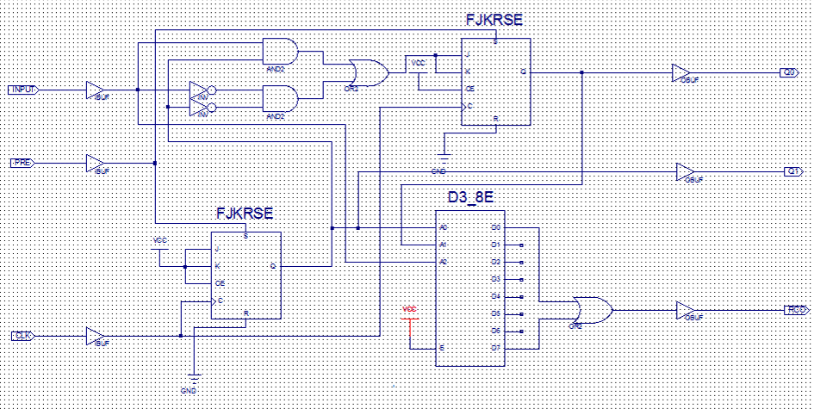

There are different ways to write the code. Below is one example. You are welcome and encouraged to copy this code into your project to use for Project 2 as long as you read it and understand what the pieces are doing. You must add additional descriptive comments to the code showing your understanding if you copy it.

LIBRARY ieee;

USE ieee.std_logic_1164.ALL;

USE ieee.numeric_std.ALL;

ENTITY sequential IS

PORT(  Q0           :             OUT      STD_LOGIC;

           Q1 :              OUT       STD_LOGIC;

RCO             :              OUT       STD_LOGIC;

          CLK             :               IN  STD_LOGIC;

          INPUT        :               IN  STD_LOGIC;

          CLR             :               IN  STD_LOGIC);

END sequential;

ARCHITECTURE behavioral OF sequential IS

                SIGNAL CE1        :               STD_LOGIC := '1';

                SIGNAL CE0        :               STD_LOGIC;

                SIGNAL IQ0  :     STD_LOGIC := '0';

                SIGNAL IQ1  :     STD_LOGIC := '0';

BEGIN

process (IQ0,IQ1,INPUT) -- output 1) the 3-8 decoder 2) Q0 3) Q1

                begin

                                if IQ0 = '1' and IQ1 = '1' and INPUT = '1' then

                                                RCO <= '1';

                                elsif IQ0 = '0' and IQ1 = '0' and INPUT = '0' then

                                                RCO <= '1';

                                else

                                                RCO <= '0';

                                end if;

                                Q0 <= IQ0;

                                Q1 <= IQ1;

                end process;

process (CLK, CLR) -- The first T flip-flop

                begin

                                if (CLK'event and CLK='1') then

                                                if CLR = '1' then

                                                                IQ1 <= '0';

                                                elsif CE1 = '1' then

                                                                IQ1 <= not(IQ1);

                                                end if;

                                end if;

                end process;

                process (CLK, CLR) -- The second T flip-flop

                begin

                                if INPUT = '1' and IQ1 = '1' then

                                                CE0 <= '1';

                                elsif INPUT = '0' and IQ1 = '0' then

                                                CE0 <= '1';

                                else

                                                CE0 <= '0';

                                end if;

                                if CLK'event and CLK = '1' then

                                                if CLR = '1' then

                                                                IQ0 <= '0';

                                                elsif CE0 ='1' then

                                                                IQ0 <= not(IQ0);

                                                end if;

                                end if;

                end process;

END;

How is the circuit simulated? The solution is to use the designed component in the test bench. We create a new file wave.vhd, from which we instantiate an instance of sequential we just defined for the simulation. You need both this test bench code on pages 5-6 in a wave.vhd file AND the behavioral description code on pages 3-4 in a sequential.vhd file.

LIBRARY ieee;

USE ieee.std_logic_1164.ALL;

USE ieee.numeric_std.ALL;

ENTITY wave IS

- - there are no inputs and outputs

END wave;

ARCHITECTURE behavioral OF wave IS

   COMPONENT sequential

   PORT(  Q0         :               OUT       STD_LOGIC;

           RCO            :               OUT       STD_LOGIC;

           Q1 :               OUT       STD_LOGIC;

           CLK              :               IN           STD_LOGIC;

           INPUT         :               IN           STD_LOGIC;

           CLR               :               IN           STD_LOGIC);

   END COMPONENT;

   SIGNAL Q0       :               STD_LOGIC := '0';

   SIGNAL CLK     :               STD_LOGIC;

   SIGNAL INPUT:               STD_LOGIC := '0';

   SIGNAL RCO    :               STD_LOGIC;

   SIGNAL Q1       :               STD_LOGIC := '0';

   SIGNAL CLR     :               STD_LOGIC := '1';

                SIGNAL CE1        :               STD_LOGIC := '1';

                SIGNAL CE0        :               STD_LOGIC;

                SIGNAL TEMPORAL : STD_LOGIC_VECTOR(5 downto 0):="000000";

                SIGNAL IQ0  :     STD_LOGIC := '0';

                SIGNAL IQ1  :     STD_LOGIC := '0';

BEGIN

--Unit under test

uut: sequential PORT MAP(

INPUT => INPUT,

CLR => CLR,

CLK => CLK,

Q0 => Q0,

Q1 => Q1,

RCO=> RCO

);

                -- *** Test Bench - User Defined Section ***

               tb : PROCESS

                BEGIN

                   for i in 0 to 50 loop -- VHDL loop statement

                          CLK <= TEMPORAL(0); --assigning the LSB of TEMPORAL to CLK

                          TEMPORAL <= std_logic_vector(UNSIGNED(TEMPORAL) + 1);

                                                                -- increment TEMPORAL

                        if (TEMPORAL = "010111") then -- VHDL if statement

                                         INPUT <= '1';

            -- set INPUT=1 when TEMPORAL = "010110",

                          end if;

                          if (TEMPORAL = "000010") then -- VHDL if statement

                                         CLR <= '0';

            -- set CLR=0 after the first clock period

                           end if;

                           wait for 50 ns; -- CLK high/low for 50ns

                      end loop;

                      WAIT;

   END PROCESS;

-- *** End Test Bench - User Defined Section ***

END