Example 2

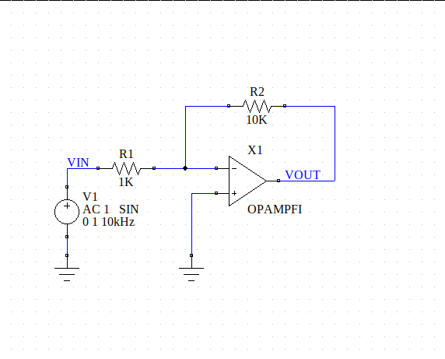
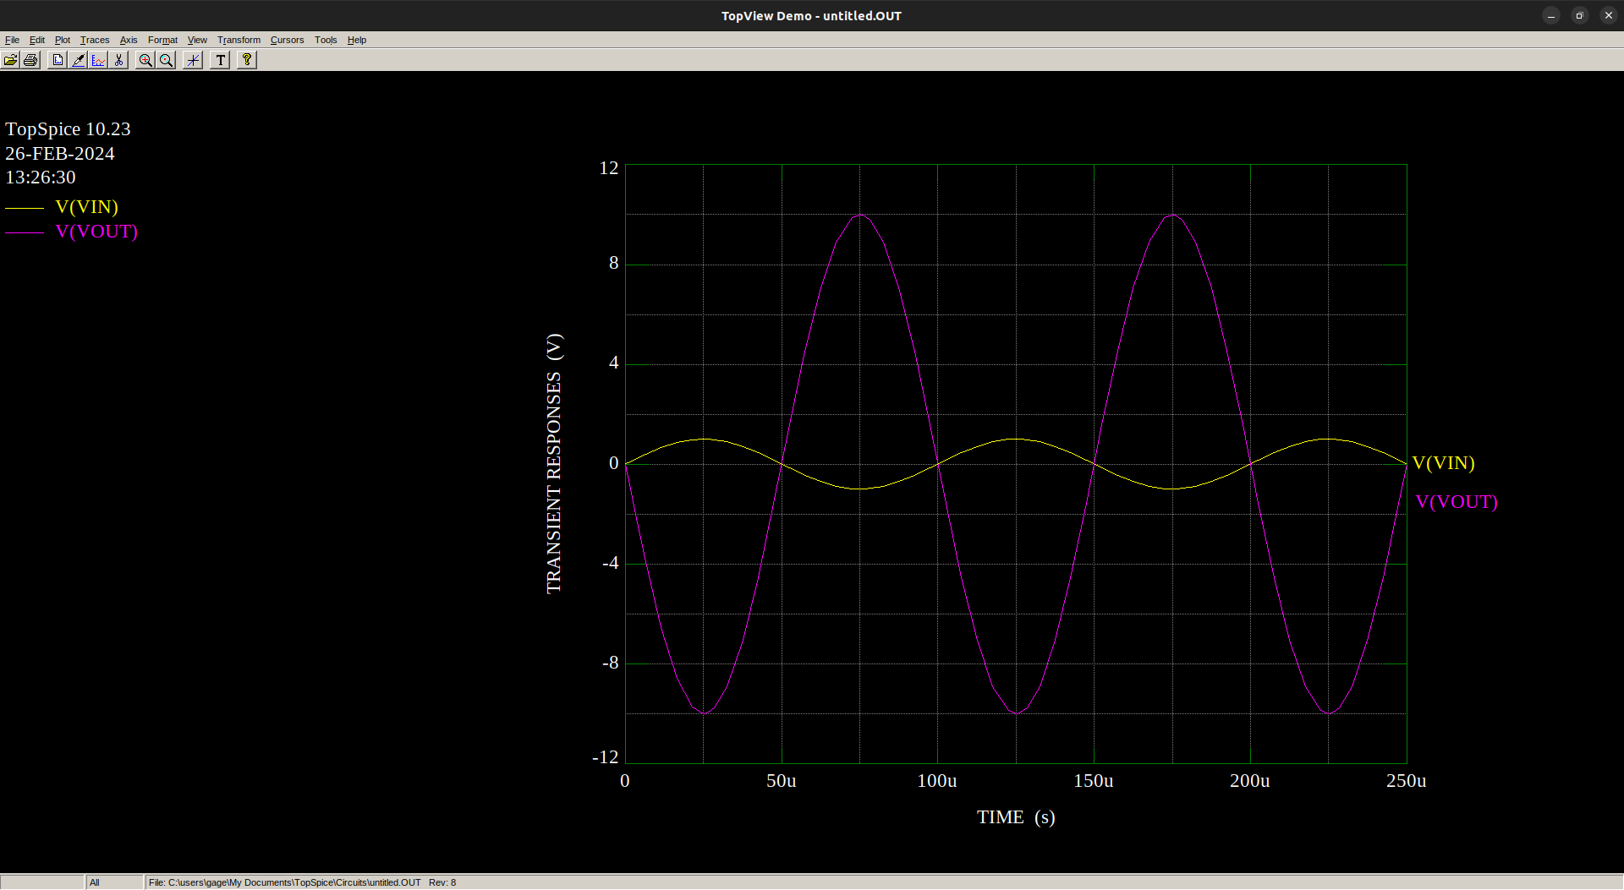

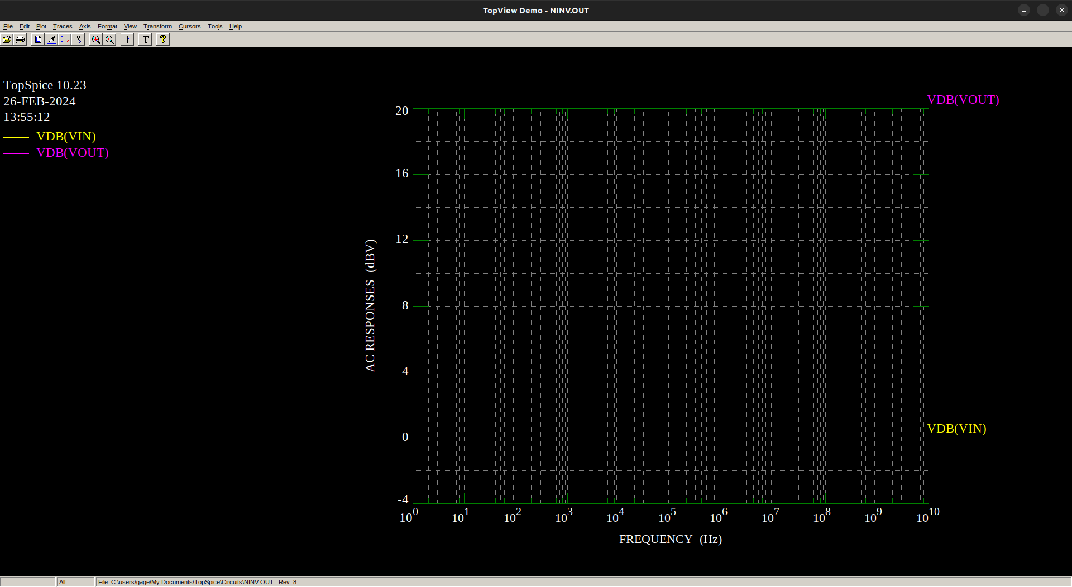

Example 3

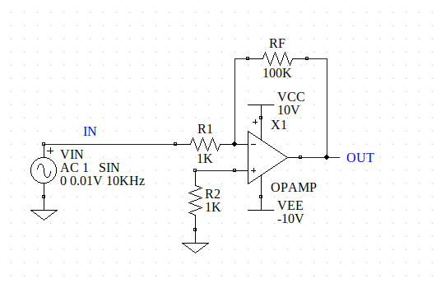
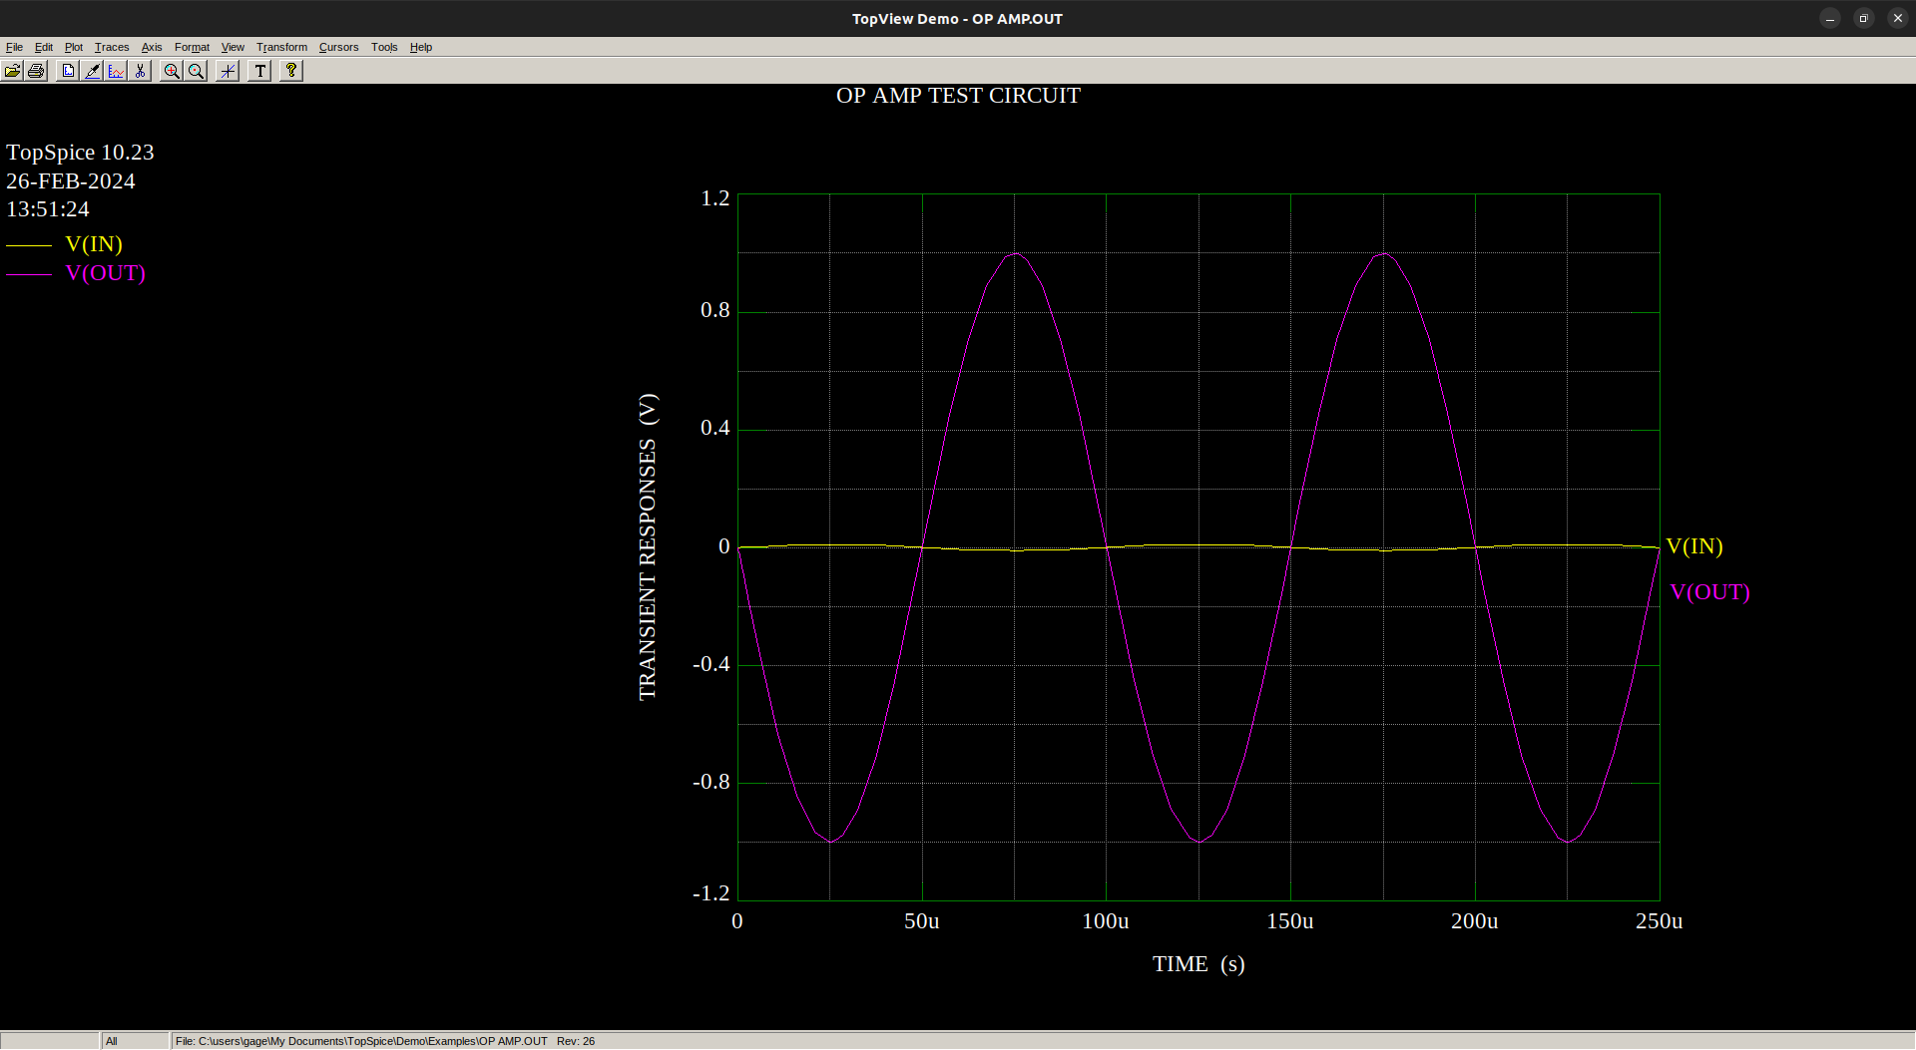
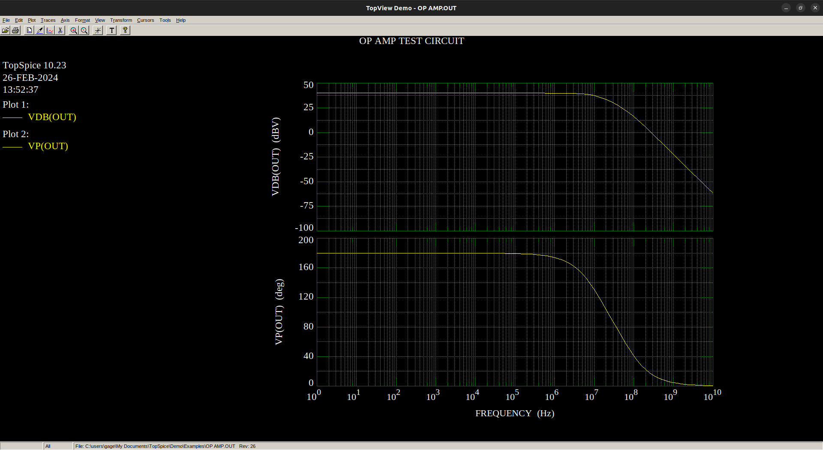
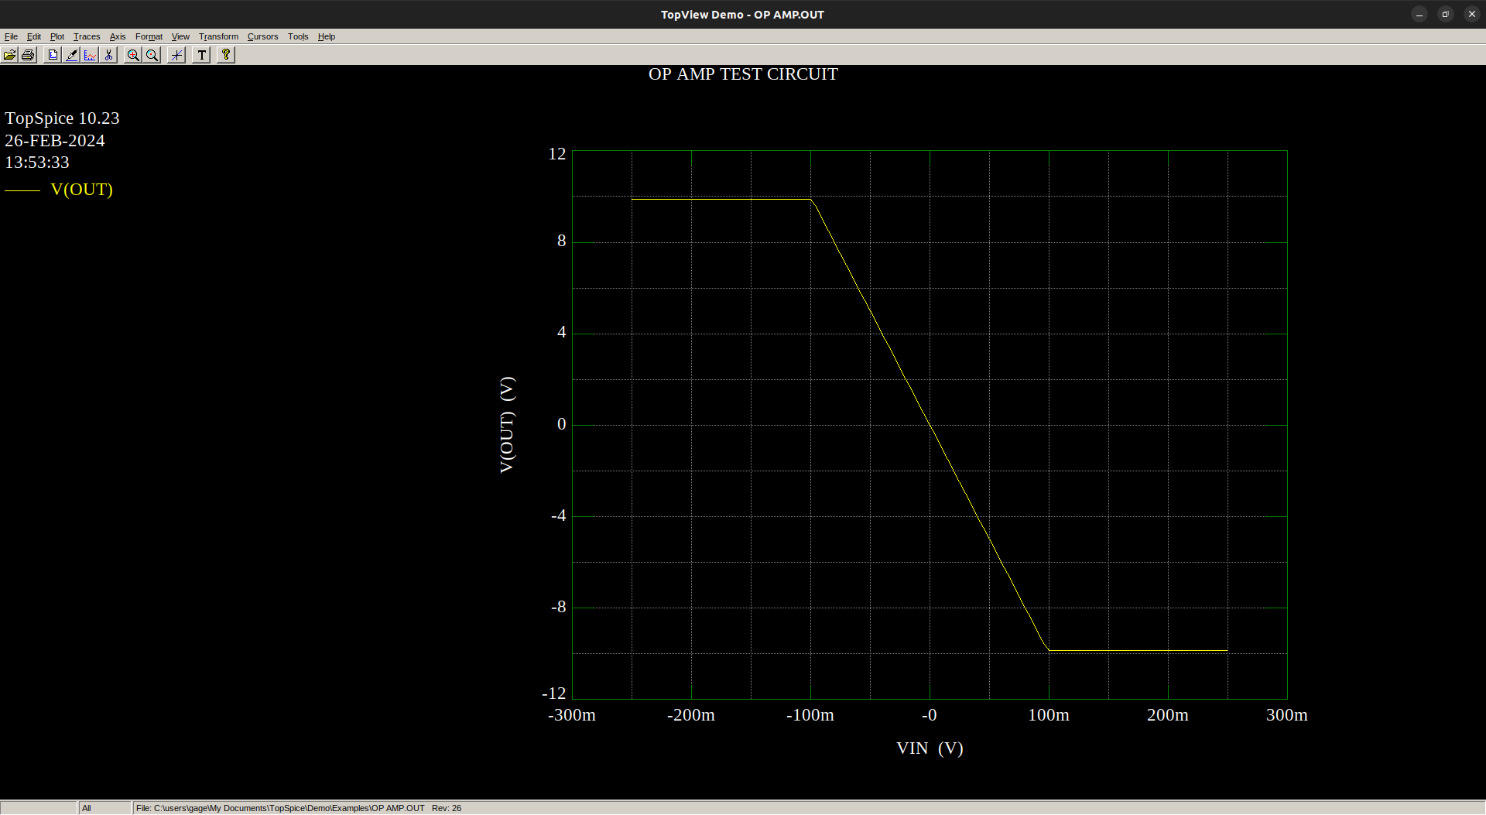

List of things:

R1) YAGEO 1kΩ Resistor - $0.10
R2) YAGEO 1kΩ Resistor - $0.10
RF) YAGEO 100kΩ Resistor - $0.09
Op-Amp) Texas Instruments LMV358IPWR - $0.42
Voltage Source) AliExpress “AC-DC AC 100V-240V to DC 5V 12V 1A 2A 2.5A Switching Power Supply Module Switch Overvoltage Overcurrent Short Circuit Protection” - $0.58

Total - $1.29, but I have zero faith in the voltage source

