Flow Framework Report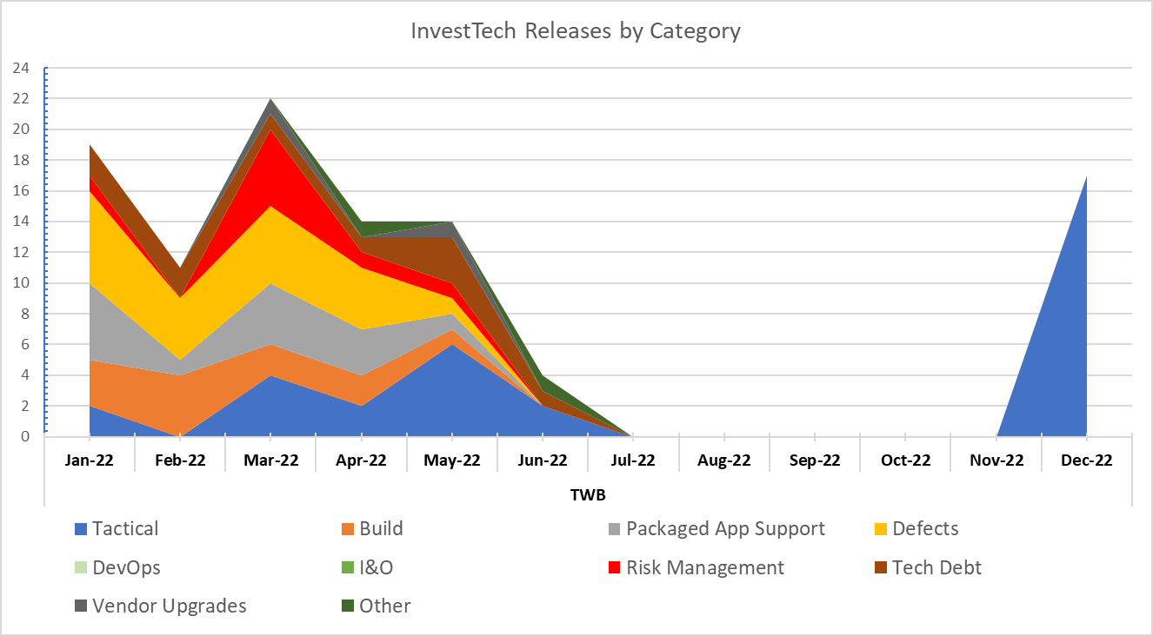

Capacity Demand Report

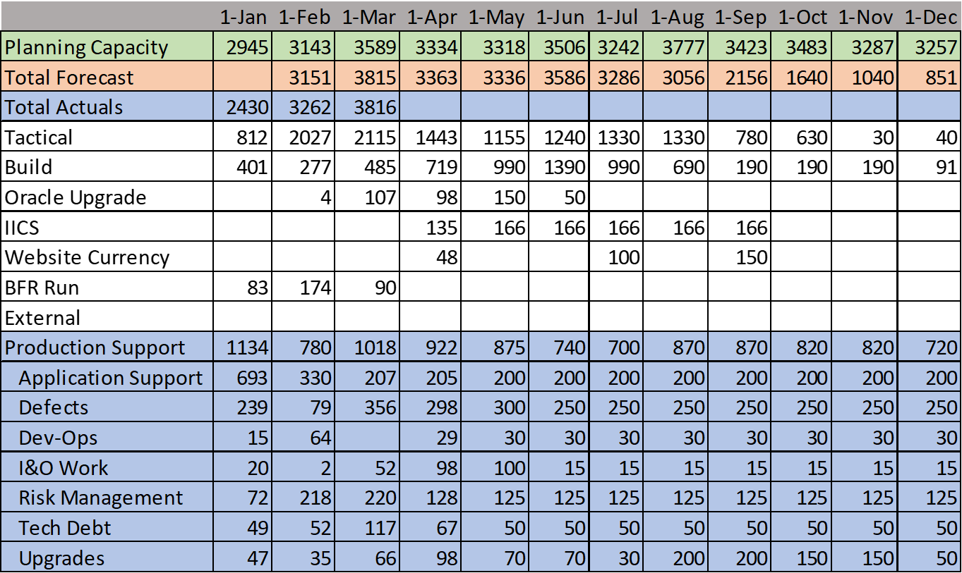

GDP by Country – [Visual Capitalist link](https://www.visualcapitalist.com/wp-content/uploads/2021/12/Global-Economy-GDP-by-Country-2021.html)

