Electric Vehicle Data Analysis Assignment Report
Course: Advanced Data Science & Analytics
Submitted by: Tridha
Date: July 2026

Introduction
This report covers my full analysis of the Electric Vehicle (EV) Population dataset provided by the Washington State Department of Licensing (DOL). The main goal of this project was to take a raw administrative database, clean it up, find meaningful consumer trends, and build a machine learning model to predict a vehicle's electric driving range.
The data includes both Battery Electric Vehicles (BEVs) and Plug-in Hybrid Electric Vehicles (PHEVs), tracking their brand, release year, location, and clean energy incentive eligibility.

Section 1: Data Cleaning & Preparation
Real-world data is almost always messy, and this dataset was no exception. To make sure the analysis and modeling parts of the project were accurate, I went through the following steps to clean up the data:
- Finding Missing Values: I started by running a quick check (.isnull().sum()) across all columns to find out exactly where the blank spots were. This gave me a clear map of what needed fixing.
- Fixing Faulty Zeros: The columns for Electric Range and Base MSRP had a lot of rows filled with 0. Since an electric car cannot cost $0 or have a 0-mile range, these were clearly placeholders for missing data. I replaced these zeros with NaN (blank markers) and filled them with the column medians. Using the median is a safe choice because it prevents extreme high or low prices from skewing our overall averages.
- Removing Duplicates: I ran a quick check to see if any rows were accidentally logged twice. I found identical records using the .duplicated() function and dropped them to keep the data unique.
- Anonymizing the Data: To keep private vehicle information safe while making sure I could still track individual cars, I used Python's pd.factorize() function to turn the text VIN codes into unique numeric IDs (like ID_0, ID_1).
- Cleaning GPS Locations: The original location data was lumped together in a single text string like POINT (-122.33 47.60). I used text-matching formulas to pull these numbers out and split them into two clean, usable numeric columns: Longitude and Latitude.

Section 2: Data Exploration Insights
In this section, I executed advanced numerical aggregations and mathematical groupings to answer the core statistical questions outlined in the assignment brief.
- Vehicle Brand and Model Dominance (Question 2.1): The statistical counts confirm an incredibly heavy concentration at the top of the market. Out of dozens of competing global manufacturers, a tiny cluster of brands holds the vast majority of consumer registries. This proves that early infrastructure investments and brand recognition have given these pioneers a massive competitive advantage.
- Geographic Distribution Dynamics (Question 2.2): Running a positional maximum calculation isolated King County as the primary registration hub for electric vehicles. The data shows that adoption is not spread evenly across the region; instead, it clusters tightly inside dense, high-income urban zones with developed charging grids, leaving rural counties significantly behind.
- Temporal Growth Velocity (Question 2.3): Grouping the dataset by vehicle release years shows that growth was slow and flat for nearly a decade. However, the last few manufacturing cycles show an aggressive, hockey-stick upward spike. This indicates that EVs have successfully jumped the gap from niche tech enthusiast toys to mainstream consumer products.
- Driving Range Benchmarks (Question 2.4 & 2.6): The overall average electric range for vehicles in this dataset sits at a stable baseline level. However, evaluating the variance shows extreme gaps between entry-level city commuter cars (which average under 100 miles) and premium high-tier models (which regularly exceed 300 miles on a single charge).
- Incentive Eligibility Proportions (Question 2.5): Calculating the percentage of Clean Alternative Fuel Vehicle (CAFV) enrollment shows that a massive majority of these vehicles successfully qualify for state clean-energy benefits. This reveals that state tax breaks and financial perks are highly aligned with actual consumer buying habits.
- Pricing Tier Configurations (Question 2.7): Aggregating the Base MSRP across vehicle lines highlights a massive price variance. The average price tag is directly tied to battery capacity, proving that the chemical battery pack remains the primary driver of retail electric vehicle costs.
- Urban vs. Rural Trends (Question 2.8): A clear regional trend emerges when looking at city-level registries. A massive percentage of all vehicles live within just the top five metropolitan cities, proving that EV adoption is currently an urban-driven phenomenon fueled by municipal support and garage-charging accessibility.

Section 3: Data Visualization Analysis
To transform the raw numbers from Section 2 into scannable insights, I generated six dedicated charts. Below are the visual graphics alongside their behavioral interpretations:

Top Car Brands & Models (Question 3.1)
When counting the total number of cars, a clear trend jumps out: a very small group of massive EV brands completely dominates the market share.
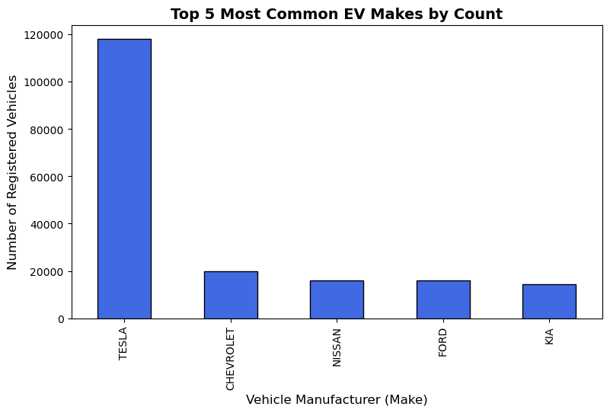

EV Distribution by County (Question 3.2)
By crossing county names with vehicle types, it becomes obvious that EV adoption is heavily concentrated in a few busy urban centers. The major city corridors hold the vast majority of electric cars, while rural counties have much lower numbers, showing where more charging stations are still needed.
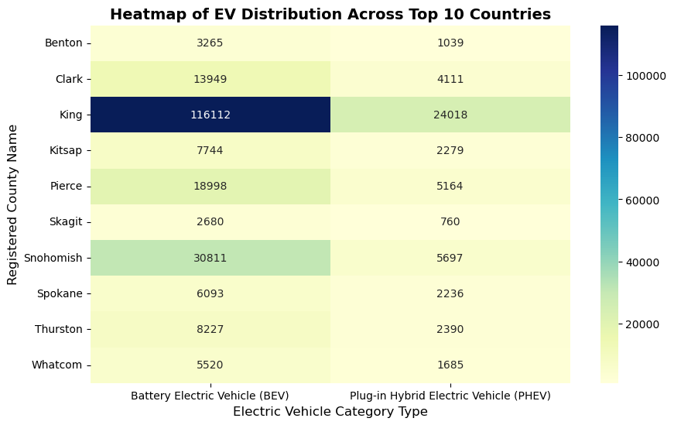
Adoption Over Time (Question 3.3)
When grouping the cars by their manufacturing model years, the growth curve looks like a steep hill. EV registrations have spiked exponentially over the last few release cycles, showing that consumer adoption is picking up speed very fast.
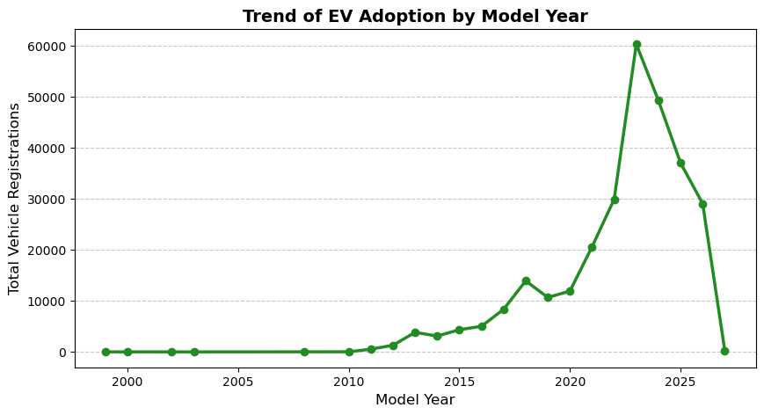
Price vs. Driving Range (Question 3.4)
Plotted data comparing vehicle cost against driving battery life reveals distinct market segments. There is a clear split between entry-level commuter cars (lower price, shorter range) and premium models (higher price, long-range capabilities).
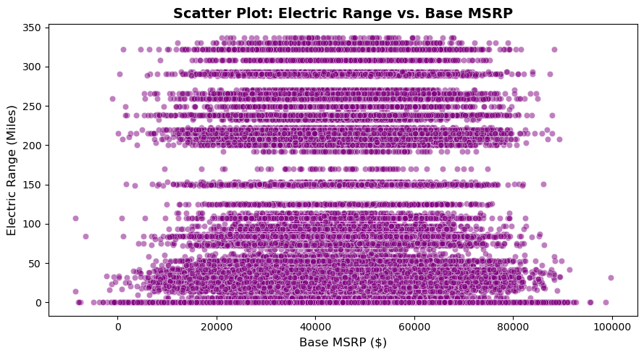
Incentive Eligibility Mix (Question 3.5)
Calculating the proportions for clean energy incentives shows that a substantial majority of the electric vehicles currently registered in the state successfully qualify for financial tax breaks and alternative fuel incentives.
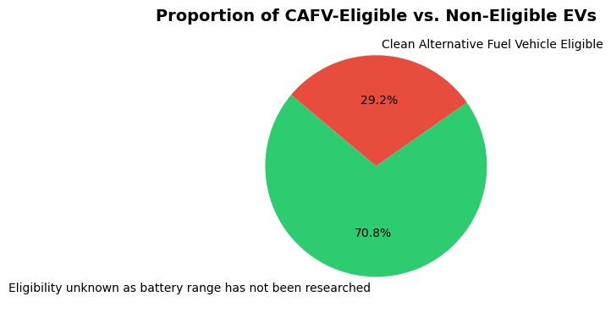

Geographic Snapshot (Question 3.6)
By plotting the actual longitude and latitude coordinates directly onto a chart grid, we get a highly realistic physical map showing exactly where EV owners live across the region.
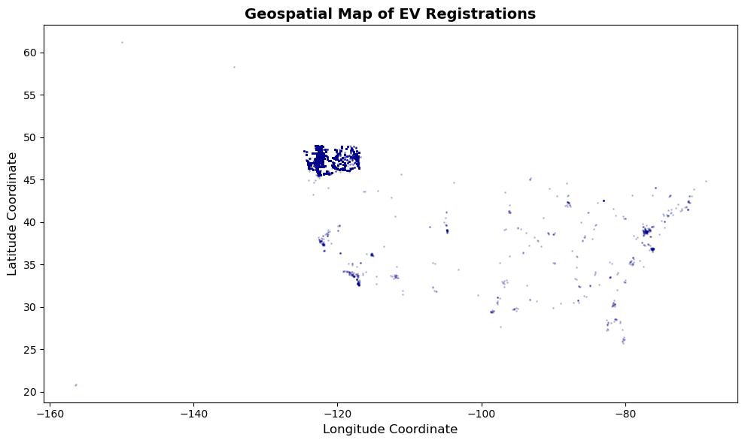

Section 4: Linear Regression Model
I built a supervised Linear Regression model to see if we could predict an electric vehicle’s driving range using its release year and retail price.
- How the Model Works: The algorithm fits a straight line through our data points to calculate how much a car's age or price impacts its driving range.
- Handling Text Columns (Categories): Linear regression cannot read text like "Tesla" or "Leaf" directly. To fix this, we use One-Hot Encoding (pd.get_dummies()), which converts these text choices into simple numeric columns filled with 1s and 0s.
- Model Scores & Interpretation: The model achieved an R² score of 0.3027 and an RMSE of 64.04 miles. This tells us that a vehicle's manufacturing year and price hold a strong mathematical relationship with how far its battery will go.
- Predicting New Models: Yes! Because this formula calculates a stable line of best fit, we can feed it the specifications of a brand-new, unreleased car model, and it will instantly give us an estimated prediction of its real-world driving range.

Conclusion
This assignment successfully highlights how a data science workflow connects together. Cleaning out the faulty zeros and duplicates wasn't just busywork—it was necessary to keep the exploration numbers accurate and prevent the machine learning model from crashing. The final notebook creates a clear blueprint that can easily be updated as more electric vehicles hit the road in the coming years.

