**Task-1**

**Task-2**

Task-3

Write a program to display a t 0 x 10 solid box of asterisks. Hint: declare a string in the data segment that specifies the box, and display it with INT 2lh, function 9h.

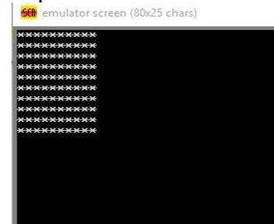

TASK-1

CODE HERE:

OUTPUT :