

**AMERICAN INTERNATIONAL UNIVERSITY–BANGLADESH (AIUB)**

**FACULTY OF ENGINEERING DEPARTMENT OF COMPUTER ENGINEERING DATA COMMUNICATION**

**Spring 2023-2024**

**Section: F**

**Group: 03**

**LAB REPORT ON**

***Introduction to MATLAB.***

**Supervised By**

**SADMAN SHAHRIAR ALAM**

**Submitted By**

|  |  |
| --- | --- |
| **Name** | **ID** |
|  |  |
| AZMINUR RAHMAN | 22-46588-1 |
|  |  |
| TRIDIB SARKAR | 22-46444-1 |
|  |  |
| ISTYAK AHMED | 21-45658-3 |
|  |  |
| MD. SAKIBUL HAQUE TANMOY | 21-45659-3 |
|  |  |
| SAFAR AHMED | 19-40752-1 |
|  |  |

Date of Experiment: **January 24, 2024**

Date of Submission: **February 07, 2024**

**Title:** Introduction to MATLAB.

**Performance Task:**

ID = AB-CDEFG-H = 22-46588-1

According to the above statement-

A = 2

B = 2

C = 4

D = 6

E = 5

F = 8

G = 8

H = 1

x1(t) = A1 cos((2π(C+D+E+F) t) + j1)

x2(t) = A2 cos((2π(C+D+E+F) t) + j2)

1. A1=A+B=2+2=4 A2=G+H=8+1=9 J1=D+G=6+8=14º J2 = 30º

x1 = 4*cos((2*pi(4+6+5+8) t) + 14)

x2(t) = 9*cos((2*pi*(4+6+5+8) t) + 30)

(b)

A=2;

B=2;

C=4;

D=6;

E=5;

F=8;

G=8;

H=1;

rad = pi/180;

A1=A+B;

j1 = (D + G)*rad;

t = -0.1 : 0.001 : 0.1;

x1 = A1 * cos((2* pi * (C + D + E + F) * t )+ j1);

plot(t,x1)

xlabel(‘time (t)’);

ylabel(‘signal (x1)’);

title(‘Signal (x1 / t)’);

*Lab Report* *Department of EEE* *Page* ***2*** *of* ***7***

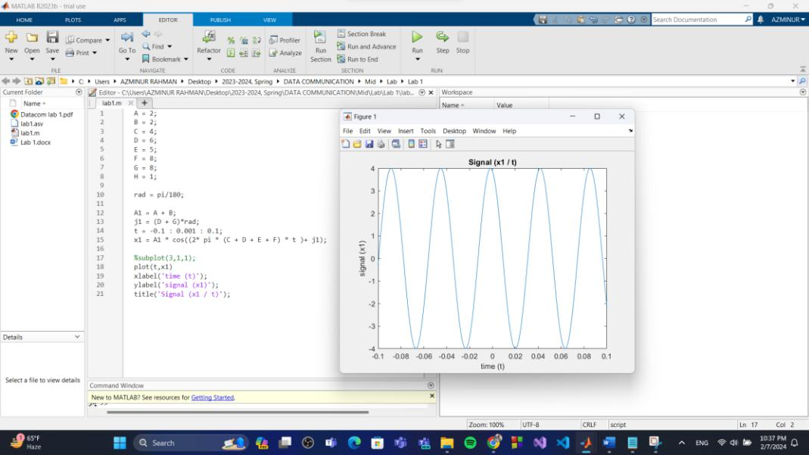

Fig 01: x1

A=2;

B=2;

C=4;

D=6;

E=5;

F=8;

G=8;

H=1;

rad = pi/180;

A2=G+H;

j2 = 30*rad;

x2 = A2 * cos((2* pi * (C + D + E + F) * t )+ j2);

plot(t,x2)

xlabel('time (t)');

ylabel('signal (x2)');

title('Signal (x2 / t)');

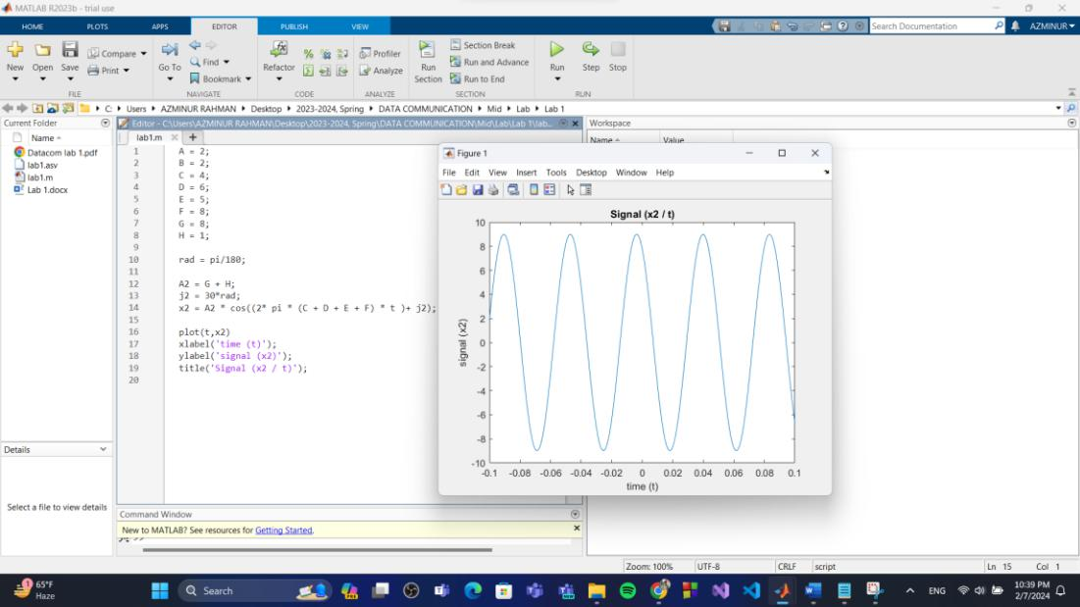

Fig 02: x2

*Lab Report* *Department of EEE* *Page* ***3*** *of* ***7***

(c)

A=2;

B=2;

C=4;

D=6;

E=5;

F=8;

G=8;

H=1;

rad = pi/180;

A1=A+B;

j1 = (D + G)*rad;

t = -0.1 : 0.001 : 0.1;

x1 = A1 * cos((2* pi * (C + D + E + F) * t )+ j1);

A2=G+H;

j2 = 30*rad;

x2 = A2 * cos((2* pi * (C + D + E + F) * t )+ j2);

plot(t, x1)

plot(t, x2)

plot(t,angle(x1)),title('Phase Plot')

plot(t,abs(x1)),title('Amplitude Plot')

plot (t, angle(x2)), title('Phase Plot')

plot (t, abs(x2)), title('Amplitude Plot')

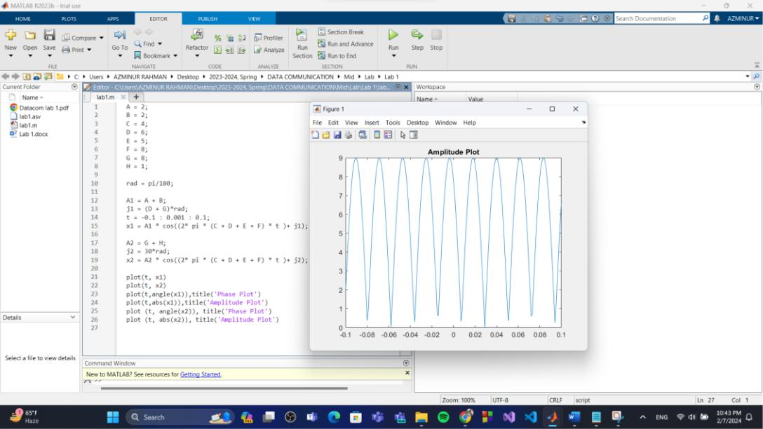

Fig 03: x1 & X2

(d)

A=2;

B=2;

C=4;

D=6;

E=5;

F=8;

G=8;

H=1;

rad = pi/180;

A1=A+B;

j1 = (D + G)*rad;

*Lab Report*

*Department of EEE*

*Page* ***4*** *of* ***7***

t = -0.1 : 0.001 : 0.1;

x1 = A1 * cos((2* pi * (C + D + E + F) * t )+ j1);

subplot(3,1,1);

plot(t,x1)

xlabel('time (t)');

ylabel('signal (x1)');

title('Signal (x1 / t)');

A2=G+H;

j2 = 30*rad;

x2 = A2 * cos((2* pi * (C + D + E + F) * t )+ j2);

subplot(3,1,2);

plot(t,x2)

xlabel('time (t)');

ylabel('signal (x2)');

title('Signal (x2 / t)');

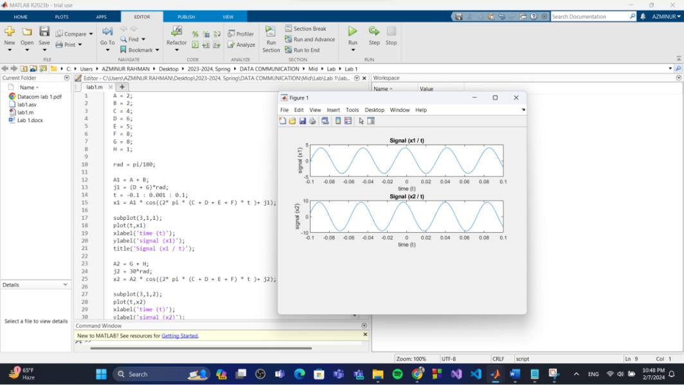

Fig 04: Subplot of X1 & X2

(e)

A=2;

B=2;

C=4;

D=6;

E=5;

F=8;

G=8;

H=1;

rad = pi/180;

A1=A+B;

j1 = (D + G)*rad;

t = -0.1 : 0.001 : 0.1;

x1 = A1 * cos((2* pi * (C + D + E + F) * t )+ j1);

subplot(3,1,1);

plot(t,x1)

xlabel('time (t)');

ylabel('signal (x1)');

title('Signal (x1 / t)');

A2=G+H;

*Lab Report* *Department of EEE* *Page* ***5*** *of* ***7***

j2 = 30*rad;

x2 = A2 * cos((2* pi * (C + D + E + F) * t )+ j2);

subplot(3,1,2);

plot(t,x2)

xlabel('time (t)');

ylabel('signal (x2)');

title('Signal (x2 / t)');

x3 = x1 + x2 ;

subplot(3,1,3);

plot(t,x3)

xlabel('time (t)');

ylabel('signal (x3)');

title('Signal (x3 / t)');

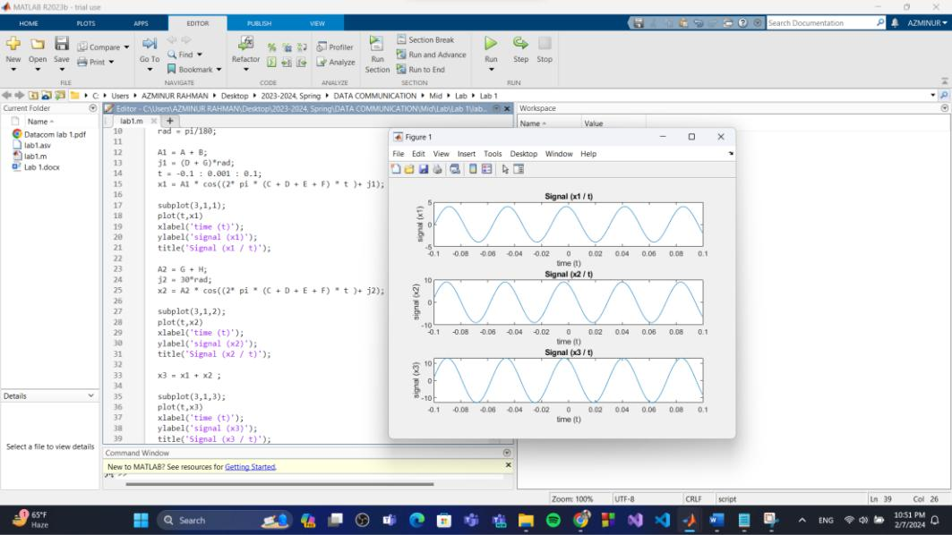

|  |  |  |  |
| --- | --- | --- | --- |
|  |  | Fig 05: Subplot of X1, X2 & X3 |  |
| (f) |  |  |  |
| A = | | 2; |  |
| B = | | 2; |  |
| C = | | 4; |  |
| D = | | 6; |  |
| E = | | 5; |  |
| F = | | 8; |  |
| G = | | 8; |  |
| H = | | 1; |  |
| rad | | = pi/180; |  |
| A1 | =A+B; | |  |
| j1 | = (D + G)*rad; | |  |
| t = | | -0.1 : 0.001 : 0.1; |  |
| x1 | = A1 * cos((2* pi * (C + D + E + F) * t )+ j1); | |  |
| A2 | =G+H; | |  |
| j2 | = 30*rad; | |  |
| x2 | = A2 * cos((2* pi * (C + D + E + F) * t )+ j2); | |  |
| x3 | = x1 + x2 ; | |  |
| plot(t, x1) | | |  |
| plot(t, x2) | | |  |
| plot(t,angle(x1)),title('Phase Plot') | | |  |
| *Lab Report* |  | *Department of EEE* | *Page* ***6*** *of* ***7*** |

plot(t,abs(x1)),title('Amplitude Plot')

plot (t, angle(x2)), title('Phase Plot')

plot (t, abs(x2)), title('Amplitude Plot')

subplot (3,1,1), plot (t,x1)

subplot (3,1,2), plot (t,x2)

subplot (3,1,3), plot (t, x3)

subplot (3,1,3), plot (t, x3)

plot (t, abs(x3)), title('Amplitude Plot')

plot (t, angle(x3)), title('Phase Plot')

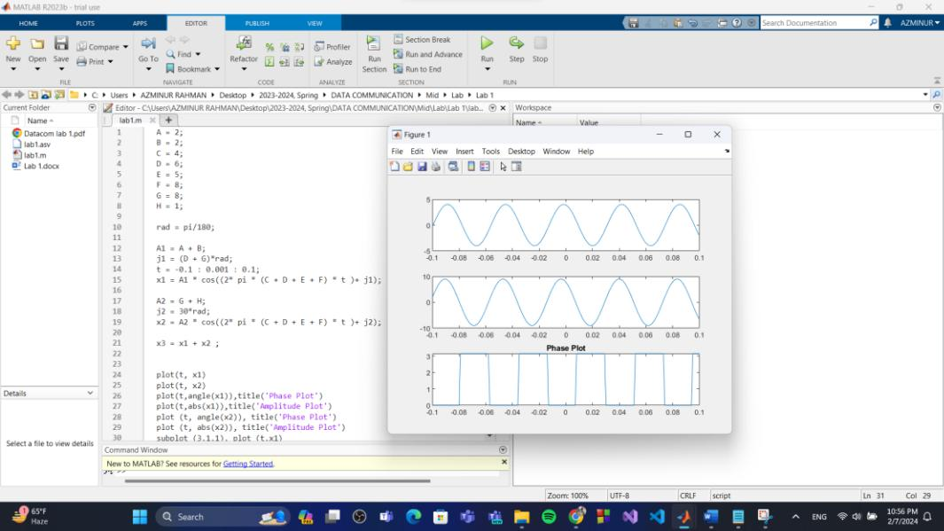

Fig 06: Phase of X3

*Lab Report* *Department of EEE* *Page* ***7*** *of* ***7***