

**AMERICAN INTERNATIONAL UNIVERSITY–BANGLADESH (AIUB)**

**FACULTY OF ENGINEERING DEPARTMENT OF COMPUTER ENGINEERING DATA COMMUNICATION**

**Spring 2023-2024**

**Section: F**

**Group: 03**

**LAB REPORT ON**

***Introduction to MATLAB.***

**Supervised By**

**SADMAN SHAHRIAR ALAM**

**Submitted By**

|  |  |
| --- | --- |
| **Name** | **ID** |
|  |  |
| AZMINUR RAHMAN | 22-46588-1 |
|  |  |
| TRIDIB SARKAR | 22-46444-1 |
|  |  |
| ISTYAK AHMED | 21-45658-3 |
|  |  |
| MD. SAKIBUL HAQUE TANMOY | 21-45659-3 |
|  |  |
| SAFAR AHMED | 19-40752-1 |
|  |  |

Date of Experiment:

Date of Submission:

**Title: Study of signal frequency, spectrum, bandwidth, bit rate, quantization using MATLAB**

ID: 22-46444-1

x1(t) = A1 cos(2π(C*10) t)

x2(t) = A2 cos(2π(F*10) t)

x3(t) = x1(t) + x2(t)

AB-CDEFG-H

A=2,

B=2,

C=4,

D=6,

E=4,

F=4,

G=4,

H=1

a) A2 = G+D = 6+4 = 10,

A2 = A+F = 2+4 = 6

b)

fs = 10000;

t = -0.1:1/fs:0.01;

C=4;

F=4;

A1 = 10;

A2 = 6;

x1 = A1*cos(2*pi*(C*10) *t); % First Signal

x2 = A2*cos(2*pi*(F*10) *t); % Second Signal

x3=x1+x2;

plot(t,x3,'y')

xlabel('time in seconds')

ylabel('Amplitude in volts')

title('Time Domain of Sinosoid')

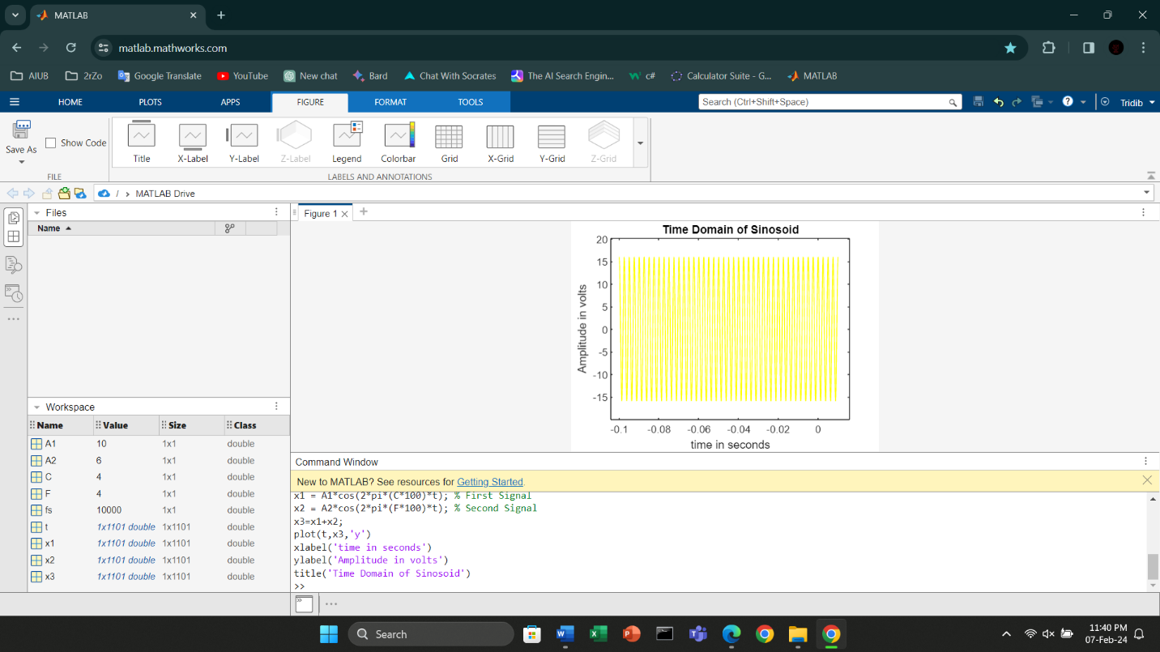

c)

fs = 1000;

t = 0:1/fs:1-1/fs;

C=4;

F=4;

A1 = 10;

A2 = 6;

x1 = A1*cos(2*pi*(C*10) * t); % First Signal

x2 = A2*cos(2*pi*(F*10) * t); % Second Signal

x3=x1+x2;

fx1=fft(x3);

fx1=fftshift(fx1)/(fs/2);

f=fs/2*linspace(-1,1, fs);

plot(f,abs(fx1));

xlabel('Frequency')

ylabel('Amplitude in volts')

title ('Magnitude FFT of cos')

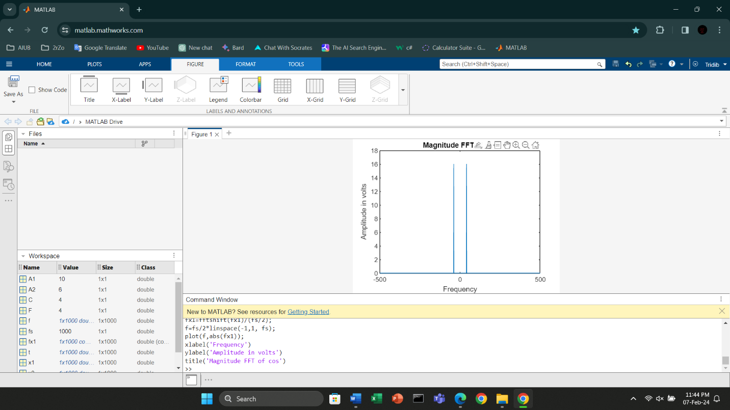

fs = 1000;t = 0:1/fs:1-1/fs; C=4;F=4;A1 = 10;A2 = 6;x1 = A1*cos(2*pi*(3*10) *t); % First Signalx2 = A2*cos(2*pi*(8*10) *t); % Second Signalx3=x1+x2;bandwidth=800-300

